

**AMERICAN INTERNATIONAL UNIVERSITY–BANGLADESH (AIUB)**

**FACULTY OF SCIENCE & TECHNOLOGY**

**OBJECT ORIENTED PROGRAMMING 2**

**Spring 2023-2024**

**Section: ___P___, Group: ____5____**

**PROJECT ON**

***Electronic Voting System***

**Supervised By**

***TOFAYET SULTAN***

**Submitted By**

| **Name** | **ID** |
| --- | --- |
| 1. **Kazi Tanzizul Haque Tanzil** | **22-47783-2** |
| 1. **Ujjoyeni Dey** | **22-49001-3** |
| 1. **Rubaiyat Ilham Rahman** | **23-50887-1** |

Date of Submission: **May, 2024**

**Table of Contents**

| **Topics** | **Page No** |
| --- | --- |
| 1. Cover Page | i |
| 1. Table of Contents | ii |
| 1. Title | 3 |
| 1. Introduction | 3 |
| 1. Case Study | 3 |
| 1. Features and Functionality | 4 - 5 |
| 1. ER Diagram | 6 |
| 1. Database Schema | 7 |
| 1. Activity Diagram | 8 |
| 1. Table Creation Query | 8 - 10 |
| 1. Normalization | 10 - 12 |
| 1. Project UI | 12 - 14 |
| 1. Database Connection String | 14 |
| 1. Conclusion | 15 |
| 1. Reference | 15 |

1. **Title:** Electronic Voting System (EVS)
2. **Introduction**

In an age marked by technological progress, traditional voting methods are undergoing significant changes. The Electronic Voting System (EVS) stands out as a pioneering solution, utilizing computing power to streamline the electoral process. In Bangladesh, where traditional voting methods have encountered challenges related to logistical constraints and electoral integrity, the adoption of online Electronic Voting System presents an opportunity for modernization. According to recent statistics from the Bangladesh Election Commission, in the 2022 parliamentary elections, over 60% of eligible voters faced difficulties accessing polling stations due to geographical barriers, underscoring the need for alternative voting mechanisms. Moreover, instances of ballot tampering and fraudulent practices have raised concerns regarding the credibility of election outcomes. Against this backdrop, the integration of EVS offers the promise of mitigating such issues by facilitating remote voting, ensuring secure authentication, and enabling real-time monitoring of electoral processes. This introduction explores the potential benefits and challenges associated with the implementation of EVS in Bangladesh, aiming to contribute to the discourse on electoral reform in the digital age.

1. **Case Study**

The Electronic Voting System (EVS) facilitates users to cast their votes for their chosen political party. Users can log in with roles as either Voter, Division Supervisor, or Head Supervisor, each with specific access privileges. Admins are also granted access and have authority over user management. Upon login, users are directed to their respective home pages based on their roles. Only one login role is permitted per user. Admins have the capability to oversee and manage all users registered within the system. Division Supervisors are limited to viewing users within their assigned division, while Head Supervisors can access information about all users who have cast their votes. Voters are restricted to casting a single vote for their preferred political party, ensuring the integrity of the voting process. Through clear role distinctions and access controls, the EVS aims to streamline the voting experience while maintaining security and transparency. The ER diagram captures these relationships, facilitating efficient data management within the system.

1. **Features and Functionality**

* **User Authentication and Role Management**
  + Users can log in with specific roles: Admin, Head Supervisor, Division Supervisor, or Voter.
  + Each role has defined access privileges within the system.
* **Role-Based Access Control (RBAC)**
  + Admins have comprehensive access and authority over user management, including the ability to view all system tables, and delete users from tables using their unique identifier (NID).
  + Head Supervisors can access user tables from all divisions, view the overall vote list table for the campaign, and update limited information in the table without adding or deleting data entries.
  + Division Supervisors can view user tables specific to their assigned division, access statistics related to their division's votes, and update limited information in the table without adding or deleting data entries.
  + Voters can log in to view information about political parties, cast a single vote for their preferred party, and are prevented from voting more than once.
* **Home Page Redirection**
  + Upon login, users are directed to their respective home pages based on their roles, ensuring a personalized and efficient user experience.
* **Data Integrity and Security**
  + The system ensures the integrity of the voting process by restricting voters to casting only one vote for their chosen party.
  + Role-based access controls prevent unauthorized users from accessing or tampering with sensitive data, enhancing overall security and transparency.
* **Streamlined Voting Experience**
  + Through clear role distinctions and access controls, the Electronic Voting System aims to streamline the voting experience, making it intuitive and user-friendly for all individuals involved.

1. **ER Diagram**

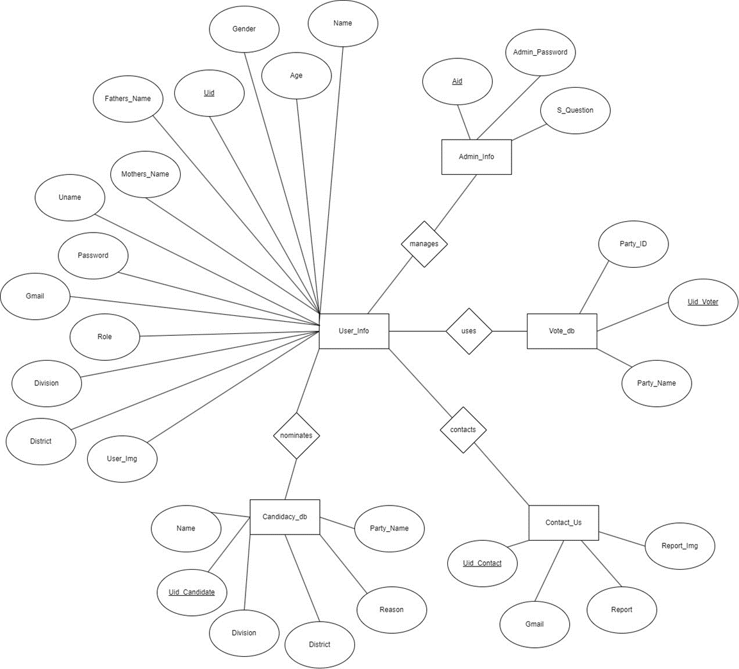

1. **Database Schema**

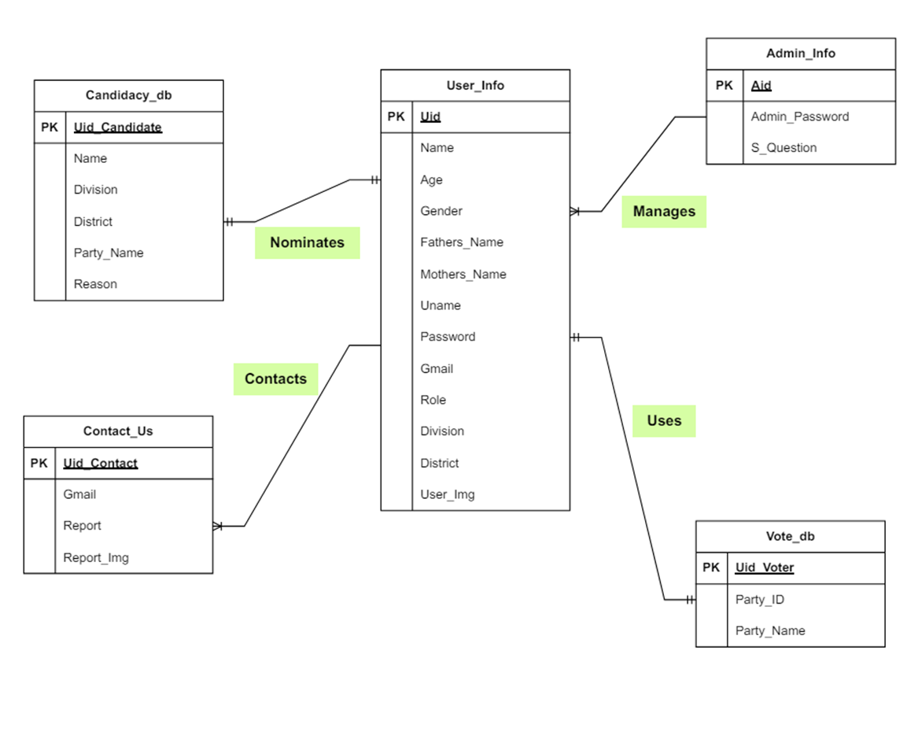

1. **Activity Diagram**

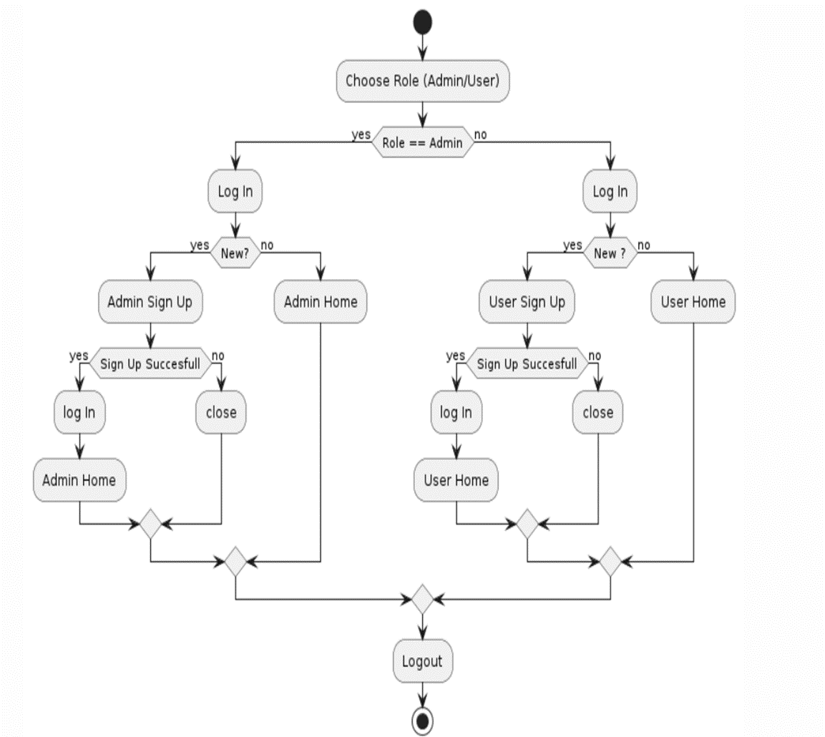

1. **Table Creation Query**

* Table 1: Admin_Info

CREATE TABLE Admin_Info(

Aid varchar(50) PRIMARY KEY,

Admin_Password varchar(50),

S_Question varchar(50)

);

* Table 2: User_Info

CREATE TABLE User_Info(

Uid varchar(50) PRIMARY KEY,

Name varchar(50),

Age varchar(50),

Gender varchar(50),

Fathers_Name varchar(50),

Mothers_Name varchar(50),

Uname varchar(50),

Password varchar(50),

Gmail varchar(50),

Role varchar(50),

Division varchar(50),

District varchar(50),

User_Img image

);

* Table 3: Candidacy_db

CREATE TABLE Candidacy_db(

Uid_Candidate varchar(50) PRIMARY KEY,

Name varchar(50),

Division varchar(50),

District varchar(50),

Party_Name varchar(50),

Reason varchar(50)

);

* Table 4: Vote_db

CREATE TABLE Vote_db(

Uid_Voter varchar(50) PRIMARY KEY,

Party_ID varchar(50),

Party_Name varchar(50)

);

* Table 5: Contact_Us

CREATE TABLE Contact_Us(

Uid_Contact varchar(50) PRIMARY KEY,

Gmail varchar(50),

Report varchar(50),

Report_Img image

);

1. **Normalization**

The initial database schema consists of the following tables:

* Admin_Info
* User_Info
* Candidacy_db
* Vote_db
* Contact_Us

Each table has been normalized and presented separately in UNF, 1NF, 2NF and 3NF.

**Table 1: Admin_Info**

* Unnormalized Form (UNF): Aid (Primary Key), Admin_Password, S_Question
* First Normal Form (1NF): Aid (Primary Key), Admin_Password, S_Question
* Second Normal Form (2NF): No changes needed, already in 2NF.
* Third Normal Form (3NF): No changes needed, already in 3NF.

**Table 2: User_Info**

* Unnormalized Form (UNF): Uid (Primary Key), Name, Age, Gender, Fathers_Name, Mothers_Name, Uname, Password, Gmail, Role, Division, District, User_Img
* First Normal Form (1NF): Uid (Primary Key), Name, Age, Gender, Fathers_Name, Mothers_Name, Uname, Password, Gmail, Role, Division, District, User_Img
* Second Normal Form (2NF): No changes needed, already in 2NF.
* Third Normal Form (3NF): No changes needed, already in 3NF.

**Table 3: Candidacy_db**

* Unnormalized Form (UNF): Uid_Candidate (Primary Key), Name, Division, District,
* Party_Name, Reason
* First Normal Form (1NF): Uid_Candidate (Primary Key), Name, Division, District,
* Party_Name, Reason
* Second Normal Form (2NF): No changes needed, already in 2NF.
* Third Normal Form (3NF): No changes needed, already in 3NF.

**Table 4: Vote_db**

* Unnormalized Form (UNF): Uid_Voter (Primary Key), Party_ID, Party_Name
* First Normal Form (1NF): ): Uid_Voter (Primary Key), Party_ID, Party_Name
* Second Normal Form (2NF): No changes needed, already in 2NF.
* Third Normal Form (3NF): No changes needed, already in 3NF.

**Table 5: Contact_Us**

* Unnormalized Form (UNF): Uid_Contact (Primary Key), Gmail, Report, Report_Img
* First Normal Form (1NF): Uid_Contact (Primary Key), Gmail, Report, Report_Img
* Second Normal Form (2NF): No changes needed, already in 2NF.
* Third Normal Form (3NF): No changes needed, already in 3NF.

1. **Project UI**

| **Loading** | **Login** |
| --- | --- |
|  |  |

| **User Registration** | **Admin Registration** |
| --- | --- |
|  |  |

| **Forgot/Reset Password** | **Voter Home** |
| --- | --- |
|  |  |

| **Head Supervisor Home** | **Division Supervisor Home** |
| --- | --- |
|  |  |

| **Contact Us** | **Apply** |
| --- | --- |
|  |  |

| **Admin Home** |  |
| --- | --- |
|  |  |

1. **Database Connection String**

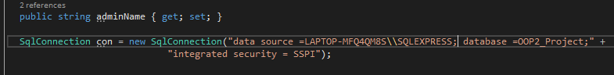

1. **Conclusion**

In summary, our project focused on electronic voting systems marks a significant step forward in modernizing democratic procedures. We aimed to develop a robust platform that adheres to the principles of fairness, integrity, and accessibility in electoral processes through careful design, thorough testing, and ongoing improvement. As we conclude this project, we look back on the journey we've taken and the accomplishments we've achieved. From the initial idea to its implementation, each stage has been characterized by dedicated teamwork and unwavering dedication. While challenges remain, we are determined to continue advancing democratic governance through technological innovation. Looking ahead, we anticipate wider adoption of electronic voting systems, which could revolutionize how societies participate in decision-making. With a strong belief in technology's transformative power, we are committed to refining our EVS to meet the changing demands of our dynamic world. Let us collectively embrace the future of democracy, where every voice is heard, and every vote holds significance.

1. **Reference**

* **National Electoral Committee (NEC). 2005. E-Voting System – Overview. Online available http://www.vvk.ee/public/dok/Yldkirjeldus-eng.pdf**
* [**https://www.youtube.com/watch?v=AYvGtilakto&t=556s**](https://www.youtube.com/watch?v=AYvGtilakto&t=556s)
* **Adida, B. 2008. Helios: Web-based open-audit voting. In Proceedings of the 17th Symposium on Security (Berkeley, CA, USA, 2008), Usenix Association, pp. 335 – 348.**
* [**https://www.youtube.com/watch?v=PY7Ojn9Kv30&t=1056s**](https://www.youtube.com/watch?v=PY7Ojn9Kv30&t=1056s)
* [**https://www.youtube.com/watch?v=iD17cWr10JsGguygvyug**](https://www.youtube.com/watch?v=iD17cWr10JsGguygvyug)
* [**https://www.youtube.com/watch?v=cZVo904hD9o&t=1sTtftyfgvg**](https://www.youtube.com/watch?v=cZVo904hD9o&t=1sTtftyfgvg)
* **D. Jefferson, A.D. Rubin, B. Simons and D. Wagner, “A Security Analysis of the Secure Electronic Registration and Voting Experiment (SERVE)”, Technical Report by U.S. Department of Defense’s FVAP (Federal Voting Assistance Program), January 05, 2004.**