**ZMQ Manual UI Testing Report – coPlay WebApp**

Contents

Introduction: 2

Test Scenarios and Results: 2

Chat Sync Between Tabs 2

Tower Click Propagation 4

Reset Button Functionality 5

Help Modal Display 7

Summary 8

# Introduction:

This report presents the results of manual UI testing for the coPlay WebApp using a multi-tab setup. The tests were performed to verify UI interactions such as chat synchronization, tower click propagation, reset functionality, and recently implemented UI enhancements. Each result is documented with relevant screenshots and captions.

To simulate a multi-user environment, the application was launched in two separate browser tabs. Each tab was served on a different local port to replicate peer-to-peer communication:

Tab 1: http://127.0.0.1:5000/

Tab 2: http://127.0.0.1:5002/

This setup allowed for independent interaction between the two clients, enabling us to observe and verify bidirectional data flow and UI consistency. All observed behaviors and sync mechanisms were captured through annotated screenshots included in this report.

# Test Scenarios and Results:

## Chat Sync Between Tabs

**Objective:** Verify that messages sent from one tab appear in another in real time.

**Result: Success** – messages were synced correctly across tabs.

**Screenshot:**

*Tab 1:*

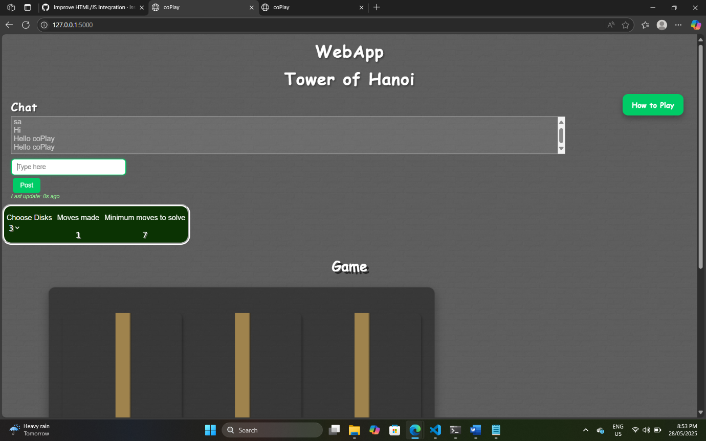

*Tab 2:*

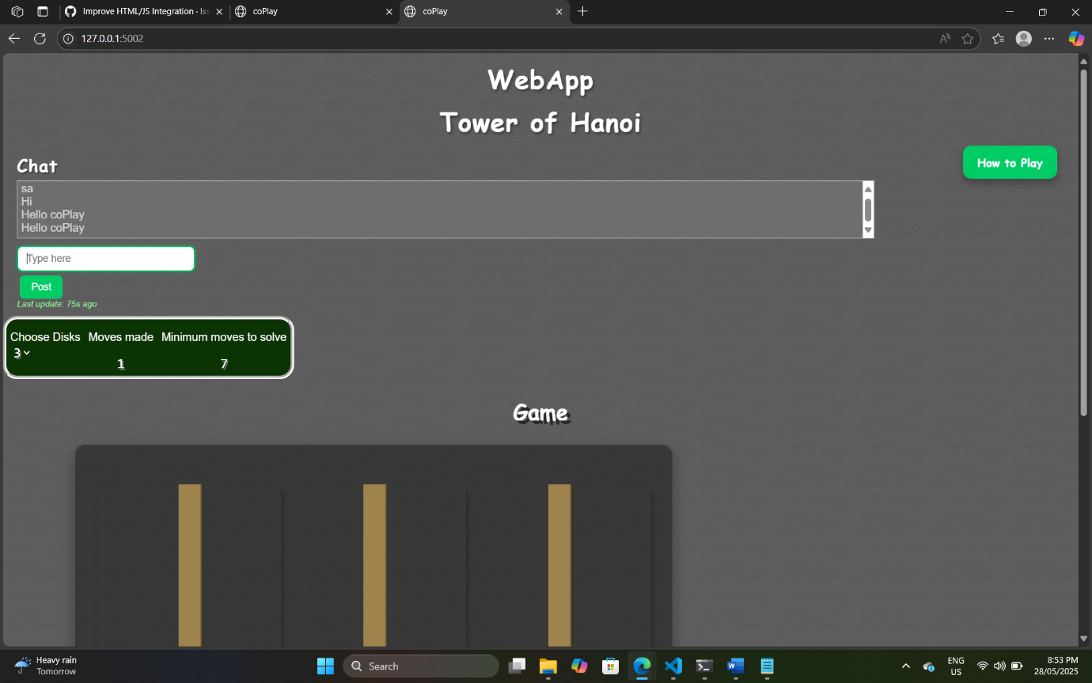

*"Chat synced in both tabs showing identical messages."*

## Tower Click Propagation

**Objective:** Ensure disk movements in one tab reflect accurately in the other.

**Result:** Success – disk movements synced perfectly.

**Screenshot:**

*Tab 1:*

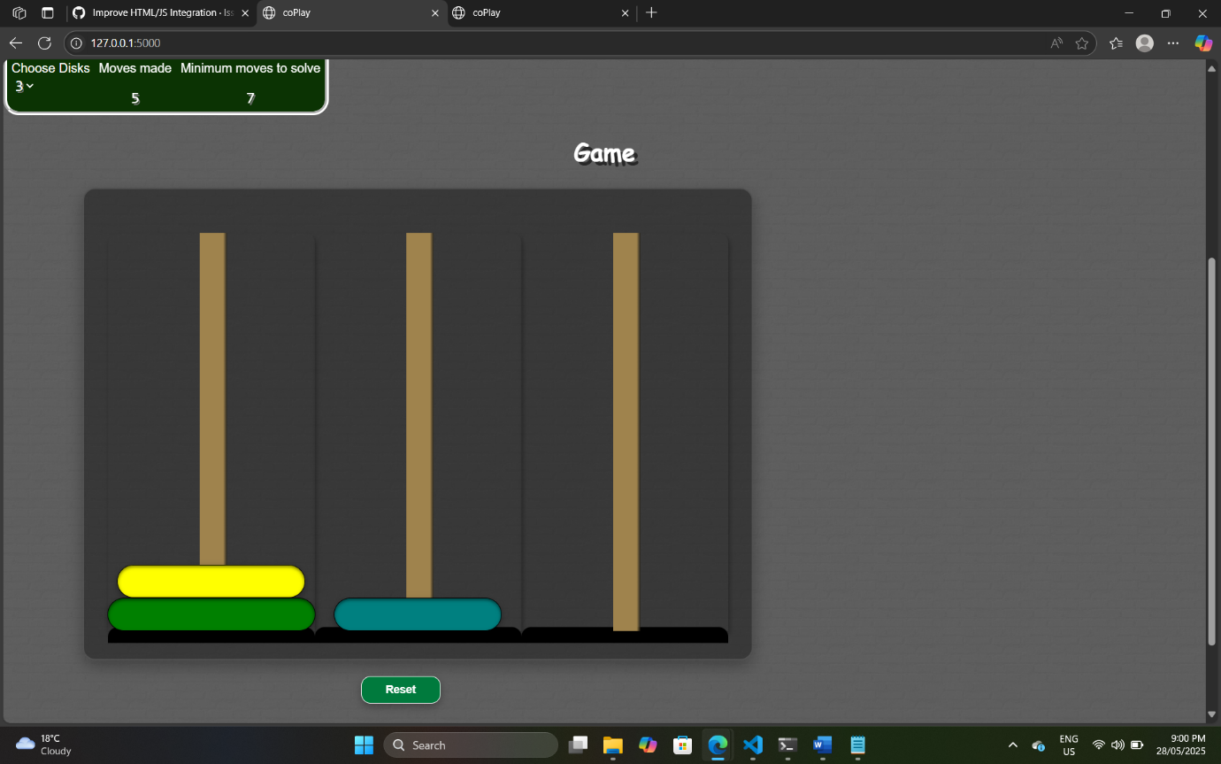

Tab 2:

*Caption: "Disk moved from Tower 1 to Tower 2, reflected in both tabs."*

## Reset Button Functionality

**Objective:** Confirm clicking "Reset" in one tab resets the game in both.

**Result:** Success – both tabs reset correctly.

**Screenshot:**

*Tab 2:*

*"Game reset applied simultaneously in both tabs."*

## Help Modal Display

**Objective:** Check if the 'How to Play' modal displays correctly.

**Result:** Success – modal appears with clear styling and instructions.

**Screenshot:**

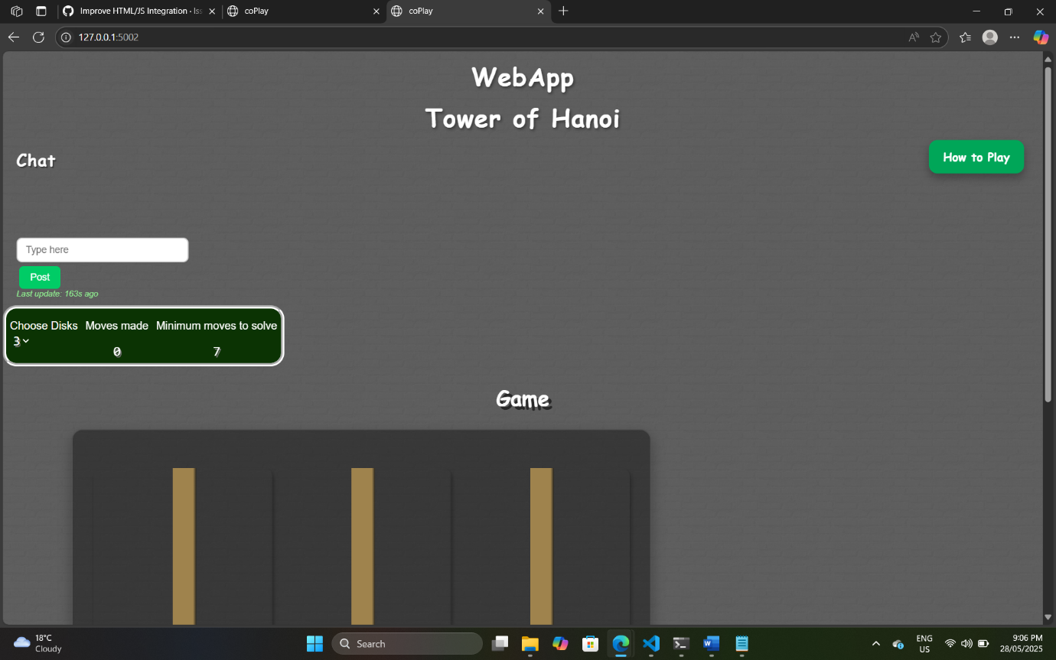

"Help modal with styled instructions and close button."

# Summary

All tests were completed successfully. The UI behaves as expected across peer tabs, and recent visual enhancements (glow effect, help modal, styling updates) are properly functioning. The app provides a responsive and consistent user experience.