

Website Design and Development Using Advance Technology

**MENTOR: SUBMITTED BY**

**Ramesh Singh Rawat Ujjwal Agarwal**

**2017099**

**CSE-D (46)**

**I choose this project because Web Development as a career opportunity is in the IT or the software industry. Clients interested in getting their online brand image established are approaching the software giants to get their Web sites designed.**

**In this project I have created a notes taking website by using various tools mentioned below:**

**HTML (Front End)**

**CSS (Front End)**

**Javascript (Front End)**

**Express Js (Back End)**

**The code of Project is mentioned below along with the screenshot of the website**

HTML code:

<!DOCTYPE html>

<html lang="en">

<head>

    <meta charset="UTF-8">

    <meta http-equiv="X-UA-Compatible" content="IE=edge">

    <meta name="viewport" content="width=device-width, initial-scale=1.0">

    <title>Keep-NOTES</title>

    <link rel="shortcut icon" href="fav-icon/logo.png" type="image/x-icon">

    <link rel="stylesheet" href="nav.css">

    <link rel="stylesheet" href="body.css">

    <link rel="stylesheet" href="responsive.css">

</head>

<body>

    <nav class="navigation">

        <div class="nav roboto">

            <ul>

                <a href="#"><li><img src="nav-icon/image-removebg-preview__1_-removebg-preview.png" alt=""></li></a>

                <a href="#"><li>Home</li></a>

            </ul>

        </div>

        <div class="search roboto">

            <input type="text" name="search" id="search-txt">

            <button class="btn" type="submit">Search</button>

        </div>

    </nav>

    <div class="container roboto">

        <h1>Welcome to Keep-NOTES</h1>

        <textarea name="" class="textarea" id="new-note" rows="10"></textarea>

        <button id="add-new-note" class="btn">Add-Note</button>

        <hr>

        <h2>Your Notes</h2>

        <div id="notes">

        </div>

        <!-- <div class=" noteCard " style="width: 13.6rem;">

            <div class="card-body">

              <h5 class="card-title">Note</h5>

              <p class="card-text mt-4">

               Lorem, ipsum dolor sit amet consectetur adipisicing elit. Consequuntur, modi. Doloremque, architecto.

              </p>

              <button id="${index}" onclick="deleteNode(this.id)" class="btn del-btn">Delete Note</button>

            </div>

          </div> -->

    </div>

</body>

<script src="js/app.js"></script>

</html>

CSS code:

/* This is nav.css file*/

*{

    margin: 0;

    padding: 0;

}

.navigation{

    display: flex;

    height: 50px;

    background-color: black;

    align-items: center;

    justify-content: space-between;

    padding: 11px 33px;

}

.nav ul {

    display: flex;

    align-items: center;

}

.nav a{

    text-decoration: none;

}

.nav  a li{

    list-style: none;

    color:white;

    font-size: 20px;

}

.nav a li img{

    width: 35px;

    padding-right: 35px;

    padding-top: 5px;

}

.search input{

    padding: 8px 8px;

    font-size: 17px;

    width: 159px;

    border-radius: 5px;

}

.search button{

    padding: 9px 9px;

    font-size: 16px;

    background-color: black;

    color: blue;

    border: 2px solid blue;

    border-radius: 5px;

}

.search button:hover{

    background-color: blue;

    color: white;

    transition:linear 90ms;

    cursor: pointer;

}

/* This is body.css file */

@import url('https://fonts.googleapis.com/css2?family=Roboto&display=swap');

@import url('https://fonts.googleapis.com/css2?family=Quicksand:wght@300&display=swap');

*{

    margin: 0;

    padding: 0;

}

.roboto{

    font-family: 'Roboto', sans-serif;

}

.container {

    width: 60vw;

    display: flex;

    flex-direction: column;

    justify-content: center;

    margin: auto;

    /* padding: 40px 0px; */

}

.container h1{

    padding: 50px 0px;

    font-size: 42px;

}

.textarea{

    border: 1px solid #ced4da;

    font-size: 17px;

    max-height: calc(1.5em + 5rem + 2px);

    padding: .975rem .75rem;

    border-radius: .25rem;

}

.btn{

    width: 87px;

    font-size: 16px;

    padding: 9px 4px;

    margin: 30px 0px;

    background-color: white;

    color: blue;

    border: 2px solid blue;

    border-radius: 5px;

}

.btn:hover{

    cursor: pointer;

    color: white;

    background-color: blue;

    transition:linear 90ms;

}

hr{

    margin-bottom: 24px;

}

.container h2{

    font-size: 33px;

}

/* #notes{

    display: flex;

    justify-content: space-evenly;

} */

.card-body{

    border: 1px solid #ced4da;

    border-radius: 15px;

    margin: 17px 0px;

    height: inherit;

    padding: 0px 15px;

}

.card-body h5{

    font-family: 'Quicksand', sans-ser;

    font-size: 25px;

    margin: 17px 0px;

}

.del-btn{

    background-color: blue;

    color: white;

   margin: 17px 0px;

    width: 108px;

}

/* This is responsive.css file */

@media screen and (max-width: 590px){

    body{

        min-width: 350px

    }

    .navigation{

        display: block;

        height: 135px;

    }

    .textarea{

        max-height: calc(1.5em + 10rem + 2px);

    }

    #notes{

        padding-top: 15px;

        padding-bottom: 49px;

    }

}

Javascript Code:

// This is app.js file

console.log("welcome to keep notes");

showNotes();

// user add note

let addBtn = document.getElementById("add-new-note");

addBtn.addEventListener("click", function (e) {

  let addTxt = document.getElementById("new-note");

  let notes = localStorage.getItem("notes");

  if (notes == null) {

    notesObj = [];

  } else {

    notesObj = JSON.parse(notes);

  }

  notesObj.push(addTxt.value);

  localStorage.setItem("notes", JSON.stringify(notesObj));

  addTxt.value = "";

  // console.log(notesObj);

  showNotes();

});

// function to display notes on the page

function showNotes() {

  let notes = localStorage.getItem("notes");

  if (notes == null) {

    notesObj = [];

  } else {

    notesObj = JSON.parse(notes);

  }

  let html = "";

  notesObj.forEach(function (element, index) {

    html += `

        <div class=" noteCard " style="width: 13.6rem;">

            <div class="card-body">

              <h5 class="card-title">Note ${index + 1}</h5>

              <p class="card-text mt-4">

               ${element}

              </p>

              <button id="${index}" onclick="deleteNode(this.id)" class="btn del-btn">Delete Note</button>

            </div>

          </div>

        `;

  });

  let notesElm = document.getElementById("notes");

  if (notesObj.length != 0) {

    notesElm.innerHTML = html;

  } else {

    notesElm.innerHTML = `Nothing to show! Use Add Note to add a new note`;

  }

}

// function for deleting notes

function deleteNode(index) {

  // console.log('deleting');

  let notes = localStorage.getItem("notes");

  notesObj.splice(index, 1);

  localStorage.setItem("notes", JSON.stringify(notesObj));

  showNotes();

}

let search = document.getElementById("search-txt");

// let searchBtn=document.getElementById('search-btn');

search.addEventListener("input", function () {

  let inputVal = search.value;

  let noteCards = document.getElementsByClassName("noteCard");

  Array.from(noteCards).forEach(function (element) {

    let cardTxt = element.getElementsByTagName("p")[0].innerText;

    if (cardTxt.includes(inputVal)) {

      element.style.display = "block";

    } else {

      element.style.display = "none";

    }

  });

});

Express js code:

// This is index.js file

const express = require("express");

const path = require("path");

const app = express();

const port = 80;

const filePath = path.join(__dirname, "..");

// console.log(filePath);

app.use(express.static(filePath));

app.listen(port, () => {

  console.log(`serving notes website at port ${port}`);

});

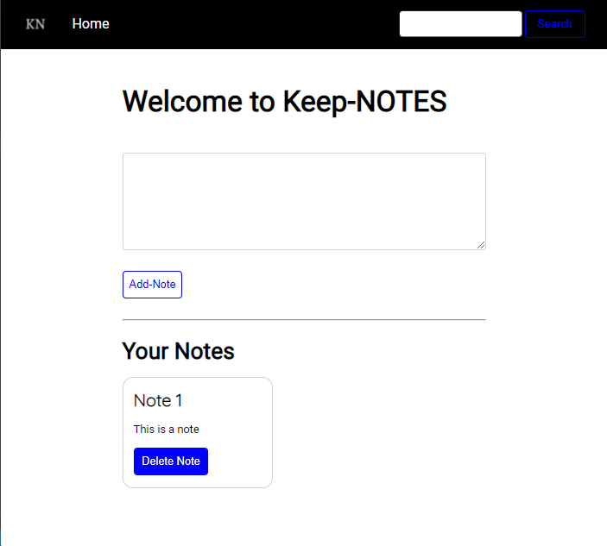Screenshots:

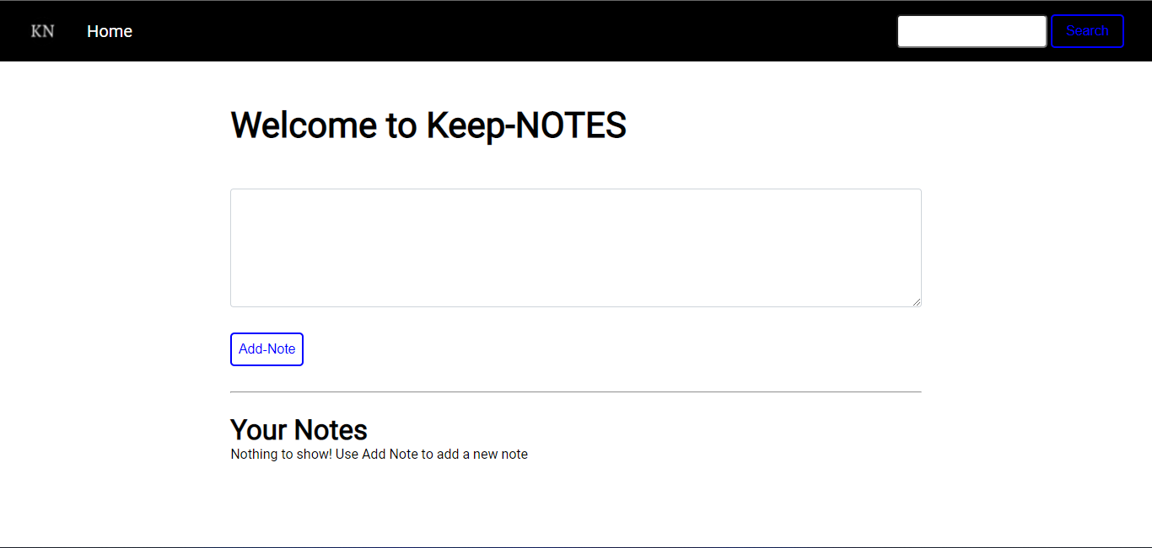

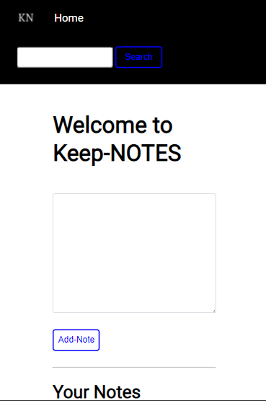

Reference:

[HTML Tutorial (w3schools.com)](https://www.w3schools.com/html/)

[CSS Tutorial (w3schools.com)](https://www.w3schools.com/Css/)

[CSS - GeeksforGeeks](https://www.geeksforgeeks.org/css/?ref=lbp)

[JavaScript Tutorial (w3schools.com)](https://www.w3schools.com/js/DEFAULT.asp)

[JavaScript Strings: The Basic Methods and Functions | JavaScript.com](https://www.javascript.com/learn/strings)

[Express "Hello World" example (expressjs.com)](http://expressjs.com/en/starter/hello-world.html)