**CHAPTER –**

Software Requirement Specifications

# 1. Introduction

## 1.1 Purpose

The software described in this document is the http://www.campusComrade.ac.in/ website and associated support pages. This document seeks to provide the Software Requirements Specifications for the Discussion Forum for the students of IIMT College Of Engineering. The purpose of this document is to record the requirements for the design and development of Discussion Forum for the students of IIMT College Of Engineering. This document describes requirements for this website, There may be a need for future updates of the website. The document reflects the current requirements of the project as understood by the project team. This document presents an initial description of the various functionalities and services provided by the software. The document will also serve the basis for acceptance testing by the user.

## 1.2 Document Conventions

There are no standard document requirements for this document.

## 1.3 Intended Audience and Reading Suggestions

Primary readers of this document are the web designers contributing to and testing of the Discussion Forum. Contributors to this document are the students of IIMT College Of Engineering. The remaining sections of this SRS describe the functional requirements for college site.

## 1.4 Product Scope

The scope of the website is to provide a platform for the students of IIMT College Of Engineering to clarify their doubts and taking some important decisions.

1. Students can ask questions and can answer them.
2. Students can create a poll .

## 1.5 References

None.

# 2. Overall Description

### 2.1 Product Perspective

The product Campus Comrade is a brand-new self-contained website meant to be used as a student interaction platform for the students of IIMT College Of Engineering, where the students can ask questions and have discussions pertaining to Institute-specific as well as global issues and topics.

### 2.2 Product Functions

The website enables the students at the institute to sign-up using the institute’s email ID using which they can login and use the website further. Authorized users are provided the following facilities:

* Ask a question or create a poll under any of the pre-defined categories.
* Answer any question or vote in any existing polls
* Upvote any answer the user supports.
* Comment on any of the answers.
* The answers of a question are sorted on the basis of number of upvotes. ● The comments on an answer are sorted based on date.

The Following diagram lists the requirements of the user and how to reach them:

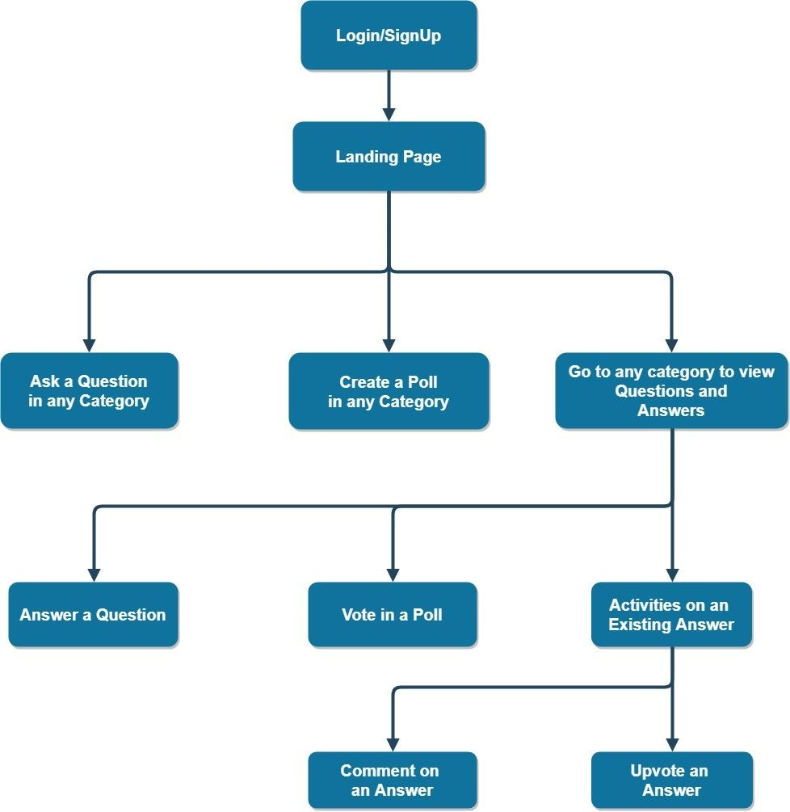

### 2.3 User Classes and Characteristics

The only target users are the students of IIMT College Of Engineering. Hence, all the target users are technology familiar and used to online social networks. All the users are undergraduate students having sufficient technical expertise for using a social interaction website (like Campus Comrade).

### 2.4 Operating Environment

The website may be used in the latest version of any appropriate browser like IE, Mozilla Firefox, Google Chrome, Opera or Netscape installed in any of the standard operating systems like Windows, Linux or Unix.

### 2.5 Design and Implementation Constraints

The site is solely focused for college related discussion and thus exclusively made for the college students. So, every update and changes made to the site will benefit the users of the college. The site will be storing the details on MongoDB environment, thus abiding by its constraints. The back-end is secured via NodeJS setup and hence will help in updating real-time updated questions effectively and on time. There is no hardware limitation as such.

### 2.6 User Documentation

For documentation, users may take help from the readme file from the github repository being maintained by the developer team of ‘Campus-Comrade’. Apart from that, a help section with FAQs and contact information will also be available on the website.

### 2.7 Assumptions and Dependencies

The users must have their IIMT College Of Engineering-issued email-ID and enrollment number for login part and for the confirmation part required to further access the site.

1. **External Interface Requirements** 
   1. **User Interfaces**

The website should work and be tested against IE, Firefox, Google Chrome and Netscape.

* 1. **Hardware Interfaces**

There are no special hardware interface requirements

### 3.3 Software Interfaces

Software requirements of the system are very nominal, and no other special requirement is there hence it is economically feasible.

**3.4 Communications Interfaces**

There are no special communication interface requirements.

1. **System Features** 
   1. **Login / Signup:**
      1. Description and Priority

The student at the institute can sign-up using the institute’s email ID using which they can login and use the other features of the website. The further functionality of the website will be enabled only after the user signs into his account.

* + 1. Stimulus/Response Sequences
       1. The student should sign-up (register) at the website using the college email-id.
       2. Then, the student can login and use the further features of the website.
    2. Functional Requirements

The following are the functional requirements for the ‘LogIn / SignUp’ feature :

REQ-1: The user should be a student of IIMT and should have his record in the college database and a valid email ID provided by the college. The user can only Sign-up / Login using the institute's email ID and will have to verify the email ID.

REQ-2: The user cannot Sign-up using any other email ID. The Sign-up process will only complete if the user tries to login with a email ID provided by institute.

REQ-3: The student can only ‘Login’ after he/she has completed the Sign-up process.

* 1. **Ask / Answer a question :**
     1. Description and Priority

The student can ask a question once he/she has logged in into the website. The question asked by the user will be visible to all the other students and the students can answer the question. Apart from this the students can also vote, comment on the answers written by the other students. And the answers with most upvote will be shown in the top.

* + 1. Stimulus/Response Sequences
       1. The student should Login to the website and then on the landing page, he/she should click on the ‘Add’ button to add a question to the feed.
       2. Then the student can write his/her question on the pop-up and can submit the question.
       3. The student can answer a question once he has logged in to the website. He/she can answer any question which is there in the feed of the user.
       4. The student can also up/down-vote and comment on an answer.
       5. The answer with most upvotes will be shown on the top.
    2. Functional Requirements

The following are the functional requirement associated with the ‘Ask/Answer a question’ feature :

REQ-1: The student should be logged in to have access to this system feature.

REQ-2: The student should not use any type of abusive language while answering or asking a question. In case of any such usage the user won’t be able to do the post until the required changes are made in the answer/question.

* 1. **Create a Poll:**
     1. Description and Priority

The student can create a poll after logging into the website. The students can also vote on the ongoing poll. They can set the poll for a specific duration. After the poll duration is completed, the student will be able to see results and pictorial representation of the polling data.

* + 1. Stimulus/Response Sequences
       1. The student should login on the website and on the landing page should click on the ‘Add’ button.
       2. The student can create poll and even specify the duration for which the poll should remain active and open for votes.
       3. The students after logging in to the website can vote on the created polls.
       4. Once the duration of the poll completes the student cannot vote on it.
    2. Functional Requirements

The following are the functional requirement associated with the ‘Create a Poll’ feature :

REQ-1: The student should be logged in to have access to this system feature.

REQ-2: The student can create a poll for any duration and any poll should not contain any abusive language. If the poll contains any abusive language it won’t be allowed to be posted and will show an error.

1. **Other Nonfunctional Requirements**

### 5.1 Performance Requirements

The system should be fully interactive and the student should have a good internet connection so that the delays involved in loading the system features are less. The features like sorting of the answers and posting will be performed in less than 3 seconds. A good configuration and system near to the server will easily communicate with less delay. In case of the increase in the distance of the system it might take upto 20 seconds to communicate the data from the server.

### 5.2 Safety Requirements

There is a possibility that the data of the user might be at risk because of any extension added on the browser from any unreliable sources. The data is securely transmitted over the institute’s server.

### 5.3 Security Requirements

There will be a confirmation link sent to the student to complete the Signup process, which will help in avoiding the spam registrations.

### 5.4 Software Quality Attributes

If the internet service gets disrupted while sending the information to the server, the information can be send again for verification. The system is easy to handle and navigating from using one feature to another will be easily executed with almost no delay. The software can be easily opened in any web browser installed in any of the operating systems like Windows, Linux

distros, etc.

### 5.5 Business Rules

Since, there is only one user class, there are no specific operating principles. But, use of abusive content in Question, Answer or Poll is strictly prohibited.

**6. Other Requirements**

None at this time.