1. Use Cases

1. Use Cases I - User

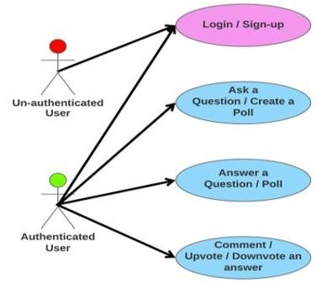

1. Use Case II - Admin

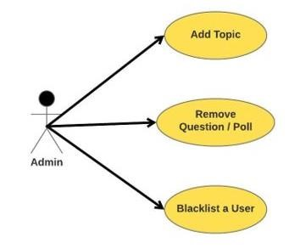

## 2. Sequences

1. Login Sequence Diagram:

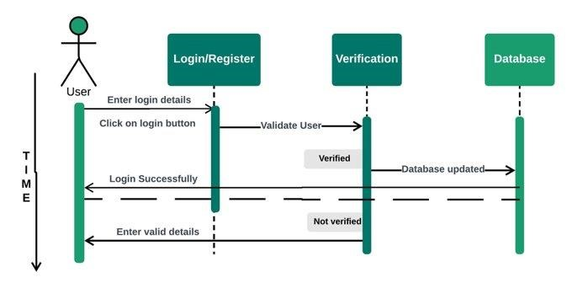

1. User Sequence Diagram I :

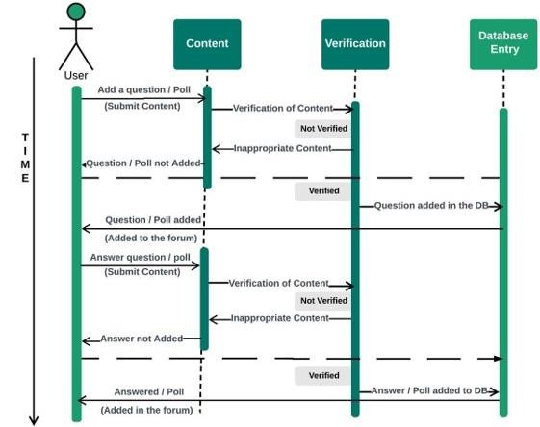

1. User Sequence Diagram II

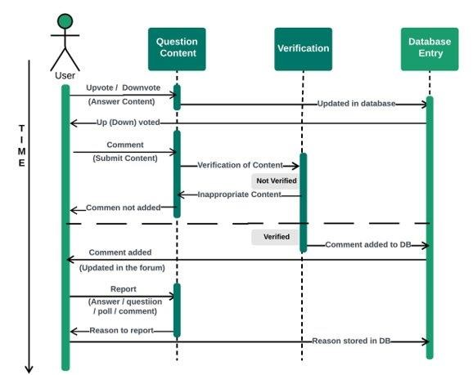

1. Admin Sequence Diagram

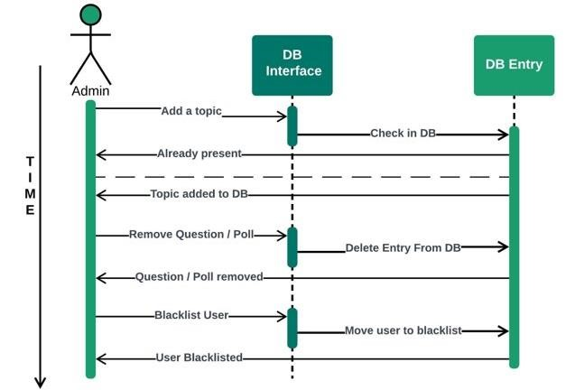

## 3. Class Diagrams

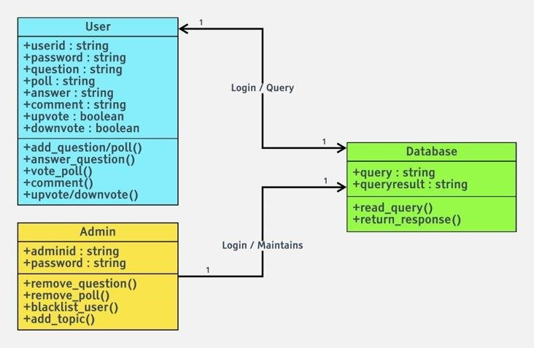

4.Test Cases

|  |  |  |
| --- | --- | --- |
| **Module** | **Test Cases** | **Action executed** |
| **1. Log in/ Sign up** | Registration of new user | Click on Register, Enter valid details, Submit |
|  |  | Click on Register, Enter invalid details (Syntax errors), Submit |
|  | Login/Sign-In of a user | Click on Login, Enter valid login details, Submit |
|  |  | Click on Login, Enter invalid login details (False credentials), Submit |
|  |  |  |
| **2. Ask or Answer a question** | Ask question | Click on the desired topic, Enter the question, Submit |
|  | Answer a question | Click on the question, Enter the answer, Submit. |
|  |  |  |
| **3. Create a Poll or Vote** | Create a Poll | Click on Create a poll, Define Statement and Options, Submit |
|  | Vote in a Poll | Click on any one of the choices |
|  |  |  |
| **4. Upvote or Downvote an**  **Answer** | Upvote an Answer | Click on Upvote |
|  | Downvote an Answer | Click on Downvote |
|  |  |  |
| **5. Add a topic (Admin only)** | Adding a topic in Database | Log in to Admin panel, Enter new  Topic Name, Heading & Description |
|  |  | Log in to Admin panel, Enter already existing Topic Name, Heading & Description |
|  |  |  |
| **6. Comment on an Answer** | Commenting on an Answer | Click on Comment, Enter comment content, Submit |

5.Test Reports

|  |  |  |  |  |
| --- | --- | --- | --- | --- |
| No. | **Action executed** | **Expected Output** | **Observed Output** | **Result** |
| **1.** | Click on Register, Enter valid details, Submit | User registered successfully | User registered successfully | Success |
|  | Click on Register, Enter invalid details (Syntax errors), Submit | Couldn't register | Couldn't register | Success |
|  | Click on Login, Enter valid login details, Submit | Logged in successfully | Logged in successfully | Success |
|  | Click on Login, Enter invalid  login details (False credentials), Submit | Wrong  UserID/Password | Wrong  UserID/Password | Success |
|  |  |  |  |  |
| **2.** | Click on the desired topic, Enter the question, Submit | Question gets added on the page | Question gets added on the page | Success |
|  | Click on the question, Enter the answer, Submit. | Answer gets added below that question | Answer gets added below that question | Success |
|  |  |  |  |  |
| **3.** | Click on Create a poll, Define Statement and Options, Submit | Poll gets added on the page | Poll gets added on the page | Success |
|  | Click on any one of the choices | Vote count gets updated | Vote count gets updated | Success |
|  |  |  |  |  |
| **4.** | Click on Upvote | Upvote count gets updated | Count does not change | Success |
|  | Click on Downvote | Downvote count gets updated | Count does not change | Success |
|  |  |  |  |  |
| **5.** | Log in to Admin panel, Enter new Topic Name, Heading & Description | Topic gets added on the page | Topic updated in Topic page | Success |
|  | Log in to Admin panel, Enter already existing Topic Name, Heading & Description | Topic name already exists | Topic name already exists | Success |
|  |  |  |  |  |
| **6.** | Click on Comment, Enter comment content, Submit | Comment gets added below answer | Comment gets added below answer | Success |

1. User Testing Report :

|  |  |  |
| --- | --- | --- |
| No. | **Action executed** | **Result / Remarks** |
| **1.** | Click on Register, Enter valid details, Submit | Working Fine |
|  | Click on Register, Enter invalid details (Syntax errors), Submit | Working Fine |
|  | Click on Login, Enter valid login details, Submit | Working Fine |
|  | Click on Login, Enter invalid login details (False credentials), Submit | Working Fine |
|  |  |  |
| **2.** | Click on the desired topic, Enter the question, Submit | Working Fine |
|  | Click on the question, Enter the answer, Submit. | Working Fine |
|  |  |  |
| **3.** | Click on Create a poll, Define Statement and Options, Submit | Working Fine |
|  | Click on any one of the choices | Working Fine |
|  |  |  |
| **4.** | Click on Upvote | Not happening in one click |
|  | Click on Downvote | Not happening in one click |
|  |  |  |
| **5.** | Log in to Admin panel, Enter new Topic Name, Heading & Description | Working Fine |
|  | Log in to Admin panel, Enter already existing Topic Name, Heading & Description | Topic is getting added as a new topic |
|  |  |  |
| **6.** | Click on Comment, Enter comment content, Submit | Working Fine |

## 10. Future Work

For the future aspects of the work, there are some more functionalities which could be added to the project:

* Direct Messaging platform on the college intranet.
* Even having options to create survey
* Using semantic analysis to remove the same questions o Automatically separating the topics in the different defined topics o Functionalities like bookmark questions, archive and many more.
* Automatic analysis of the poll displays as soon as the poll ends.