ACROPOLIS INSTITUTE OF TECHNOLOGY AND RESEARCH

**Department of CSE - Data Science**

# Synopsis

On

**Event Analyser**

**1. Introduction**

**1.1 Overview**  
This project leverages Artificial Intelligence and Machine Learning (AIML) combined with data science to improve event management. The model is designed to assist both organizers and attendees in evaluating and enhancing event quality. Its primary goal is to provide event organizers with a comprehensive suite of tools, simplifying event management and focusing on efficient data analysis.

**1.2. Purpose**  
The purpose of this project is to streamline data management for event organizers, particularly during multi-day events with numerous activities. Managing data in such scenarios can be complex and overwhelming, specially for events where multiple subevents are conducted, managing the data of vast audience becomes a Task so for such scenarios we will be providing a smooth data management technique. Our model aims to consolidate all necessary tools onto a single platform, enabling organizers to handle event data more effectively.

Example – To explain it more clearly let’s take an example of E-Summit which is conducted by Entrepreneurship Development Cell wherein multiple events are organised different days and in such case managing the data of the attendees becomes a little tough along with this when we look from audience perspective then audience can use our services where we will be providing a smart event recommendation for the audience which will suggest them the most relevant event they should attend. Moreover we will be providing various other services to the organisers and the attendees to improve their experience about events.

**2. Literature Survey  
 2.1 Existing Problem**  
 Current event management systems face several issues:

* Large volumes of data are difficult and time-consuming to manage.
* Essential features like event quality analysis, feedback evaluation, networking, and data management are either unavailable or scattered across multiple platforms.
* Existing solutions like BookMyShow, AllEvents.in, Excel, Eventio, and Taskade lack some key features necessary for comprehensive event management.

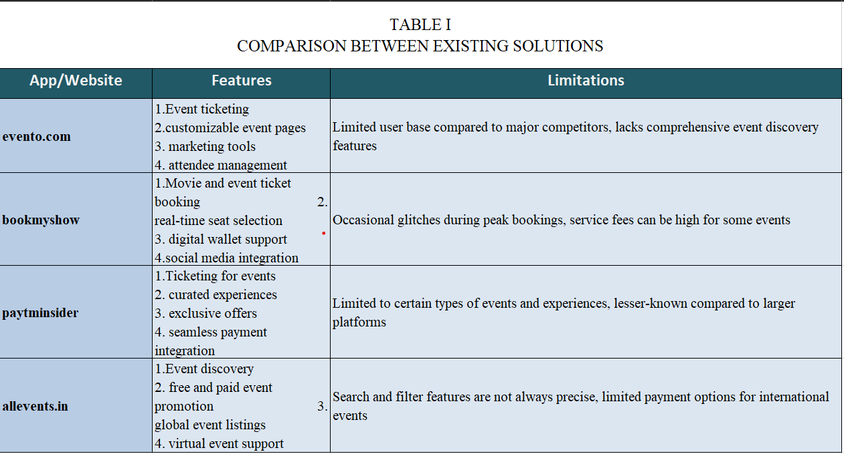

This table gives a summarised description about what the existing solutions have and the limitations which are needed to be covered up.

**2.2 Proposed Solution**Our proposed solution consolidates all essential event management tools into one user-friendly model. The key features include:

* User-Friendly Dashboard: Create and manage events, track participants, and receive real-time updates.
* AI-Powered Suggestions: Recommendations for event improvements, attendee segmentation, and trending content ideas.
* Feedback Analysis: Automate feedback collection, sentiment analysis, and keyword extraction.
* Analytics Dashboard: Monitor event metrics, compare performance, and predict outcomes.
* Engagement Tools: Live polls, Q&A, networking, and gamification features to enhance participant interaction.
* Post-Event Reports: Automatically generate detailed and customizable reports.
* Smart Event Suggestions : This will help the client to choose among the various events and find the best fit for them.

**3. Theoretical Analysis  
3.1 Block Diagram**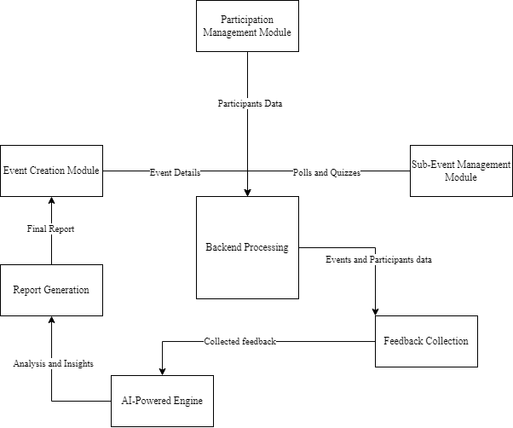

**Fig.1.1 Block Diagram**

3.2 Hardware/Software Designing

User-Side Requirements

Basic Hardware Requirements:

Processor: Intel i3 or equivalent

RAM: 2 GB or more

Storage: 128 GB SSD/HDD

Graphics Card: 1 GB or integrated graphics

OS: Windows 10, Ubuntu, or any lightweight Linux OS

Display: 1024x768 resolution or higher

Internet: Stable connection for real-time updates, feedback submission, and event participation

Basic Software Requirements:

Browser: Latest version of Chrome, Firefox, Edge, or Safari (for web-based interface)

Internet Browser Support: JavaScript enabled

Frontend Compatibility: HTML5, CSS3, JavaScript supported by most modern browsers.

Developer-Side Requirements

Hardware Requirements:

Processor: Intel i5 or higher (or equivalent AMD processor)

RAM: 8 GB or more (16 GB recommended for smoother multitasking)Storage: 256 GB SSD (or higher for larger projects)

Graphics Card: 2 GB dedicated GPU (optional, for development requiring GPU support)

OS: Windows 10, Ubuntu, or macOS (for cross-platform development)

Display: 1920x1080 or higher resolution (for better multitasking in development)

Software Requirements:

Frontend Development:

Languages: HTML5, CSS3, JavaScript

Framework: React.js or React Native (for mobile apps)

Tools: VS Code or Sublime Text (code editor), Node.js (for running React/JS apps), Tailwind CSS (if needed)

Backend Development:

Languages: Python (Flask) or JavaScript (Express.js)

Database: SQLite (for simple, lightweight development) or MySQL (for larger, production-level data)

Libraries: Flask or Express.js for backend API developmen

Version Control: GitHub/Git

Testing Tools:

Frontend: Browser developer tools, Jest (for React)

**4. Applications**

Corporate Events: Conferences, seminars, and networking events, where seamless registration, feedback analysis, and attendee engagement are crucial.

Entertainment: Concerts, festivals, and film screenings that require efficient participant tracking, real-time updates, and post-event reporting.

Academic: Workshops, webinars, and multi-day symposiums, where the model can streamline scheduling, audience interaction, and speaker management, ensuring a smooth flow of events.

Social Gatherings: Weddings, parties, and charity events that benefit from organized data management, guest feedback, and personalized experiences.

Trade Shows and Exhibitions: Large-scale expos, product launches, and fairs, where real-time participant tracking and analytics help organizers gauge interest and improve attendee satisfaction.

Multi-Day College Events: College festivals, hackathons, and summits that span multiple days often involve numerous activities happening simultaneously, making it challenging to manage. Our model can handle participant registration, event scheduling, and real-time updates across different days.

**REFERENCES**

[1] Event Espresso. (13/09/2015). Top 16 Event Planning Challenges You Need to Know [Online]. Available: https://eventespresso.com/top-16-event-planning-challenges-you-need-to-know/

[2] Taskade. (07/09/2015). AI Event Planning Generators [Online]. Available: https://www.taskade.com/templates/ai-event-planning

[3] AllEvents. (12/08/2012). Discover Events Happening in Your City [Online]. Available: https://allevents.in

[4] BookMyShow. (13/07/2006). Book Tickets for Movies, Events, Plays, Sports, and Activities [Online]. Available: https://in.bookmyshow.com/

[5] Paytm Insider. (02/12/2007)

. Discover Events & Book Tickets Online [Online]. Available: https://insider.in/

[6] Eventbrite. (15/05/2004). Discover Great Events or Create Your Own & Sell Tickets [Online]. Available: https://www.eventbrite.com/

[7] Ticketmaster. (17/10/2005). Buy Concert, Theatre, Sports, and Event Tickets [Online]. Available: <https://www.ticketmaster.com/>

**GITHUB REPOSITORIES :** Ujjwal3492 (<https://github.com/Ujjwal3492/MInorG18.git>)

**GUIDED BY :-  GROUP MEMBERS:-**  Prof. Deepak Singh Chouhan Sir Muskan khobre (0827CD221051)

Rishabh Tiwari (0827CD221059)

Ujjwal Soni (0827CD221073)

Vinay Patel (0827CD221077)