- Screenshot showing the GitHub Actions workflows
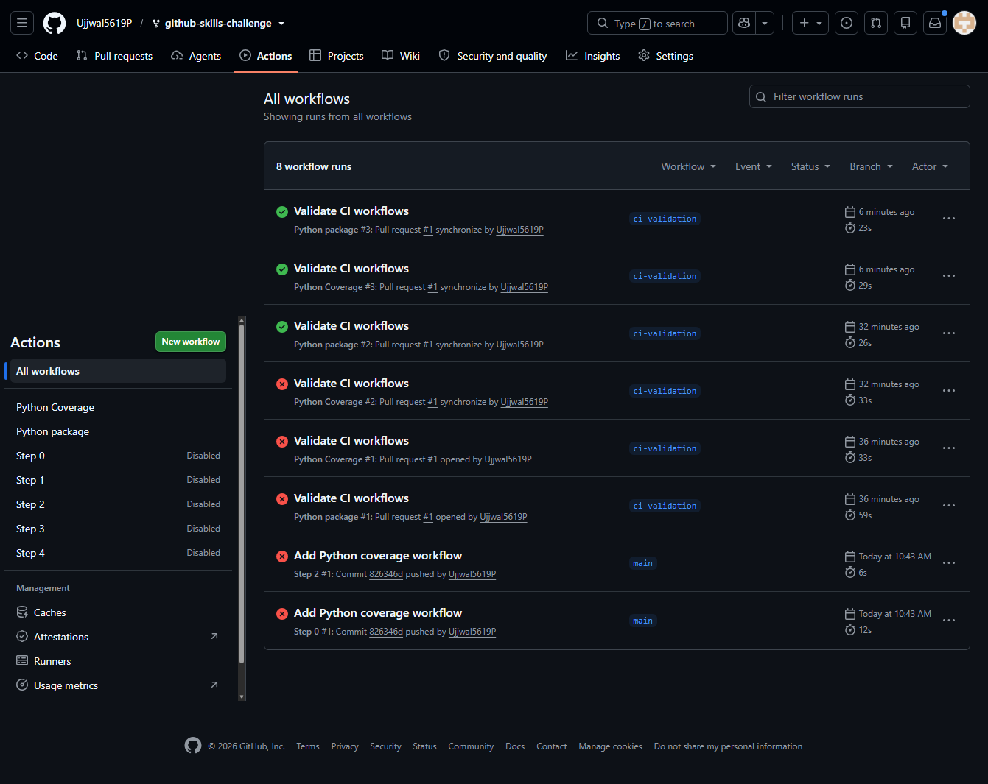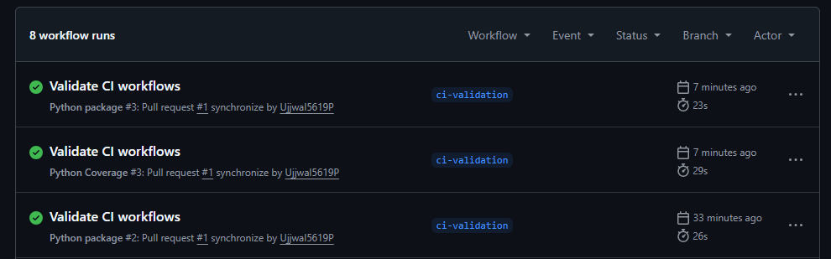

- Screenshot showing a successful test workflow execution

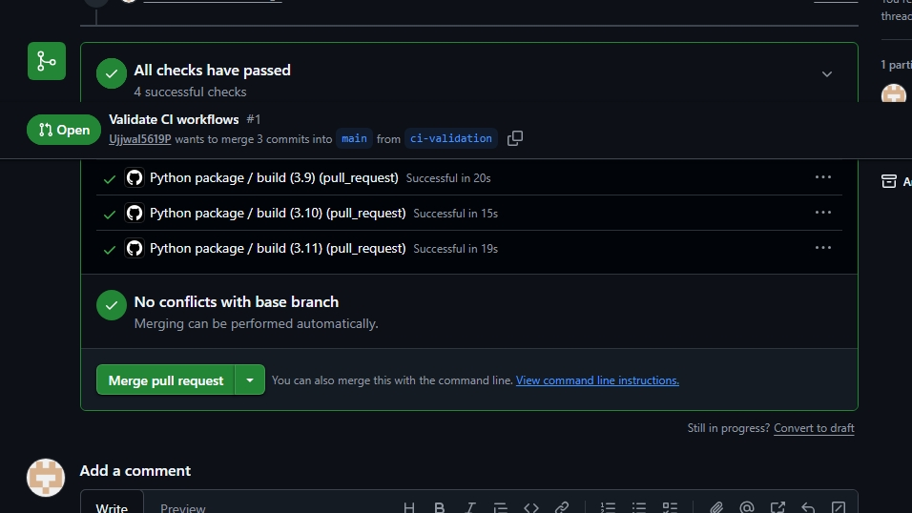

- Screenshot showing the coverage result/comment on the pull request

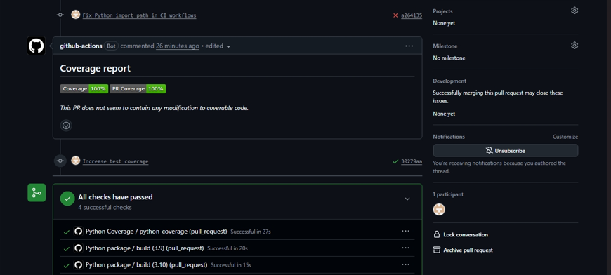

- Screenshot showing the final repository/workflow files
