☁ CampusCloud
Smart Student Management Portal

Cloud Computing Project Report

Project Title | CampusCloud — Smart Student Management Portal
Subject | Cloud Computing (AWS)
Technology Stack | React + Vite | Flask | SQLite | Amazon DynamoDB
AWS Services | EC2 · DynamoDB · CloudWatch · Auto Scaling · IAM
Submitted By | Ujjwal Khatri
Date | October 2026

1. Project Overview

CampusCloud is a full-stack, cloud-enabled Student Management Portal built to demonstrate the real-world application of AWS cloud services in an educational context. The system provides a modern SaaS-style dashboard where administrators can register, search, edit, and delete student records stored in either a local SQLite database (development) or Amazon DynamoDB (production).

Key Objectives
- ✔ Build a visually polished, responsive student-record management system.
- ✔ Demonstrate cloud persistence using Amazon DynamoDB via Boto3.
- ✔ Host the backend on Amazon EC2 with Gunicorn + Nginx.
- ✔ Monitor CPU utilisation via Amazon CloudWatch.
- ✔ Auto-scale the EC2 fleet with a target-tracking scaling policy.
- ✔ Secure AWS access using IAM Roles — no hard-coded credentials.

2. Technology Stack

Layer | Technology | Purpose
Frontend | React 19 + Vite 6 | SPA with component-based UI
Styling | Tailwind CSS v4 | Utility-first, responsive design
Icons | Lucide React | Consistent icon system
Backend | Python Flask 3 | REST API server
Local DB | SQLite (python built-in) | Zero-config local persistence
Cloud DB | Amazon DynamoDB | Serverless NoSQL at scale
AWS SDK | Boto3 | DynamoDB / CloudWatch API calls
Server | Gunicorn + Nginx | Production WSGI + reverse proxy
Hosting | Amazon EC2 (Ubuntu 22.04) | Virtual machine deployment
Scaling | EC2 Auto Scaling Group | Elastic horizontal scaling
Monitor | Amazon CloudWatch | CPU & request metrics
Security | IAM Role | Credential-free AWS access

3. AWS Cloud Architecture

The diagram below shows how each AWS service fits into the CampusCloud architecture:

┌─────────────────────────────────────────────────────────┐
│ Internet / Browser │
└───────────────────────────┬─────────────────────────────┘
│ HTTP
┌───────────────────────────▼─────────────────────────────┐
│ Amazon EC2 (Auto Scaling Group) │
│ Ubuntu 22.04 · Nginx (port 80) → Gunicorn (port 5000)│
│ Flask REST API (app.py) │
└──────────────┬──────────────────────┬────────────────────┘
│ DynamoDB API │ CloudWatch API
┌──────────────▼──────────┐ ┌─────────▼──────────────────┐
│ Amazon DynamoDB │ │ Amazon CloudWatch │
│ campus_students table │ │ CPU & custom metrics │
└─────────────────────────┘ └────────────────────────────┘
│ IAM Role (no keys)
┌──────────────▼──────────────────────────────────────────┐
│ AWS IAM (EC2 instance role) │
│ AmazonDynamoDBFullAccess · CloudWatchAgentServerPolicy │
└──────────────────────────────────────────────────────────┘

AWS Services Explained
- Amazon EC2: Hosts the Flask backend. Ubuntu 22.04, t3.micro. Accessible on port 80 via Nginx.
- Auto Scaling Group: Monitors CPU; spins new EC2 instances when utilisation exceeds 60%.
- Amazon DynamoDB: Serverless key-value store. Table: campus_students, partition key: id (String).
- IAM Role: Attached to EC2; grants DynamoDB + CloudWatch access without any hard-coded credentials.
- Amazon CloudWatch: Collects CPU metrics from EC2. Alarm triggers Auto Scaling policy.

4. Features Implemented

Feature | Description
Dashboard | Statistics cards (Total Students, Courses, Registrations, Cloud Status), recent-activity feed, hero banner.
Add Student | Modal form with full validation: required fields, email format check, duplicate student-ID detection.
Edit Student | Pre-filled modal; PUT /api/students/<id> updates the record in SQLite or DynamoDB.
Delete Student | Confirmation modal before DELETE /api/students/<id>.
Student Table | Searchable (name, ID, email) and filterable by course; colour-coded avatars; date registered column.
Cloud & AWS Page | Live DB-mode indicator, architecture card grid, step-by-step deployment guide.
DB Mode Indicator | Sidebar badge shows 'Local SQLite' or 'AWS DynamoDB' — no fake status.
Toast Notifications | Success/error toasts with auto-dismiss and manual close.
Responsive Layout | Sidebar collapses on mobile; cards reflow with CSS grid auto-fit.
Loading States | Skeleton loaders and spinner animations while fetching data.
Empty State | Friendly illustration + CTA when no students exist.

5. Application Screenshots

The following screenshots were captured from the live running application at http://localhost:5173.

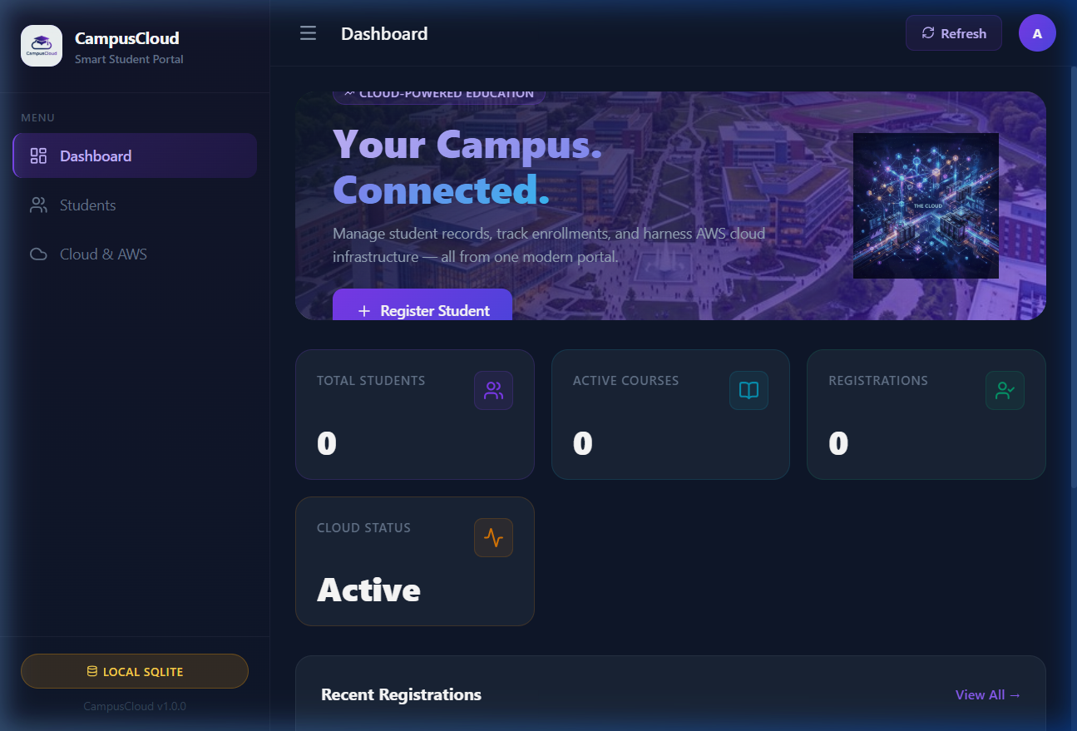
Figure 1 — Dashboard: Hero banner, statistics cards, and recent registrations

[Screenshot not found: ]
[Screenshot not found: ]
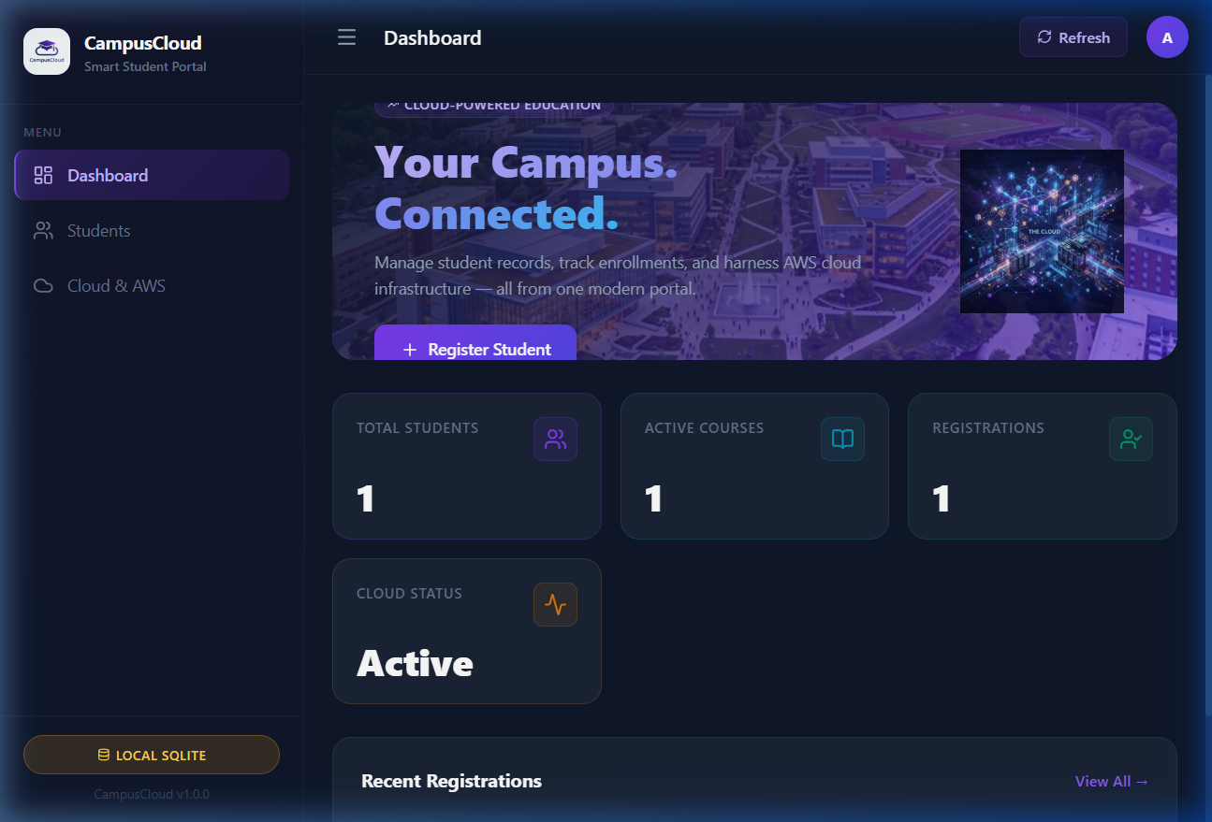
Figure 4 — Success toast after adding the first student

[Screenshot not found: ]
[Screenshot not found: ]
[Screenshot not found: ]
[Screenshot not found: ]
[Screenshot not found: ]
[Screenshot not found: ]

6. REST API Reference

Method | Endpoint | Description
GET | /api/status | Returns DB mode, version, and AWS connection status
GET | /api/stats | Returns total students, courses breakdown, recent entries
GET | /api/students | List all students (supports ?q= search and ?course= filter)
POST | /api/students | Add a new student (JSON body)
GET | /api/students/<id> | Fetch a single student by UUID
PUT | /api/students/<id> | Update a student's details
DELETE | /api/students/<id> | Delete a student record

7. Local Setup Instructions

Backend (Flask)
cd backend
pip install -r requirements.txt
# Copy environment variables:
copy .env.example .env
# Run the Flask dev server:
python app.py
# Backend available at http://localhost:5000

Frontend (React + Vite)
cd frontend
npm install
npm run dev
# Frontend available at http://localhost:5173

8. AWS Deployment Steps

Step 1 — Launch EC2
Launch a t3.micro Ubuntu 22.04 instance in your VPC. Open ports 22 (SSH), 80 (HTTP), and 5000 (Flask) in the Security Group.

Step 2 — Create DynamoDB Table
Table name: campus_students
Partition key: id (String)
Billing mode: On-demand (PAY_PER_REQUEST)

Step 3 — Create IAM Role
Create an EC2 IAM Role with:
• AmazonDynamoDBFullAccess
• CloudWatchAgentServerPolicy
Attach the role to your EC2 instance.

Step 4 — Install Dependencies
sudo apt update && sudo apt install python3-pip nginx -y
git clone <your-repo> campuscloud
cd campuscloud/backend
pip3 install -r requirements.txt

Step 5 — Configure Environment
sudo nano /etc/environment
Add:
DB_MODE=aws
DYNAMO_TABLE=campus_students
AWS_REGION=us-east-1

Step 6 — Run with Gunicorn
gunicorn -w 4 -b 127.0.0.1:5000 app:app --daemon

Step 7 — Configure Nginx
proxy_pass http://127.0.0.1:5000 in your server block

Step 8 — Build & Deploy Frontend
cd frontend && npm run build
Serve the dist/ folder via Nginx static files

Step 9 — Set Up Auto Scaling
Create a Launch Template from your EC2 instance.
Create Auto Scaling Group with:
• Min 1, Max 3 instances
• Target-tracking policy: CPU @ 60%

Step 10 — CloudWatch Alarm
Create CPUUtilization alarm → trigger scale-out when CPU > 60% for 2 consecutive 5-minute periods.

9. Database Schema

SQLite / DynamoDB — students table
Field | Type | Notes
id | String (UUID) | Primary Key — auto-generated
student_id | String | Unique student roll number
name | String | Full name of the student
email | String | Email address (validated)
course | String | Enrolled course name
created_at | ISO 8601 String | Record creation timestamp (UTC)
updated_at | ISO 8601 String | Last modified timestamp (UTC)

10. Conclusion

CampusCloud successfully demonstrates how a modern, full-stack web application can be designed, built, and deployed on the AWS cloud platform. By combining a React-powered frontend with a Flask backend, SQLite for local development, and Amazon DynamoDB for production, the project provides a seamless developer experience while showcasing real cloud-computing concepts.

The inclusion of EC2 Auto Scaling, CloudWatch monitoring, and IAM role-based access elevates the project from a basic CRUD application to a genuinely cloud-native solution — aligned with industry best practices for security, scalability, and observability.

Key Takeaways:
• Serverless NoSQL (DynamoDB) scales automatically without infrastructure management.
• EC2 Auto Scaling ensures high availability under variable load.
• IAM Roles eliminate the security risk of hard-coded AWS credentials.
• CloudWatch provides real-time visibility into application health.
• A modern SaaS-style UI improves usability and demonstrates UI/UX skills.

CampusCloud · Cloud Computing Project · 2026 · Ujjwal Khatri

