DISTRIBUTED COMPUTING
PRACTICAL ASSIGNMENT REPORT
Deploy a Web Application on AWS with EC2, DynamoDB, CloudWatch and Auto Scaling

PROJECT SUMMARY
A small Python Flask Student Record Management System is deployed on an Amazon EC2 instance. The cloud application uses Amazon DynamoDB for persistence, Amazon CloudWatch for metrics and alarms, and an EC2 Auto Scaling Group with target tracking.

Student name | Maharshi Trapasiya
Enrollment number | 2410111175
Course / semester | CSE AI-ML (B1)

1. Aim and Objectives
Aim: To deploy a web application on AWS EC2 and integrate it with DynamoDB, CloudWatch monitoring, and EC2 Auto Scaling.

Objectives
- Develop and test a small Flask web application locally before deployment.
- Host the application on Amazon EC2 using Gunicorn and Nginx.
- Store student records in Amazon DynamoDB using Boto3 and an EC2 IAM role.
- Observe EC2 CPU utilization using Amazon CloudWatch.
- Configure an Auto Scaling Group with minimum, desired, and maximum capacity and a CPU target-tracking policy.

2. Services and Tools Used
Service / tool | Purpose
Python + Flask | Implements the Student Record Management System and its routes.
Amazon EC2 | Runs the cloud-hosted application on Amazon Linux 2023.
Nginx + Gunicorn | Nginx accepts HTTP on port 80 and proxies requests to Gunicorn on 127.0.0.1:8000.
Amazon DynamoDB | Stores student records in the StudentRecords table.
AWS IAM role | Provides the EC2 application temporary credentials to access the DynamoDB table.
Amazon CloudWatch | Displays EC2 CPUUtilization metrics and scaling-related alarms.
EC2 Auto Scaling | Maintains the configured capacity and supports scaling based on average CPU utilization.
GitHub | Hosts the source repository cloned by the EC2 startup script.

3. Deployment Architecture
WEB BROWSER
User opens the public EC2 IPv4 address using HTTP.
NGINX :80
Receives the request and reverse-proxies to the application.
GUNICORN :8000 → FLASK
Runs app:app on 127.0.0.1:8000; application logic handles student CRUD.
BOTO3 + EC2 IAM ROLE
Uses the EC2 role to call DynamoDB without hard-coded AWS access keys.
DYNAMODB: StudentRecords
Persists student_id, name, email, course, and created_at attributes.
CloudWatch observes EC2 metrics. The Auto Scaling Group uses a target-tracking CPU policy to adjust desired capacity within the configured limits.

4. Configuration Summary and Procedure
Resource | Configuration used
AWS Region | Asia Pacific (Sydney) — ap-southeast-2
DynamoDB table | StudentRecords; partition key student_id (String); on-demand capacity
IAM policy / role | StudentRecordsDynamoDBPolicy / StudentRecordsEC2Role
Security group | student-records-sg; inbound HTTP TCP/80 from 0.0.0.0/0; SSH TCP/22 from My IP
Launch Template | student-records-launch-template; Amazon Linux 2023; t3.micro; key pair student-records-key
Auto Scaling Group | student-records-asg; minimum 1, desired 1, maximum 2
Scaling policy | Target tracking on Average CPU utilization, target 50% (verify policy details in the console)
Website endpoint observed | http://3.25.192.106/ (public IPv4 shown in the captured session; may change after instance replacement)

Procedure followed
- Generate and test the Flask application locally with SQLite storage.
- Push the project to a public GitHub repository and update deploy/user_data.sh for ap-southeast-2.
- Create the DynamoDB StudentRecords table and configure the EC2 IAM role/policy.
- Create the security group and Launch Template with the startup script as User Data.
- Create the Auto Scaling Group with desired 1, minimum 1, and maximum 2 instances.
- Verify the public application, DynamoDB item persistence, CloudWatch CPU metrics, scaling alarms, and activity history.
Evidence note: The uploaded captures are used wherever they show the relevant real AWS/application screen. Three illustrations are included for missing views (EC2 Running state, terminal deployment, and the policy detail view). They are clearly marked as illustrative and must not be presented as authentic AWS captures.

Evidence 1 — Application running locally
The local development instance is open at http://127.0.0.1:5000 and the interface indicates Local Mode: SQLite. The screenshot shows student records in the local directory.
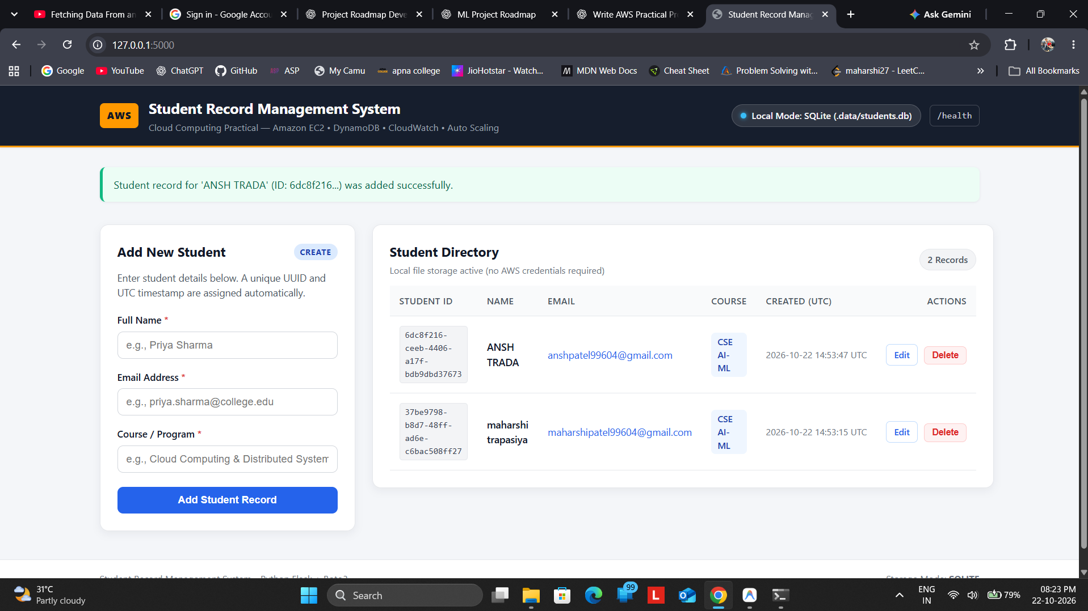
Figure 1. Local application in SQLite mode with sample records.

Evidence 4 — Application opened from the EC2-hosted endpoint
The browser address bar shows the public IPv4 endpoint. The interface reports AWS Mode: Amazon DynamoDB, and a student record is listed in the Student Directory.
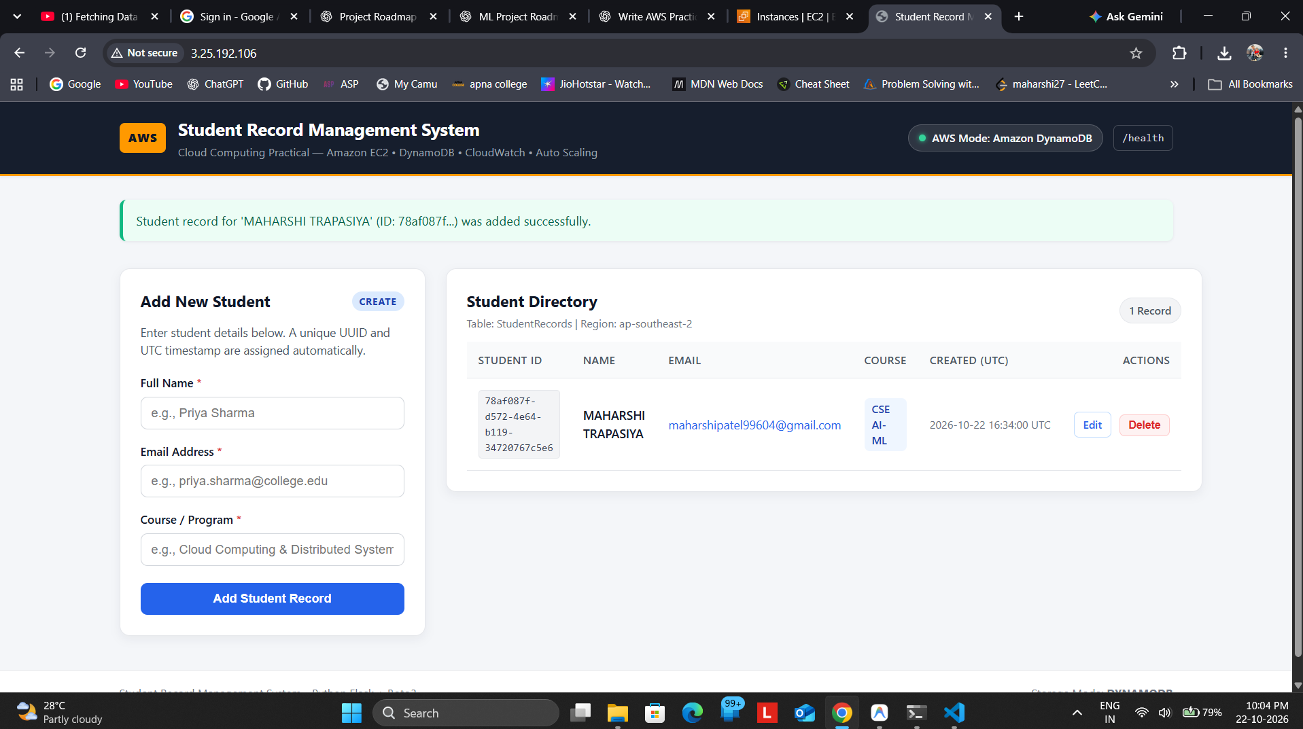
Figure 4. Deployed Student Record Management System in AWS/DynamoDB mode.
Observation: The shown public IP may change after the instance is replaced or relaunched.

Evidence 5A — DynamoDB table created
The DynamoDB Tables page shows StudentRecords as Active with the partition key student_id (String).
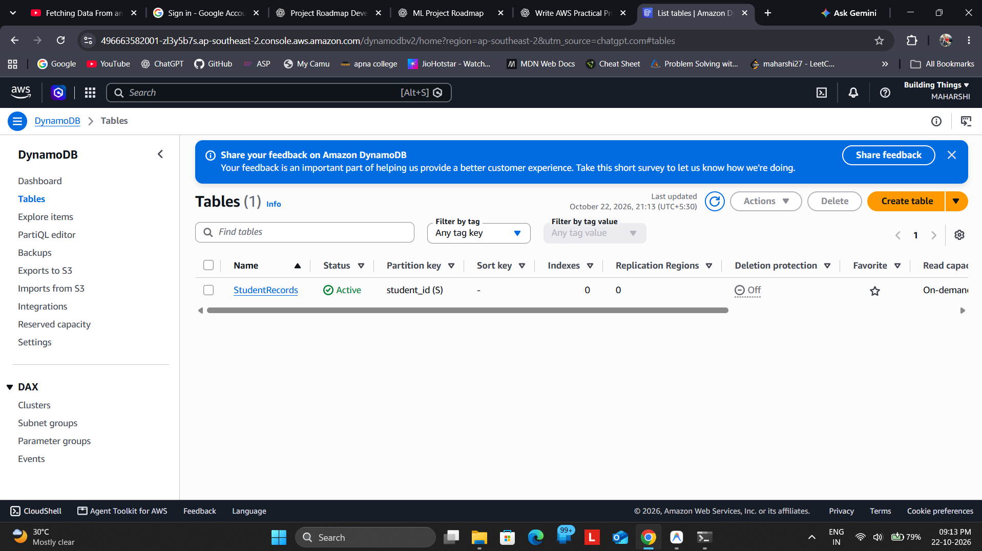
Figure 5A. StudentRecords table is active in the Sydney region.
Observation: The DynamoDB region matches the application setting: ap-southeast-2.

Evidence 5B — DynamoDB sample item
The DynamoDB item explorer reports one item returned from StudentRecords. The row displays student_id, course, created_at, email, and name attributes.
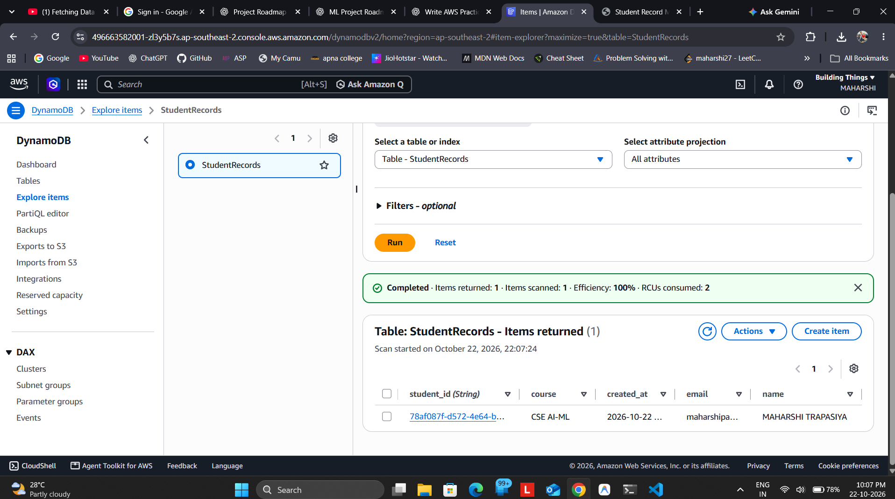
Figure 5B. Student record stored in DynamoDB.
Observation: This is the stronger persistence check: the item is visible in the table explorer, not only in the web page.

Evidence 6A — CloudWatch CPU utilization graph
The CloudWatch Metrics page shows the EC2 CPUUtilization metric as a line graph for the last hour in Sydney.
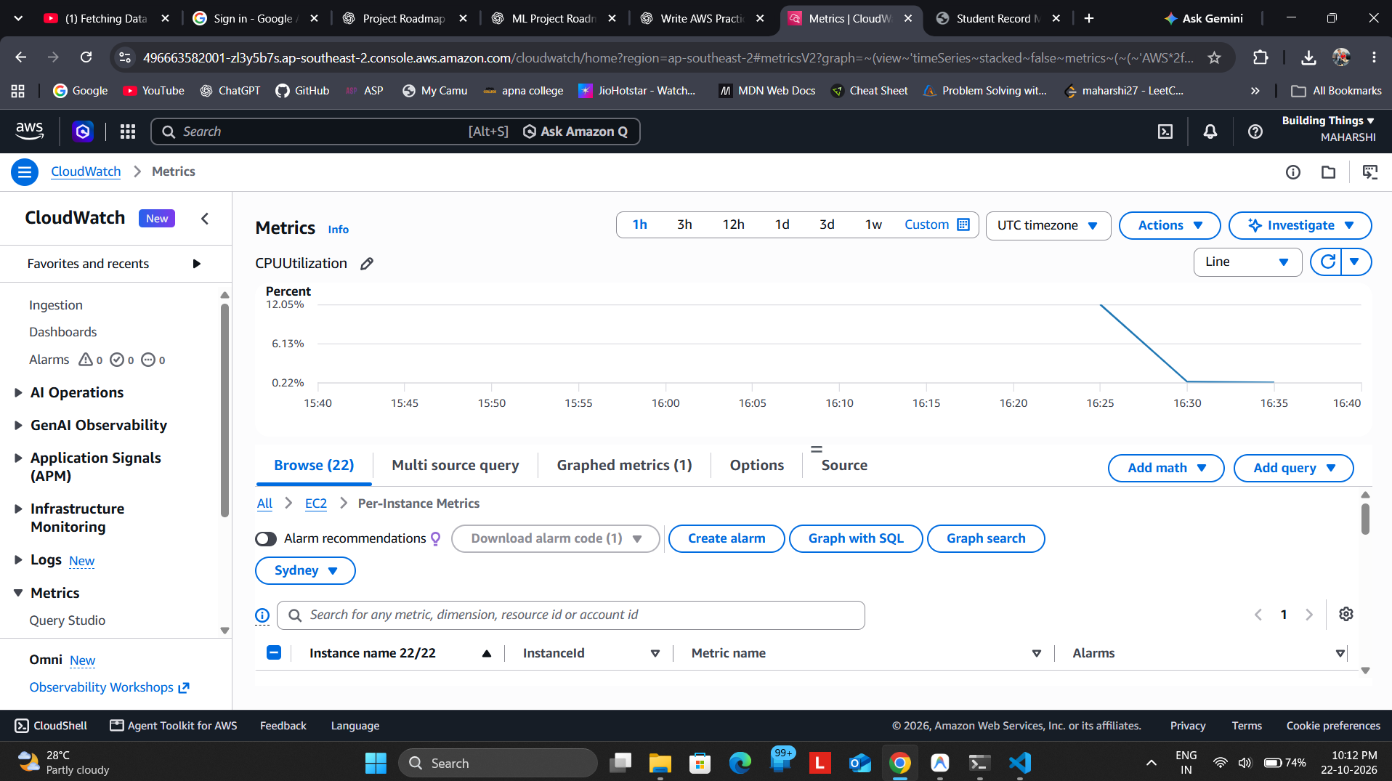
Figure 6A. EC2 CPUUtilization metric graph in CloudWatch.
Observation: Basic EC2 monitoring may report at five-minute intervals, so the graph can update with a delay.

Evidence 6B — CloudWatch metric data table
A second view of the selected CPUUtilization metric shows the data table, including minimum, maximum, sum, average, and datapoints.
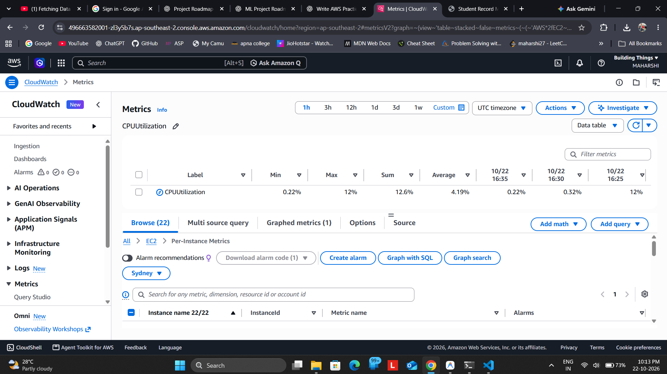
Figure 6B. Tabular view supporting the CPU metric graph.
Observation: Supplementary view for interpreting the plotted CPU values.

Evidence 7 — CloudWatch alarms and states
CloudWatch shows two target-tracking alarms associated with student-records-asg. At the time of capture, one alarm was in ALARM and one showed INSUFFICIENT_DATA.
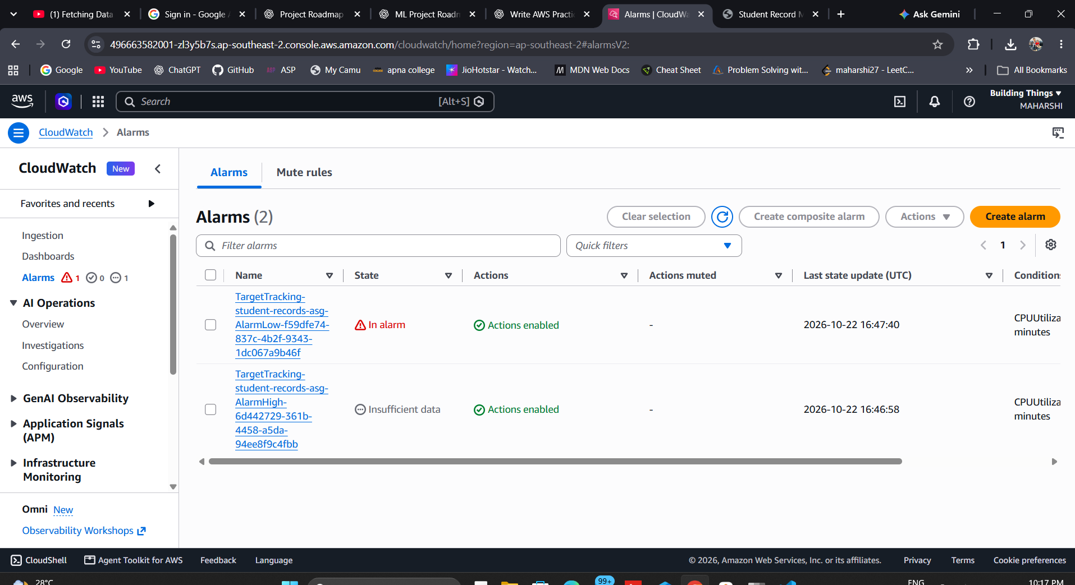
Figure 7. Target-tracking CloudWatch alarms and their states.
Observation: Alarm state is time-dependent and may change as new CPU metrics arrive. INSUFFICIENT_DATA is a possible temporary state.

Evidence 8 — EC2 Launch Template
The Launch Template details view shows student-records-launch-template, default version 1, Amazon Linux 2023 AMI, instance type t3.micro, key pair student-records-key, and the security group ID.
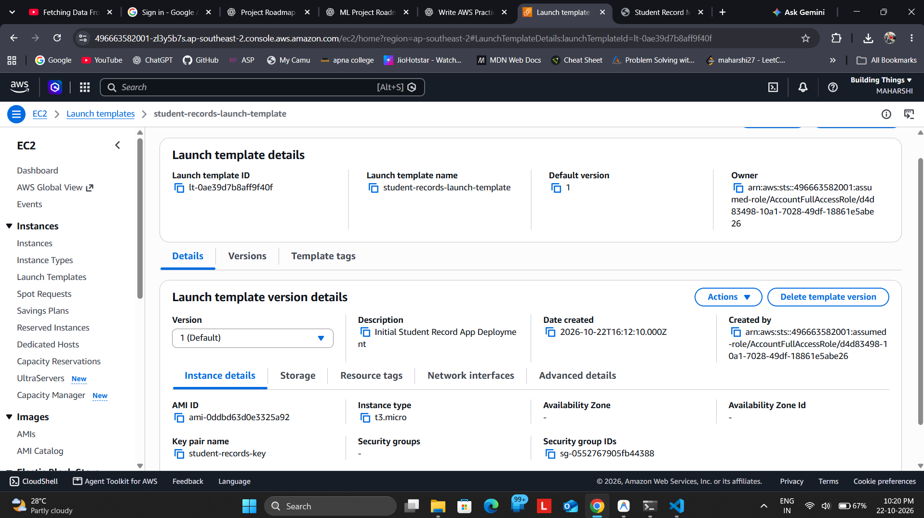
Figure 8. Launch Template configuration.
Observation: The template stores the base instance configuration used by the Auto Scaling Group.

Evidence 9 — Auto Scaling Group capacity
The Auto Scaling Group details view shows student-records-asg at desired capacity with desired capacity 1 and scaling limits 1–2, corresponding to minimum 1 and maximum 2.
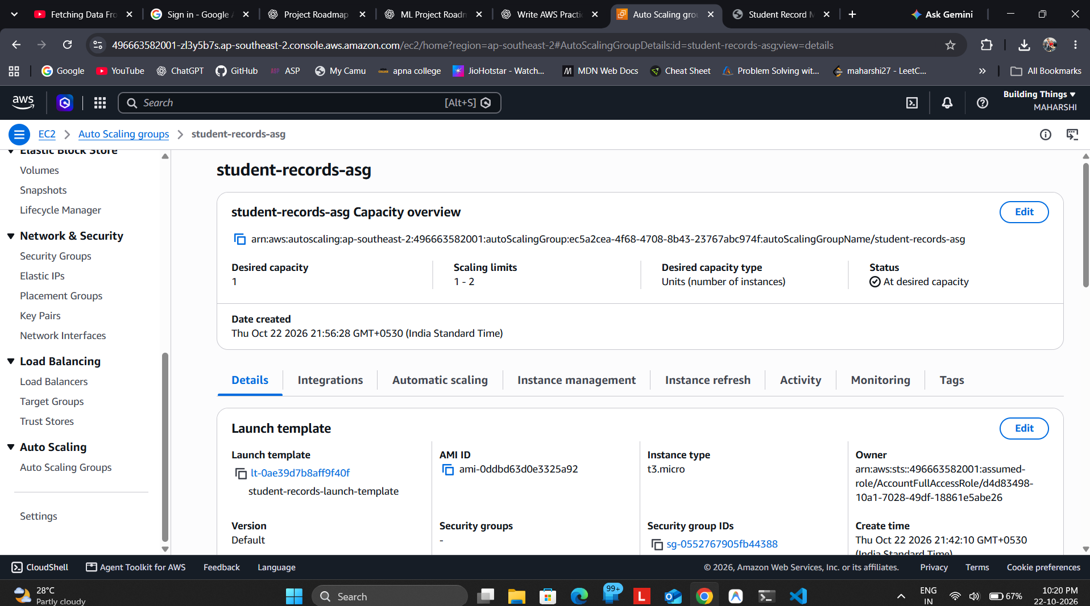
Figure 9. Auto Scaling Group capacity overview and associated Launch Template.
Observation: The list view captured earlier showed minimum 1, desired 1, and maximum 2 while capacity was still updating; the later details view shows the group at desired capacity.

Evidence 10A — Target-tracking scaling policy
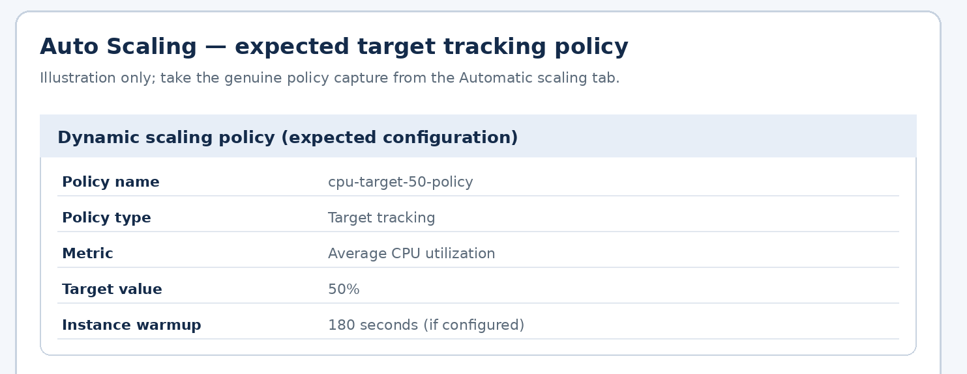

Evidence 10B — Auto Scaling activity history
The Activity history records a successful EC2 instance launch, with the group increasing capacity from 0 to 1 in response to its desired-capacity setting.
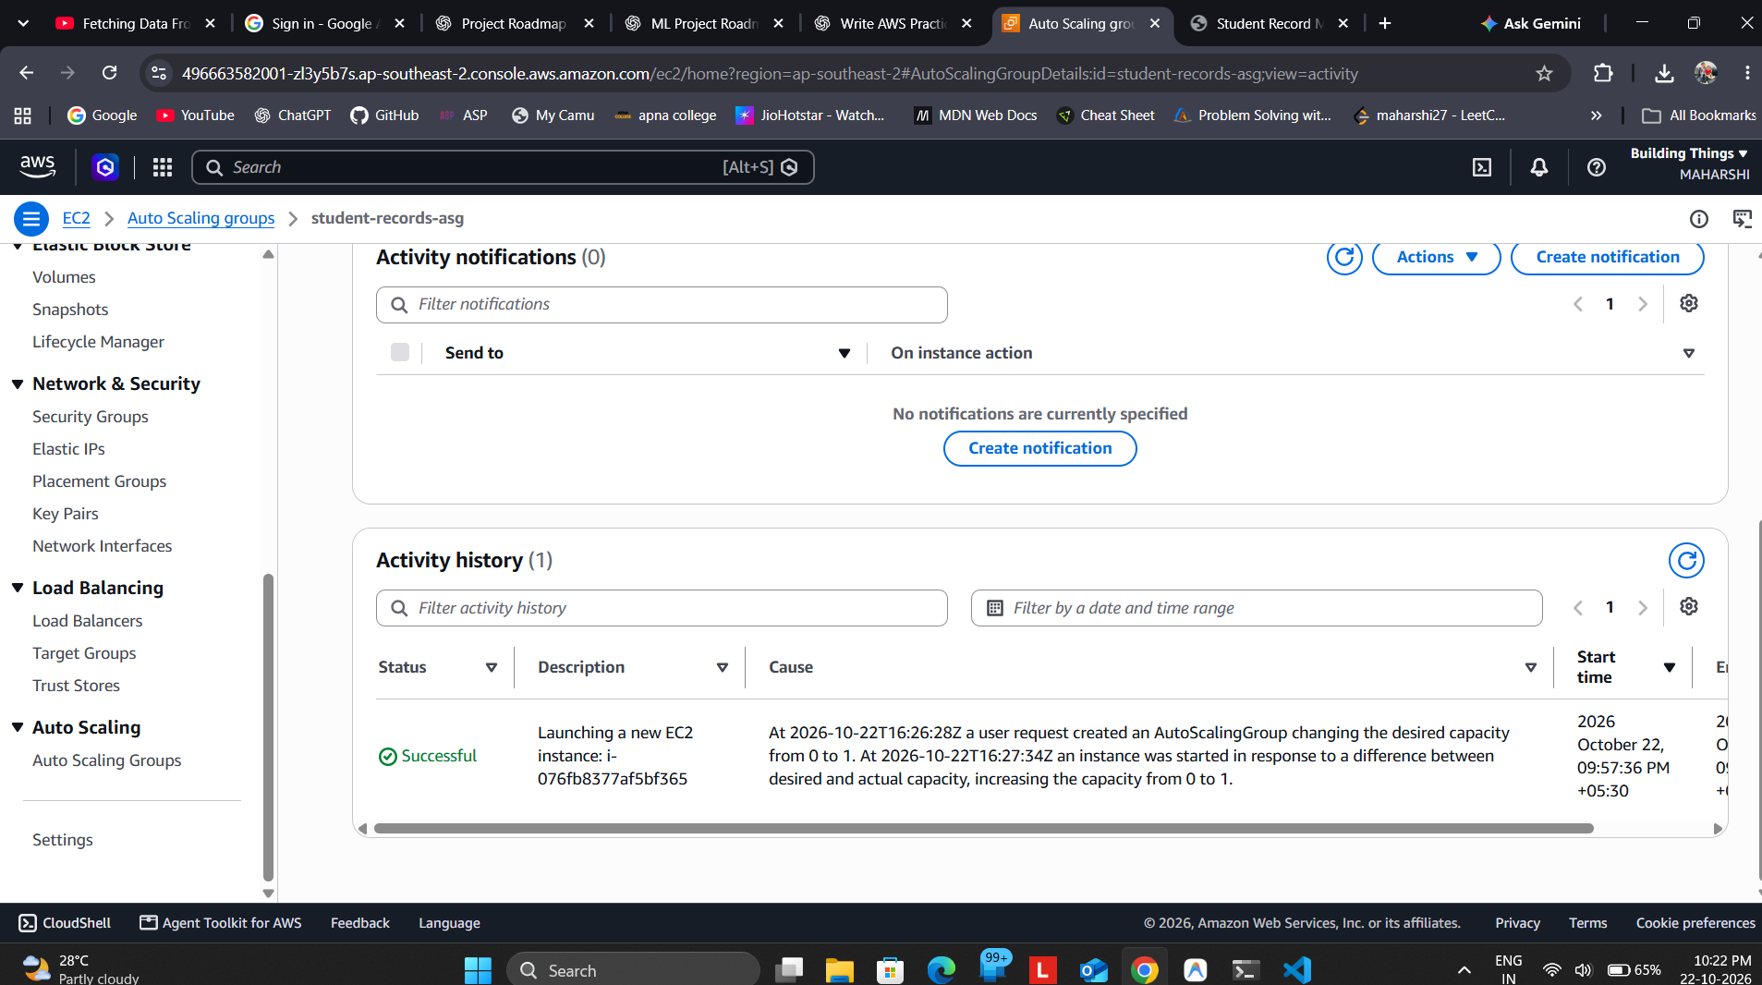
Figure 10B. Successful instance launch shown in Auto Scaling activity history.
Observation: This provides actual evidence of the Auto Scaling Group responding to its initial desired capacity.

Evidence S1 — Initial public application state (supplementary)
This earlier capture shows the public application in AWS/DynamoDB mode before a student record was visible in the directory. It is included only as a setup-progress capture; Figure 4 is the stronger final application evidence.
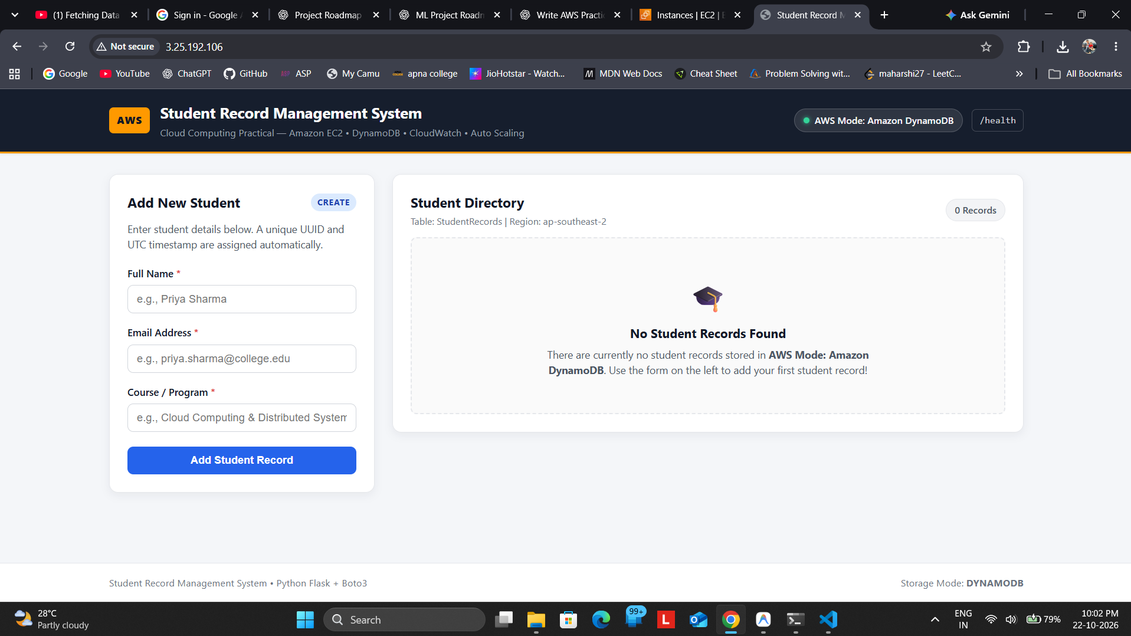
Figure S1. Initial public application state before record population.
Observation: For final grading, prefer the later screenshot with a successful add message and a visible record.

Evidence S2 — DynamoDB table overview (supplementary)
This table-details capture was taken during setup and showed table metadata. Item count in the table overview can differ from the later item-explorer query or be stale; Figure 5B directly shows the item returned.
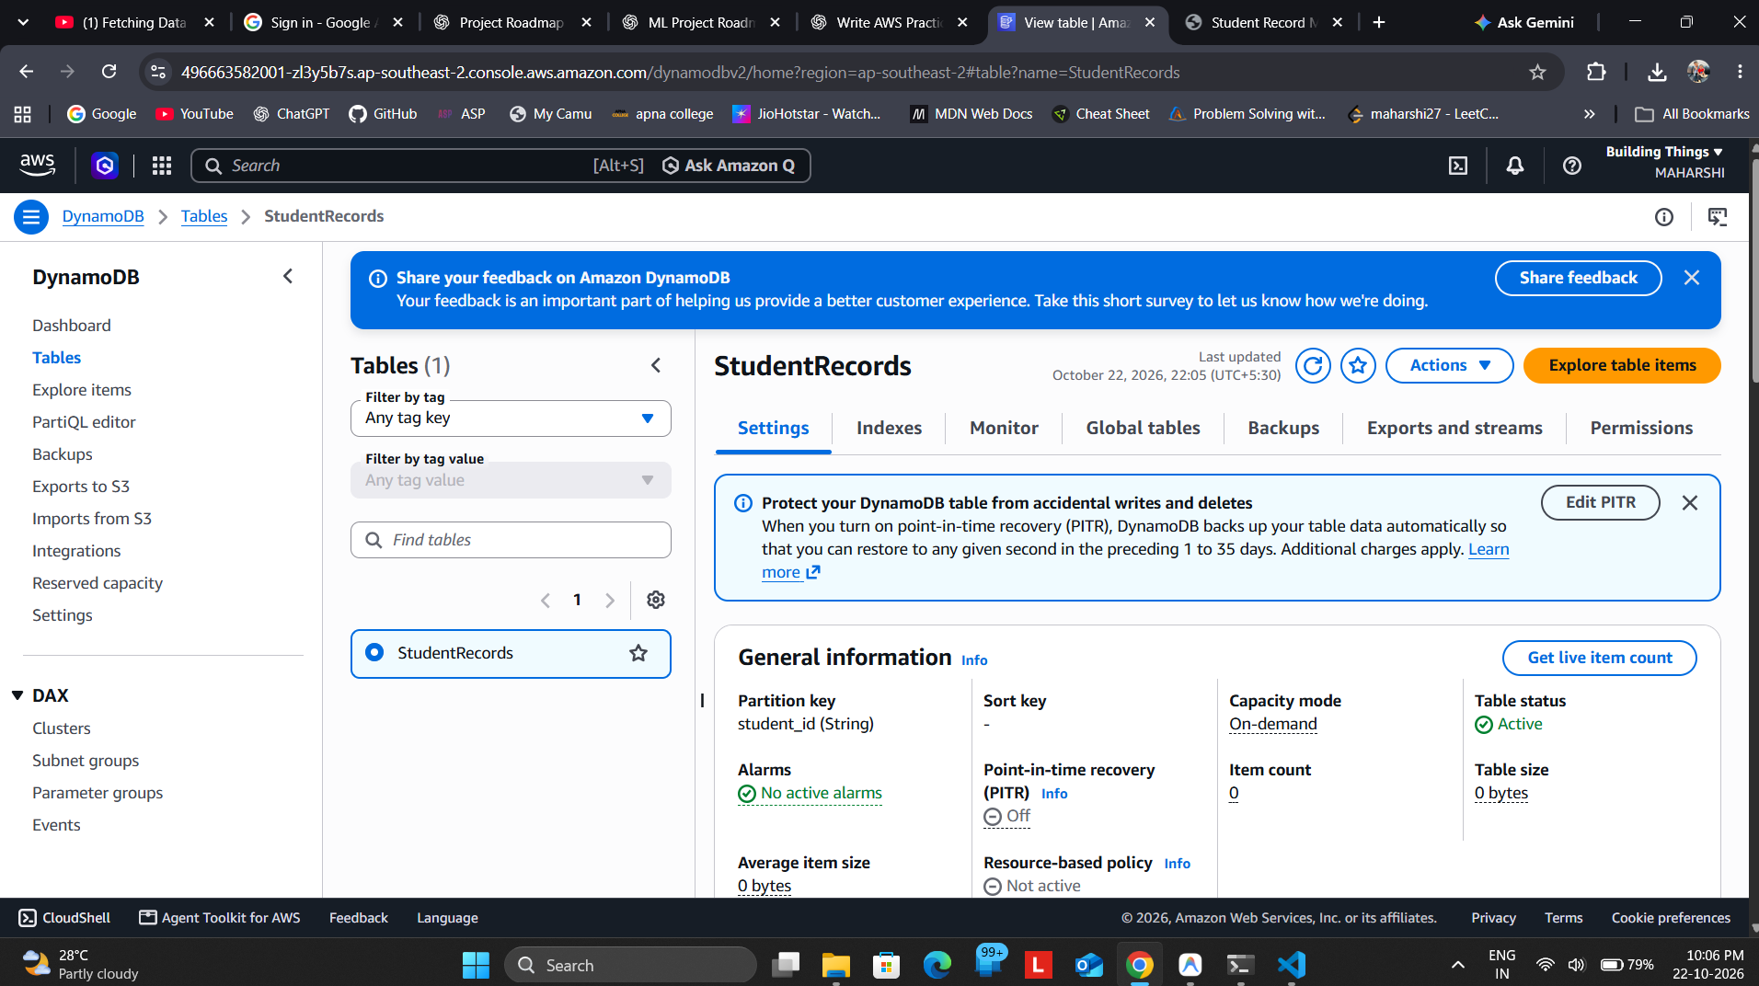
Figure S2. DynamoDB table settings and metadata during setup.
Observation: Use Figure 5B as the primary proof of stored sample data.

Evidence S3 — Auto Scaling initial state (supplementary)
This list view shows the Auto Scaling Group immediately after creation while its capacity was still updating. The later Activity history screenshot records a successful instance launch.
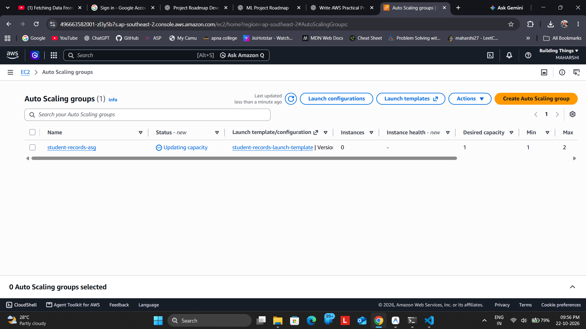
Figure S3. Initial Auto Scaling Group status during provisioning.
Observation: The initial “Updating capacity” state is expected during launch and is superseded by the successful activity shown in Figure 10B.

5. Result and Conclusion
A Python Flask Student Record Management System was deployed to an EC2-hosted public endpoint. The deployed interface reported AWS Mode: Amazon DynamoDB, and a student item was visible in the StudentRecords DynamoDB table. CloudWatch CPUUtilization data and target-tracking alarms were captured. The Auto Scaling Group was configured with desired capacity 1 and limits from 1 to 2, and its activity history recorded a successful EC2 instance launch.
The practical demonstrates the basic integration of compute, managed NoSQL storage, monitoring, and scaling services on AWS. The public endpoint uses HTTP for this demonstration and should not be treated as a production-secure endpoint.

Final completion checklist
- Local application screenshot inserted.
- Public EC2-hosted application screenshot inserted.
- DynamoDB table and actual item screenshots inserted.
- CloudWatch CPU metric and alarm screenshots inserted.
- Launch Template and Auto Scaling capacity/activity screenshots inserted.
- Replace illustrative evidence images for EC2 Running state, terminal deployment, and policy detail with actual screenshots before submitting if required by the instructor.
- After submission/demo, delete unneeded AWS resources to avoid further charges.
Important final note: The red-labelled illustrative images are intentionally not represented as authentic AWS evidence. For a fully evidence-complete submission, replace those three pages with screenshots captured directly from your actual EC2 and Auto Scaling console/terminal.

