E-Commerce SQL Analysis
SQL Queries

1. Total Revenue
Calculates the sum of all order values to determine overall revenue.
SELECT SUM(total_price) AS total_revenue
FROM sales_data;



2. Total Orders
Counts the total number of orders placed.
SELECT COUNT(*) AS total_orders
FROM sales_data;



3. Average Order Value
Computes the mean value per order, rounded to two decimal places.
SELECT ROUND(AVG(total_price), 2) AS avg_order_value
FROM sales_data;



4. Revenue by Region
Breaks down total revenue by geographic region, sorted highest first.
SELECT
region,
SUM(total_price) AS revenue
FROM sales_data
GROUP BY region
ORDER BY revenue DESC;

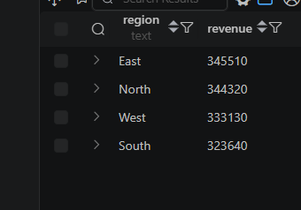

5. Revenue by Category
Shows total revenue for each product category.
SELECT
category,
SUM(total_price) AS revenue
FROM sales_data
GROUP BY category
ORDER BY revenue DESC;

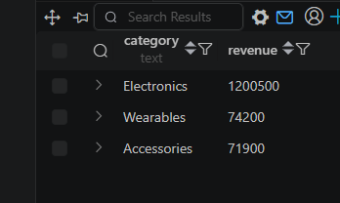

6. Count Unique Customers
Returns the number of distinct customers who have placed at least one order.
SELECT COUNT(DISTINCT customer_id) AS unique_customers
FROM sales_data;



7. Top 10 Customers by Spending
Lists the ten highest-spending customers with their total expenditure.
SELECT
customer_id,
SUM(total_price) AS total_spent
FROM sales_data
GROUP BY customer_id
ORDER BY total_spent DESC
LIMIT 10;

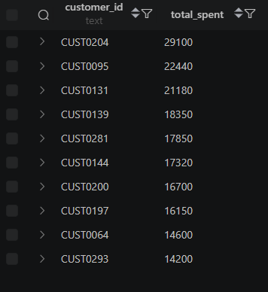

8. Revenue by Gender
Compares total revenue segmented by customer gender.
SELECT
gender,
SUM(total_price) AS revenue
FROM sales_data
GROUP BY gender;
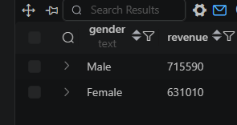

9. Monthly Revenue Trend
Aggregates revenue month by month to visualize seasonal trends.
SELECT
DATE_FORMAT(order_date, '%Y-%m') AS month,
SUM(total_price) AS revenue
FROM sales_data
GROUP BY DATE_FORMAT(order_date, '%Y-%m')
ORDER BY month;

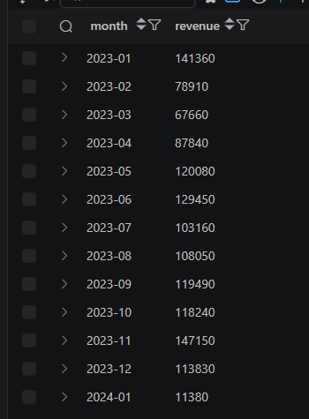

10. Most Popular Products
Ranks products by total units sold.
SELECT
product_name,
SUM(quantity) AS units_sold
FROM sales_data
GROUP BY product_name
ORDER BY units_sold DESC;

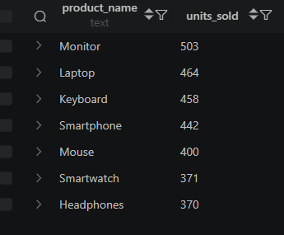

11. Average Order Value by Region
Compares mean order value across different regions.
SELECT
region,
ROUND(AVG(total_price), 2) AS avg_order_value
FROM sales_data
GROUP BY region
ORDER BY avg_order_value DESC;

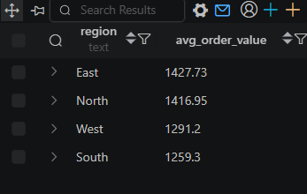

12. Return Rate
Calculates the percentage of orders that were returned.
SELECT
ROUND(
100.0 * SUM(CASE WHEN shipping_status = 'Returned' THEN 1 ELSE 0 END)
/ COUNT(*),
2
) AS return_rate
FROM sales_data;
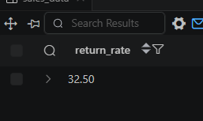

13. Products with Highest Return Rate
Identifies which products have the most returns, helping target quality improvements.
SELECT
product_name,
COUNT(*) AS total_orders,
SUM(CASE WHEN shipping_status = 'Returned' THEN 1 ELSE 0 END) AS returned_orders,
ROUND(
100.0 * SUM(CASE WHEN shipping_status = 'Returned' THEN 1 ELSE 0 END)
/ COUNT(*),
2
) AS return_rate
FROM sales_data
GROUP BY product_name
ORDER BY return_rate DESC;
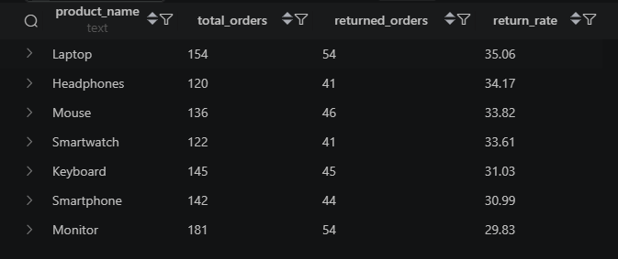

14. Rank Customers by Revenue
Uses a window function to assign rank positions to customers based on total spending.
SELECT
customer_id,
SUM(total_price) AS revenue,
RANK() OVER (
ORDER BY SUM(total_price) DESC
) AS customer_rank
FROM sales_data
GROUP BY customer_id LIMIT 20;

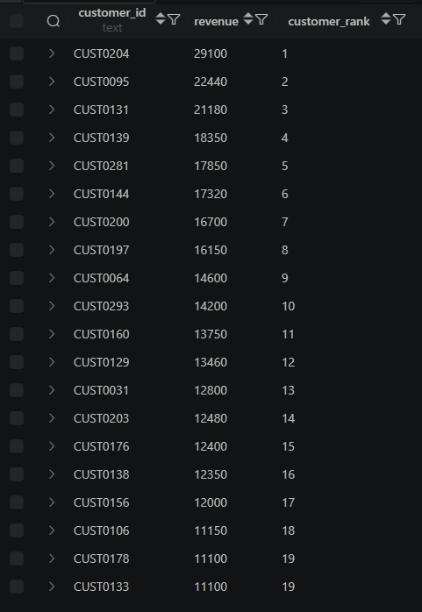

15. Top-Selling Product in Each Region
Uses a CTE with ROW_NUMBER to find the best-selling product per region.
WITH product_sales AS (
SELECT
region,
product_name,
SUM(quantity) AS units_sold,
ROW_NUMBER() OVER (
PARTITION BY region
ORDER BY SUM(quantity) DESC
) AS rn
FROM sales_data
GROUP BY region, product_name
)
SELECT *
FROM product_sales
WHERE rn = 1;

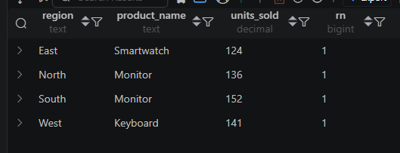

16. Customers Spending Above Average
Filters for customers whose total spend exceeds the overall customer average using a subquery.
WITH customer_spending AS (
SELECT
customer_id,
SUM(total_price) AS total_spent
FROM sales_data
GROUP BY customer_id
)
SELECT *
FROM customer_spending
WHERE total_spent > (
SELECT AVG(total_spent)
FROM customer_spending
);

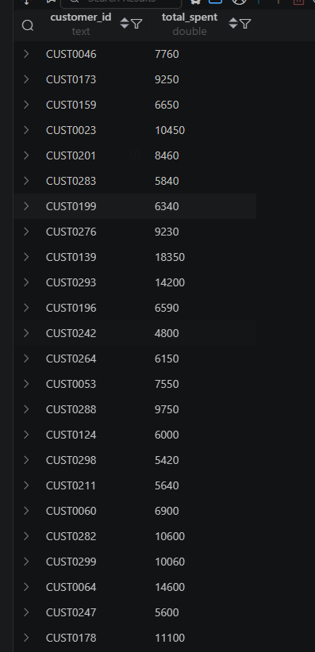

17. Revenue Contribution by Region
Shows each region's revenue along with its percentage share of total revenue.
SELECT
region,
SUM(total_price) AS revenue,
ROUND(
100.0 * SUM(total_price) /
SUM(SUM(total_price)) OVER (),
2
) AS contribution_pct
FROM sales_data
GROUP BY region
ORDER BY revenue DESC;
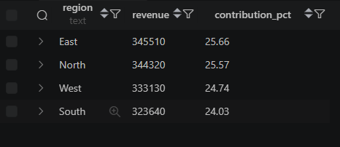

18. Month-over-Month Growth
Calculates the percentage change in revenue compared to the previous month using LAG().
WITH monthly_sales AS (
SELECT
DATE_FORMAT(order_date, '%Y-%m') AS month,
SUM(total_price) AS revenue
FROM sales_data
GROUP BY DATE_FORMAT(order_date, '%Y-%m')
)
SELECT
month,
revenue,
LAG(revenue) OVER (ORDER BY month) AS prev_month,
ROUND(
((revenue - LAG(revenue) OVER (ORDER BY month))
/ LAG(revenue) OVER (ORDER BY month)) * 100,
2
) AS growth_pct
FROM monthly_sales
ORDER BY month;

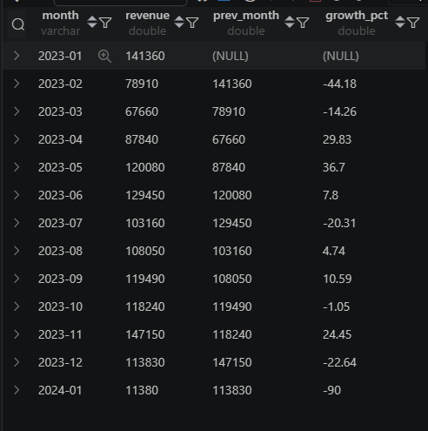

19. Pareto Analysis (Top 20% Customers)
Retrieves the top 58 customers by revenue to support 80/20 Pareto analysis.
WITH customer_sales AS (
SELECT
customer_id,
SUM(total_price) AS revenue
FROM sales_data
GROUP BY customer_id
)
SELECT *
FROM customer_sales
ORDER BY revenue DESC
LIMIT 58;

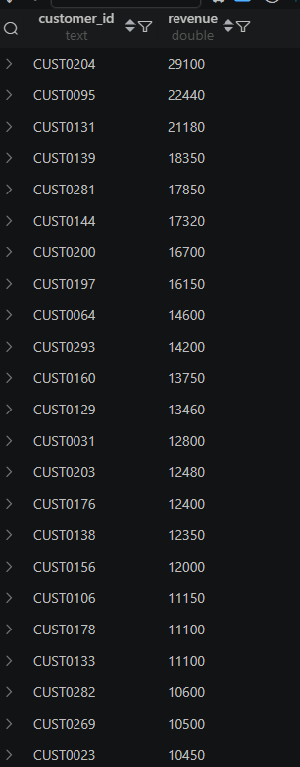

20. Executive Dashboard Metrics
A single query returning five KPIs: total orders, unique customers, total revenue, average order value, and units sold.
SELECT
COUNT(*) AS total_orders,
COUNT(DISTINCT customer_id) AS customers,
SUM(total_price) AS revenue,
AVG(total_price) AS avg_order_value,
SUM(quantity) AS units_sold
FROM sales_data;

