**IS-95 CDMA**

**Classification of CDMA**

What is CDMA?

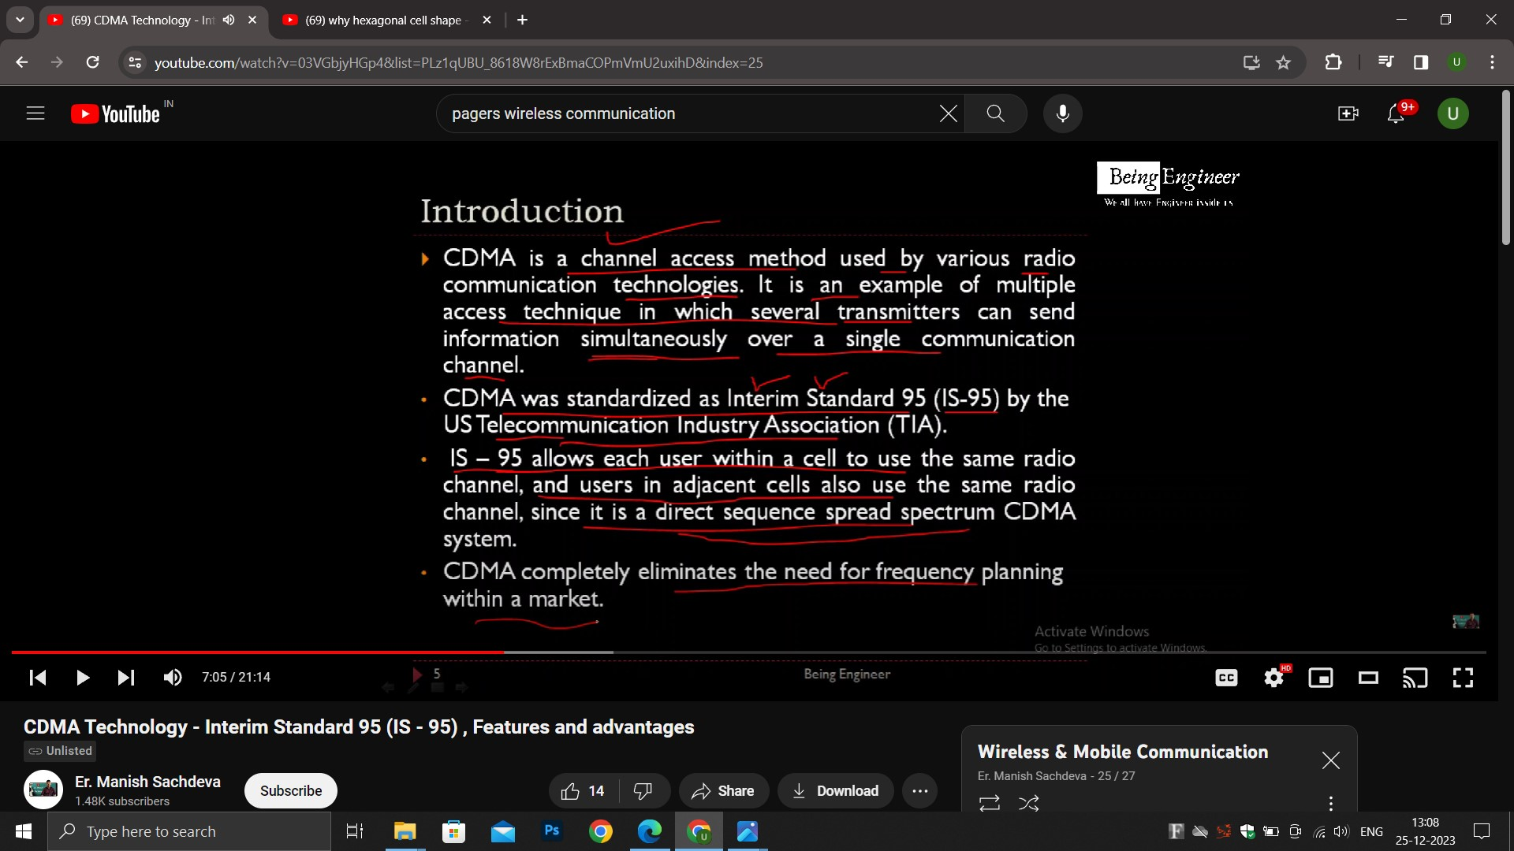

The codes don’t get intermixed , the receivers get the information from the respective senders without any interferance.

-------------------------------------------------Optional-----------------------------------------------

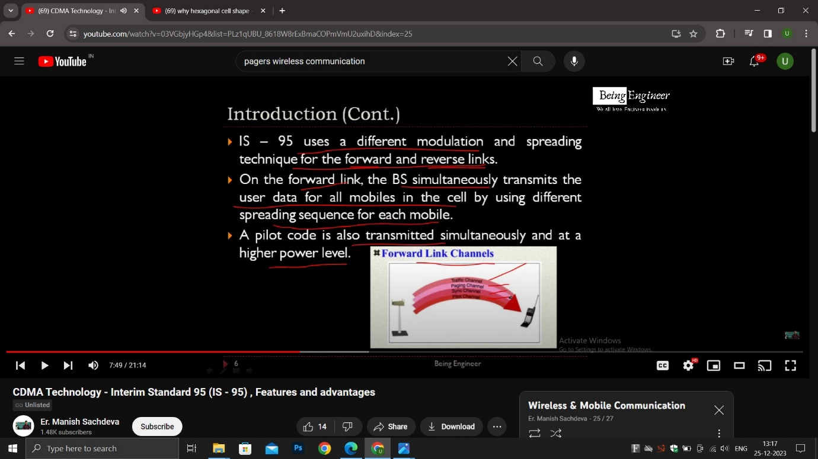

----------------------------------------------------------------------------------------------------

Important points:

There is a dual mode in which both AMPS/CDMA can be used.

It uses soft handoff.

It has advanced telephony features like call waiting , voice mail.



Advanatge:

Enhanced security.

Reach to rural areas which are far from cells.

Increased efficiency , the carrier can serve more subscribers.

Disadvantage:

Not as popular as the GSM.

Has proprietary nature and hence flaws of cdma are unknown to engineering community.

Does not provide international roaming unlike gsm.

GSM vs IS95

1. User info is stored in sim in GSM , but in CDMA user info is stored in device.
2. GSM uses tdma, fdma but IS95 uses CDMA.
3. GSM is popular used by 74% people as compared to 26% cdma
4. Data and voice can be simultaneously transmitted in gsm unlike cdma
5. GSM has less security and cdma has more security.
6. GSM is globally available but cdma is present in fewer countries.

Mobility Management:

A geographical area is divided into cells and each cell is assigned a bunch of frequencies and each cell has a base station which has trans receivers and control unit. A mobile switching center manages and controls all base stations. MSC is responsible for authentication, location update and call delivery process.

Mobility management tracks where the subscribers are? and provides other mobile phone services like roaming which helps to send and receive voice call and send and receive data when moving outside the home network or geographical coverage area or visitor network.

Mobility Management = Handoff management + Location management

Handoff = soft-handoff, hard-handoff.

Location management:

It aims at tracking the current location of the user so that incoming packets can be routed to its mobile station. Location must be updated regularly for avoiding delay in incoming packets.

Location management = location update + paging

Location update: When mobile station moves in different locations in a cell it asks the network operator to update the location.

Paging: Provides one to one communication b/w mobile st. and base st.

**NETWORK SIGNALING:**

# What Is Signaling?

Signaling refers to the exchange of information between call components required to provide and maintain service.

As users of the PSTN, we exchange signaling/information with network elements all the time. Examples of signaling between a telephone user and the telephone network include: dialing digits, providing dial tone, accessing a voice mailbox, sending a call-waiting tone, dialing *66 (to retry a busy number), etc.

**Types Of signaling:**

In-band signaling:

Signaling in which signaling(control signals) is carried on same path/band and frequency as of voice. Its also known as channel associated signaling.

Out of Band signaling:

It’s the signaling in which the signaling (control signals) use a different band/path and frequency as of the voice trunks. Its also called common channel signaling.

# What is SS7?

# Signaling System 7 (SS7) is an architecture for performing out-of-band signaling in support of the call-establishment, billing, routing, and information-exchange functions of the public switched telephone network (PSTN).

SS7 is a means by which elements of the telephone network exchange information. Information is conveyed in the form of messages. SS7 messages can convey information such as:

* + Someone just dialed 800-555-1212. Where do I route the call?
  + The called subscriber for the call on trunk 11 is busy. Release the call and play a busy tone.
  + The route to XXX is congested. Please don’t send any messages to XXX unless they are of priority 2 or higher.

SS7 is characterized by *high-speed packet data* and *out-of-band signaling*.

# SS7 Architecture

# The ss7 architecture comprises of the following components which are connected with the signaling links ie A-link, B-link , C-link, D-link, E-link, F-link . The signaling links are used for connection b/w different components of the network.

# STP: Signaling transfer Point

# SSP :Signaling switching point

# SCP: Signaling control point

SS7 is a means or protocol using which voice and media is exchanged between different networks.

**Following are the links:**

A-link : Access Link (Gives connection b/w STP and SCP)

B-link : Bridge Link (Gives connection b/w STP and STP)

C-link : Cross Link (Gives cross connection b/w STP and STP)

D-link : Diagonal Link (Gives diagonal connection b/w STP and STP)

E-link : Extended Link (Gives connection b/w SSP/SCP and SSP/SCP)

F-link : Failure link (Used as a substitute when any above link fails)

**What is a signaling point?**

Each signaling point in SS7 architecture is identified by its numeric code which carries message b/w different components of SS7 architecture.

**Types of Signaling points?**

STP ,SCP ,SSP.

SSP – Facilitate voice and media exchange b/w local subscribers and converts voice signal to ss7 signaling link.

STP – Works as a router , A telephone n/w can have more STP’s for reducing traffic etc.

SCP- A database which stores information of users and used to handle queries of subscribers.

Spread Spectrum Systems:

Increasing the bandwidth of the baseband signal as compared to the original signal with help of pseudo-random noise.

Advantages:

1. Security: Because of the pseudo random noise in the signal being transmitted security increases and message becomes difficult to decode, the pseudo random noise is only know to the transmitter. Thus there is estrablishment of secure comminication.
2. Immunity to distortions: The signal being tranmitted already has noise due to use of pseudo random noise and hence noise in the channel wont affect our signal much.
3. Immune to interference/jamming: If bandwith of signal is small then someone can send an interfering signal in that bandwidth for creating interference but in spread spectrrum the bandwidth increases so it becomes difficult to interfere with the signal.
4. We can use any multiple access technique like tdma,fdma or cdma in spread spectrum systems.
5. Prevention of detection and to limit power flux density.

Pseudo random noise is deterministic (same being used at both modulator and demodulator and periodic in nature.

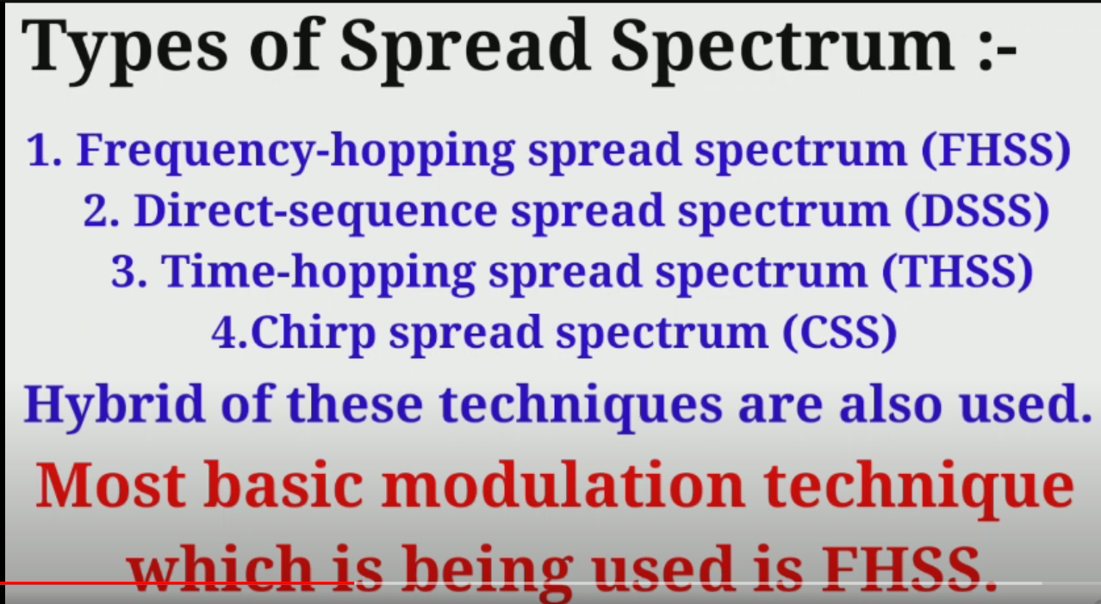

Power Control in CDMA:

We need power control because there is near-far problem.

All the paths on which the user is transmitting will have some path loss. Consider that in a cell there is a base station at center of the cell , there is a user near the base station and there is a user at the edge of the cell. Then the user near the base station would be transmitting with higher power and less path loss as the user is near to BS , but for the user which is near the edge of cell the distance is more and hence path loss is more and power of transmission is lesser.

In CDMA because these users will transmit information on the same channel or frequency , the only difference is that the users will use different PN sequence or code, thus the user who is near the BS will Jam the signal of the user at edge. This is called the near far effect. To overcome the near-far problem the base stations should transmit information with same power level. Thus to achieve this the user near the BS should transmit with lower power as compared to the users far from BS so that even if there is a path loss , the information is received at the BS with same power.

Thus to achieve the same power levels we use open loop and closed loop systems.

Open loop systems:-

There are 2 requirements:

1. All signals received at BS must be of same power level.
2. Only minimum required RF should be transmitted from base station to mobile station in order for no signal to be jammed.

How does Open loop systems work?

During signaling, information is received at the mobile stations from the base station , the mobile station uses this information to estimate the path loss and do coarse adjustments in its power levels. The power level also depends on cell size and increases with the increase in cell size.

Closed loop systems:

There are 2 requirements.

First requirement:

Instead of mobile phone understanding the power levels , the SNR is calculated at the base station or cell site receiver apart from that there is predetermined thresholds used at base station or cell site receiver. Then the mobile station is instructed on power level of its transmission.

The mobile receives a power command after each 1.25 ms and mobile responds by adjusting the power level of its transmission on the basis of the received bit (o for increase and 1 for decrease).

Second requirement:

The base station transmits continuously at lower power levels unless the mobile station asks it to increase the power level for a successful comunication.