**POWER BI ASSINGMENT**

**Power BI Installation: -**

**• Install Power BI Desktop and share the final screenshot of the report view page which appears when power desktop starts.**

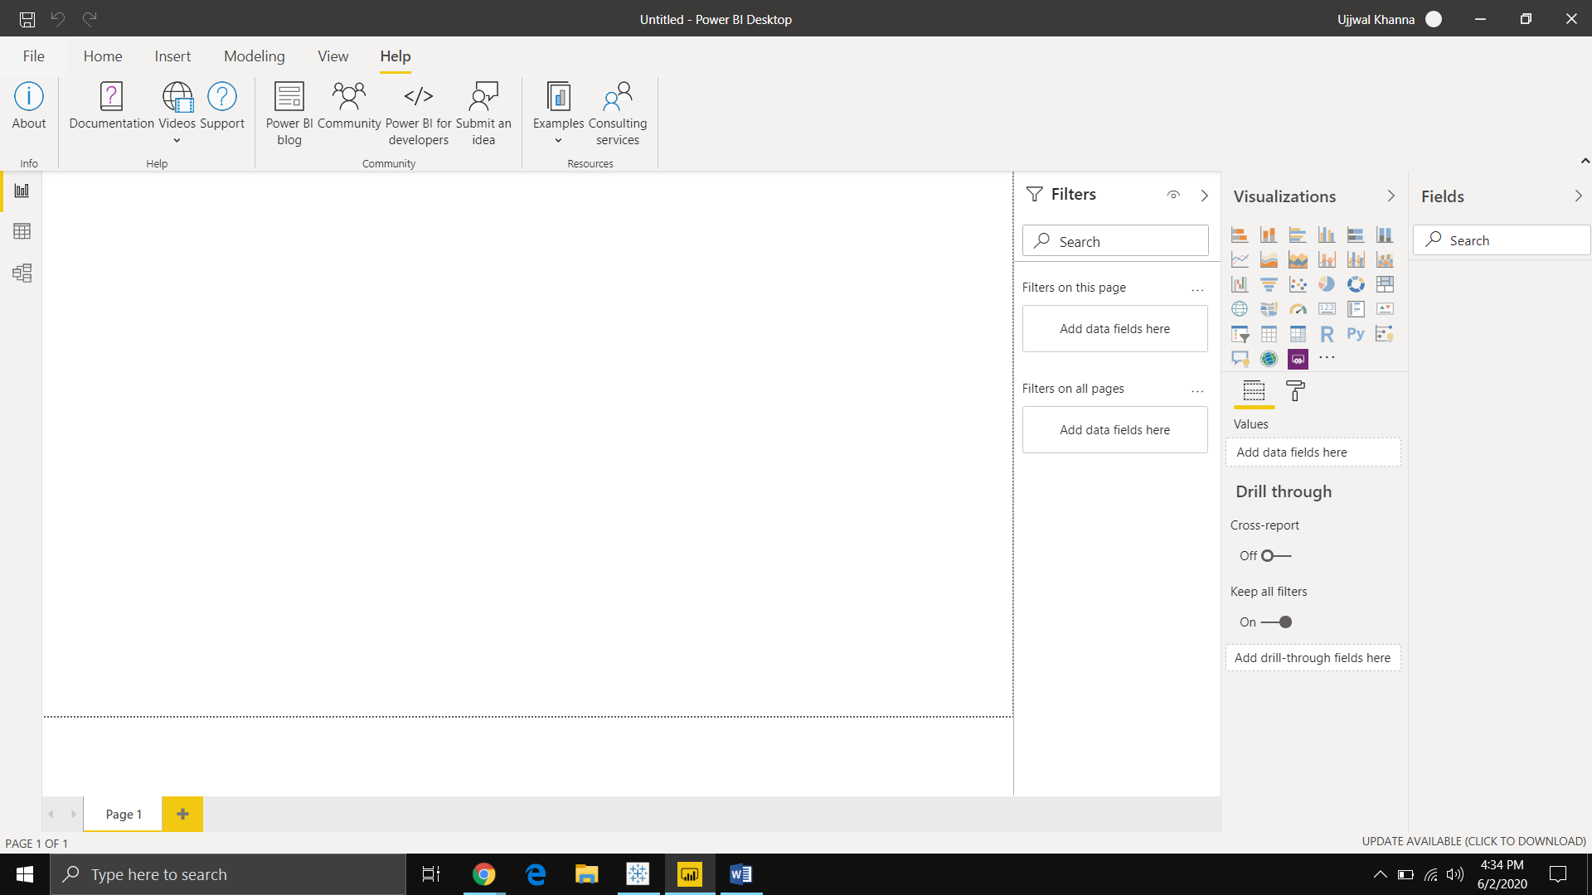

**Prepare a document and with the following screenshot**

**− Report View**

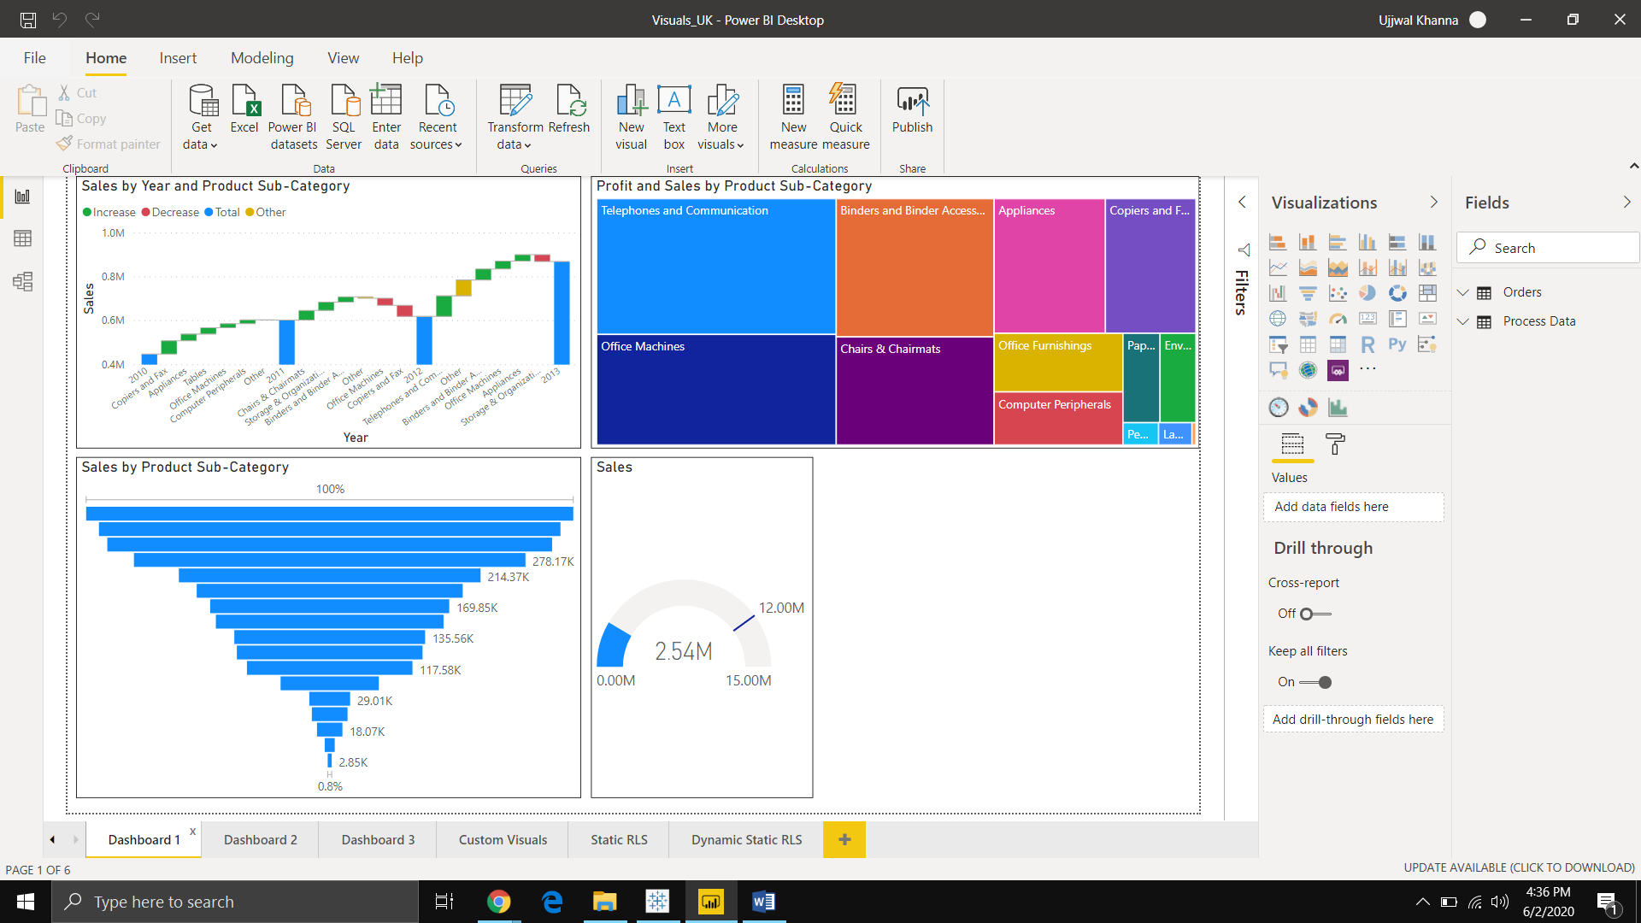

**− Data View**

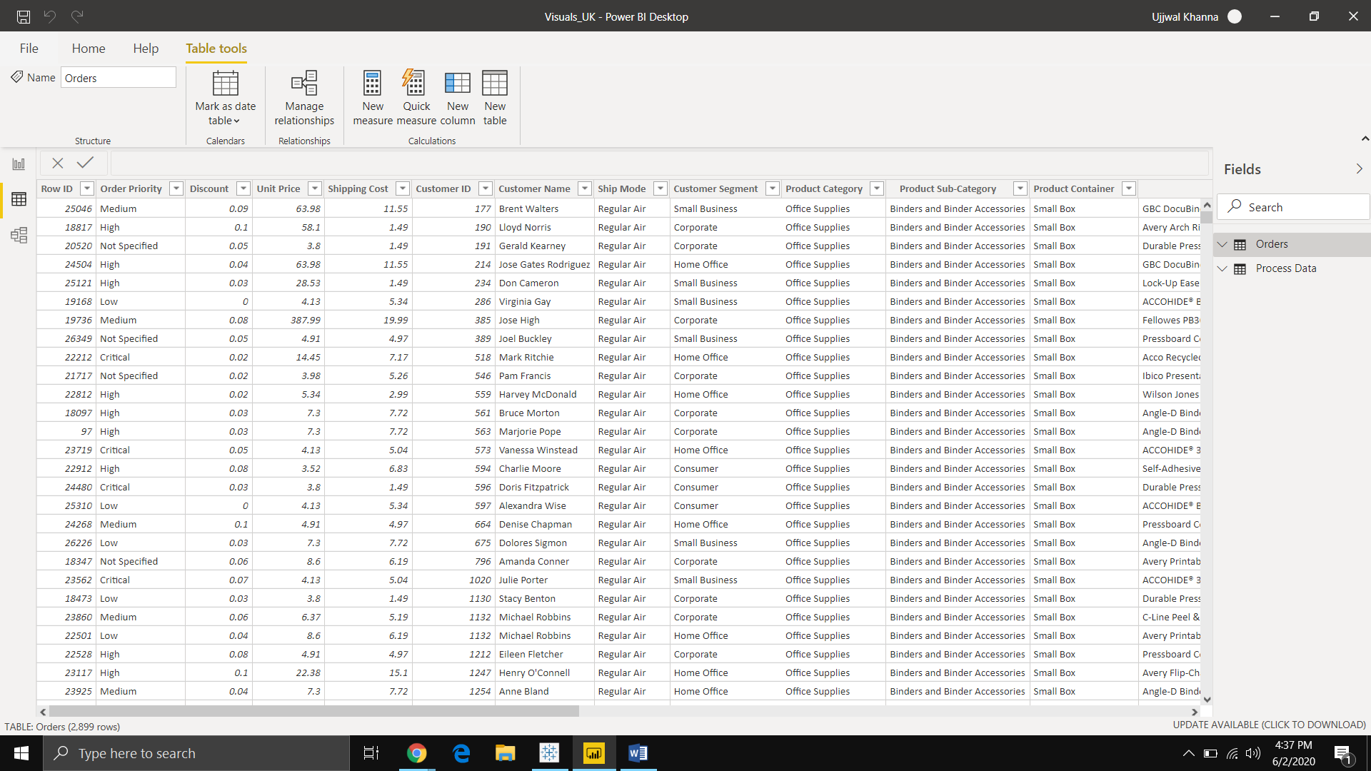

**− Model View**

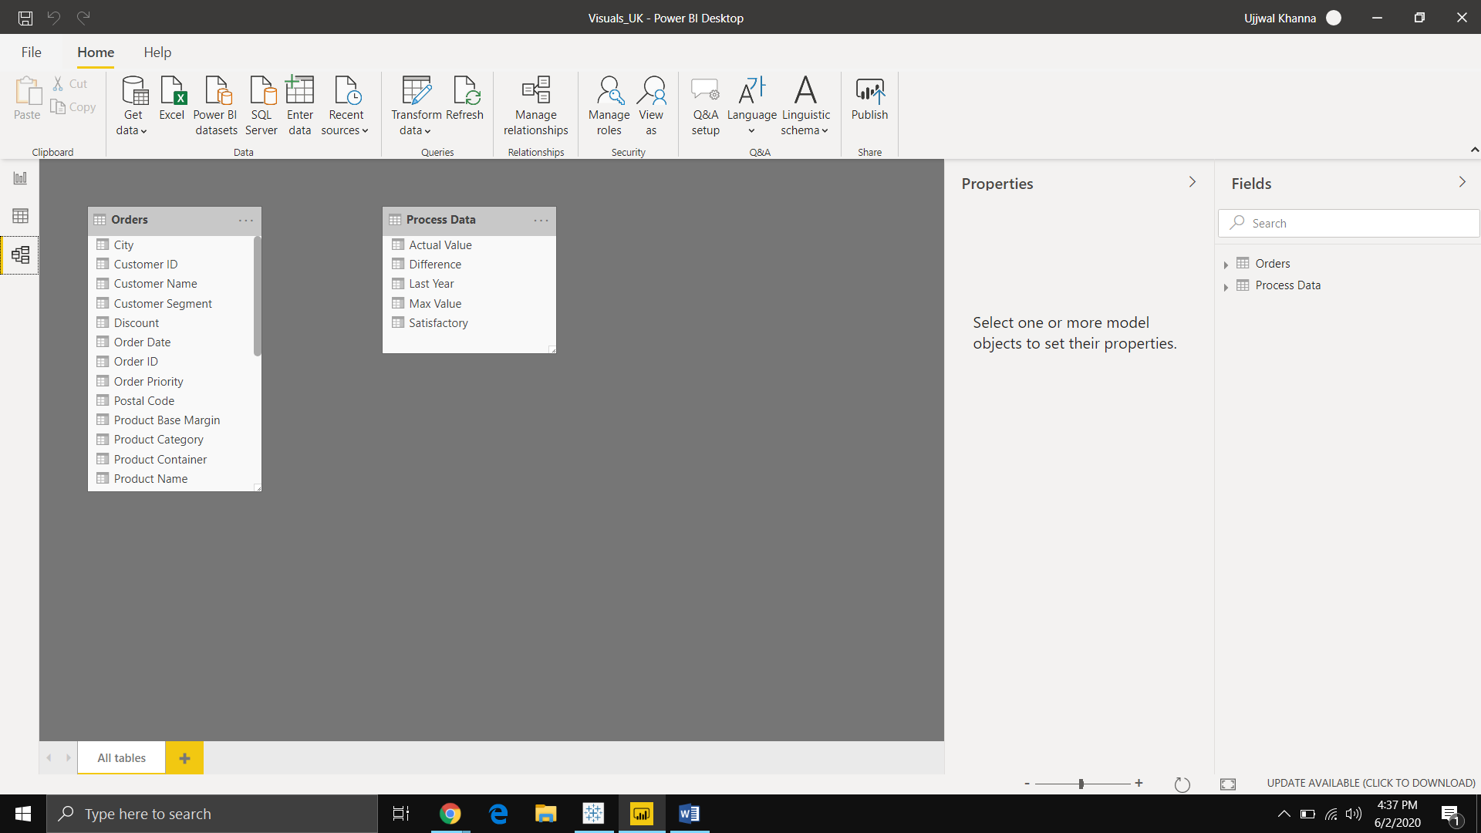

**− Power Query Editor**

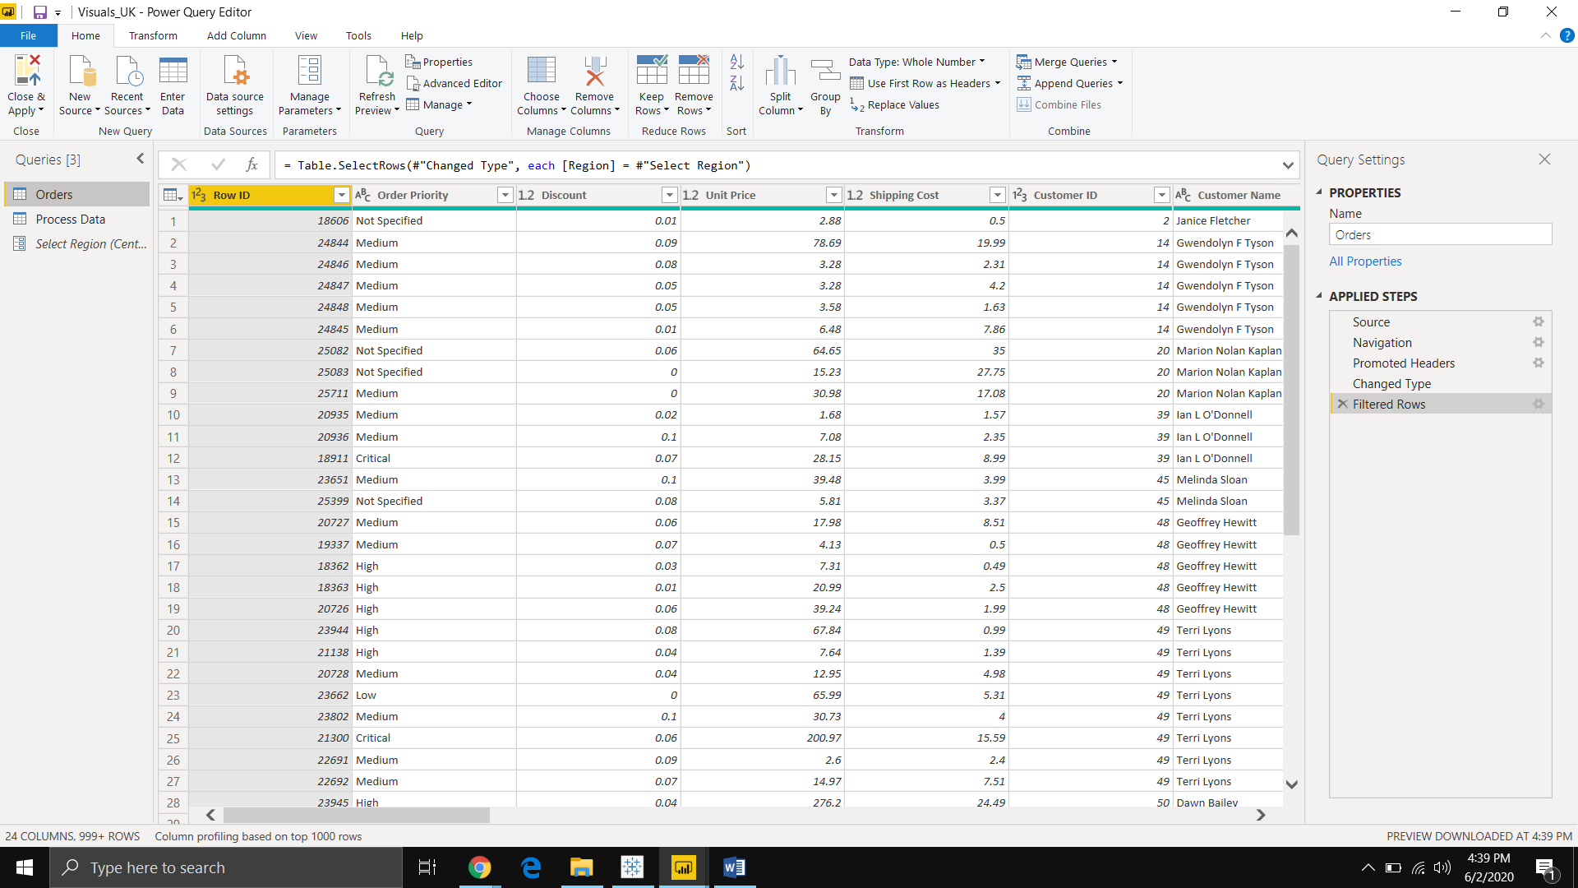

**− Advance Editor**

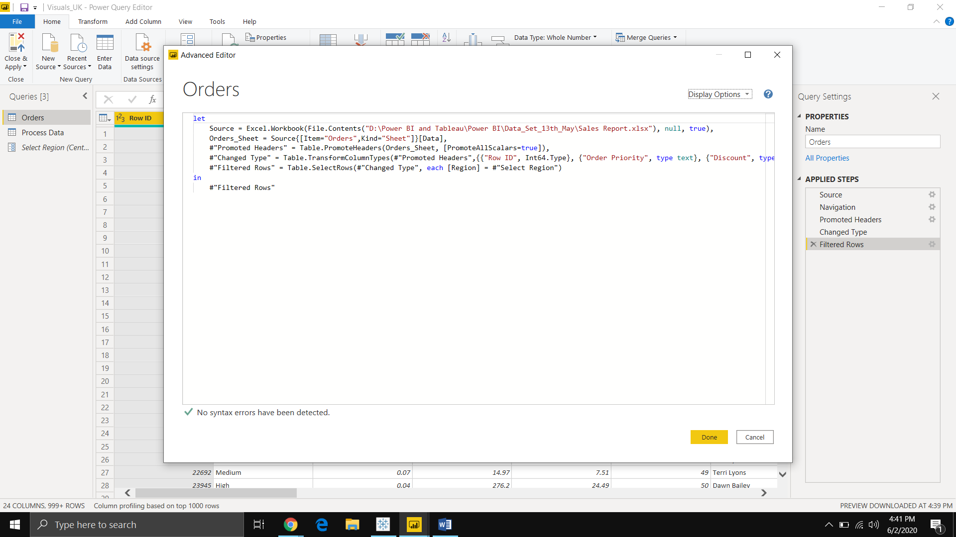

**Prepare a document with details of the following along with their price**

* **Power BI Desktop**

Power BI Desktop is a free application you install on your local computer that lets you connect to, transform, and visualize your data. With Power BI Desktop, you can connect to multiple different sources of data, and combine them (often called modeling) into a data model. This data model lets you build visuals, and collections of visuals you can share as reports, with other people inside your organization. Most users who work on business intelligence projects use Power BI Desktop to create reports, and then use the Power BI service to share their reports with others.

Despite its free nature, you may be surprised at what Microsoft has included with Power BI Desktop:

* You can connect and import data from over 70 cloud-based and on-premises sources
* The same rich visualisations and filters from Power BI Pro
* Auto-detect that finds and creates data relationships between tables and formats
* Export your reports to CSV, Microsoft Excel, Microsoft PowerPoint and PDF
* Python support
* Save, upload and publish your reports to the Web and the full Power BI service
* Storage limit of 10 GB per user

Naturally, there are some feature limitations with the free Power BI Desktop that give further incentive to upgrade.

* Can’t share created reports with non-Power BI Pro users
* No App Workspaces
* No API embedding
* No email subscriptions
* No peer-to-peer-sharing
* No support to analyze in Excel within Power BI Desktop

Basically, All of Power BI’s basic features - cleaning and preparing data, connectors to data sources, custom reports, visualizations and exports to Microsoft apps are included in Power BI Desktop. Thus, whatever core functionality or features are available in Power BI Desktop are also standard in the higher-tier, paid versions.

**Pricing-** This offering is ***free*** to any single user and includes data cleaning and preparation, custom visualizations and the ability to publish to the Power BI service.

* **Power BI Pro**

Power BI Pro is the full version of Power BI, complete with the ability to use Power BI for both building dashboards and reports and unlimited viewing, sharing and consumption of your created reports (and reports shared by others) - the latter not possible with Power BI Desktop.

A breakdown of Power BI Pro’s differences against Power BI Desktop:

1. Ability to embed Power BI visuals into apps (PowerApps, SharePoint, Teams, etc)
2. Native integration with other Microsoft solutions (Azure Data Services)
3. Share datasets, dashboards and reports with other Power BI Pro users
4. Can create App Workspaces and peer-to-peer sharing
5. Self-service and modern BI in the cloud
6. Collaboration, publishing, sharing, and ad-hoc analysis
7. Fully managed by Microsoft

***Pricing: -***

* The Pro plan costs ***$9.99/user/month.***

It includes data collaboration, data governance, building dashboards with a 360-degree real-time view and the ability to publish reports anywhere. Users can try it a free trial for 60 days before purchasing the subscription.

* **Power BI Premium**

Power BI Premium is the most expensive tier of Power BI currently available and very distinct from the other two versions available on the market.

On top of the features and functionality standard to all versions of the service, users of Power BI Premium get:

* Increased data capacity limits and maximum performance
* Access to one API surface
* Ability to embed Power BI visuals into apps (PowerApps, SharePoint, Teams, etc)
* Larger storage sizes for extended deployments
* Geo distribution, higher refresh rates, isolation, pin to memory, read-only replicas
* Power BI Report Server

Power BI Premium differs from the free version and Power BI pro in its licensing model, which only suits a specific size and type of organization and business scenario. You can purchase Premium in a range of capacity sizes that offer different numbers of memory and virtual cores that can scale as your data analysis requirements change.

**Pricing: -** The Premium plan starts at ***$4,995 a month*** per dedicated cloud compute and storage resource.