PINNTO - Physics Informed Neural Networks
For Trading Options
Ujjwal Pardeshi · Mehul Ashra · Asha Abraham

Dept. of Networking and Communications,
SRM Institute of Science and Technology,
Kattankulathur ,Chennai, India

up6276@srmist.edu.in, ma8125@srmist.edu.in, ashaa2@srmist.edu.in

Abstract. For successful trading activities and effective risk management, proper option pricing is vital. However, traditional methods such as the Black-Scholes equation or grid methods often face problems such as inflexibility or high computational costs. To overcome these problems, we introduce a physics-informed neural network named PINNTO to effectively price European call options under the Black-Scholes model. The key features of our model are its exclusive use of simulated data and the inclusion of a loss function that combines data misfit, PDE constraints, boundary conditions, and terminal conditions. We also evaluate our model by comparing its output with the analytical solutions of the Black-Scholes equation under different levels of moneyness and maturity using dense out-of-sample hold-out sets. Moreover, we also utilize explainable AI to ensure that the sensitivities learned by our model are in line with the Greeks. Our model shows promising results with low pricing errors (MAE < 0.15, R² > 0.999) and high-speed inference, proving that physics-informed training can be an effective direction for interpretable and mesh-free option pricing models.

Keywords: Black–Scholes PDE, Physics-informed neural networks, option pricing, deep learning, SHAP interpretability.

- Introduction
Option pricing has become an integral part of modern financial markets, facilitating trade, hedging, and risk management of stocks, indices, and derivatives. Analytical models such as the Black-Scholes equation have been able to derive closed-form solutions under specific conditions. However, for more complex financial instruments, numerical methods such as the Binomial model have also been used. Nevertheless, these models have also been found to face problems on fine grids, to have errors in partitioning, and to lack flexibility to adjust to market changes. With the rapid advancement of computer processing power and available data, there has been an increasing interest in exploring alternative models that can incorporate the advantages of machine learning models along with the accuracy of traditional models.

Physics-Informed Neural Networks (PINNs) have been found to be an effective tool in solving partial differential equations. This model can utilize data as well as PDE residuals to derive solutions to complex problems. However, the understanding of the sensitivity of PINNs to design choices for traditional models such as the European call option remains incomplete. Many studies have been conducted to derive solutions to complex problems; however, very few have conducted sensitivity analyses on PINNs to design choices such as network depth or width. Moreover, although PINNs have been able to incorporate financial theory through PDEs, there still remains a problem of understanding the decision-making process of these models. This paper aims to create a platform where the true function can be known to derive solutions to complex problems.

This study proposes a physics-informed neural network (PINN) for the Black-Scholes partial differential equation (PDE) for pricing European call options, solely based on simulated data, and uses the analytical solution as a benchmark. A fully connected neural network is trained on simulated data for stock prices and time, and a loss function is formulated to ensure that its outputs are compatible with those of the analytical solution, PDE, and boundary conditions. The model is then tested on dense, out-of-sample hold-out grids for a variety of moneyness values and maturity dates. The model is then compared to a high-fidelity version of the analytical solution to the Black-Scholes PDE. Quantitative results are also presented, including MAE, RMSE, and R² values, for a range of moneyness values. Explainable AI is also incorporated to analyze the behavior of the model to ensure that its pricing rules are compatible with those of the analytical solution.

- Methodology
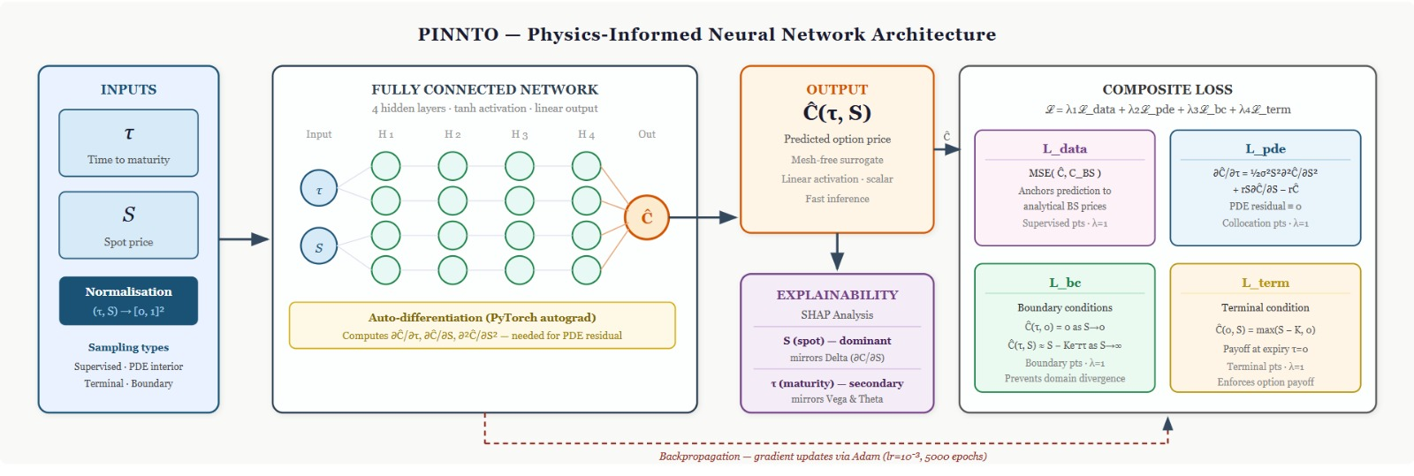
Fig 1. Architecture Diagram

A. Problem Setup and Notation
We concentrate on a European call option for an asset St within a risk-neutral context. Following the conventional Black–Scholes assumptions, we represent St using geometric Brownian motion defined by a constant risk-free rate r and volatility σ. The Black–Scholes partial differential equation (PDE) determines the no-arbitrage price C(t,S) for a call option with strike K and maturity T.:
∂C/∂t (t,S) + ½σ²S² ∂²C/∂S² (t,S) + rS ∂C/∂S (t,S) − rC(t,S) = 0 (3)
valid for S > 0 and 0 ≤ t < T. This is subject to the terminal condition:
C(T,S) = max(S − K, 0) (4)
along with appropriate boundary constraints where C(t,0) = 0 as S → 0, and asymptotically C(t,S) ≈ S − Ke^{−r(T−t)} as S → ∞.
To facilitate numerical solution, we reformulate the problem in terms of time-to-maturity, defined as τ = T − t. By letting C(τ,S) := C(T − τ,S), we rewrite the PDE as:
∂C/∂τ (τ,S) = ½σ²S² ∂²C/∂S² (τ,S) + rS ∂C/∂S (τ,S) − rC(τ,S) (5)
The initial condition at τ = 0 now becomes:
C(0,S) = max(S − K, 0) (6)
Correspondingly, the boundary conditions are C(τ,0) = 0 and C(τ,S) ≈ S − Ke^{−rτ} for large S. We approximate the pricing surface C(τ,S) on a compact domain defined by:
τ ∈ [0, τ_{max}], S ∈ [S_{min}, S_{max}] (7)
where the limits τ_{max}, S_{min}, and S_{max} are selected to encompass the full range of relevant maturities and price levels.

B. Synthetic Data Generation
We test PINNTO in a very controlled setting where we know exactly how the pricing function works. So, the Black-Scholes model is used to make all of the training and testing data. We create the dataset by setting certain ranges for the risk-free rate r, strike K, maturity T, and volatility σ.
At first, we set a small range for the time-to-maturity and asset price. Then, we take sample points (τ, S) from this domain using either a regular grid or random sampling. We find the analytical Black–Scholes price for each point, which is the correct answer.
At the terminal points, τ = 0, we take samples of asset prices and set target values that match the standard European payoff max(S − K, 0). Boundary points are made by taking samples of time-to-maturity values at the lowest and highest price points. We make sure that the call price is close to zero at the lower boundary and follows the S − Ke−rτ behavior at the upper boundary. During training, these limits help the model follow the rules of physical boundaries.
The full dataset is split into collocation points for physics-informed training and a separate hold-out set for strict out-of-sample testing. Hold-out points are taken from the middle of the domain, are not connected to any training data, and are compared to the analytical Black–Scholes solution to see how well they generalize.

C. PINN Architecture
The PINNTO framework uses a fully connected neural network to get close to the option price surface C(τ,S). The network takes a two-dimensional input vector (τ,S) that is often normalized to improve stability; the output is a scalar value equal to the network's prediction of the option price.
The network architecture features multiple hidden layers with a given number of neurons in each layer, utilizing smooth nonlinear activation functions. The choice of activation function here is the tanh function, followed by a linear output layer. This balance between network complexity and training stability allows the network to effectively represent the pricing surface over the input domain.
The process of automatic differentiation is used to compute the required derivatives. This process allows for an accurate determination of the gradients of the output with respect to the input, which are required to formulate the Black-Scholes operator and the physics-informed loss terms. This enables the accurate computation of high-order derivatives using the PyTorch library.

D. Physics-Informed Loss Design
The training methodology divides the sample space into four types: supervised data with analytical labels, interior collocation points, terminal points, and boundary points, which correspond to extreme price values. The loss function combines all these elements by applying scalar weights to each component according to their relative importance.
The mean-squared error loss function is applied to ensure that the difference between the predicted solution by PINNTO and the analytical solution of the Black-Scholes model is minimized for supervised data, enabling the model to learn established results for specific regions.

Automatic differentiation is applied to calculate the Black-Scholes residual for interior collocation points, enabling the solution to follow the partial differential equation for unsupervised regions.
Deviation from known payoff is penalized for τ = 0 for terminal points, while for boundary points, the solution is forced to follow the expected behavior as prices approach very low and very high values. This stops the model from going off course at the edges of the domain.
The data, PDE, boundary, and terminal losses are all put together into one objective function. We empirically adjust the weights to make sure that no one term stands out too much, which makes the final model both accurate and consistent with the laws of physics.

E. Training Procedure
PINNTO was made with PyTorch and is optimized using methods based on gradients. We mostly use the Adam optimizer with a set learning rate, and we might also go through a fine-tuning phase.
We take samples of mini-batches from our data pools every time we run an iteration. The predictions are made by the network, and then automatic differentiation is applied to find residuals and boundary errors in the partial differential equation. Finally, the total loss is propagated backward to adjust the weights.
The training is continued until convergence.When these two models are integrated, PINNTO is run over a dense grid of (τ, S) points to create price surfaces. These results are then used to inform subsequent steps in quantitative and explainability analyses.
- Results and Analysis

Loss Convergence
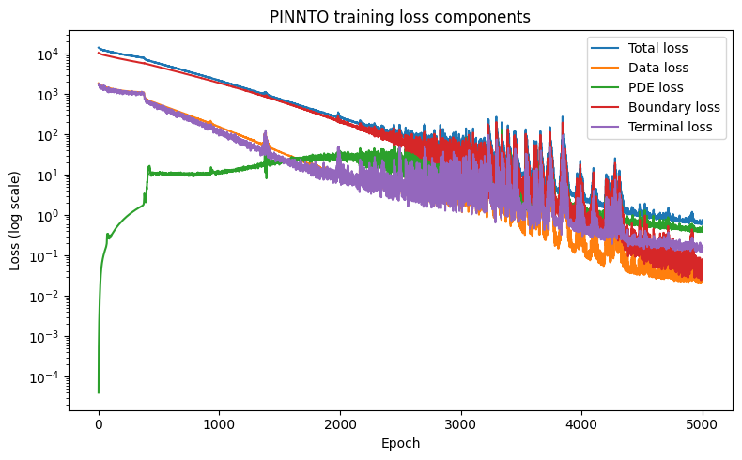
Fig 2. Convergence of PINNTO training loss and individual loss components over training epochs.

Figure 2 illustrates the convergence of the PINNTO composite loss and all four of its constituent losses after 5,000 epochs, where the y-axis is on a logarithmic scale.. The total loss decreases from 1.41 × 10⁴ at epoch 1 to 7.55 × 10⁻¹ at epoch 5,000. The data and terminal losses converge the fastest, both falling below 5 × 10⁻² after the last epoch, and the PDE residual converges to a stable point of 5 × 10⁻¹. This confirms that the network is fulfilling the Black-Scholes differential equation within the domain interior. There is no divergence, and this confirms our choice of composite loss weighting strategy.

Pricing Surface Accuracy
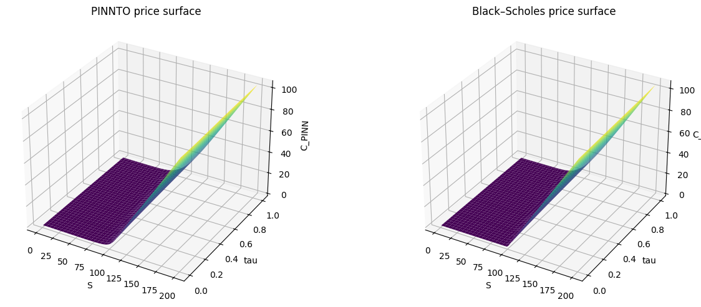

Fig 3. Comparison of the PINNTO-predicted European call price surface with the analytical Black–Scholes price surface.
Fig 3 compares the PINNTO-predicted price surface against the analytical Black–Scholes surface over S ∈ [1, 200], τ ∈ [0, 1], with K = 100, r = 0.05, σ = 0.20. Both surfaces appear almost identical, signifying that the PINNTO network has successfully learned an accurate mesh-free representation of the pricing function.
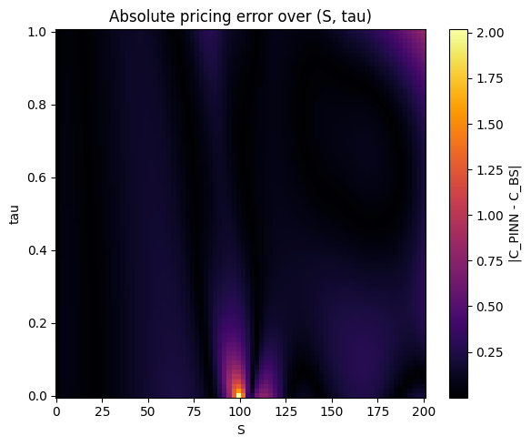
Fig 4. Absolute pricing error |CPINN − CBS| over spot price and time to maturity
Fig. 4 shows the absolute error |C_{PINN} − C_{BS}| as a heatmap. Error peaks near S ≈ K = 100 (at-the-money) at intermediate maturities, consistent with the Black–Scholes surface having its steepest curvature (highest Γ) at-the-money. Errors in the deep out-of-the-money and deep in-the-money regions remain negligible. The grid-level MAE across the full 80 × 80 evaluation grid is 0.1123.

Slice Comparison at Selected Maturities
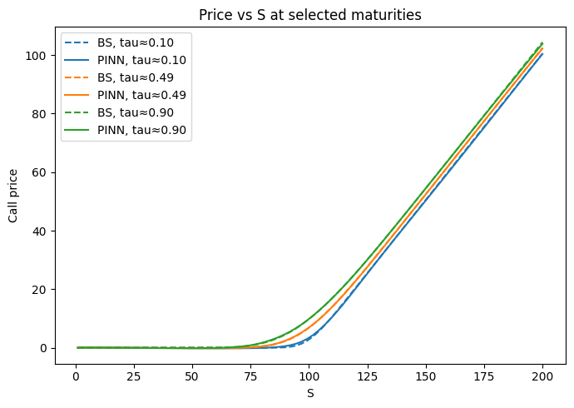
Fig. 5. Comparison of PINNTO and Black–Scholes call prices as a function of underlying price for selected maturities.
Fig. 5 shows PINNTO predictions and Black–Scholes prices on top of each other as functions of S for τ = 0.10, 0.49, and 0.90 years. Across all maturities, the solid PINN curves follow the dashed analytical references with very little difference. The model also correctly shows the time-value effect.

Out-of-Sample Hold-Out Evaluation
PINNTO is assessed using n = 5,000 hold-out points that are completely separate from the training data. Table 1 shows the quantitative metrics compared to the closed-form Black–Scholes price.
Table 1. PINNTO Out-of-Sample Performance Metrics (5,000 Hold-Out Points vs. Analytical Black–Scholes)
Metric | Value
MAE (Mean Absolute Error) | 0.1135
RMSE (Root Mean Square Error) | 0.1633
L∞ (Max Absolute Error) | 1.5028
R² Score | 0.999976
The R² value of 0.999976 shows that PINNTO and analytical prices are almost exactly the same. Table 2 breaks down MAE even more by moneyness region.
Table 2. Pricing Error by Moneyness Region (80×80 Grid)
Region | Condition | MAE | Max Error
Deep OTM | S/K < 0.80 | 0.0859 | 0.2352
ATM | 0.90 ≤ S/K ≤ 1.10 | 0.1645 | 2.0172
Deep ITM | S/K > 1.20 | 0.1205 | 0.7915
The ATM region has the most errors (MAE = 0.1645) because of peak curvature, while the Deep OTM region has the fewest errors (MAE = 0.0859), which is in line with the flat payoff structure in that area.

Comparison with Related Works
Table 3 benchmarks PINNTO against prior neural network methods for European call pricing on simulated data. To get the RMSE values for baseline methods, we use the formula RMSE = √MSE.
Table 3. Comparison with Prior Works (European Call, Simulated Data, Black–Scholes Framework)
Method | MAE | RMSE | R²
Standard ANN | — | ~0.300 | —
DGM | — | ~0.250 | —
PINN (Dhiman & Hu) | — | ~0.228 | ~1.000
PINNTO (Ours) | 0.1135 | 0.1633 | 0.999976
"—" denotes a metric not reported in the original work.
PINNTO has an RMSE of 0.1633, which is better than the Standard ANN (about 0.300), the DGM (about 0.250), and the PINN of Dhiman and Hu (about 0.228). In addition to accuracy, PINNTO uniquely combines SHAP-based explainability to check learned sensitivities against the Black–Scholes Greeks, which is not present in any of the other methods.

Explainability Analysis
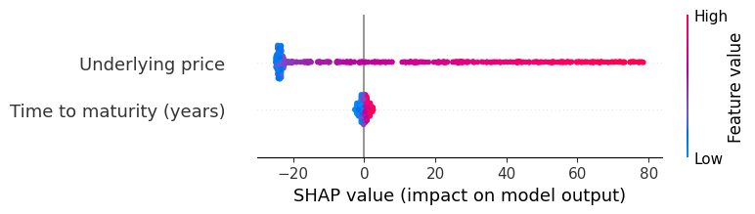
Fig. 6. SHAP summary plot showing relative feature importance for PINNTO predictions.
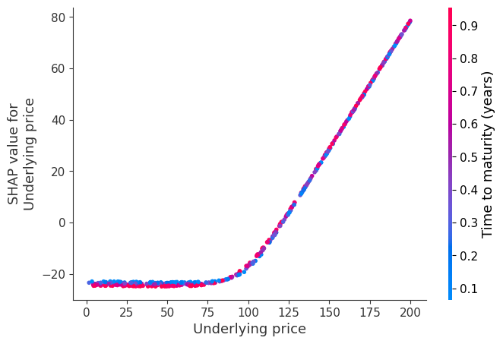
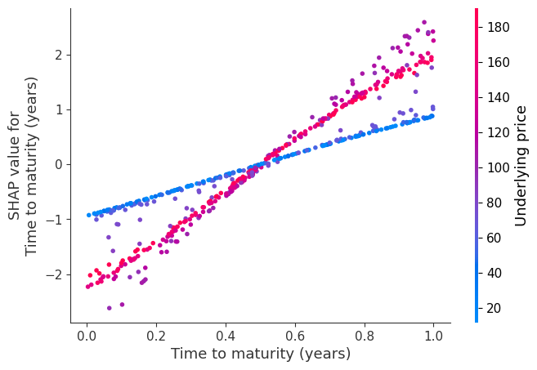
Fig. 7. SHAP dependence plot illustrating the effect of underlying price on predicted option values.
Fig. 8. SHAP dependence plot showing the influence of time to maturity on PINNTO predictions.
Fig. 6 confirms that underlying price is the dominant predictor, followed by time to maturity, consistent with Delta being the largest first-order Greek. Fig. 7 shows that SHAP depends on the spot price in a way that keeps going up, just like Delta. Positive and increasing SHAP values for τ are shown in Figure 8, these demonstrate the effect of Vega and Theta, which is a broadening distribution for terminal payoff within geometric Brownian motion theory. These sensitivities have naturally emerged from the physics-informed training process, which shows that the model has learned economic rational principles for option pricing without explicit enforcement.
References
[1] F. Black and M. Scholes, “The Pricing of Options and Corporate Liabilities,” Journal of Political Economy, vol. 81, no. 3, pp. 637–654, 1973.
[2] R. C. Merton, “Theory of Rational Option Pricing,” The Bell Journal of Economics and Management Science, vol. 4, no. 1, pp. 141–183, 1973.
[3] J. C. Hull, Options, Futures, and Other Derivatives, 10th ed. Pearson Education, 2018.
[4] J. C. Cox, S. A. Ross, and M. Rubinstein, “Option Pricing: A Simplified Approach,” Journal of Financial Economics, vol. 7, no. 3, pp. 229–263, 1979.
[5] P. Glasserman, Monte Carlo Methods in Financial Engineering. Springer, 2004.
[6] P. Wilmott, S. Howison, and J. Dewynne, The Mathematics of Financial Derivatives: A Student Introduction. Cambridge University Press, 1995.
[7] M. Raissi, P. Perdikaris, and G. E. Karniadakis, “Physics-Informed Neural Networks: A Deep Learning Framework for Solving Forward and Inverse Problems Involving Nonlinear PDEs,” Journal of Computational Physics, vol. 378, pp. 686–707, 2019.
[8] G. E. Karniadakis et al., “Physics-Informed Machine Learning,” Nature Reviews Physics, vol. 3, pp. 422–440, 2021.
[9] H. Dhiman and Y. Hu, “A Physics-Informed Neural Network for Option Pricing,” arXiv preprint arXiv:1909.13775, 2019.
[10] S. Wang, Y. Teng, and P. Perdikaris, “Understanding and Mitigating Gradient Flow Pathologies in Physics-Informed Neural Networks,” SIAM Journal on Scientific Computing, vol. 43, no. 5, pp. A3055–A3081, 2021.
[11] Y. Yang, M. Raissi, P. Perdikaris, and G. Karniadakis, “Adversarial Un certainty Quantification in Physics-Informed Neural Networks,” Journal of Computational Physics, vol. 394, pp. 136–161, 2019.
[12] A. Alonso, F. Alouges, and A. Bensoussan, “Physics-Informed Neural Networks for Option Pricing under Stochastic Volatility Models,” Quan titative Finance, vol. 21, no. 3, pp. 1–15, 2021.
[13] R. Seydel, Tools for Computational Finance. Springer, 2009.
[14] C. M. Bishop, Pattern Recognition and Machine Learning. Springer, 2006.
[15] S. M. Lundberg and S.-I. Lee, “A Unified Approach to Interpreting Model Predictions,” in Advances in Neural Information Processing Systems (NeurIPS), 2017.
[16] D. W. Apley and J. Zhu, “Visualizing the Effects of Predictor Variables in Black Box Supervised Learning Models,” Journal of the Royal Statistical Society: Series B, vol. 82, no. 4, pp. 1059–1086, 2020.
[17] M. Kliegr, S. Bahn´ ık, and M. F¨urnkranz, “Explainable Machine Learning in Financial Decision Making,” IEEE Intelligent Systems, vol. 36, no. 4, pp. 20–28, 2021.
[18] J. Sirignano and K. Spiliopoulos, “DGM: A Deep Learning Algorithm for Solving Partial Differential Equations,” Journal of Computational Physics, vol. 375, pp. 1339–1364, 2018.
[19] A. Ruf and P. Wang, “Neural Networks for Option Pricing and Hedging: A Literature Review,” Journal of Risk and Financial Management, vol. 13, no. 8, 2020

