

|  |
| --- |
|  |
| Assignment 1  Student ID: 301284284 |
| |  |  |  | | --- | --- | --- | | Ujjwal Poudel | 6/2/23 | Introduction to Database | |

**STUDENT ID: 301284284**

**STUDENT NAME: UJJWAL POUDEL**

**ASSIGNMENT-1:**

**Q. 1 Create Employee table as defined above. Ensure the Emp_name and EMP_emailid are not null.**

**SQL COMMAND:**

--Creating table

CREATE TABLE Employee

(

--using EMP_ID as primary key

EMP_id NUMBER PRIMARY KEY,

--not null: must provide value for this variable

EMP_name VARCHAR2(20) NOT NULL,

EMP_department VARCHAR2(20),

EMP_contactno NUMBER,

EMP_emailid VARCHAR2(20) NOT NULL,

EMP_salary NUMBER,

--CHECK constraint ensures the value must be either 'yes' or 'no'

EMP_ispermanent VARCHAR2(20) CHECK (EMP_ispermanent IN ('yes', 'no'))

);

**OUTPUT:**

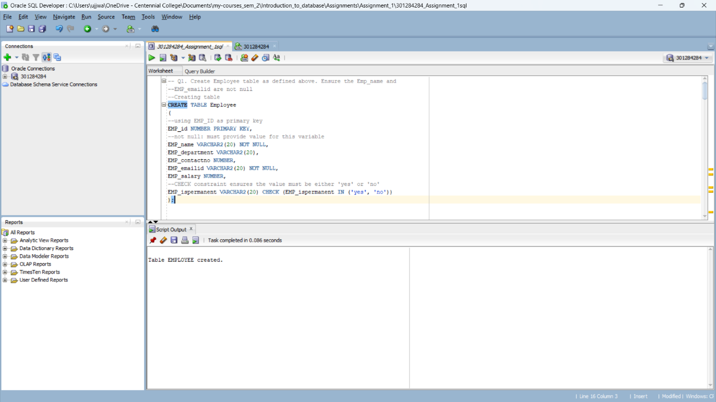

**Q. 2 Insert the second and third rows in one Insert command in the Employee table.**

**SQL COMMAND:**

INSERT ALL INTO

Employee(EMP_id, EMP_name, EMP_department, EMP_contactno, EMP_emailid, EMP_salary, EMP_ispermanent) VALUES (2, 'Emily', 'D-112', 7543129865, 'emily@example.com', 4817, 'yes')

Employee(EMP_id, EMP_name, EMP_department, EMP_contactno, EMP_emailid, EMP_salary, EMP_ispermanent) VALUES (3, 'Michael', 'D-111', 7865432190, 'michael@example.com', 5163, 'no')

**OUTPUT:**

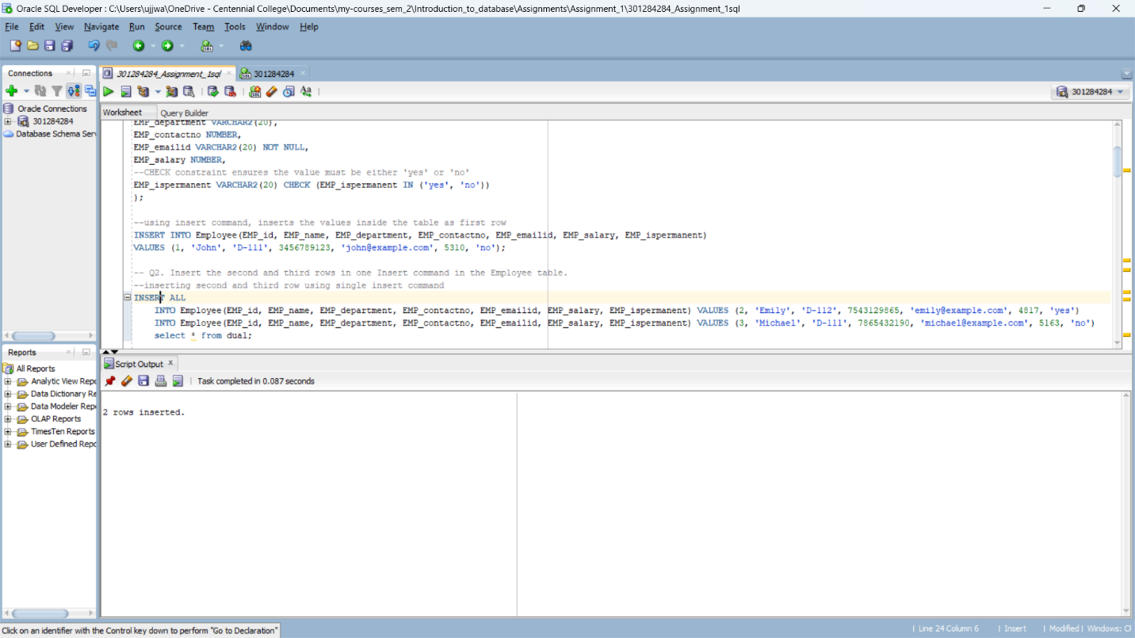

**Q. 3 Delete the row/s from the Employee table where the salary is more than 5000.**

**SQL COMMAND:**

DELETE FROM EMPLOYEE

WHERE EMP_salary > 5000;

**OUTPUT:**

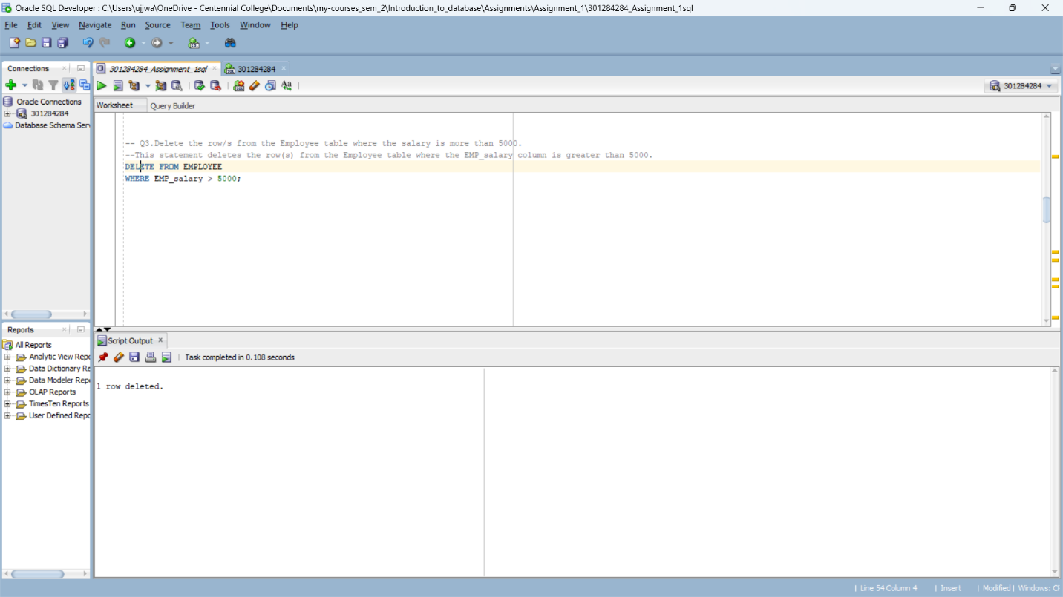

**Q. 4 Display the detail of the employee whose name starts with A and whose third character is d following any number of characters.**

**SQL COMMAND:**

SELECT * FROM Employee

WHERE EMP_name LIKE 'A_d%';

**OUTPUT:**

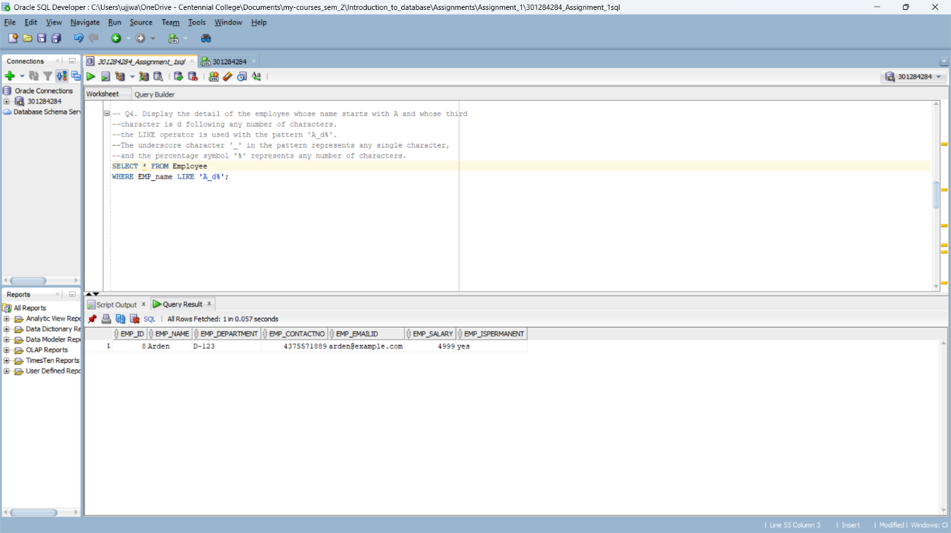

**Q. 5 Display the details of the employee who works either for department D-111 or D-112.**

**SQL COMMAND:**

SELECT * FROM Employee

WHERE EMP_department IN ('D-111', 'D-112');

**OUTPUT:**

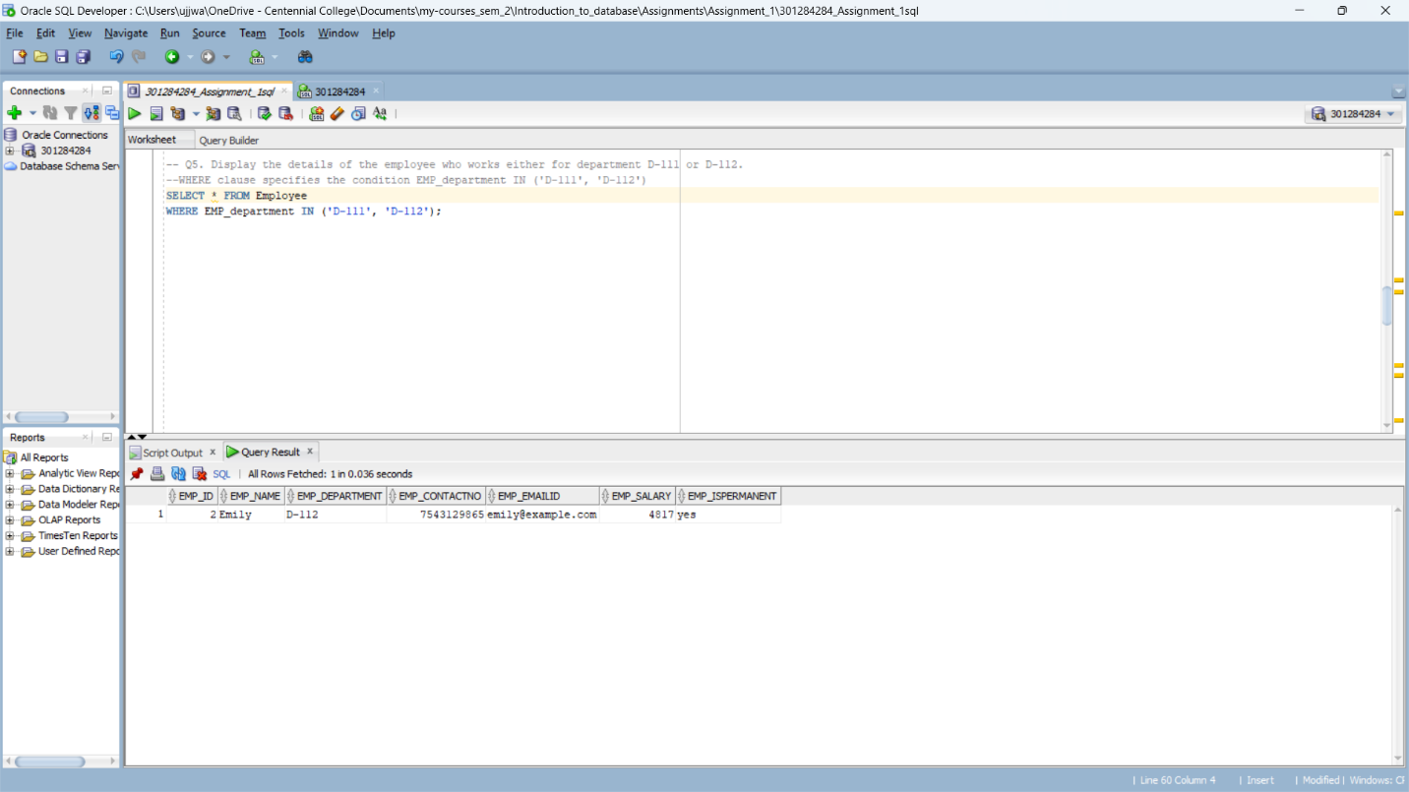

**Q. 6 Write an SQL command to display the detail of an employee whose email is in my.Centennialcollege.ca.**

**SQL COMMAND:**

SELECT * FROM Employee

WHERE EMP_emailid LIKE '%@my.centennialcollege.ca';

**OUTPUT:**

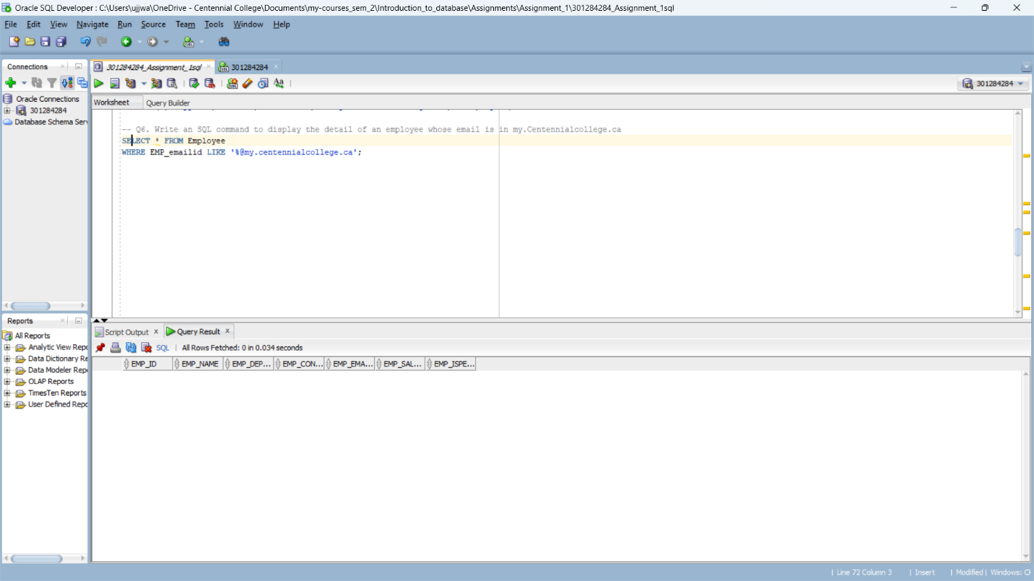

**Q. 7 How many permanent Employees take a salary more than 3000?**

**SQL COMMAND:**

SELECT * FROM Employee

WHERE EMP_ispermanent = 'yes' AND EMP_salary > 3000;

**OUTPUT:**

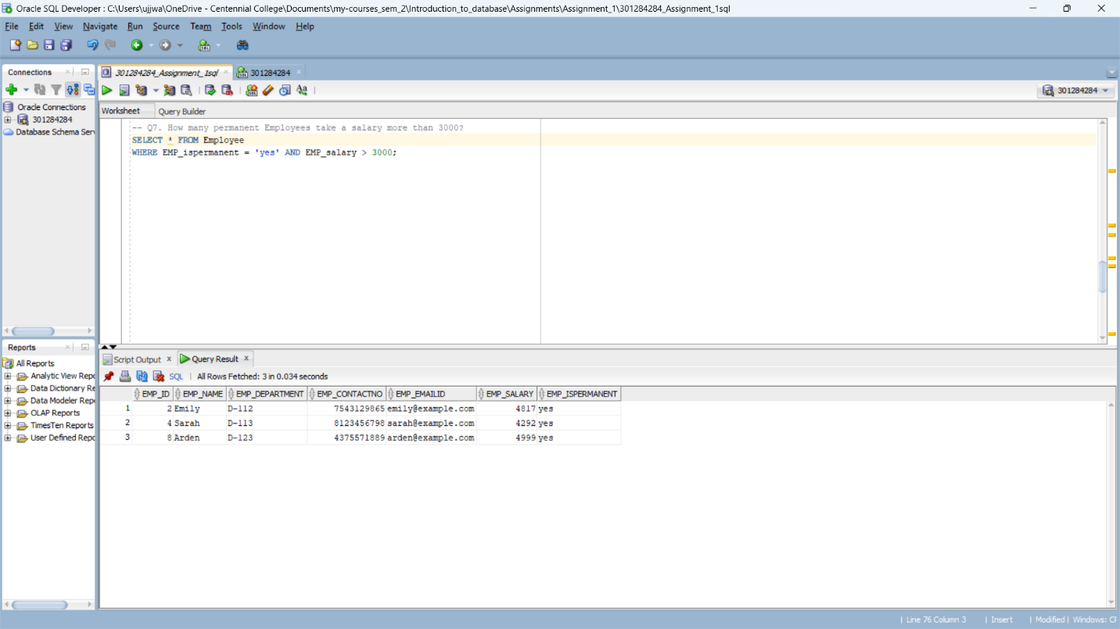

**Q. 8 What is the highest salary that is paid to permanent employees?**

**SQL COMMAND:**

SELECT MAX(EMP_salary)

FROM Employee

WHERE EMP_ispermanent = 'yes';

**OUTPUT:**

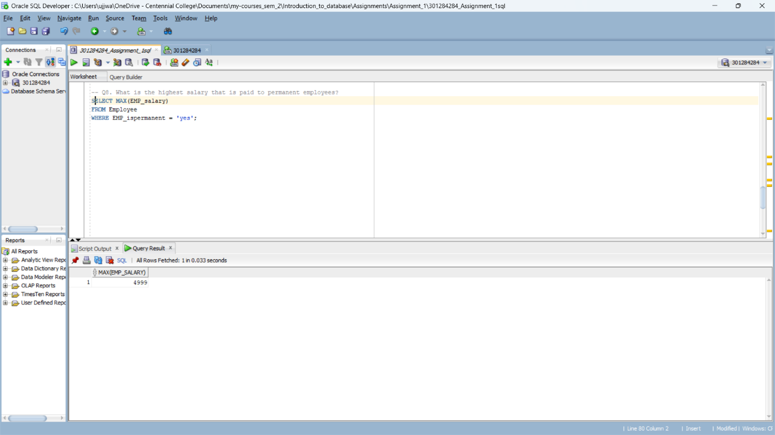

**Q. 9 Display the Employee name and Employee contact number of the Employee who works in department D-123.**

**SQL COMMAND:**

SELECT EMP_name, EMP_contactno

FROM Employee

WHERE EMP_department = 'D-123';

**OUTPUT:**

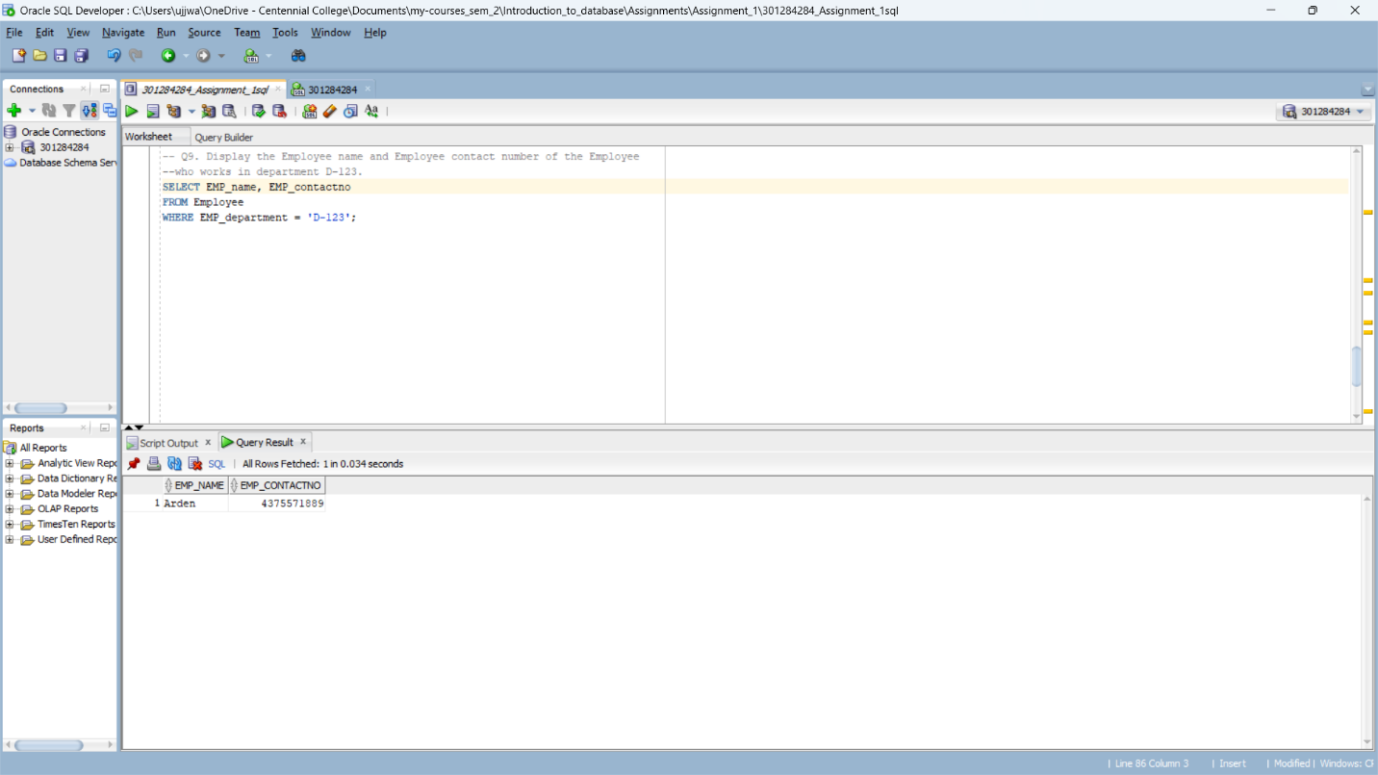

**Q. 10 How many distinct departments are in employee table?**

**SQL COMMAND:**

SELECT COUNT (DISTINCT EMP_department)

FROM Employee;

**OUTPUT:**

