|  |  |
| --- | --- |
|  | Software Engineering Requirements |
|  | Group Project |
|  | Ujjwal Poudel, Pham Name, Radmir Name  301284284, Pham student number, Radmir student number  6/2/23 |

**Table Of Contents:**

1. Introduction

1.1 Purpose

1.2 Document Conventions

1.3 Intended Audience and Reading Suggestions

1.4 Project Scope

1.5 References

2. Overall Description

2.1 Product Perspective

2.2 Product Features (Functions)

2.3 User Classes and Characteristics

2.4 Operating Environment

2.7 Assumptions and Dependencies

3. External Interface Requirements

3.1 User Interfaces

3.2 Hardware Interfaces

3.3 Software Interfaces

4. Stakeholder Register

5. Interview Questions

6. Functional Requirements List

7. Non-functional Requirements List

8. Use Cases

9. waiting on Pham

10. Use Case Diagram

**Section A: Introduction**

**1.1 Purpose:**

The purpose of this document is to specify the software requirements for the development of Fifty50, a mobile application designed to assist students living in group accommodations. Fifty50 aims to simplify expense management and promote effective coordination within student groups. By providing a platform for dividing expenses, organizing tasks, and facilitating communication, Fifty50 enhances the living experience for students in shared living arrangements.

**1.2 Document Conventions:**

This SRS follows standard typographical conventions with no specific fonts or highlighting that carry special significance. However, acronyms used throughout the document are defined and listed in the "Table of Acronyms" section for clarity and understanding. Additionally, the use case numbering in the document aligns with the first digit of the corresponding functional requirements to maintain consistency and ease of reference.

Table of Acronyms:

|  |  |
| --- | --- |
| **Acronym** | **Description** |
| SQL | Structured Query Language |
| DB | Database |
| API | Application Programming Interface |
| UI | User Interface |
| SRS | Software Requirements Specification |

**1.3 Intended Audience and Reading Suggestions:**

The intended audience for this document includes developers, project managers, testers, and documentation writers involved in the development of Fifty50. It is also relevant for marketing staff who may require an understanding of the application's features and objectives. End users, specifically students living in group accommodations, should also review this document to gain insights into the functionality and benefits of Fifty50.

**1.4 Project Scope:**

Fifty50 is a startup application focused on addressing the needs of students living in group accommodations. Initially, the application aims to provide features for expense management, task organization, and communication within student groups. However, Fifty50 has a broader vision for the future, with plans to expand its range of software offerings to cater to additional needs and challenges faced by students. The goal is to continually develop and provide innovative solutions that enhance the overall student experience. As a startup, Fifty50 is committed to growth and adapting to the evolving requirements of students, with the intention of delivering a comprehensive suite of software products to facilitate various aspects of student life.

**1.5 References:**

Certainly! Here are the references and websites used to research the project problem for Fifty50:

Splitwise: <https://www.splitwise.com/> - A popular expense-sharing application that provides features for splitting and managing group expenses.

Tricount: <https://www.tricount.com/en/> - A website and mobile application that helps users track and split expenses among groups.

The Balance: <https://www.thebalancemoney.com/best-bill-splitting-apps-4170968> - A website that offers financial advice and recommendations, including a list of the best bill-splitting apps.

Flutter: Flutter is the framework used for developing the Fifty50 application. The application will be developed using Flutter version 3.10.3 For more information about Flutter, you can refer to the official Flutter website: https://flutter.dev/.

Flutter Documentation: The official documentation for Flutter provides detailed information about the framework, its features, and how to use it. You can access the Flutter documentation at <https://docs.flutter.dev/>.

**Section B: Overall Description**

**2.1 Product Perspective:**

Fifty50 is a new, self-contained software application specifically designed to address the needs of students living in group accommodations. It is not a follow-on member of a product family, nor does it replace any existing systems. Fifty50 is an independent product that aims to provide a comprehensive solution for managing group expenses and coordinating day-to-day tasks among students.

**2.2 Product Features (Functions):**

The main features of Fifty50 include:

Expense Tracking and Splitting: Users can enter and track shared expenses, allocate costs among group members, and calculate individual shares.

Task Organization and Assignment: Users can create and assign tasks within the group, set deadlines, and track task completion status.

Push Notification Reminders: The application will send push notifications to users as reminders for pending tasks, upcoming deadlines, and unsettled expenses.

Grocery List and Budget Allocation: Users can create and manage a shared grocery list, track expenses related to groceries, and allocate budgets for different expense categories.

Building Responsibilities: The application allows users to assign and manage shared responsibilities related to building maintenance and chores within the group.

Communication and Messaging: Users can communicate and share updates, reminders, and messages within the group through the application.

These features provide a high-level summary of the main functionalities of Fifty50. More detailed descriptions and specifications will be provided in Section 3 of the SRS document.

**2.3 User Classes and Characteristics:**

The anticipated user classes for Fifty50 include:

Students in Groups: Students living in group accommodations, such as shared apartments or dormitories, who need to manage shared expenses, track individual contributions, and coordinate financial matters within their group.

Families: Families or households who want to track and manage their budget collectively. This includes parents, children, or other family members who are involved in financial planning and expense management.

Individuals: Individuals who want to track and manage their personal budget and expenses. This user class includes single individuals, working professionals, or anyone who seeks a tool to monitor their financial activities and stay organized.

Each user class has distinct characteristics and requirements, and Fifty50 aims to cater to their specific needs for efficient expense management and budget tracking.

**2.4 Operating Environment:**

The Fifty50 application will operate in the following environment:

Hardware Platform: The application will be available for smartphones and tablets, specifically targeting iOS and Android devices. Users will be able to access and utilize Fifty50 through their mobile devices.

Operating Systems: Fifty50 will be compatible with iOS and Android operating systems. Users with devices running iOS and Android will be able to install and use the application.

Database: The application will utilize Firestore, a NoSQL document database provided by Google. Firestore will be used to store and manage user data, expense records, task information, and other relevant information required for the functionality of Fifty50.

Web Browsers: Since Fifty50 is designed as a mobile application for smartphones and tablets, it will not have web browser compatibility. Users will access and interact with the application through dedicated iOS and Android apps, rather than through web browsers.

Mobile Platforms: Fifty50 will be available as a mobile application on the iOS App Store for iOS devices (such as iPhones and iPads) and on the Google Play Store for Android devices. Users can download and install the respective app based on their device's operating system.

Please note that the operating environment described above is specifically tailored for mobile devices (iOS and Android) and utilizes Fire store as the database.

**2.7 Assumptions and Dependencies:**

Development of the Fifty50 application will be done using the Flutter framework.

The initial version of the application will be in alpha stage, with subsequent beta versions to accommodate increasing user capacity.

A free database solution will be used during the alpha stage.

In the beta stage, the application will be scaled to handle at least 1000 users.

Upon the official launch, a robust server infrastructure will be implemented to support a larger user base.

**Section C: External Interface Requirements**

**3.1 User Interfaces:**

Fifty50 will provide a mobile interface developed using the Flutter framework. The application will be available for iOS and Android platforms, allowing users to access the features and functionalities of the app seamlessly.

**3.2 Hardware Interfaces:**

Fifty50 primarily operates as a software application and does not have direct hardware interfaces. However, it may utilize device hardware capabilities such as the camera or GPS for certain features.

**3.3 Software Interfaces:**

No specific software interfaces are mentioned currently. However, as the development progresses, there may be a need for integration with third-party services or APIs for features like calendar synchronization, payment processing, or OCR functionality.

**3.4 Use Cases**

|  |  |  |  |
| --- | --- | --- | --- |
| Use Case name | List of related Requirements ID | Actor (s) | Brief Description |
| Create Group Expense | FR01, FR02 | User Coordinator (Operational Stakeholder) | The User Coordinator initiates the process of creating a new group expense within Fifty50. They will enter expense details, such as the expense name, total cost, and a list of group members who participated in the expense. The system will automatically calculate individual shares and notify all group members about the new expense. |
| View Expense Report | FR06 | Financial Analyst (Operational Stakeholder), Management (Operational Stakeholder) | The Financial Analyst and Management can access an expense report feature, allowing them to view comprehensive reports based on user data. They can customize the report parameters, apply filters, and view aggregated expense data for analysis and decision-making. |
| Expense Limit Notification | NFR09 | Financial Analyst (Operational Stakeholder), Student (Operational Stakeholder) | The system monitors expenses against predefined limits set by the Financial Analyst. If a student's expenses exceed the limit, the system will trigger a color notification to alert the student. Different colors indicate different levels of exceeding the limits. |
| Predict Future Expenses | FR07 | Financial Analyst (Operational Stakeholder) | The Financial Analyst can access the future expense predictor feature, which analyzes past expenses and trends to forecast future expenses. The predictions and insights provided will aid in financial planning and budget allocation. |
| Assign Task | FR04, FR08 | Team Lead (Operational Stakeholder), Student (Operational Stakeholder) | A Team Lead can create and assign tasks to specific students within the group. They will set the task description, due date, and assign it to one or multiple students. Students will receive notifications about the assigned task and can mark it as done through checkboxes or voting. |
| Push Notification Reminders | FR05 | Student (Operational Stakeholder) | The system sends push notifications to students as reminders for pending tasks, upcoming deadlines, and unsettled expenses. The push notifications are delivered to their mobile devices. |
| Communication and Messaging | N/A | Team Lead (Operational Stakeholder), Student (Operational Stakeholder) | Users can communicate and share updates, reminders, and messages within the group through the application. This feature facilitates effective collaboration and coordination among group members. |
| View Group Tasks | FR04 | Team Lead (Operational Stakeholder), Student (Operational Stakeholder) | Both Team Leads and Students can view the list of group tasks, their descriptions, due dates, and progress statuses. This helps in staying organized and updated about ongoing tasks. |
| Log into the System | N/A | User (Operational Stakeholder) | The User, either a student or an operational stakeholder, logs into the Fifty50 system using their registered credentials, which may include Google or Facebook accounts. Upon successful authentication, the system grants access to the user's respective profile and functionalities. |

**Appendix C: Stakeholder Register:**

|  |  |  |  |  |  |
| --- | --- | --- | --- | --- | --- |
| **Stakeholder Name** | **Stakeholder Position** | **External/Internal** | **Stakeholder Contact Details** | **Operational/Executive** | **Interest** |
| Jharana  Ranabhat | End User | External | j.ranabhat@gmail.com | Executive | High |
| Nabin Dahal | Programmer | Internal | Ndahal2060@gmail.com | Executive | Medium |
| Ujjwal Poudel | Programmer | Internal | Ujjwalpoudel010@gmail.com | Executive | Medium |
| Aditya Pradhan | UI/UX Designer | Internal | Aadupradhan123@gmail.com | Executive | Medium |
| Aaryan Khatri | Database Expert | Internal | Khatriaryan2001@gmai.com | Executive | Medium |

**Appendix D: Interview Questions**

|  |  |  |
| --- | --- | --- |
| Interview Questions | | |
| Question | Stakeholder Position | Answer |
| Are there any specific reasons why you currently ship products only to Canada? Are there any plans to expand to other continents or countries in the future? | Marketing Officer | Currently, our focus is on launching the first version of the application in Canada. However, if we receive more users and secure investor support, we are open to expanding our services worldwide in the future. |
| Can you provide more details about the specific times during the day when you would access the service? Are there any peak usage periods or preferred time slots? | Customer | As a customer, I would access the service provided by the new product at various times throughout the day. The service should be available 24/7 to cater to different schedules and preferences. |
| Can you share any specific requirements or preferences regarding the type of database used? Are there any specific features or capabilities that are important for your company? | Database Administrator | For our company, we have chosen to use Firestore as the database for the application. It offers the necessary features and capabilities to support our requirements. |
| Are you open to receiving external funding for the development and growth of the application? If yes, what are the potential areas or features that you would prioritize with additional funding? | Investor | As of now, the application is not funded by stakeholders. However, we are open to considering external funding opportunities. With additional funding, we would prioritize enhancing user experience, expanding the user base, and investing in marketing efforts to promote the application's adoption. |
| How do you envision the user interface and overall user experience of the application? Are there any specific design principles or preferences that should be taken into consideration? | User Experience Designer | As a user experience designer, I aim to create an intuitive and user-friendly interface for the application. It would be helpful to understand any specific design principles or preferences that stakeholders have in mind to ensure the design aligns with their vision and meets the expectations of the target users. |

**Section D: Functional Requirements**

|  |  |  |  |  |
| --- | --- | --- | --- | --- |
| Requirement ID | Requirement Title | Description | Priority | Requester |
| FR01 | Alerts | The system should give the student a mobile notification/alert when the advisor is ready to see them. | Expected | Student |
| FR02 | User Authentication | The system should incorporate Google and Facebook sign-in options for user authentication, providing users with the ability to log in using their existing social media accounts. | High | Security Officer |
| FR03 | Profile Management | Users should be able to switch between different expense groups, such as personal, home, college, and custom, within their profiles. This allows them to manage their expenses separately for each group. | Low | End Users |
| FR04 | Task Creation | Users should be able to create and manage tasks within the system. They should be able to set task deadlines, assign tasks to other users, and track task progress. The system should also include an emergency request feature for urgent purchases of items such as groceries. | Medium | Team Leads |
| FR05 | Notifications | The system should send notifications to users for important updates, such as new messages, task assignments, or upcoming deadlines. | High | Project Manager |
| FR06 | Reporting | The system should generate reports based on user data and provide options for customizing report parameters, such as date range, filters, and data aggregation. | Medium | Management |
| FR07 | Future Expense Predictor | The system should analyze past expenses and predict future expenses based on trends and patterns. It should provide users with insights and forecasts to help them plan their budgets effectively. | High | Financial Analyst |
| FR08 | Checkbox/Voting Messaging | The system should provide a messaging system with checkbox or voting functionality for task management. Users can mark tasks as done using checkboxes or use voting to indicate task progress. | High | Team Leads |
| FR09 | Expense Limit Notifications | The system should implement a color notification system to alert users when their expenses exceed predefined limits. Different colors can be used to indicate various levels of exceeding the limits. | Medium | Financial Analyst |
| FR10 | Add/Invite Members | The system should have functionality to add or invite members to expense groups. This allows users to collaborate and share expenses within specific groups. | Medium | End Users |

**Section E: Non-Functional Requirements (NFR)**

|  |  |  |  |  |
| --- | --- | --- | --- | --- |
| Requirement ID | Requirement Title | Description | Priority | Requester |
| NFR01 | Performance | The system should demonstrate optimal performance by providing fast response times, quick data retrieval, and efficient processing of user requests. | High | System Administrator |
| NFR02 | Scalability | The system should be designed to scale effectively to accommodate increased user load and growing data volumes. | Medium | System Administrator |
| NFR03 | Usability | The system should be designed with a user-friendly interface and intuitive navigation to enhance user experience and ease of use. | High | UI/UX Designer |
| NFR04 | Security | The system should implement robust security measures, including data encryption, access control, and protection against unauthorized access or data breaches. | High | Security Officer |
| NFR05 | Reliability | The system should be reliable, ensuring minimal downtime and data loss, and providing backup and recovery mechanisms to safeguard user data. | Medium | IT Department |
| NFR06 | Accessibility | The system should comply with accessibility standards, ensuring that users with disabilities can effectively access and use the application. | Medium | Accessibility Officer |

**USE CASE NAME:**

Predict Future Expenses

**PRIMARY ACTOR:**

App’s User

**GOAL IN CONTEXT:**

To view the future cost forecast

**PRECONDITIONS:**

The user must have a valid account and log in to the system successfully.

**TRIGGER:**

The App’s user decides to see the predicted future expense when they need to make a financial plan.

**SCENARIO**:

1. The user logs onto the app/website of Fifty50.

2. The user starts to fill up the UserID’s information.

3. The user continues to fill up the password information.

4. The Fifty50’s system will display all the feature buttons.

5. The user chooses the “ Predict Future Expenses” feature.

6. The system will display all the necessary statistical information that is needed to be filled up.

7. The user fills up all the necessary statistical information and then submits it.

8. The system starts to calculate the statistical information.

9. The system displays the result that shows the predict future expense.

**EXCEPTION:**

1. UserID or password are incorrect or not recognized.

2. Choosing the wrong feature to calculate the expense.

3. The filled statistic is not correct.( filling word instead of number).

**PRIORITY:** High

**FREQUENCY OF USE**: frequent

**CHANNEL TO ACTOR:**

Via PC-based browser or mobile app and Internet connection

**SECONDARY ACTORS:**

Financial analyst.

**CHANNELS TO SECONDARY ACTORS:**

Financial analyst system, PC -based system, mobile phone system.

**SWIMLANE DIAGRAM:**

**Use Case Diagram**

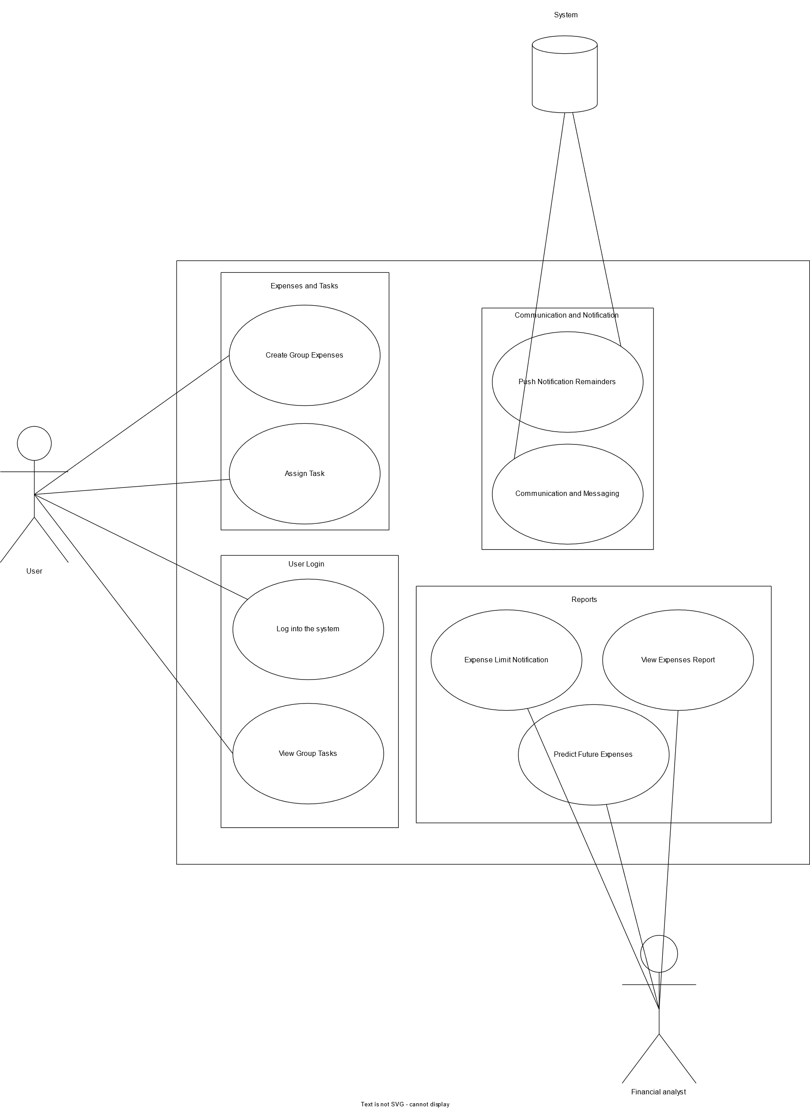

**Appendix E: Class Diagrams**

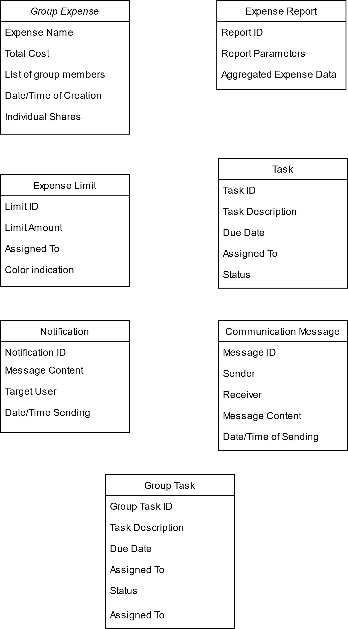

**CRC Diagram:**

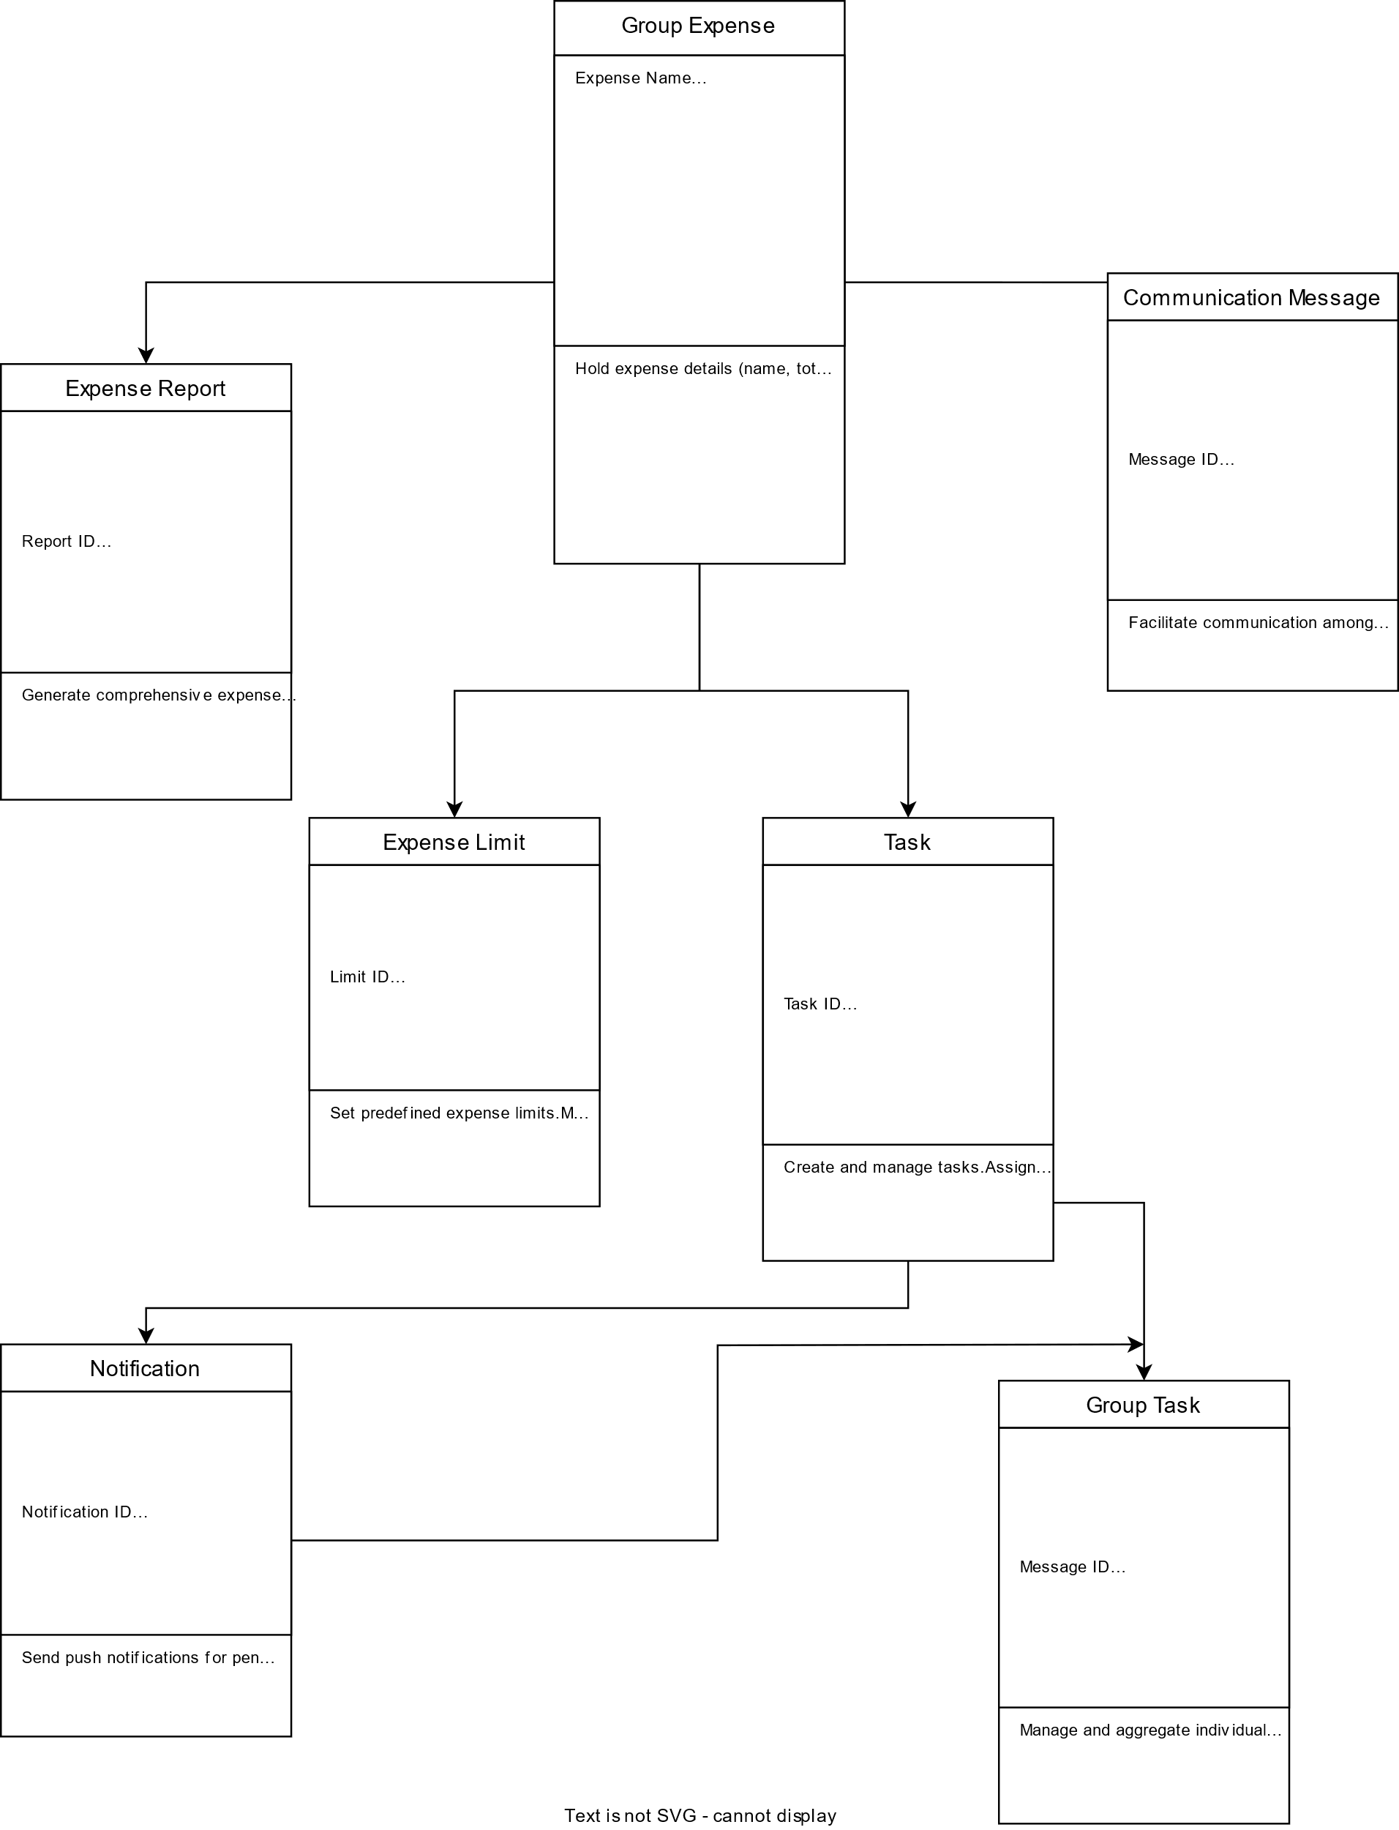

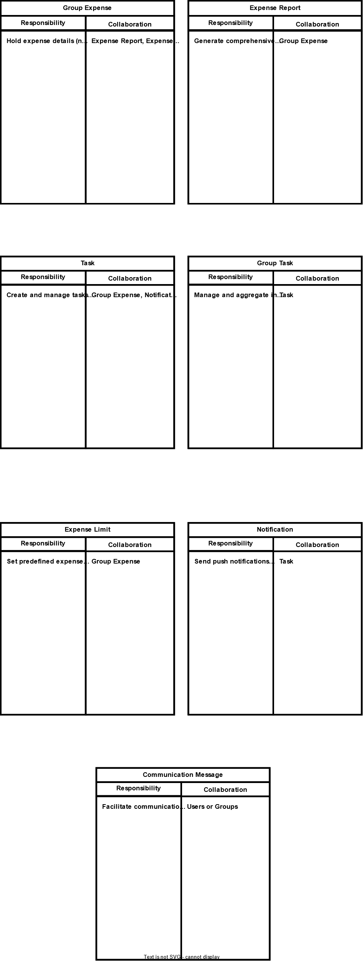

**Index Cards**