**CENTENNIAL COLLEGE**

**COMP 301: UNIX/LINUX OPERATING SYSTEMS**

**Assignment#4**

**STUDENT NAME: Ujjwal Poudel ID: 301284284**

**Questions:**

1. CAR APP - Display of cars. Write a script to display the menu of cars. If you choose Mercedes Benz or BMW, then your APP has to display “I like **German** cars”, Toyota/Honda, then “I like **Japan** cars”, Kia/Hyundai - “I like **Korean** cars”, Ford/Jeep then “I like **American** cars”, Chery/Great wall then “I like **China** cars”. Use any construct/loop.

OUTPUT:

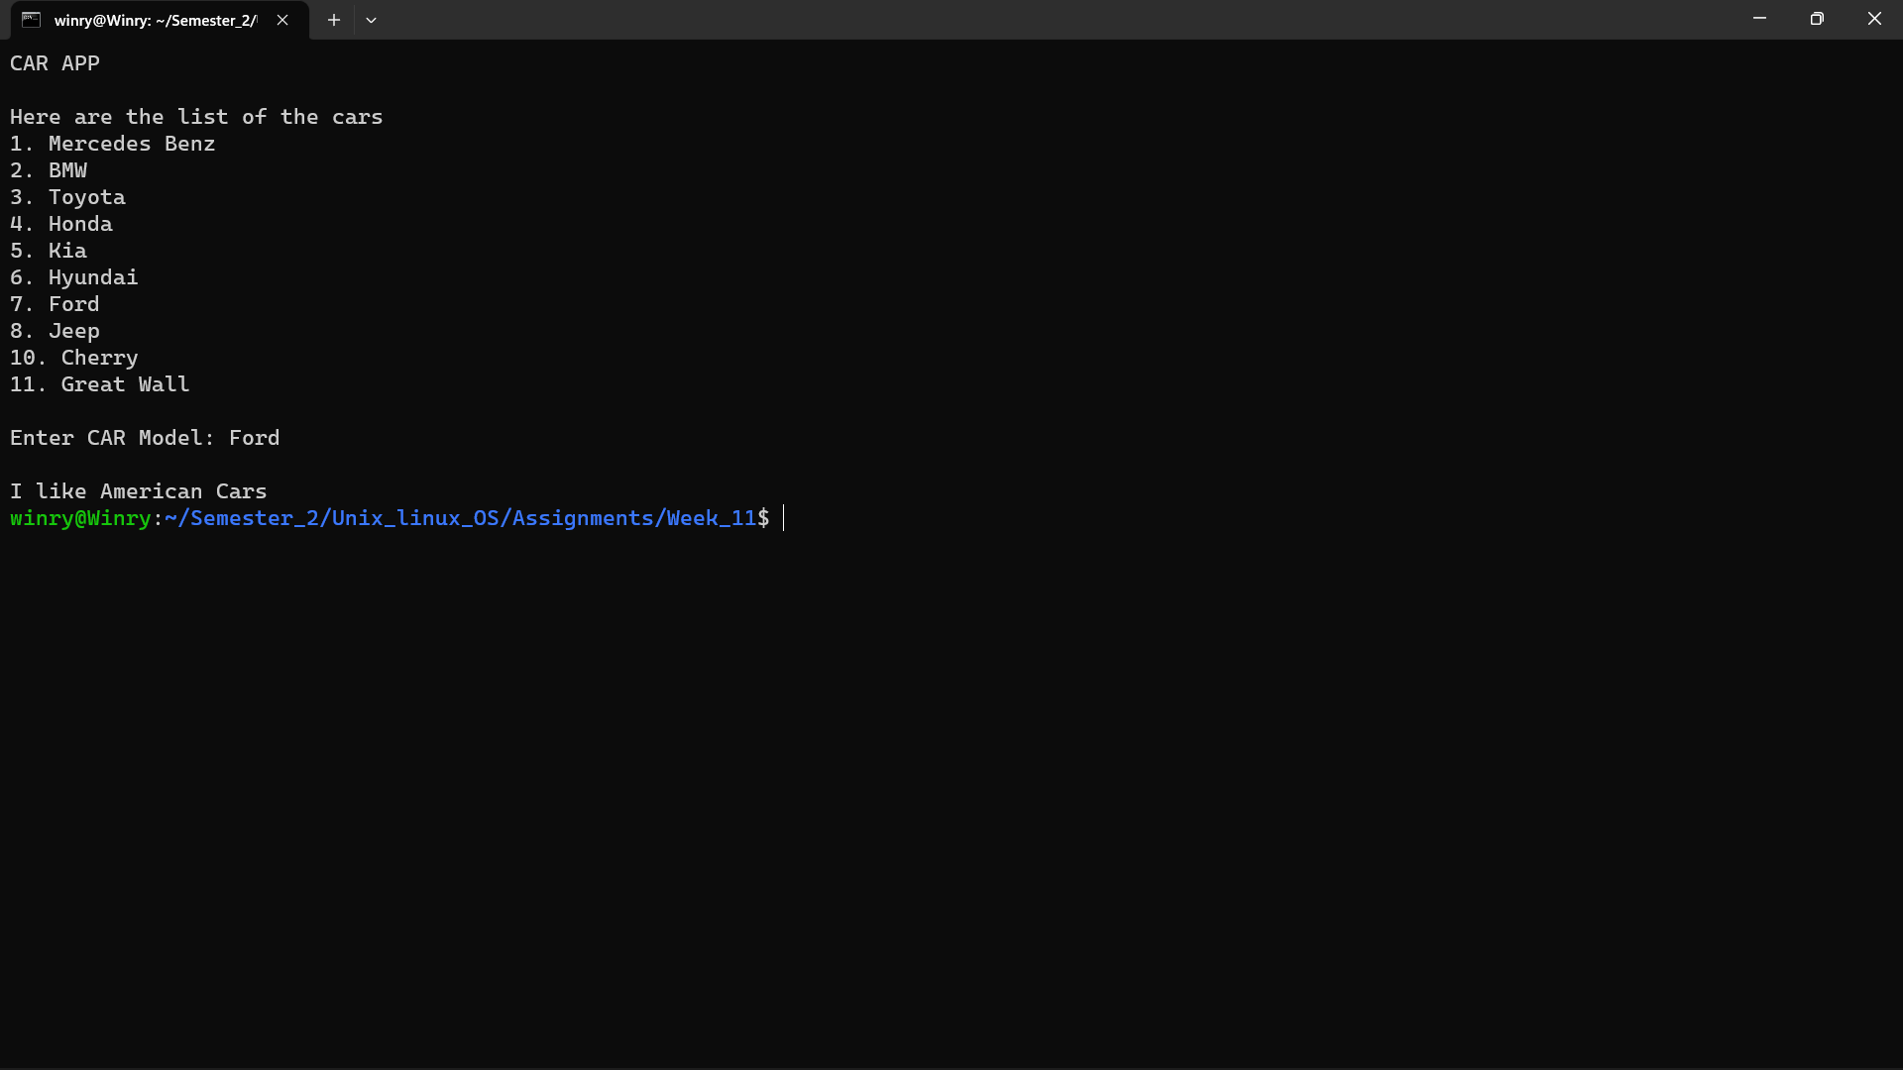

SCRIPT:

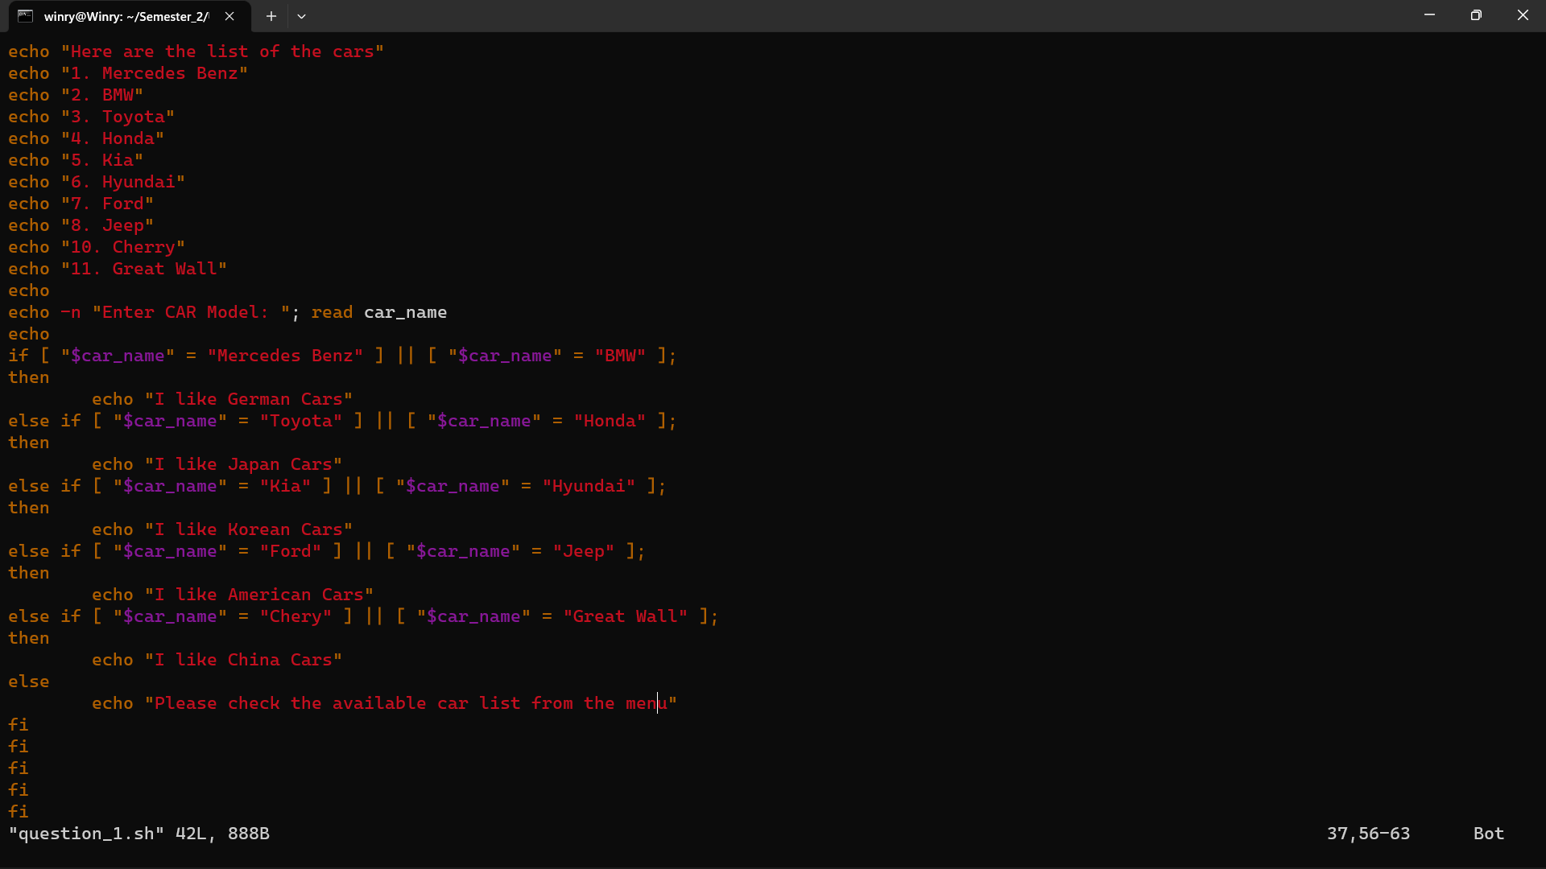

1. Write the shell script to input the electricity unit charge and calculate the total electricity bill according to the given condition:

For first 50 units CAD 0.75/unit

For next 100 units CAD 1.20/unit

For next 100 units CAD 1.50/unit

For unit above 250 CAD 1.75/unit

An additional surcharge of 25% is added to the bill.

OUTPUT:  
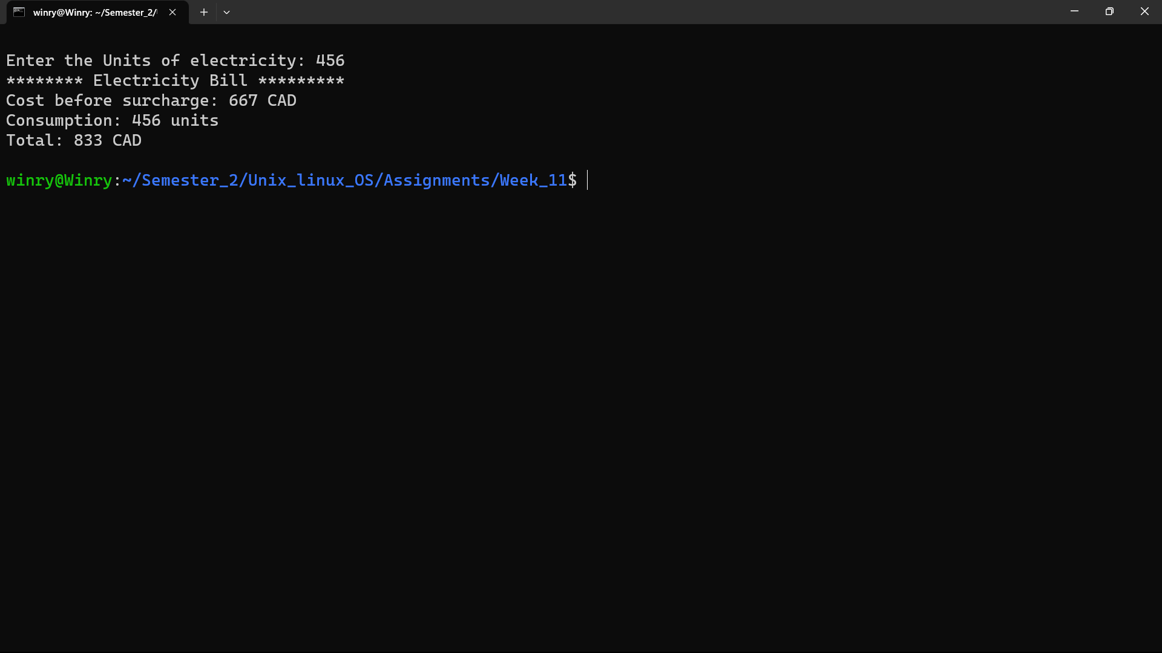SCIRPT:  
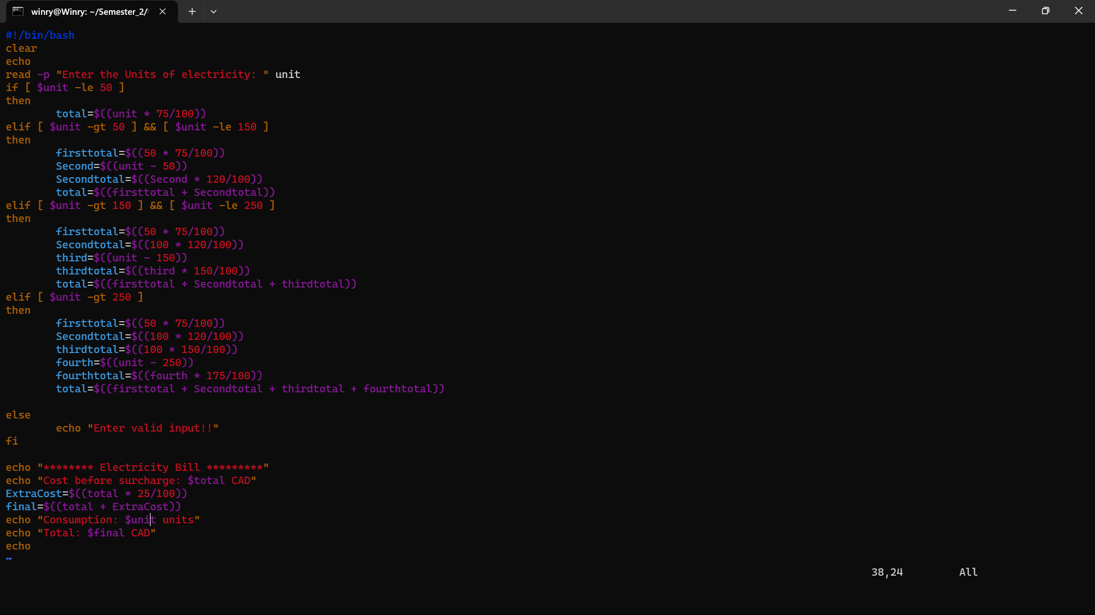

3. Write a shell script to find the output of the following geometric shapes.

Please enter your choice (1 or 2 or 3 , 4 to Exit):

1. Area and perimeter of the trapezoid
2. Circumference and Area of the circle
3. Volume and Area of the sphere
4. Exit

SCRIPT:

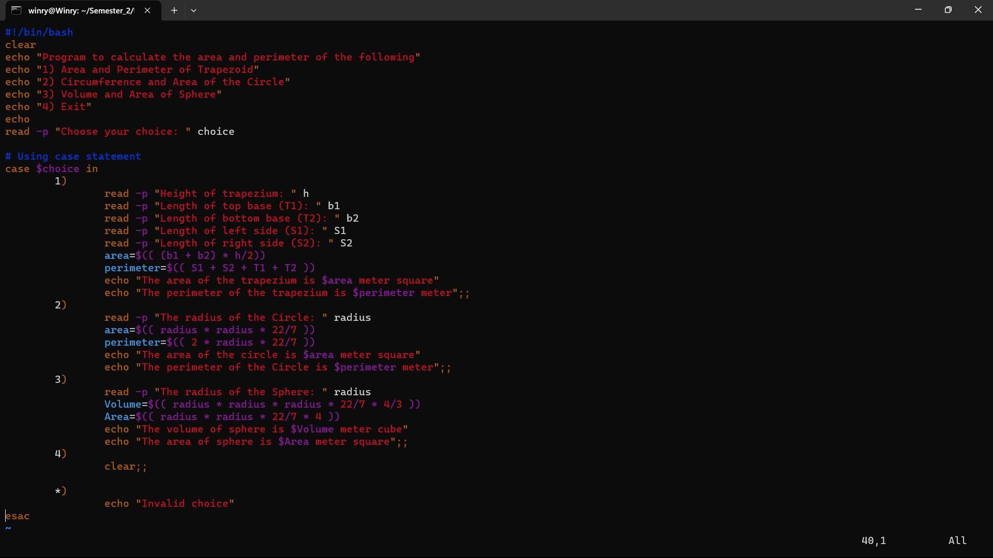

OUTPUT:

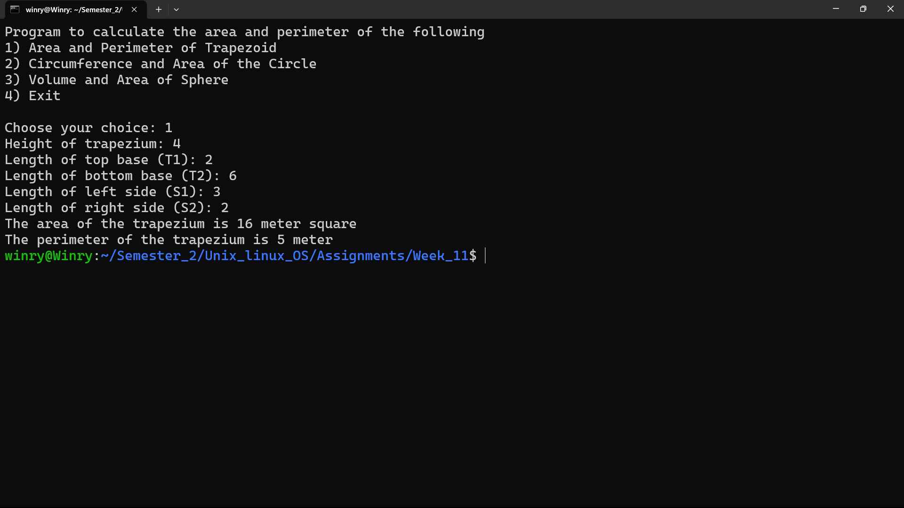

1. Write a shell script to develop an app for the Toronto bank which has the proposal to offer loans to the customers, you are the software engineer of the bank and you are assigned the job to execute the following tasks. Refer to the credit score table for the loan interest rate to be applied per year:

(Note: The loan amount should be greater than $5000 and interest calculated per year)

1. Input the customer_name, credit score and the loan_amount
2. Check at the credit score value to print the interest rate. (For ex, If the credit score is 800, the output has to show excellent, the interest rate for your loan amount is 8.5%)
3. Print the loan amount that the customer will receive after applying the interest rate

based on the credit score (refer to the table).

1. The interest and tax should be **calculated per year** (12 months)
2. Print the interest to be **paid each month and also after three years** by the customer.

**Loan interest rates by credit score (Table):**

| **Credit score** | **Interest rate** |
| --- | --- |
| 760-900 (excellent) | 8.5% |
| 725-759 (very good) | 7.3% |
| 660-724 (good) | 6.4% |
| 560 – 659 (fair) | 5.1% |
| 300 – 559 (poor) | 4% |

.

SCRIPT:   
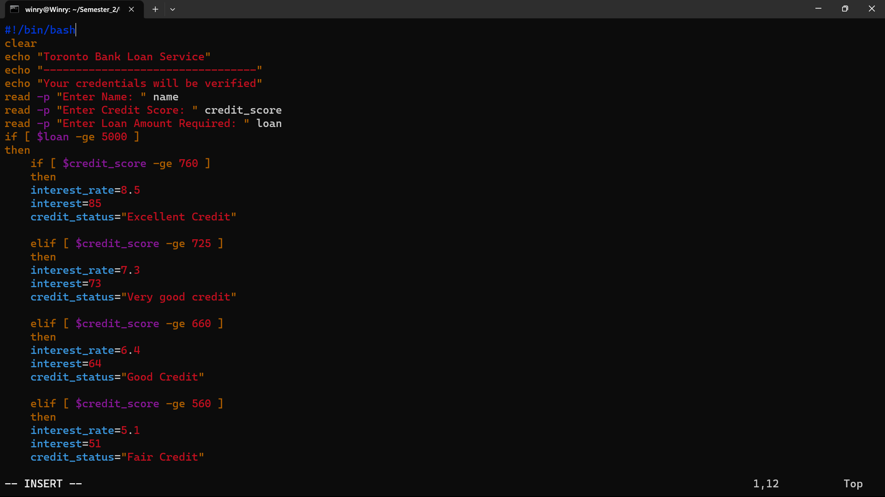

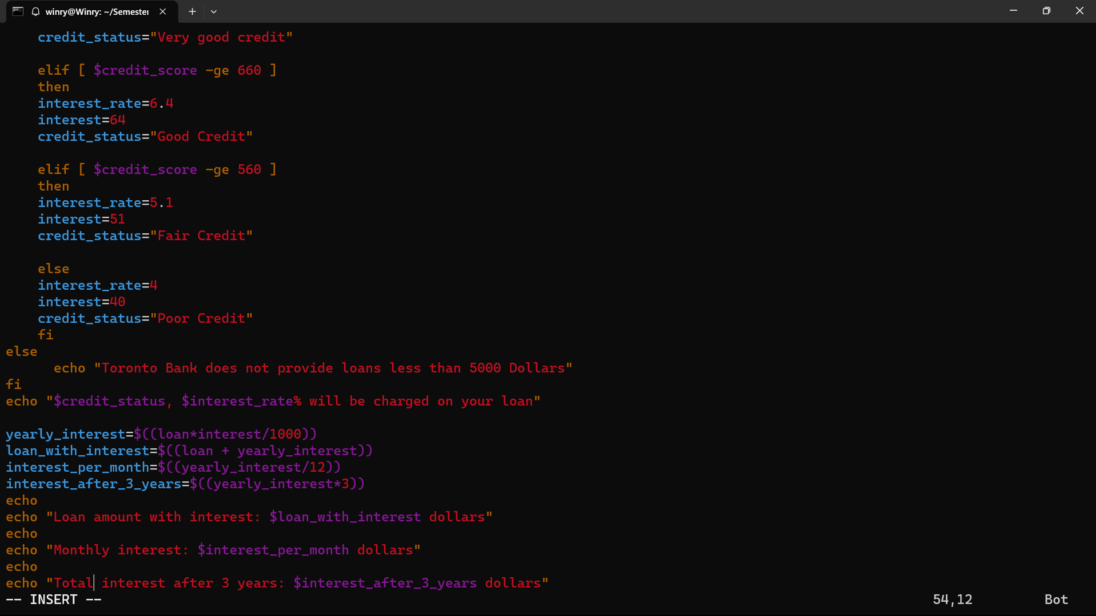

OUTPUT:

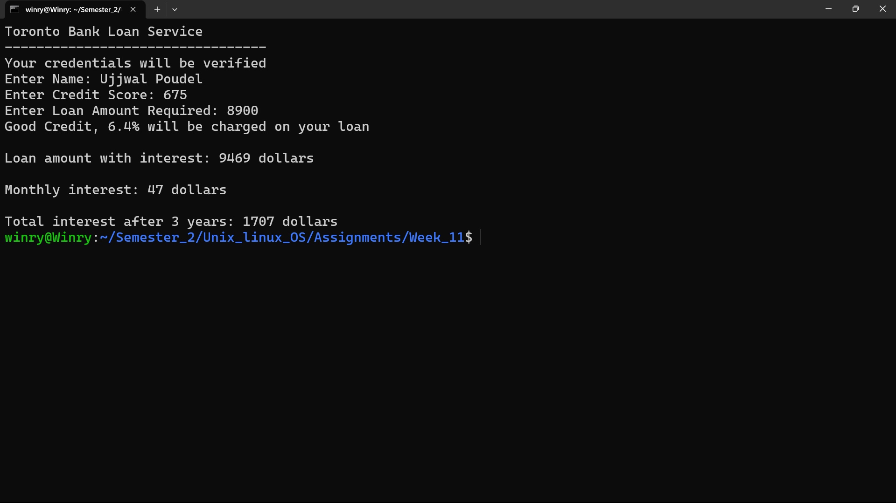

1. Write a shell script program to calculate the net pay (monthly salary) of an employee who works in an IT company called Centrum Software’s, Toronto, considering the allowances (TA, DA, HRA) and deductions (Harmonized sales tax – HST), (Retail Sales tax- RST). Give the basic pay as user defined input.

**(Gross pay** is your total pay before taxes and deductions, while **net pay** is your “take-home pay” or what’s left after payroll taxes and other deductions are taken out.0

Net pay calculation: **Salary = Basic pay + Allowances – (Taxes, Deductions)**

1. TA = 15% of basic pay
2. DA = 2% of basic pay
3. HRA = 10% of basic pay
4. HST = 10%
5. RST = 5%

#### Print the Company name, Employee name, Taxes, allowances, gross pay and the net pay.

SCRIPT:

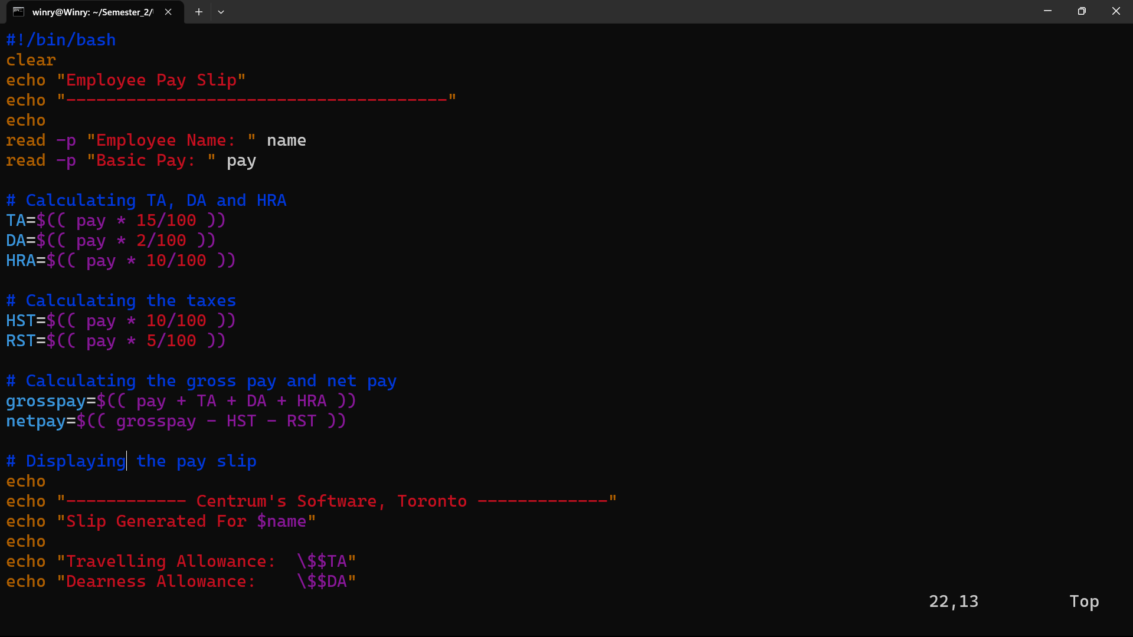

# 

# OUTPUT:

