CENTENNIAL COLLEGE
COMP 301: UNIX/LINUX OPERATING SYSTEMS
Assignment#3
STUDENT NAME: Ujjwal Poudel ID: 301284284

QUESTIONS:

1. Create a shell script to display your first name, last name, enrollment ID, the program and the courses you study in this semester. Use the correct variables to display the variables to the standard output (screen).

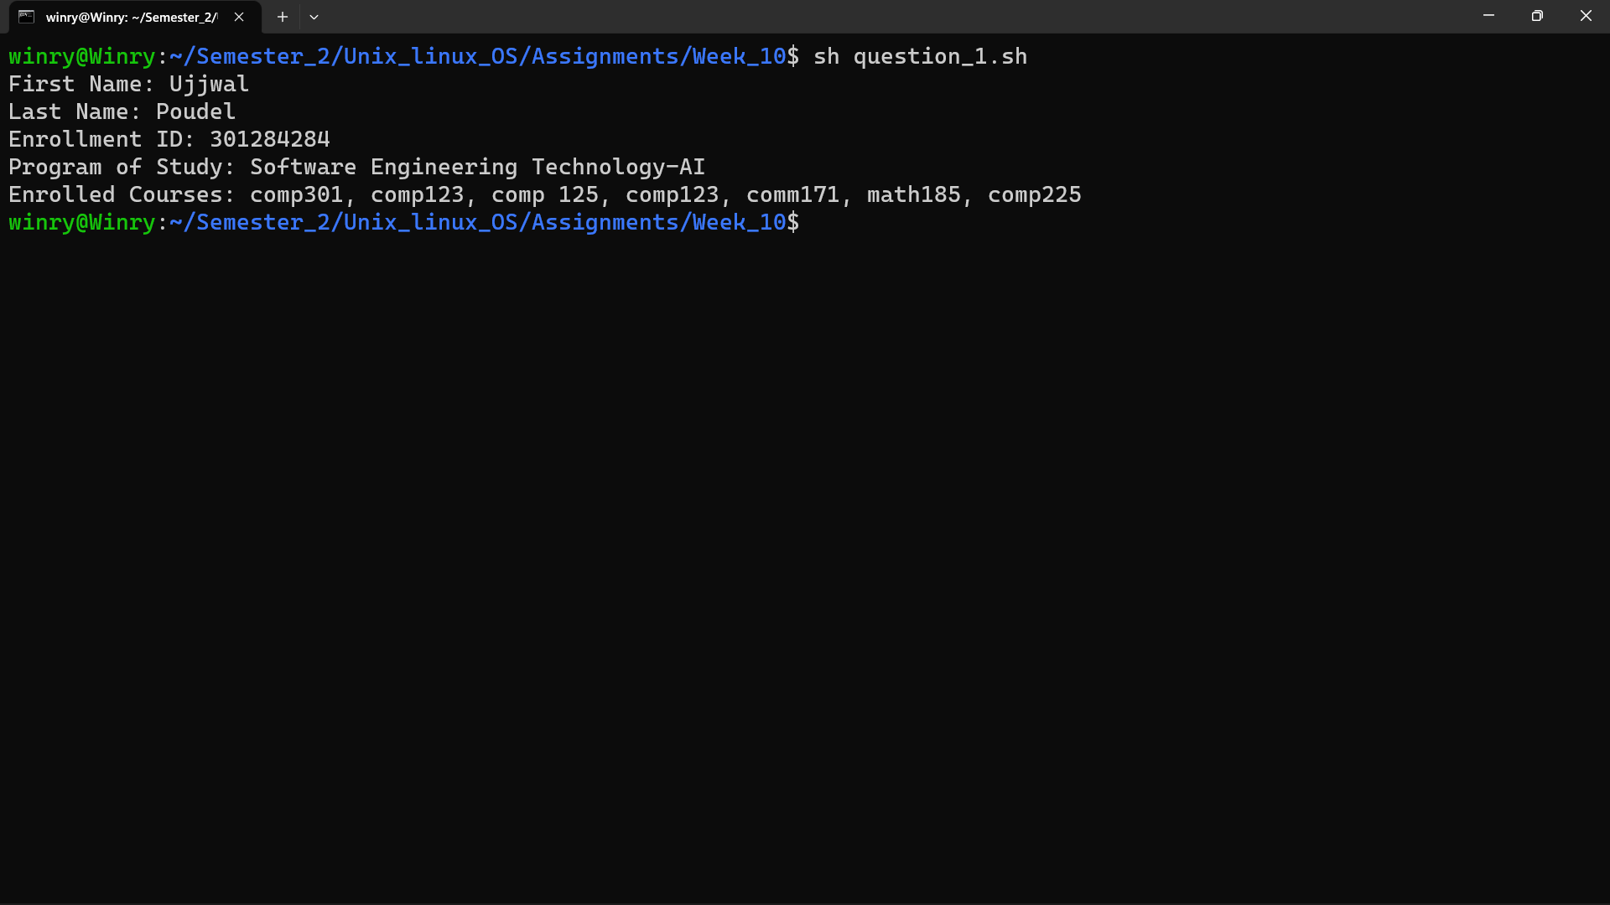

2. Automate following tasks using bash scripting:
- Display the files with its access permissions
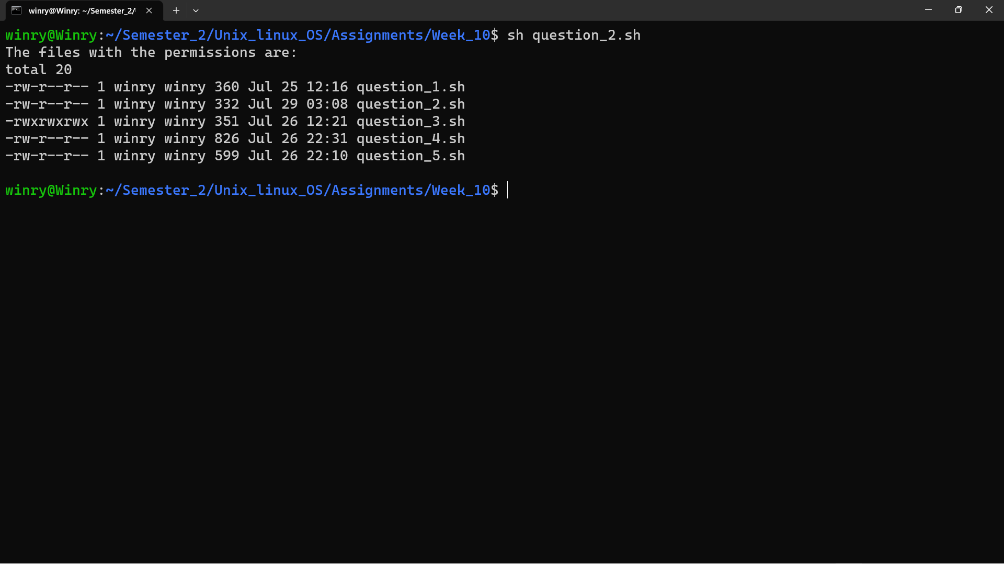
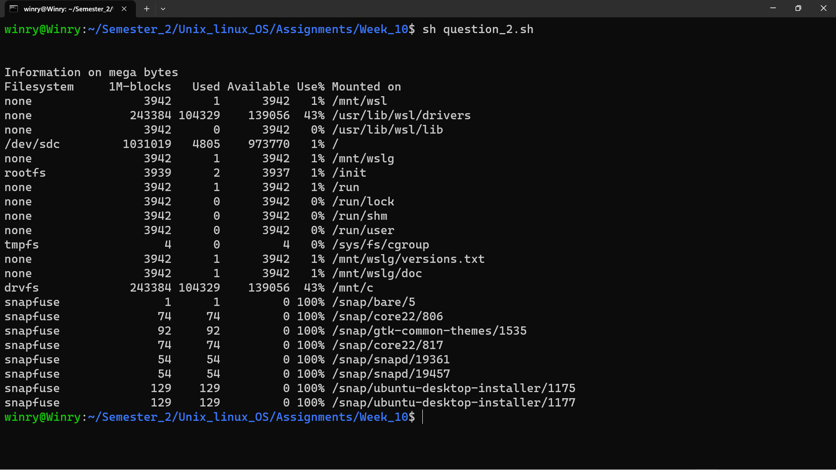
- Display the information in megabytes about how the space allotted in the file system (used and the free space)
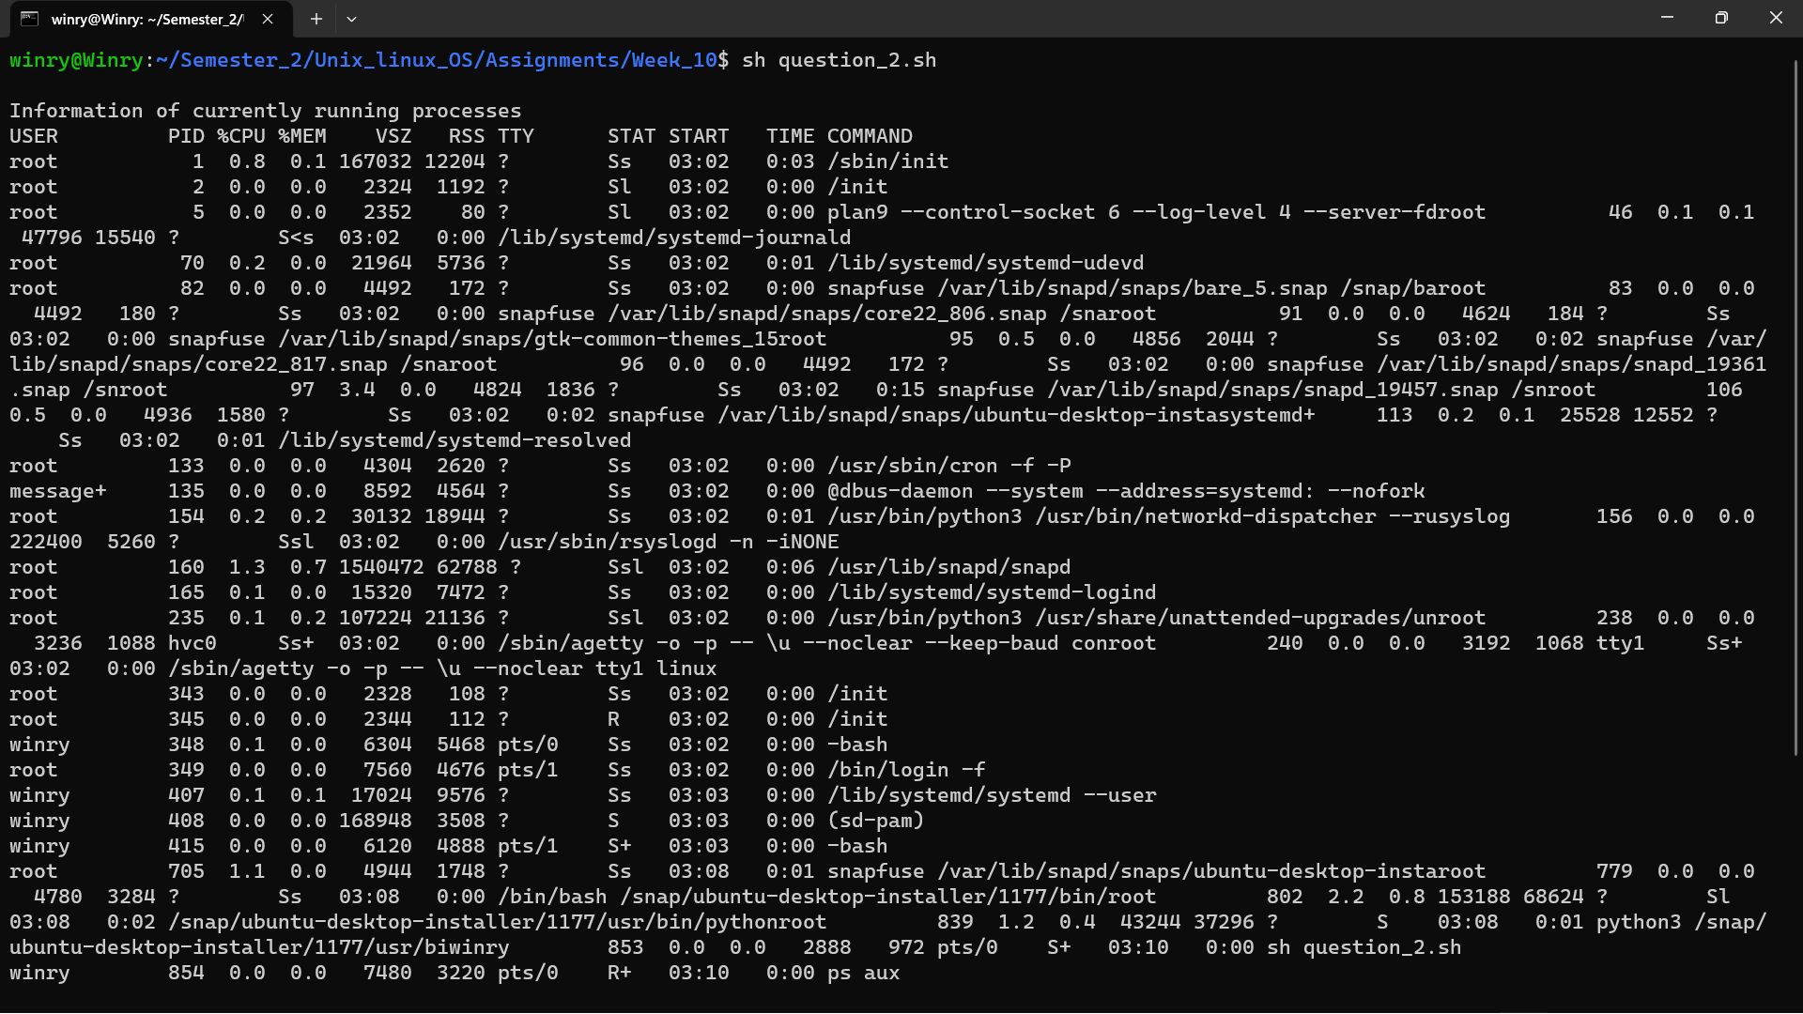
- Display the currently running processes

- Display how long the system has been up since the last boot
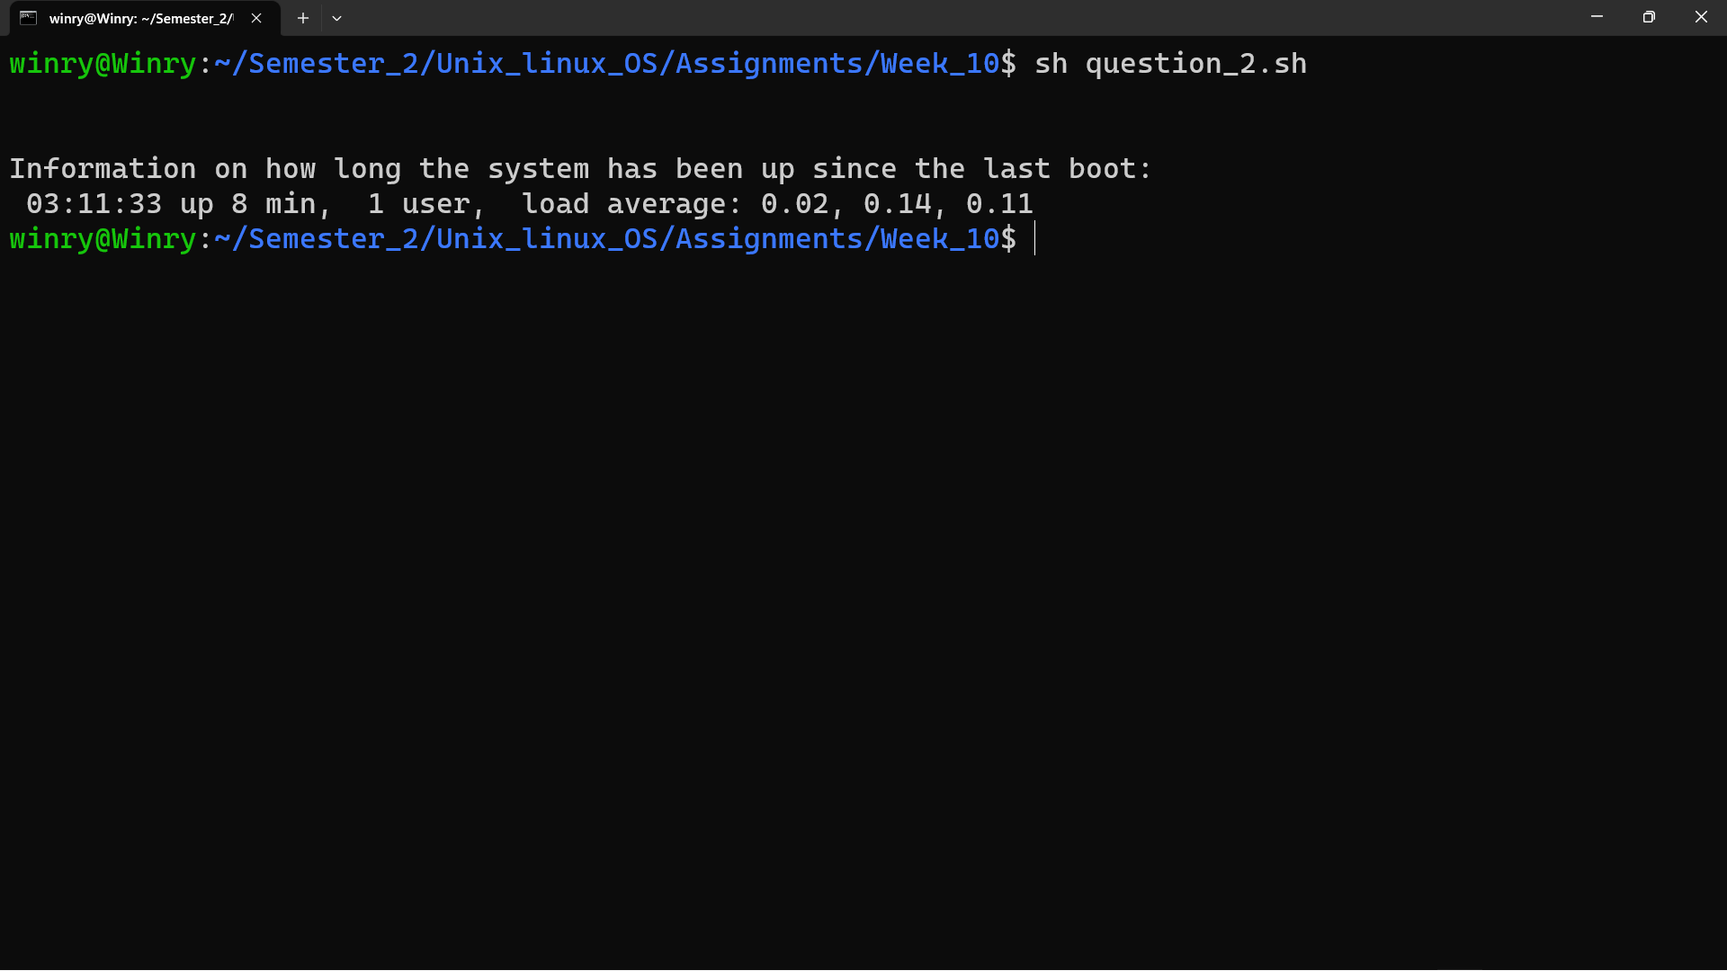

- Write a bash script to receive the username and password from the keyboard. Set the username to be your name and the password to be ‘COMP301’. If the username and password matches then the output to be displayed is “valid user”, otherwise it has to display “invalid user”.
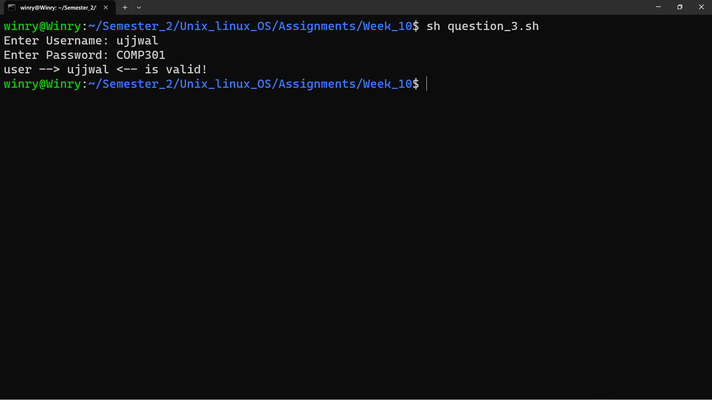
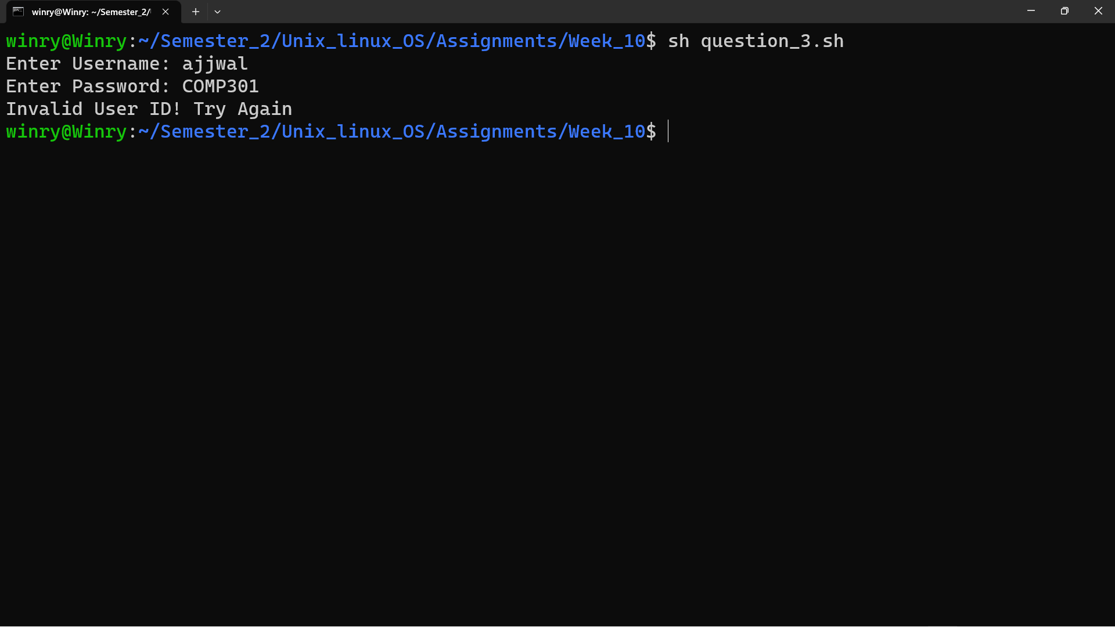

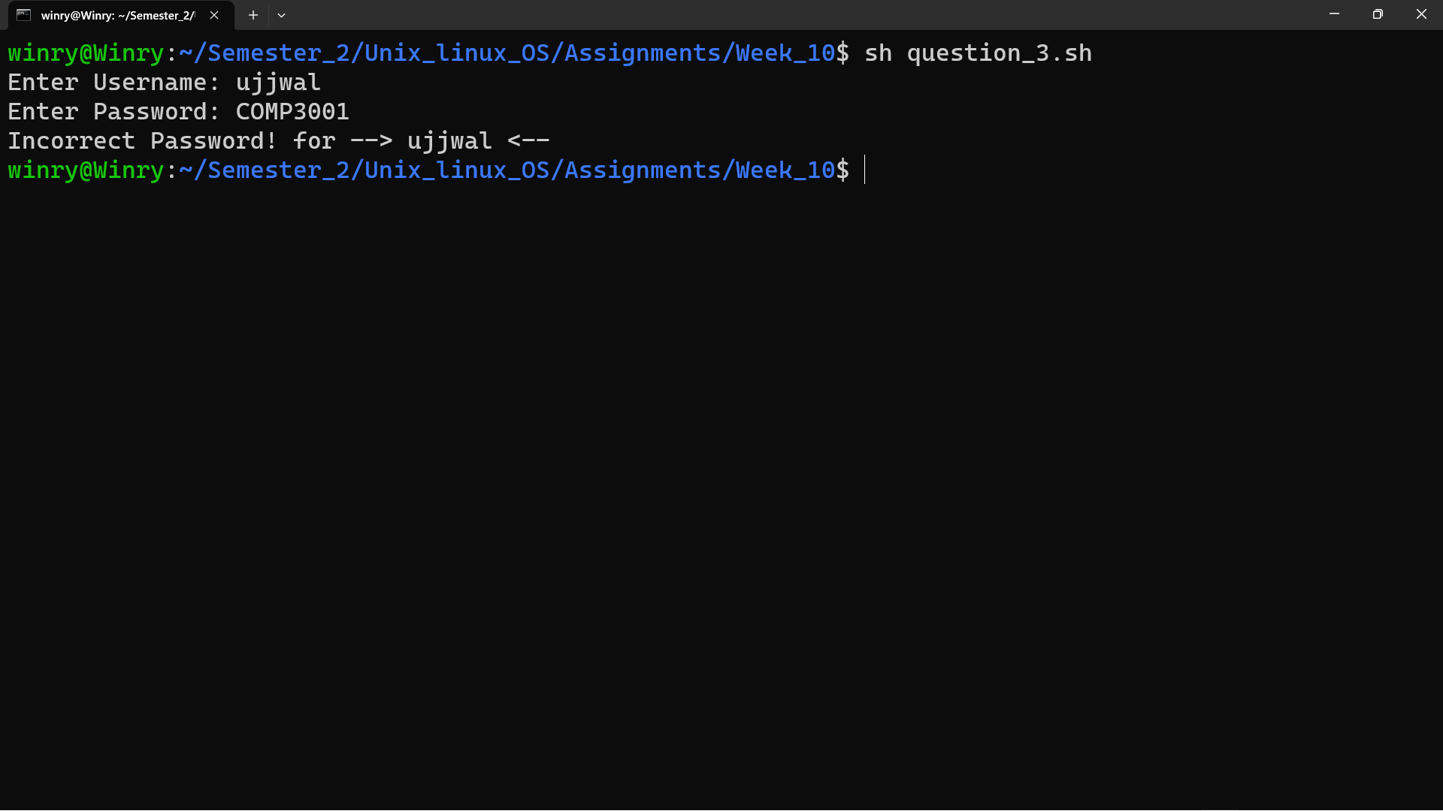

- In a grocery store, there is a seasonal discount to customers for the case payments.
The discount structure is:
a) If the purchase made is less than $500 then Tax = 3.5% and discount = 10%
b) If the purchase is greater than $500 then tax = 2% and discount = 25%

Write the Bash script to calculate the total amount to be paid by the customer. (Note: apply the tax after the discount).
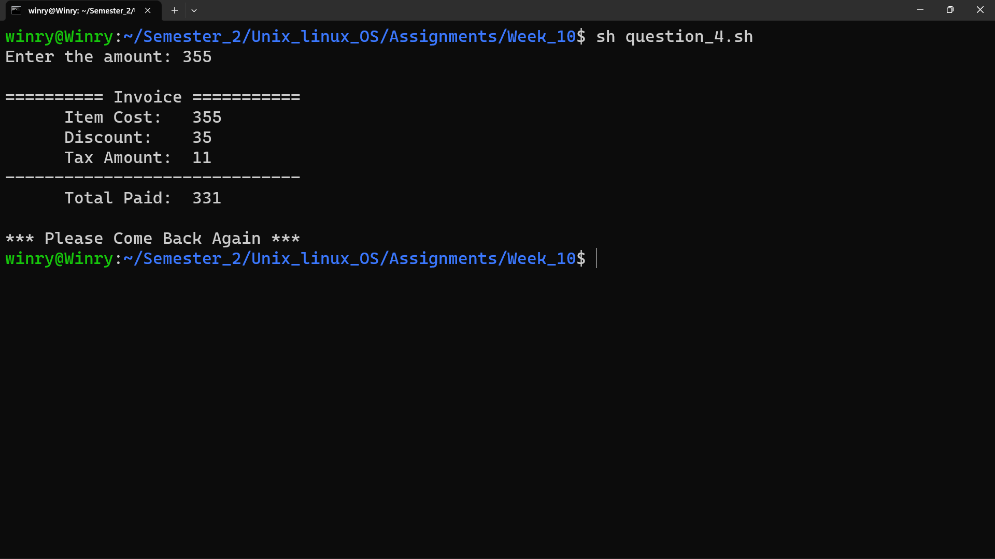
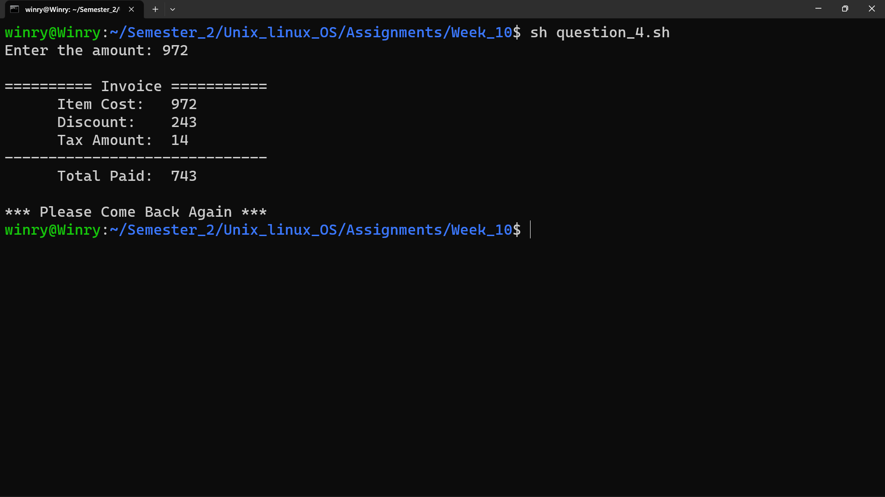
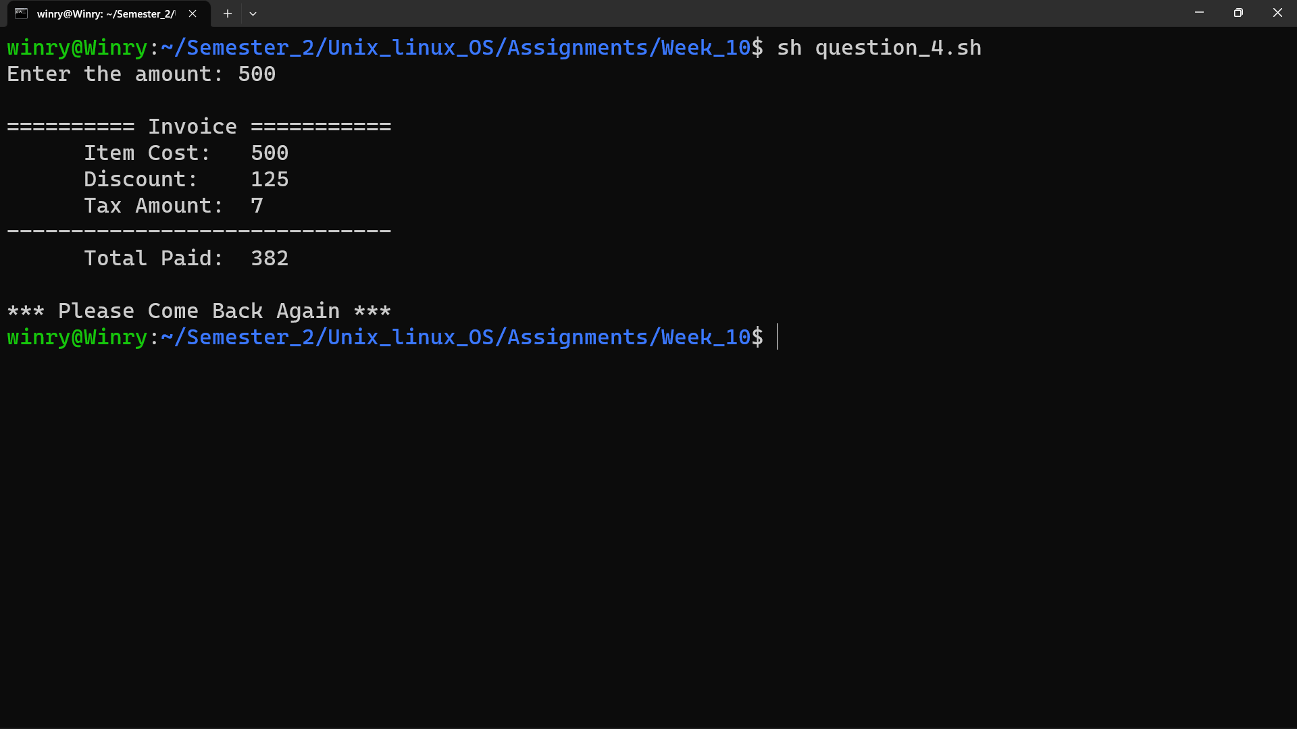

5. Write the shell script that asks the user to enter a wind velocity (in knots), then display the corresponding description as found in the table.

Velocity (knots) |  |  | Description
< 1 |  |  | Calm
1 | – | 5 | Light air
6 – 29 |  |  | Breeze
30 – 47 |  |  | Gale
48 | – | 65 | Storm
> 65 |  |  | Hurricane




