**Group members names (Last, First):**

*For full marks, provide detailed solutions in the spaces provided. Use statistical software* ***only*** *for Question 6. Late assignments will not be accepted.*

1. Pollutant present in air (in ppm) in the sample collected from six urban areas are listed below.

**Data**: 4700, 4200, 7900, x, 8200, 6200 **[3 marks]**

Find:

a) x, knowing that the mean is 5380 ppm

b) The mode

c) The range

**Solve by hand (without the use of software) and include full solutions.**

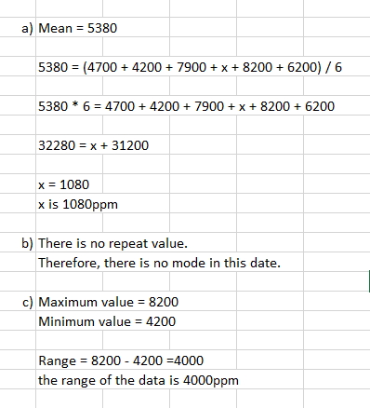

1. Following stem and leaf plot represents the marks of Math210 students in statistics test out of 60.

**[4 marks]**

|  |  |  |  |  |  |  |  |  |  |
| --- | --- | --- | --- | --- | --- | --- | --- | --- | --- |
| Stem | Leaves | | | | | | |  |  |
| 0 | 0 |  |  |  |  |  |  |  |  |
| 1 | 4 |  |  |  |  |  |  |  |  |
| 2 | 8 |  |  |  |  |  |  |  |  |
| 3 | 0 | 1 | 2 | 4 | 8 |  |  |  |  |
| 4 | 0 | 1 | 1 | 1 | 2 | 3 | 4 | 5 | 9 |
| 5 | 3 | 4 | 5 | 7 | 8 | 9 |  |  |  |
| 6 | 0 |  |  |  |  |  |  |  |  |

Find:

1. The median
2. The 55th percentile

**Solve by hand (without the use of software) and include full solutions.**

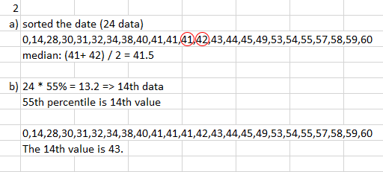

1. The following data represents the weights (in lbs.) of postal packages delivered by a postal office during a one-hour period on a certain day:

14.7, 16.0, 2.4, 10.6, 21.3, 17.5, 36.4, 12.8, 11.8, 13.9

1. What is the interquartile range? **[3 marks]**
2. Are there any **mild or extreme** outliers in the data? Perform all necessary calculations to justify your answer. Use the method involving the interquartile range to identify the outliers. **[3 marks]**

**Solve by hand (without the use of software) and include full solutions.**

Ans: Arranging the data in Ascending order.

2.4, 10.6, 11.8, 12.8, 13.9, 14.7, 16.0, 17.5, 21.3, 36.4

Q3 (P75) = 75 / 100 x 10 = 7.5 = 8th Item = 17.5

Q1 (P25) = 25 / 100 x 10 = 2.5 = 3rd Item = 11.8

a. Inter Quartile range (IQR) = Q3 – Q1 = 17.5 – 11.8 = 5.7

b. There is mild outlier 2.4 and Extreme Outlier 36.4. The description is shown in the figure below:

3 x IQR = 3 x 5.7 = 17.1

1.5 x IQR = 1.5 x 5.7 = 8.55

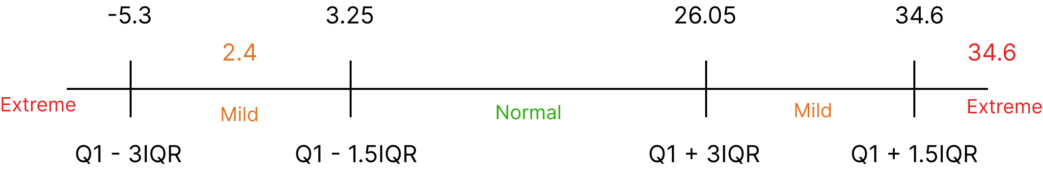

1. The mean of final scores for a Statistics course is 71% with a standard deviation of 11%.

Find:

1. The z – score for a mark of 87%. **[2 marks]**
2. Would a student having a score 1.95 standard deviations below the mean pass the course (Consider the passing score 50%). **[2 marks]**

**Solve by hand (without the use of software) and include full solutions.**

**Round answers to two decimal places as needed.**

Mean (X) = 71%

Standard Deviation (S) = 11%

1. Z-score (Z) = (x – X) / S = (87 – 71) / 11 =1.45

The Z-score is 1.45.

1. X = 71, S = 1.95, Z = 1.45  
   X = Z x S + = 1.45 x 1.95 + 71 = 73.83%.  
   Hence, The Student will pass the course, since his mark is 73.83%, while the passing score is 50%.

5. In a research project to determine the relationship between the hours spent on video games and student’s grades, 6 students were randomly chosen and below data was collected. **Solve by hand (without the use of software) and include full solutions.**

|  |  |
| --- | --- |
| x (number of hours spent on video games) | y (student’s grades in %) |
| 7 | 62 |
| 2 | 94 |
| 5 | 86 |
| 9 | 48 |
| 4 | 76 |
| 8 | 55 |

a) Draw a scatter plot for the data (Do not use any software)  **[2 marks]**

b) Find the equation of the line of best fit. Draw the line of best fit on the scatter plot diagram. (Do not use any software) Round off the coefficients to three decimal places. **[6 marks]**

c) Find the coefficient of determination (Do not use any software). Write a statement of interpretation for it. Round to four decimal places.  **[3 marks]**

6. Solve question 5 again, **using a statistical software** (i.e., Excel, JMP, etc.). Copy and paste the software output to your assignment.

**[2 marks]**