

Section: 001

Ujjwal Poudel Student ID: 301284284

Centennial college

***Student Name: Ujjwal Poudel***

Lab 1 assignment (Section 1)

**Table of Contents**

**Part - A Page**

1. Computer Architecture 2
   1. Input unit 2
   2. Processing unit 2
   3. Output unit 3
2. Memory Units 4
   1. Primary memory 4
   2. Cache memory 4
   3. Secondary memory 5
3. Mother Board Ports 5
4. Other Latest Devices 6
5. Best Configuration While new Purchasing Computer 6

**Part – B**

1. Application software 7
2. System software 7
3. Operating systems 7
4. Networking 8
   1. LAN 8
   2. WAN 8
   3. WLAN 9
   4. MAN 9
   5. SAN 10
   6. PAN 10
   7. EPN 11
   8. VPN 11

**PART - A**

**1. Computer Architecture**

Computer Architecture is the design of the component of a computer system. Basically, a computer system functions with three units input unit, processing unit and output unit. Each detail is described below with a diagram.

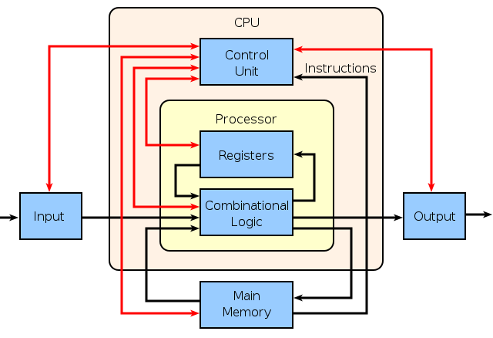

Fig 01: Computer Architecture

1.1. Input unit:

In this unit, data is instructed to the computer through input devices. Input device examples are keyboard, mouse, microphone, webcam and so on. The picture of input devices are given in next page.

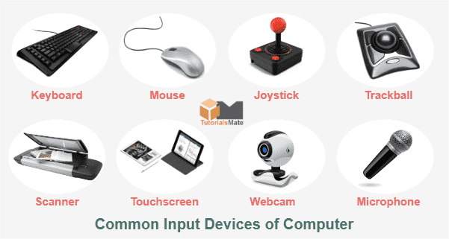

Fig 02: Input Devices

1.2. Processing unit:

The data taken from the input devices are then processed in the processing unit. The processing unit is also called the brain of the computer. The most used processing unit is CPU. The processing unit consists of four components control unit, registers, combinational logic unit, and memory unit. The picture of CPU is shown in the next page.

1. Control unit: It receives the data from the memory unit to process the data.
2. Registers: It receives the data from the control unit and holds certain data from fast processing.
3. Combinational logic unit: It is the arithmetical and logical calculator of the computer system.
4. Main Memory: It is the storage unit of a computer system which stores data.

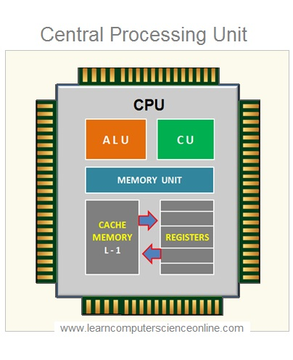

Fig 03: Processing Unit

1.3. Output unit:

The output unit displays the results of processed data. The output is displayed through output devices like monitors, printers and so on. Visually output devices are given in the picture.

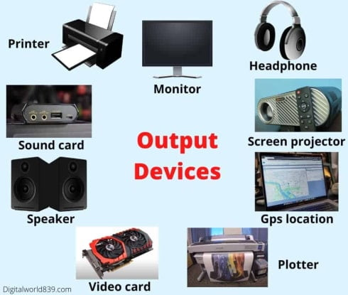

Fig 04: Output Devices

**2. Memory Units**

In general, computer system uses three memory types, primary memory, cache memory and secondary memory. RAM and ROM are the examples of primary memory, whereas hard disk, scan disk, pen drive are the examples of secondary memory.

2.1. Primary Memory:

A computer cannot function without primary memory. These types of memory has limited usage, they are volatile so, the data is lost when power is off. Primary memory are slow as compared to cache memory. RAM and ROM are primary memory types. The figure below shows the primary memory.

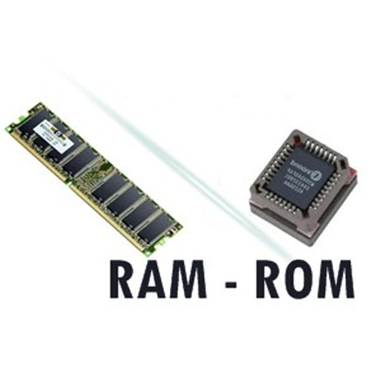

Fig 05: Primary memory types

2.2. Cache Memory:

A cache memory hold the data from primary memory for processing, they are usually fast as compared to primary memory. Their main function is to execute data for short period of time. However they have less capacity to hold data. The figure below shows cache memory.

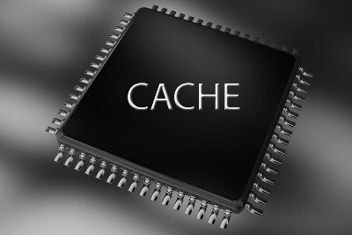

Fig 06: Cache memory

2.3. Secondary Memory:

A secondary memory is the external memory of the computer system. They are used extra data storage. They are non-volatile memory. Some of the examples of secondary memory are hard disk, scan disk, pen drive and so on. The figure below shows secondary memory types.

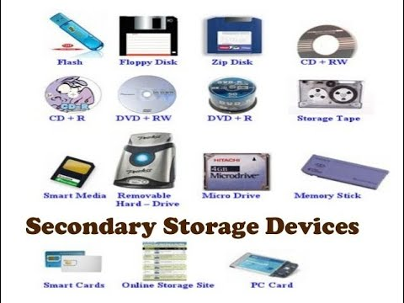

Fig 07: Secondary memory types

**3. Mother board ports**

A mother board is the connecter of all the parts of a computer system. Mother board uses different types of ports to connect to the parts of computer system, those ports are called mother board ports. Pictures of commonly used mother board ports are given below. Some of the commonly used ports are;

1. USB port (universal serial ports): It is the connecter of devices which supports USB cables.
2. VGA port: This port connect with the wire to access the monitor.
3. Power cable port: This port connects the CPU to main power system to function the computer.
4. Ethernet port: Ethernet ports are used for connecting the computer to internet using Ethernet cables.
5. Sockets: Sockets are specially designed to connect microphone and speakers to the computer system.
6. DVI port: DVI port is used as the connecter to video graphics card and monitor.

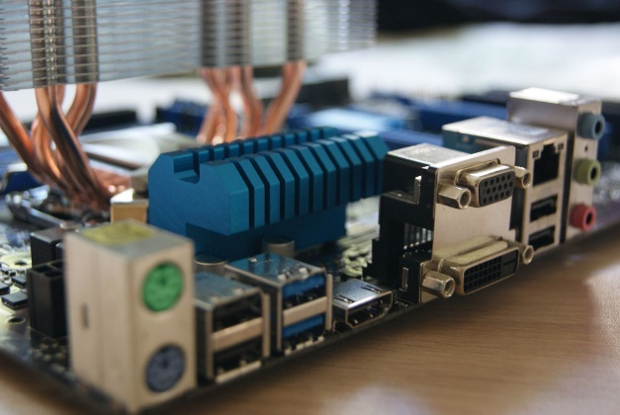

Fig 08: Different mother board ports

**4. Other latest devices**

There are different latest technologies developed till now using computer system. Some of those are digital watch, android phone, smart TV, smart kitchen appliances and so on. The picture includes some of the latest devices,

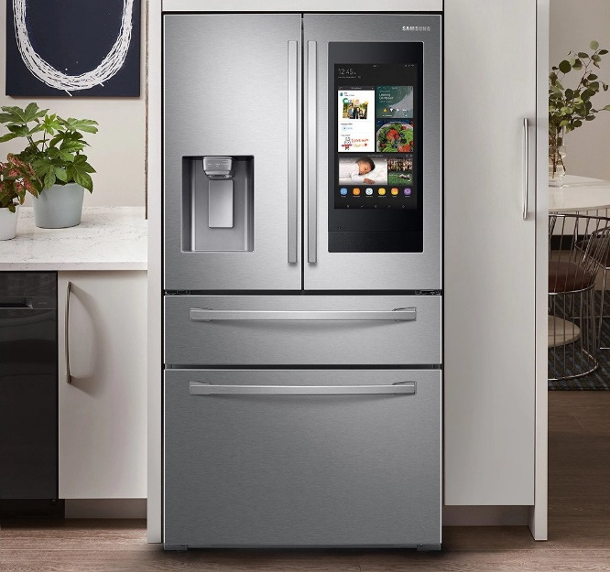

 Fig 09: Smart kitchen tools

**5.** **Best configuration while purchasing new computer**

The main component of a computer system is CPU. Therefore, before selecting anything while purchasing, the main focus should be on processing speed. In general, processing unit is calculated in GHz (Giga Hertz). The more processing unit is, the better a computer system performs. Similarly, the memory and storage are also the main components of computer system. In terms of memory, RAM plays a crucial role in processing data. The concepts apply same for both, the more RAM and storage is, the better the computer system functions. For storage, there are two mostly used drive, solid state drive and hard disk drive (SSD and HDD). SSDs are faster, lighter and quitter than HDDs. Thus, choosing SSD is better option while purchasing new device.

**PART – B**

**6. Application software**

The software designed to perform particular task in a particular environment are application software. There are many application software that are designed for their specific purpose some of the examples of these software are given below:

1. Microsoft Word: It is used for editing words or documents
2. Adobe Photoshop: It is used for editing pictures
3. Wondershare Filmora: It is used for editing videos

**7. Systems software**

Systems software is the home for all other software which means it provides a platform to other software to perform tasks. Usually, system software are developed by computer manufacturers. For example, Microsoft designed windows, Apple designed mac OS, Linux and so on.

**8. Operating systems**

Operating system is the main system of computer which perform or execute all the function and programs in the computer system. It is also known as the brain of the computer. The operations in the operating system includes processing of software like application or system software, memory management, file management, security, interactions between users using data, coordination with other software or computer systems and so on.

**9. Networking**

The process of sending and retrieving data and information between many computer systems is known as computer networking. The different types of computer networking are explained below.

9.1 LAN:

Local Area Network (LAN) is the connection between two or more personal computer systems using cables or wires inside a building or small office. It is an inexpensive networking of computer system. The picture below gives a clear representation of LAN.

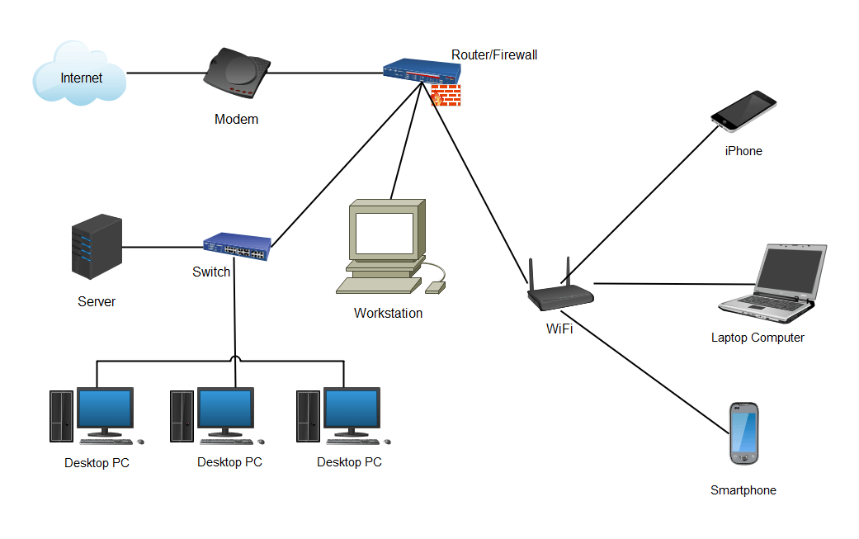

Fig 10: Local Area Network

9.2 WAN:

Wide Area Network (WAN) is the connection between computer systems covering a large group of users inside a whole country. Internet and telephone networks are the examples of WAN.

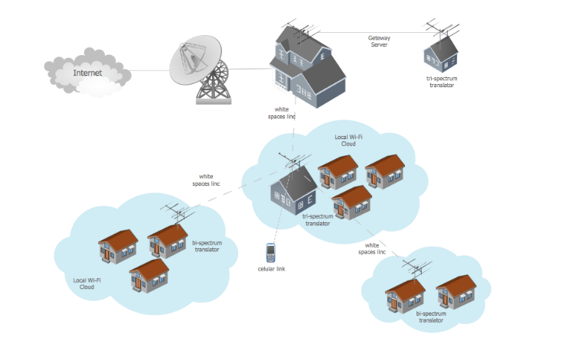

Fig 11: Wide Area Network

9.3 WLAN:

Wireless Local Area Network (WLAN) is the connection between two or more personal computer system wirelessly inside a building or small office. Picture representation of WLAN is given below.

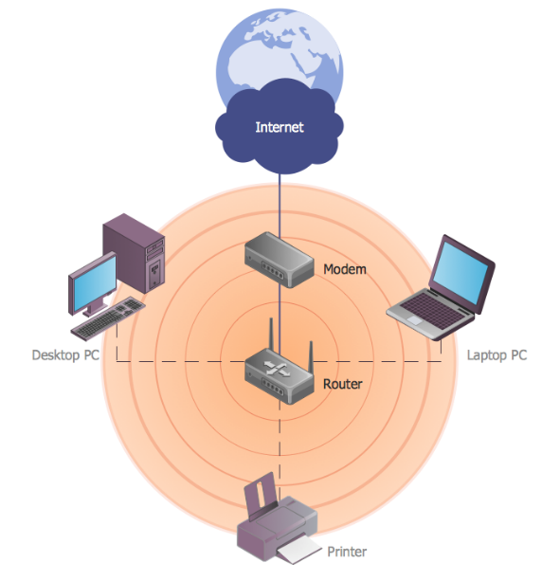

Fig 12: Wireless Local Area Network

9.4 MAN:

Metropolitan Area Network (MAN) is the connection between computer systems in large area like a city, district or a country. It is the connections between LANs in a large area. The diagram of MAN is given below.

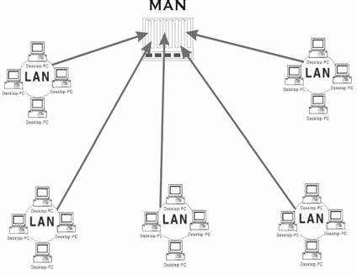

Fig 13: Metropolitan Area Network

9.5 SAN:

Storage Area Network (SAN) is the connection between different computer systems in several storage units. The SAN helps users to share data and information while storing in different servers. The visual representation of SAN is given below.

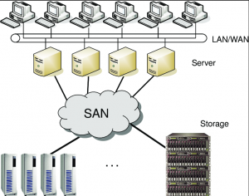

Fig 14: Storage Area Network

9.6 PAN:

Personal Area Network (PAN) is the connection of devices closer to the user with the computer system. The examples of PAN connected devices are Bluetooth mouse, speakers, and so on.

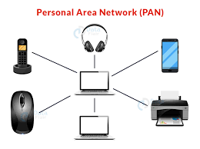

Fig 15: Personal Area Network

9.7 EPN:

Enterprise Private Network (EPN) is the connection between different computer systems in an organization to share data and instructions privately. The visual diagram is given below.

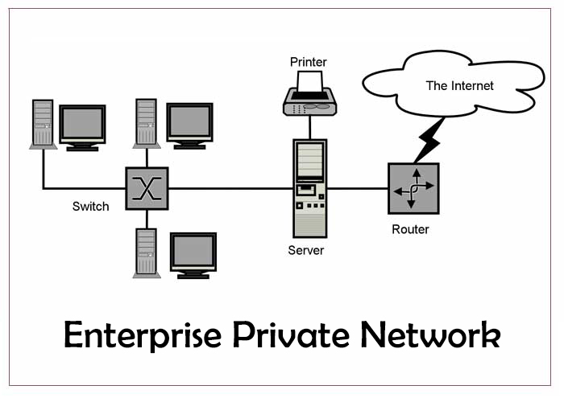

Fig 16: Enterprise Private Network

9.8 VPN:

A Virtual Private Network (VPN) is service network that provides encryption in the connection. VPN is generally used to browse internet anonymously. A diagram is VPN is given below.

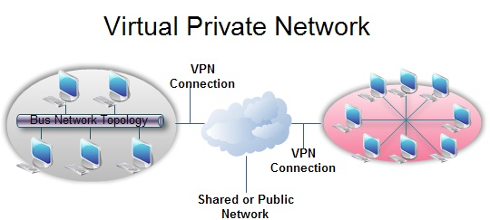

Fig 17: Virtual Area Network

**References:**

Input Device: https://images.app.goo.gl/nkkFSNx8NJNX5QF48

Computer Architecture: https://images.app.goo.gl/bCzQirFcK7EXESqJA

Processing Unit: https://images.app.goo.gl/ZEMGKyQt7AUouzba7

Output Device: https://images.app.goo.gl/chUaPwsVFt7UFmAM6

Secondary Memory: https://images.app.goo.gl/amorcbHhRsch4VaU8

Primary Memory: https://images.app.goo.gl/FEz6mVVaBvd1xwuy6

Cache Memory: https://images.app.goo.gl/548LUNnG4qokMVke9

Mother Board Ports: https://images.app.goo.gl/o5viXmaF1K5RN54a9

Smart Kitchen Tools: https://images.app.goo.gl/Pb1YCw5KKxTQJaiPA

Computer Configurations: https://guardian.ng/technology/what-to-look-for-when-buying-a-computer-in-2021/

Centennial College Logo: https://images.app.goo.gl/Y1wUjHS2madPKcVCA

LAN: https://images.app.goo.gl/SkwLwMhZzGpQgByr5

WAN: https://images.app.goo.gl/vwfqdbrS1gnJ3DPZA

WLAN: https://images.app.goo.gl/42fTG1fU18beuCFN7

MAN: https://images.app.goo.gl/mqbPo7nn2rCxvoKm9

SAN: https://images.app.goo.gl/ZYXpghkNgvCm4FiM6

PAN: https://images.app.goo.gl/QviyPPgaYLoP4eJQ6

EPN: https://images.app.goo.gl/wE71DKwaKs3XF8JS8

VPN: https://images.app.goo.gl/Sy3GDjiVR41iLc7r9