Ujjwal Poudel

[301284284]

[Python Assignment]

[Comp-120]

**Python Code:**

"""Week_6 Exercise_1"""

#Question_1

#Here are my 3 favourites

print("Programming")

print("Web Desigining")

print("Artificial Intelligence")

#Question_2

#using variables to store student details

first_name = "Ujjwal"

last_name = "Poudel"

address = "100 Parkway Forest Drive, Toronto, Ontario"

print(f"\nHi I am {first_name} {last_name} and I reside in {address}\n")

"""Week_6 Exercise_2"""

#This software records the user who are active

active_users = ['jam', 'sam', 'juju', 'whocares', 'if', 'he', 'teaches', 'well']

active_users.pop() #removes the last element from the list by default

active_users.append('juju') #adds the given element in list in last index by default

print(active_users)#This is the modified list

print(active_users[0:5:2]) #This is the sliced list, skipping every second element

"""Week_6 Exercise_3"""

#Here the lists of course name you are enrolled in

courses = ['Comp100', 'Comp213', 'Gned400']

#using conditional statements to check the course title

course_name = input("Please enter your course name: ").capitalize()

if course_name in courses:

print(f"{course_name} is available in first semester!")

else:

print(f"{course_name} is not available in first semester.")

#using index to get the items in the list

print(f"\nyou are enrolled in {courses[0]}")

print(f"you are also enrolled in {courses[1]}")

print(f"The first course you are enrolled in is {courses[2]}")

courses.append('Comp216') #appendig a new course in the list

print(courses, "\n") #prints the modified list

"""Week_8 Exercise_1"""

#Question_1

favorite_languages = {

'jen': 'HTML',

'sarah': 'c',

'edward': 'ruby',

'phil': 'C#',

}

#Change the value from C# to Python for the key phil

favorite_languages["phil"] = "python"

#Add an item in the dictionary

favorite_languages["ujjwal"] = "C++"

#Remove an item from the dictionary

favorite_languages.pop("edward")

#List all the values in the dictionary

print(favorite_languages.values(), "\n")

"""Week_8 Exercise_2"""

#create a python dictionary called student.

#Include student name, age, subject, semester, grade and lab keys.

#Include the value for each key accordingly.

#Display keys separately and values separately in the print statement.

student = {

'name': 'Juju Chan',

'age': 19,

'subject': 'Software-Engineering-Technology',

'semester': 'First',

'grade': 'A',

'lab': '3'

}

print(student.keys())

print(student.values())

"""Week_9 Exercise_1"""

#Write a program in python using if condition.

#Input the temperature (user input).

#check if the temperature is less than 98 display the result as cold.

#otherwise if the temperature more than 98 , display the result as Hot.

#otherwise display them as normal.

temperature = int(input("Enter the temperature: "))

if temperature > 98:

print("HOT! Is this really Canada?\n")

elif temperature < 98:

print("Cold! These cloths aren't enough.\n")

else:

print("The temperature is normal.\n")

"""Week_9 Exercise_2"""

#Program to iterate agile values through a list using indexing.

#create the following agile values in list.

#use for loop and iterate over the list:

agile_values = ['Individuals and interactions', 'Working software ', 'Customer collaboration ','Responding to change']

index_value = agile_values.index('Individuals and interactions')

print("Here are the following agile values:")

for values in agile_values:

print(index_value, agile_values[index_value])

index_value += 1

**Screenshots of Outputs:**

1. **Week 6, Exercise 1, Question 1**

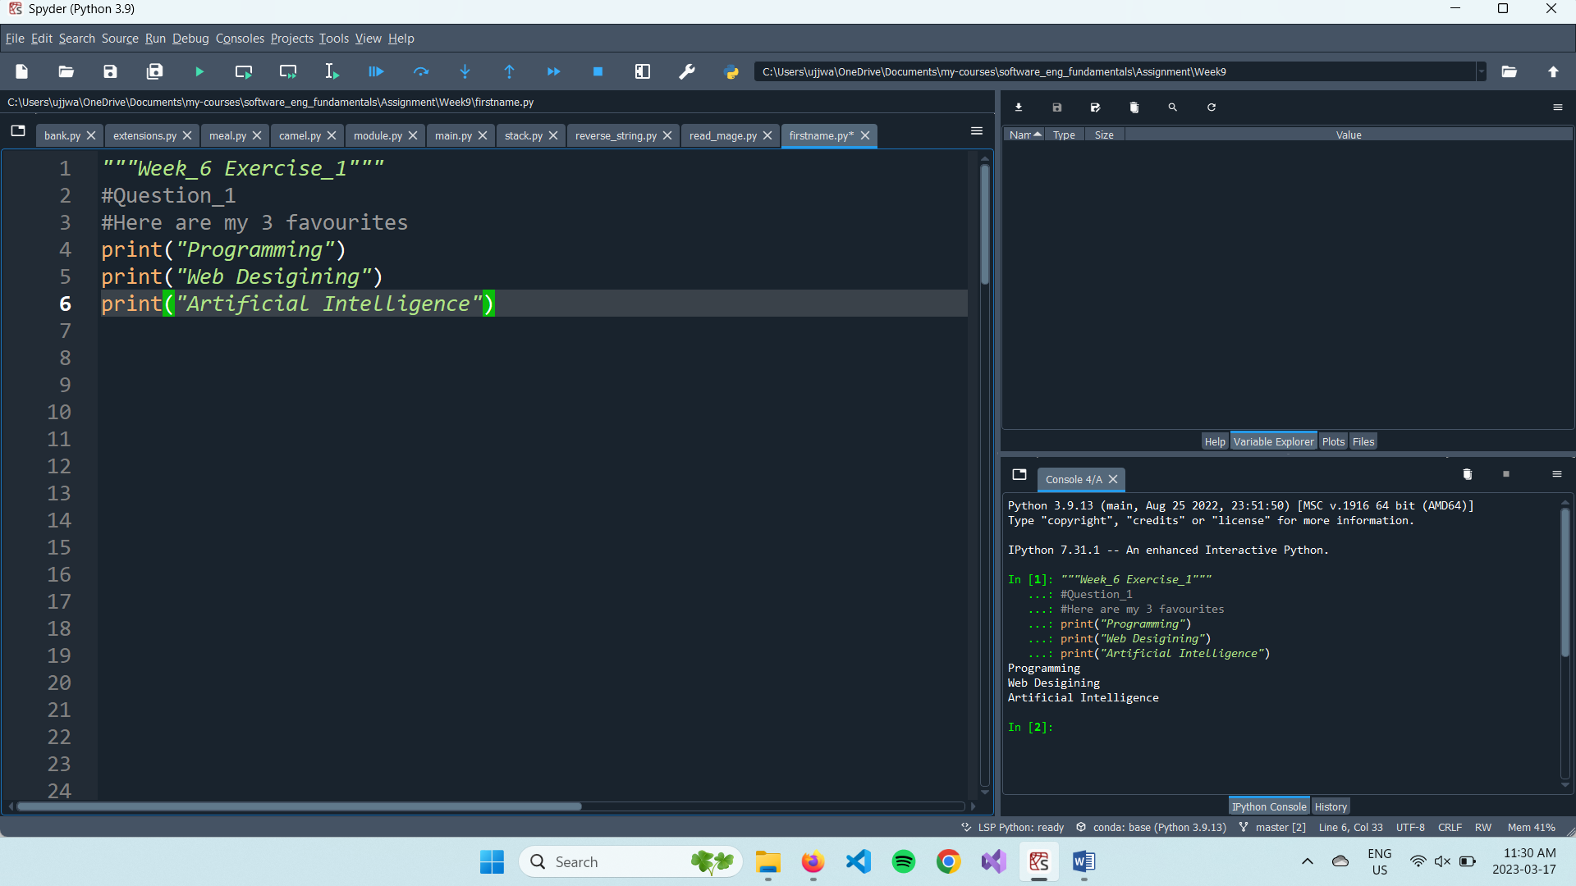

1. **Week 6, Exercise 1, Question 2**

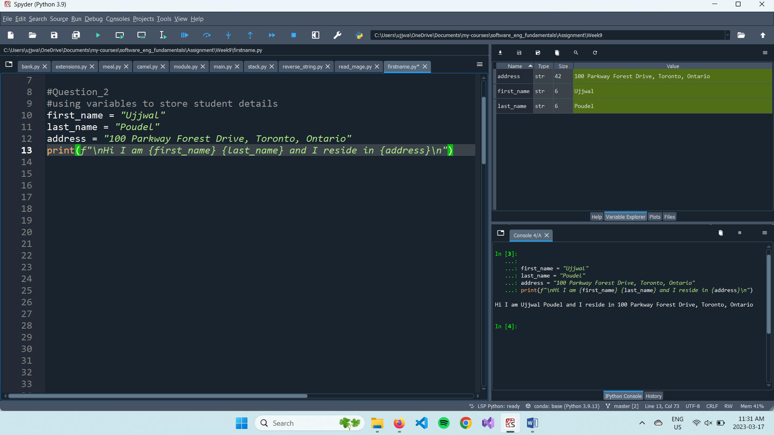

1. **Week 6, Exercise 2**

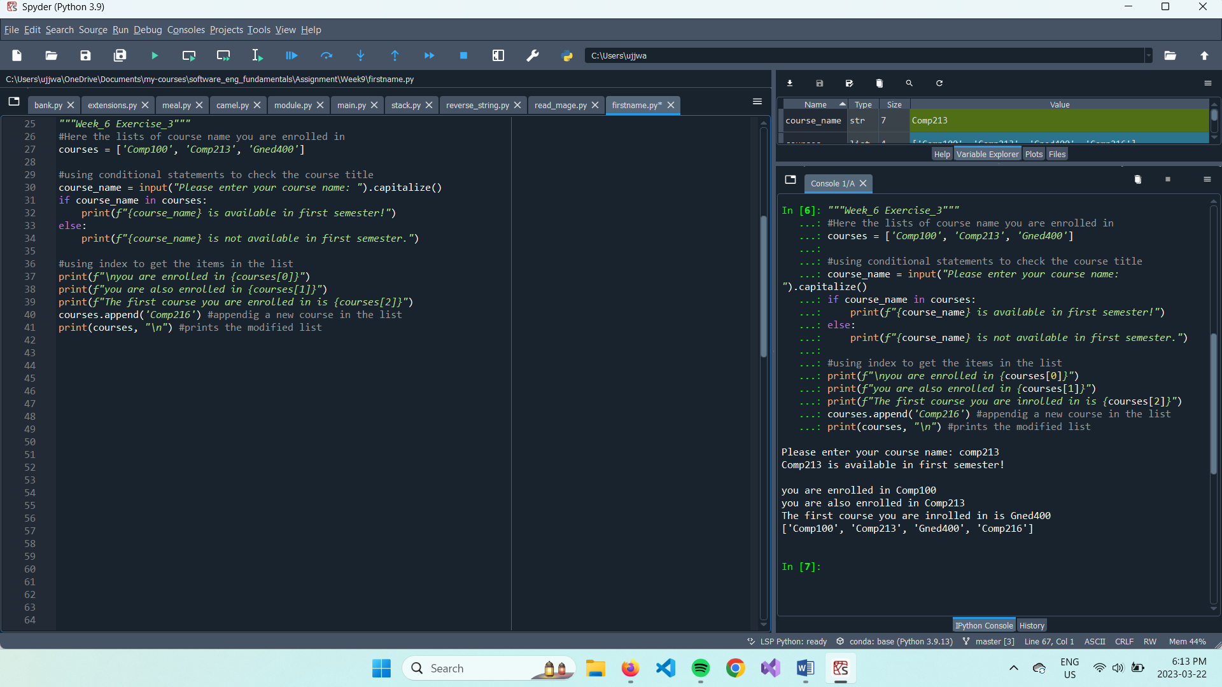

1. **Week 6, Exercise 3**

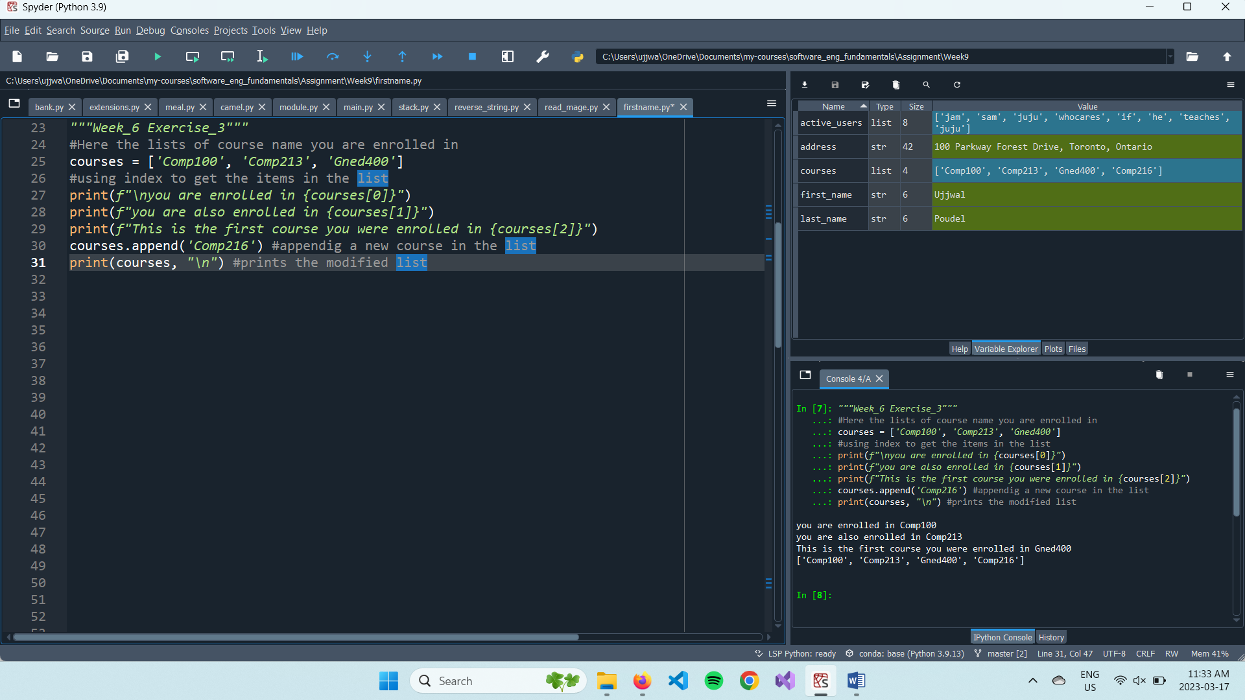

1. **Week 8, Exercise 1**

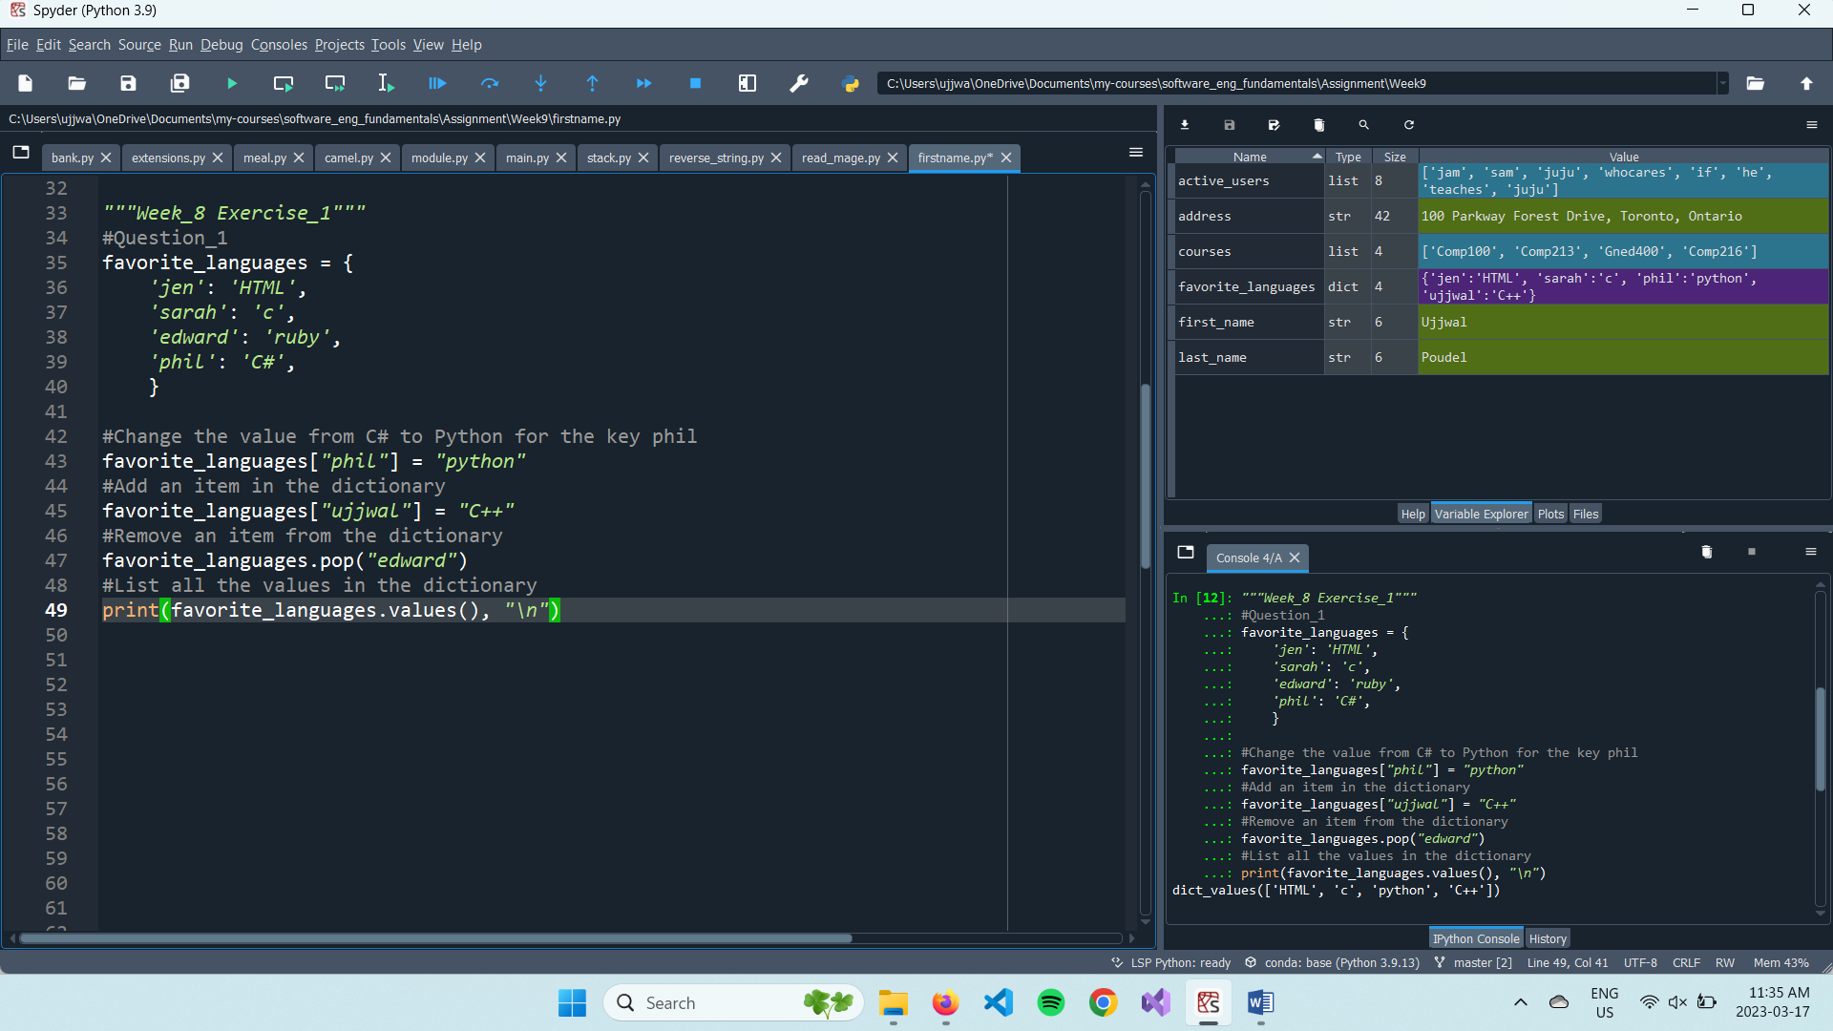

1. **Week 8, Exercise 2**

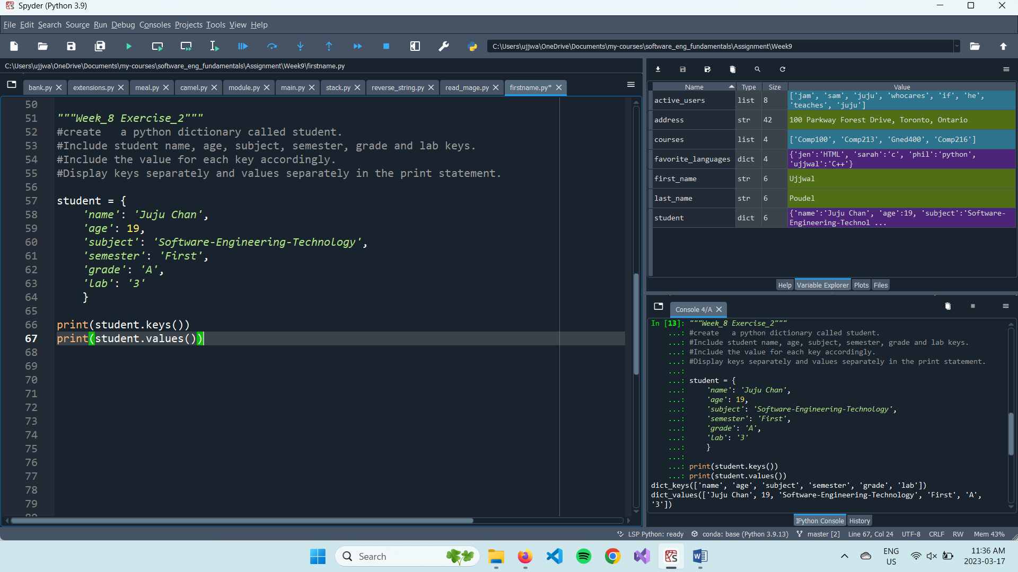

1. **Week 9, Exercise 1**

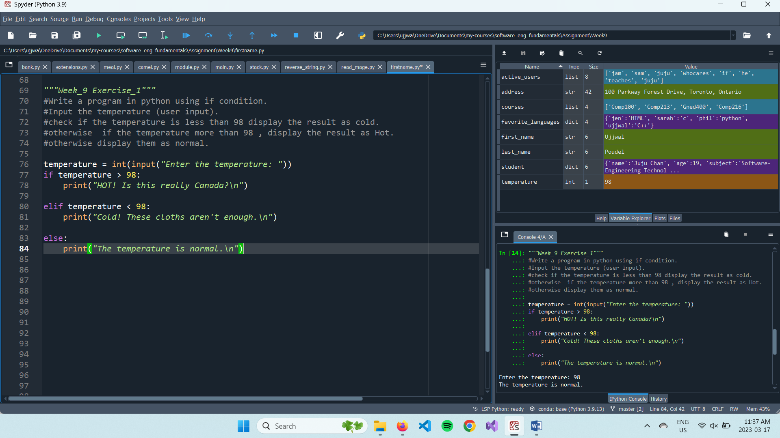

1. **Week 9, Exercise 2**

