Udacity – Path Planning Project

Submitted by: Ujjwal Saxena

Date: May-11-2018

# Objective

The objective of this project is to run the car in simulator to follow lane lines and to not collide with other cars. Also to switch the lanes safely if there is a slow moving vehicle ahead of our car.

# Rubric Points

## Compilation

### The code compiles correctly.

I used spline.h library and added in the source folder. The code compiled without any errors.

## Valid trajectories

|  |  |
| --- | --- |
| Description | Result |
| The car is able to drive at least 4.32 miles without incident. | Car drove more than 25 miles without any incident |
| The car drives according to the speed limit. | Car never crossed the speed limit |
| Max Acceleration and Jerk are not Exceeded. | Within given limit |
| Car does not have collisions. | No collisions |
| The car stays in its lane, except for the time between changing lanes. | Car stays in the lane |
| The car is able to change lanes | Car successfully changed lanes when it’s safe to change lane. |

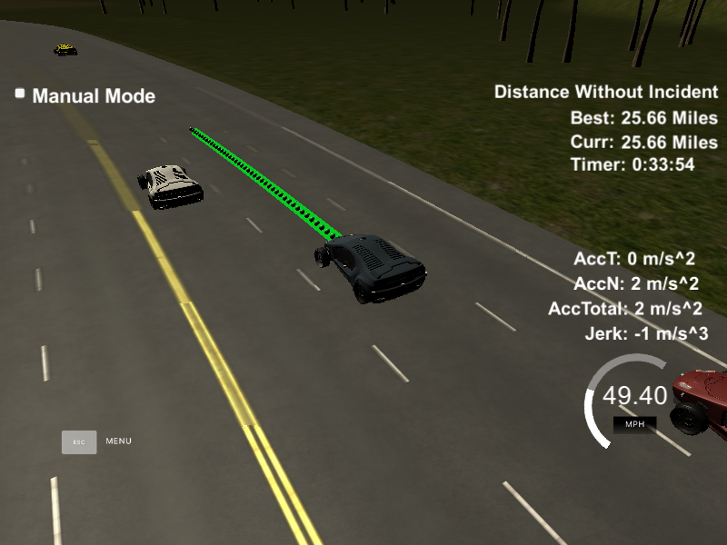

Figure Screenshot of the successfull run

## Reflection

### Model description:

The main.cpp file listens to the message sent from the simulator (using web sockets). The simulator sends the data related to car, like Car’s location, velocity, yaw rate, speed and Frenet coordinates (longitudinal and lateral displacement). It also sends the data from the sensor fusion which contains data for other cars in vicinity.

The working of the model can be broken down in following three parts:

#### Prediction

The data from the sensor fusion and simulator is used to generate the predictions about the likely behavior of moving objects. Like if there is a car in front of us, what it will do in future and based on that we will decide the behavior of our car. Also this data will be used to detect the cars in the adjacent lanes and make maneuver decisions in next step.

#### Behavior Planning

Based on the prediction of the other moving objects we decide the behavior of our car. There can be following behaviors which our car can do based on the other moving cars:

|  |  |
| --- | --- |
| Prediction | Behavior of our car |
| Car ahead us is too close | Slow down our car |
| Car ahead us is driving slow | See if we can change lane safely |
| Both left and right lanes are safe to change lane | Change lane which has longer free run before a car appears. |
| Car ahead us is slow and there is another car in left lane | Change the lane to right (but see first if it is safe to change the lane and we are not in the right most lane) |
| Car ahead us is slow and there is another car in right lane | Change the lane to left (but see first if it is safe to change the lane and we are not in the left most lane) |
| There is no car ahead of us or car is too far away | Increase the speed of the car to approx. speed limit and maintain the lane |

The buffer distance between our car and car ahead is set as 25 meters.

We try to change the lane if there is no vehicle in the side lane in front of us for 25 meters and there is no car too close to us(approx. 5 meters) which is coming from behind (there might be a car coming too fast from side lanes while we plan to change the lane).

#### Trajectory Generation

Our car calculates the trajectory based on the speed, other vehicles position - velocity and current lane, car coordinates and past path points. To make the trajectory smooth we add the last two points from the previous trajectory path. If there are no previous paths we calculate the previous point from the current yaw rate and the current car coordinates.

Also we add three way points in next 30 meters, 60 meters and 90 meters to the trajectory. All these points are then shifted to the car reference angle (local car coordinates) – this is done to simplify the calculations.

We then use spline library to get the remaining points of the trajectory based on the current path (we are adding total of 50 points to the trajectory). All these points are then again moved to the global coordinates (so that these can be sent to the simulator to generate the trajectory and to drive the car based on this trajectory)

# Conclusion

This project helps us to visualize the Path planning and helps us to understand why it is one of the most crucial parts of the autonomous vehicle. Safety is one of the most important point in the path planning.