Project Report

Title- Using data Mining to improve business in chain restaurant (McDonald's store).

Name | Enrollment Number | Contributions
Ujjwal Singh | 24911013 | Implementation
Ruchi Kumari | 24911019 | Presentation
Ganga Srujan | 21114035 | Report
Munugala Charan Tej | 21114062 | Report
Bandi Pavan Karthik | 21114026 | Report

Problem Statement:
Using data Mining to improve business in chain restaurant (McDonald's store).
Algorithms Used:
K-Means Clustering:
K-Means clustering is a popular method of clustering data in an unsupervised machine learning scenario. K-Means does not enter the supervised learning scenario because it does not have labeled data but finding patterns and structure from the data itself. K-Means clustering takes a collection of data points and partitions that data into K groups where each data point belongs to a cluster with the closest mean called the centroid. K-Means starts with K centroids. The centroids can be randomly selected as the K random points in the dataset. Then, each data point is assigned to clusters associated with its closest centroid. The centroid is then calculated by taking the mean of all the points assigned to the cluster. This procedure of assigning data points to clusters based on the closest centroid and calculating means of each clusters centroids is repeated iteratively until the centroids from cycle to cycle do not change significantly after several cycles.
DBSCAN:
DBSCAN (Density-Based Spatial Clustering of Applications with Noise) is an unsupervised machine learning algorithm that clusters based on density, rather than distance from a centroid, as is the case for K-Means. Unlike K-Means, DBSCAN does not require the prior identification of the number of clusters and can discover clusters of arbitrary shape, which is particularly useful for data sets that may have complex shapes or noise. The clustering process uses two parameters: epsilon (ε) is the maximum distance between two points for them to be considered neighbors, and minPts is the minimum number of points to make a dense region. In DBSCAN, a point is classified as a core point if it has at least minPts neighbors within ε, whereas a border point has fewer than minPts neighbors (but is within ε of a core point) and a noise point has no core point reachable from it. DBSCAN forms clusters by connecting core and reachable border points and classifies noise points as outliers in the dataset. DBSCAN is robust to noise and outliers and can cluster data when the size and shape of clusters vary. The shortcomings of DBSCAN are that its performance can be hindered by normalized distances in datasets with varying cluster densities, and it can be difficult to know the best values for ε and minPts without knowing anything about the dataset or inspecting the data visually.
HDBSCAN:
HDBSCAN (Hierarchical Density-Based Spatial Clustering of Applications with Noise) is a higher-level clustering algorithm, which improves DBSCAN with respect to dealing with clusters that have different densities. Whereas DBSCAN demands fixed parameters such as epsilon (ε), which can prove to be tricky to adjust for datasets with uneven density, HDBSCAN eliminates the necessity for a global distance threshold and instead builds a hierarchical tree of clusters depending on the levels of varying densities. It then summarizes this tree into a flat clustering by choosing the most stable clusters. The primary parameter in HDBSCAN is min_cluster_size, which specifies the minimum size a cluster of points must be to qualify as a cluster. HDBSCAN assigns points to core clusters and marks others as noise, like DBSCAN, but with more flexibility and precision. This makes it particularly valuable for real-world data where clusters are not necessarily separable or have the same shapes or densities. Moreover, HDBSCAN offers a cluster stability score, which can be used to assess the reliability and strength of every cluster. Overall, HDBSCAN is a robust and efficient clustering algorithm that takes the best of density-based and hierarchical clustering methods.
Insights:
Store Clusters: Nature Occurring Business Areas
One of the insights gained from the clustering analysis is discovering natural store groupings through geographic proximity and density. Unlike standard region segmentation—based on administrative geographies such as states, counties, or zip codes—clustering enables the data to tell us something on its own. Employing algorithms like HDBSCAN, we revealed clusters that mimic the way stores naturally cluster together based on customer need and convenience of location. These clusters can then be used to delineate operating zones that are much more reflective of real customer behavior and mobility patterns. As an example, a cluster of stores in close proximity to an urban corridor could be a marketing region, such that the brand can customize promotions according to common demographic or cultural characteristics. Delivery zones can similarly be established around these clusters so that logistics are more efficient and service is faster. Regional managers may also employ these clusters to track store performance within consistent, contextually homogeneous territories, enhancing control and resource utilization.

Outliers: Possibility of Market Gaps or Redundancy Threats
Another key benefit of density-based clustering algorithms like DBSCAN and HDBSCAN is that they can detect outlier stores—those that are far away from all of the dominant clusters. These stores could be serving distant or underserved neighborhoods, or they could be possible aberrations in store placement policy. From a business standpoint, such standalone stores deserve extra care. They might need hyper-local marketing efforts to maintain traffic, e.g., local outreach programs, events, or online advertising focused on local customers. Others, however, could be potential targets for performance monitoring if they constantly underperform because they are geographically isolated. Additionally, those outliers may also represent risky expansion efforts or heritage stores that no longer fit today's demand patterns. Identifying outliers allows companies to either fortify their existence in underdeveloped areas or redeploy strategic resources to more viable regions.

Over-Saturation: Cannibalization and Inefficient Competition
Clustering also reveals areas where store concentration is exceptionally high. Where multiple units trade within close proximity of each other, cannibalization becomes a threat, as stores end up competing unintentionally for the same pool of customers. This not only breaks sales into fragments but also waters down brand experience, especially where stores vary in terms of quality, service, or atmosphere. Through visual and analytical determination of over-saturated areas, firms such as McDonald's can make informed decisions to consolidate, reposition, or diversify store formats within a cluster. For instance, one outlet may be specialized in drive-thru and delivery, while another specializes in dine-in experience. Alternatively, low-performing outlets in high-density locations may be closed or re-located to maximize service coverage and profitability. Such findings are precious in mature markets where growth potential is constrained, and strategic fine-tuning is required to sustain competitive advantage and operating effectiveness.

Expansion Planning: White Space Targeting Opportunities
Clustering not only indicates where a firm is already established but also where it is not. The areas between existing clusters—commonly known as "white spaces"—identify areas with few or no stores. These areas may represent untapped markets that possess adequate population, economic activity, or infrastructure to sustain new store openings. When measured against market research statistics, these white spaces are top expansion opportunities. Instead of relying on intuition or random geographic principles, companies can utilize clustering to find holes in the network where the addition of a new store would occupy a significant gap and capture fresh demand. This strategy not only makes expansion aggressive but also smart by minimizing risks inherent in bad location choices.

Geo-Aware Marketing & Logistics Optimization
Clustering also improves marketing accuracy and logistics effectiveness. By segmenting stores into data-driven clusters, marketing teams can create location-based campaigns that speak more strongly to regional cultures, tastes, and habits. For example, suburban clusters may be more responsive to family dinner bundles, whereas urban clusters may respond to mobile-ordering deals or late-night offers. Logistically, clusters can optimize supply chain routing, delivery of inventory, and scheduling of personnel. Cluster-wise routing is possible for delivery trucks, which saves time and money. Several close-by locations can be served by maintenance personnel in one visit. Even personnel training programs may be cluster-based to maintain uniformity and effectiveness across comparable store environments. Overall, clustering helps enable a localized and responsive business approach in marketing, operations, and supply chain management.
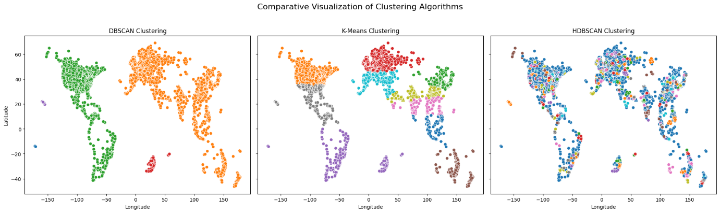
Silhouette Score:
Silhouette Score is a measure that assesses the quality of a clustering outcome by determining how well an object fits into its own cluster in relation to other clusters. It gives a means of determining the cohesion (how close a point is to other points within its cluster) and separation (how far from points in other clusters a point is). For every point in the data, the silhouette measure lies between -1 and 1. It approaches 1 when the point is well clustered by its own group and ill-clustered from neighboring groups, and this represents a good group assignment. For the point between groups, its value is about 0, while a negative value suggests the point has perhaps been misallocated to a different group. Overall silhouette score is an average of single scores over all data points and is a convenient metric to use for comparing different clustering setups or determining the ideal number of clusters. High average silhouette scores will usually indicate better-differentiated clusters, which makes this statistic particularly useful for applications involving algorithms such as K-Means or DBSCAN.
Davies Bouldin Index:
The Davies-Bouldin Index (DBI) is a metric that evaluates clustering by taking the average similarity between each cluster to its closest neighbor based on intra-cluster distance (how close points are to one another) and inter-cluster distance (how far apart clusters are). The lower the value on the Davies-Bouldin Index, the greater the clustering is. The index calculates a ratio of within-cluster scatter to between-cluster separation for each cluster and identifies the worst-case (most similar) pair of clusters, then reports the average of those worst-case similarities across all clusters. The Davies-Bouldin Index approaches the comparison between the like, or similar, and the unlike, or dissimilar, whereas the Silhouette Score ranges from -1 to 1 (higher is better), but Davies-Bouldin Index can go significantly higher, but the lower the value the better. It also provides a mechanism to compare the performance of different clustering algorithms or different numbers of clusters or categorical group constructs and select the model that produces the most distinct, and cohesive, clustering of variables.
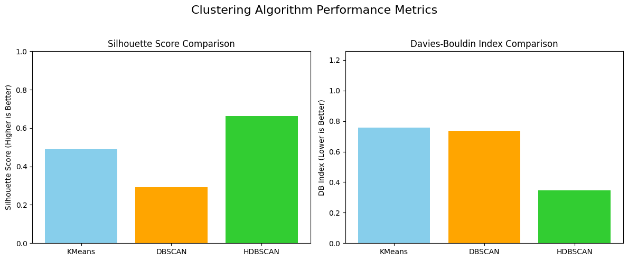
Results:
Of the algorithms tested, HDBSCAN was the most resilient, providing the most significant clusters and best performance in both visual and statistical measures. In contrast to the more common assumptions of symmetrical, uniform clusters, HDBSCAN allows for the irregularities and nuances of real-world geography—perfect for companies with expansive, non-uniform footprints like McDonald's.
The capacity to reveal natural clusters, identify over-saturation, identify outliers, and recognize expansion gaps provides business leaders with an active set of tools for streamlining operations. Further, combining clustering with visualization and geographic mapping capabilities enables these findings to be quickly interpreted and addressed by cross-functional teams.
In a more competitive and data-driven marketplace, such clustering methods provide a competitive advantage. They enable companies to:
- Segment markets with precision
- Tailor services to regional demand
- Improve logistical efficiency
- Expand strategically
- Avoid costly redundancies
- Maximize profitability

Finally, clustering converts store location information from a static list of coordinates to a living map of opportunity, enabling organizations to make wiser, quicker, and more confident decisions.

