BIRLA INSTITUTE OF TECHNOLOGY & SCIENCE, PILANI
Work Integrated Learning Programmes | Machine Learning Operations
End to End MLOps for Heart Disease Risk Prediction
AIMLZG523 | Assignment 01
Name: Ujjwal
Student ID 2025ae05260
BITS email 2025ae05260@wilp.bits-pilani.ac.in
Submission date 20 October 2026
GitHub repository github.com/UjjwalSk/mlops-assignment-1

Executive summary
This project implements a reproducible machine-learning workflow for binary classification on the Cleveland subset of the UCI Heart Disease dataset. The workflow prepares and validates 303 records, explores the data, tunes Logistic Regression and Random Forest models, records experiments in MLflow, packages the selected scikit-learn pipeline, and serves predictions through a FastAPI application. Automated checks, a Docker Compose monitoring stack, and Kubernetes manifests complete the delivery path.
The refreshed run selected Logistic Regression because it achieved the higher holdout ROC-AUC (0.9578). Random Forest achieved higher accuracy (90.16%) and recall (96.43%), so the choice depends on the stated ranking metric rather than a claim that one model dominates every measure. The API and monitoring stack were exercised on the BITS Prayogshala remote machine; Minikube showed two running replicas and a successful port-forward health check. The cluster did not expose a LoadBalancer address, and the HPA reported unknown resource metrics during the recorded run.
Evidence area | Recorded result
Prepared data | 303 records · 13 predictors · 6 missing values
Best holdout ROC-AUC | 0.9578 · Logistic Regression
Automated checks | 13 tests passed · Ruff checks passed
Runtime evidence | API, Docker Compose monitoring, and Minikube screenshots
Scope: this is an academic prototype based on a small historical dataset. It is not a clinical device and is not intended for diagnosis or treatment.

01 SYSTEM DESIGN

Architecture and MLOps workflow
The implemented path connects model development to a monitored API while keeping training and serving artifacts reproducible.
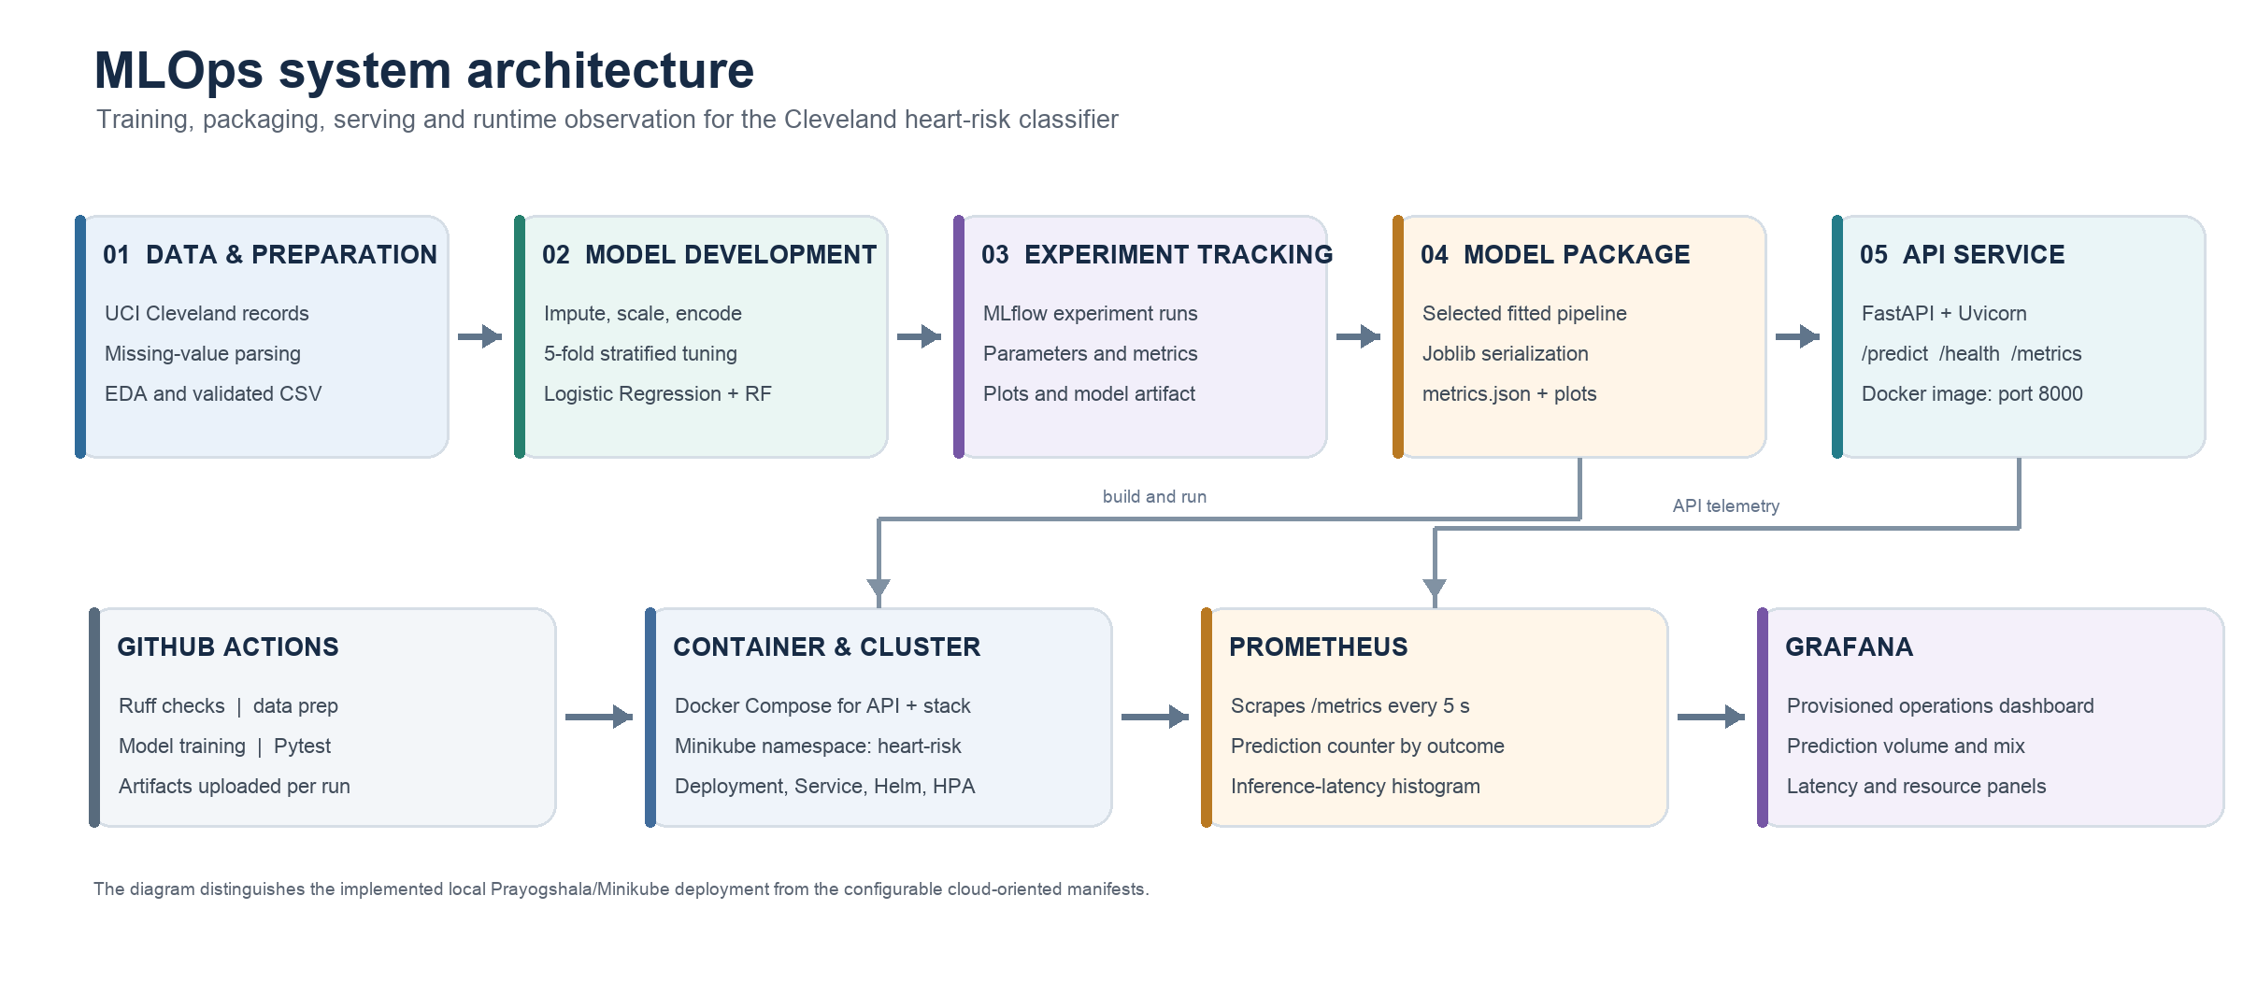
Figure 1. Implemented training, packaging, serving and monitoring components.
The training path starts with the supplied UCI archive. A preparation script converts missing-value markers, validates the schema and writes a processed CSV. A scikit-learn Pipeline keeps imputation, scaling and encoding inside cross-validation, reducing the risk of preprocessing leakage. GridSearchCV tunes two classifiers; MLflow stores run parameters, metrics and artifacts. The selected fitted pipeline is serialized to Joblib for API inference.
The runtime path uses FastAPI with cached model loading and three operational endpoints: /health, /predict and /metrics. Docker Compose runs the API alongside Prometheus and Grafana. For the recorded Prayogshala run, Kubernetes resources were applied in the heart-risk namespace through Minikube; the service was checked through kubectl port-forward.
GitHub Actions is configured to lint, prepare data, train, run tests and upload artifacts. The workflow definition is present in the repository; this report records local test and remote deployment evidence, not a claim that a hosted GitHub Actions run completed.

Implementation traceability
Component | Repository evidence
Preparation and EDA | scripts/prepare_data.py · scripts/run_eda.py
Training and tracking | src/heart_risk/train.py · MLflow runs · artifacts/
Serving and tests | src/heart_risk/api.py · tests/ · Dockerfile
Deployment and telemetry | k8s/ · monitoring/ · docker-compose.yml

02 DATA UNDERSTANDING

Dataset preparation and exploratory analysis
The report uses the Cleveland subset and the project’s refreshed EDA outputs.
The processed file contains 303 patient records and 13 predictors. The source target has values 0–4; the pipeline maps 0 to the absence class and values greater than 0 to the presence class. Six feature values were missing in the analyzed data and are handled by model-pipeline imputers. The class counts are 164 absence cases and 139 presence cases (45.9% positive).
Dataset measure | Run value
Observations | 303
Predictors | 13
Missing feature values | 6
Target 0 · absence | 164 (54.1%)
Target 1 · presence | 139 (45.9%)
Exploratory plots summarize the age distribution, class balance and correlations. The class proportions are sufficiently close to balanced for the baseline comparison, but they do not remove the need to inspect class-specific errors. The categorical-feature charts and numerical boxplots are included with the generated figures in reports/figures/.
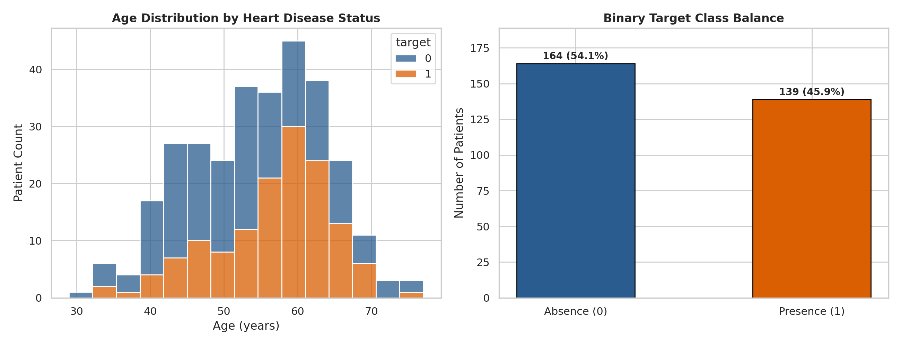
Figure 2. Age distribution and target balance (reports/figures/distribution_and_balance.png).
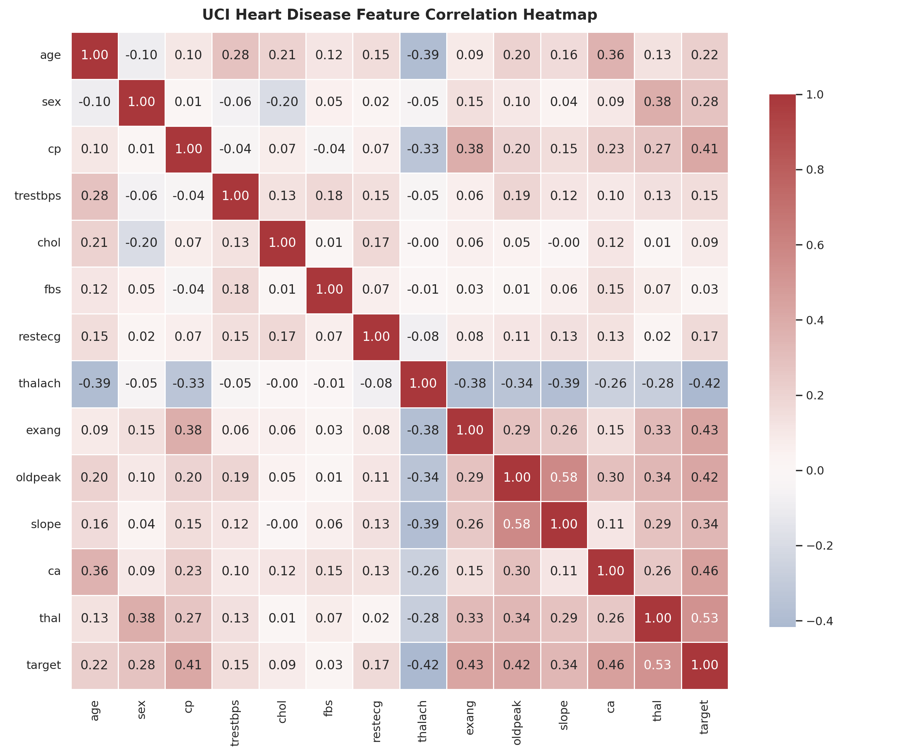
Figure 3. Correlations are descriptive associations, not causal effects.

03 MODELING APPROACH

Preprocessing and candidate models
All transformations are fitted within the estimator pipeline so cross-validation evaluates the complete modeling procedure.
A stratified 80/20 split with random_state=42 creates the training and holdout partitions. Model selection within the training partition uses shuffled, stratified five-fold cross-validation and ROC-AUC scoring. The preprocessing stages are embedded in a ColumnTransformer and then in each classifier Pipeline.
Feature group | Fields | Training-fold transformation
Continuous | age, trestbps, chol, thalach, oldpeak, ca | Median imputation, then standard scaling
Categorical | cp, restecg, slope, thal | Most-frequent imputation, then one-hot encoding
Binary | sex, fbs, exang | Most-frequent imputation; retain 0/1 values

Search strategy
- Logistic Regression uses class_weight="balanced" and max_iter=2000; the search covers C = 0.01, 0.1, 1, 5, 10 and solvers lbfgs and liblinear.
- Random Forest uses class_weight="balanced"; the search covers 100, 200 or 300 trees, four max_depth choices, two min_samples_split values and three min_samples_leaf values.
- The best configuration for each estimator is refit on the full training partition. The holdout partition has 61 records and is used for the recorded evaluation metrics and plots.
The pipeline is serialized as artifacts/heart_risk_pipeline.joblib. Keeping preprocessing with the estimator lets the API accept the original 13 feature fields without reproducing transformations in serving code.
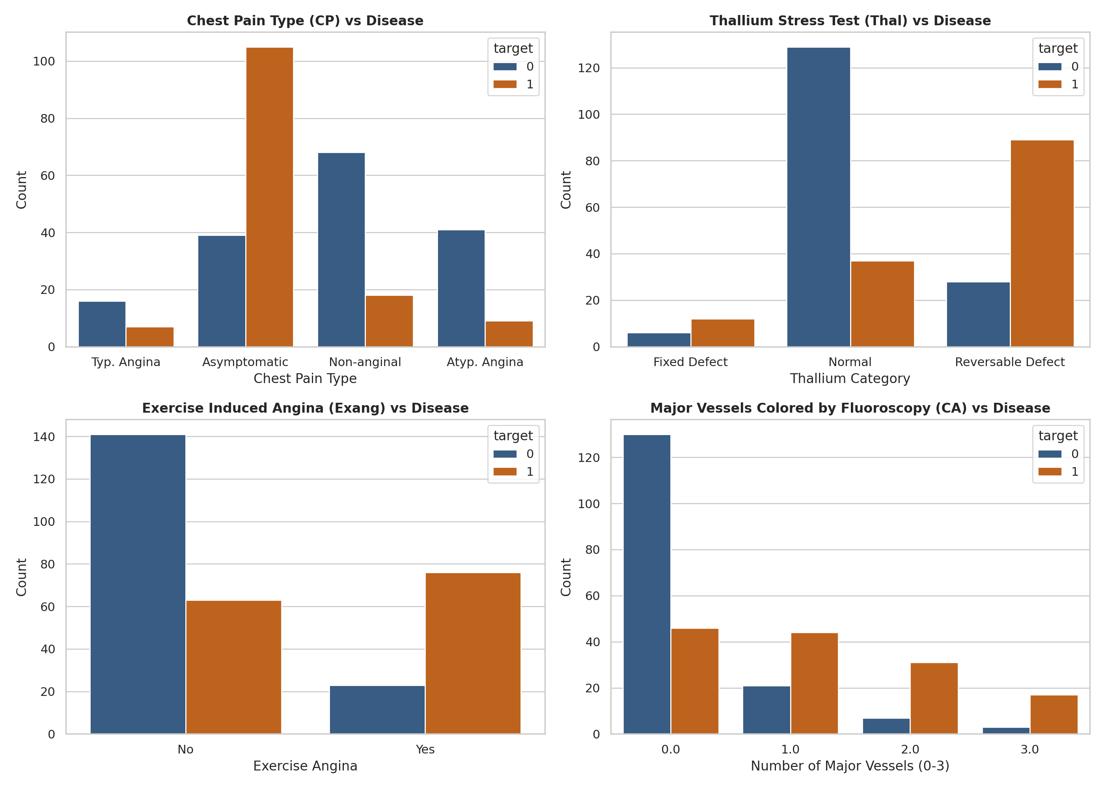
Figure 4. Selected categorical feature distributions by target class; category codes are treated as nominal inputs.

04 EVALUATION

Holdout performance and model selection
Metrics below are from the refreshed artifacts/metrics.json and the 61-record holdout partition.
Model | CV AUC | Accuracy | Precision | Recall | F1 | Holdout AUC
Logistic Regression | 0.9082 | 86.89% | 81.25% | 92.86% | 86.67% | 0.9578
Random Forest | 0.9003 | 90.16% | 84.38% | 96.43% | 90.00% | 0.9535
Logistic Regression is the stored model because the training script selects the candidate with the higher holdout ROC-AUC. Random Forest led on accuracy, precision, recall and F1 in this run. Both models performed strongly on this split, but the differences are small and should not be treated as evidence of clinical utility.
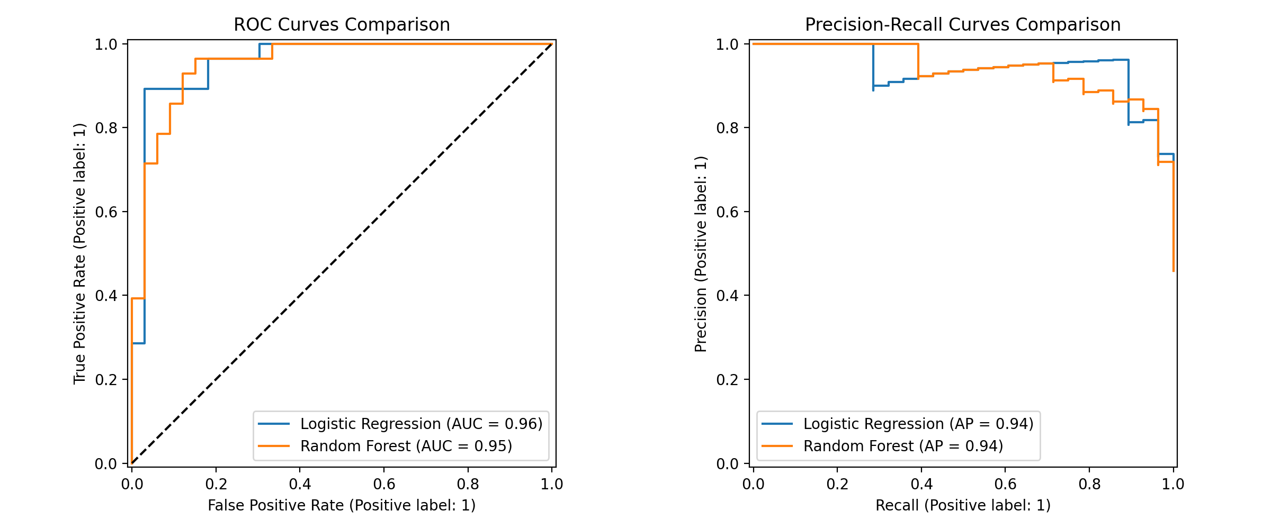
Figure 5. Holdout ROC and precision-recall curves for both models.
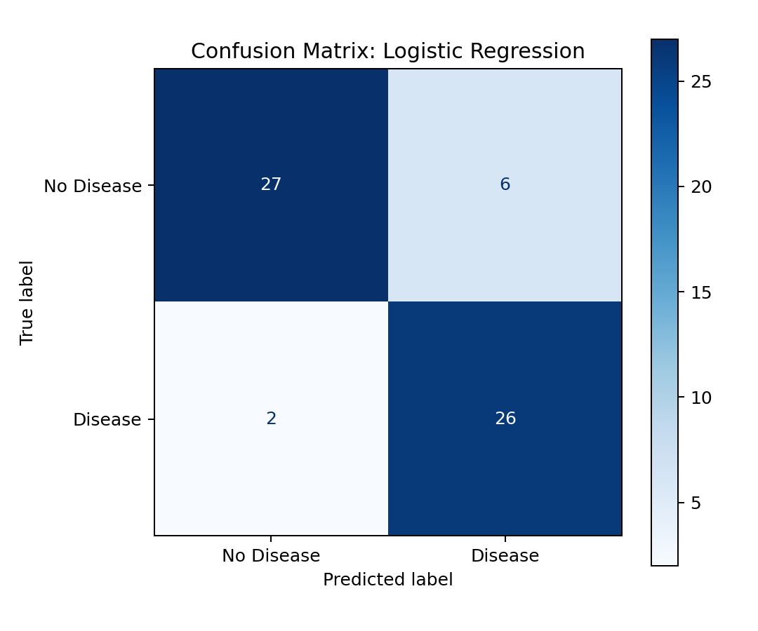
Figure 6. Logistic Regression confusion matrix: 27 true negatives, 6 false positives, 2 false negatives and 26 true positives.
Evaluation caveat: the same holdout AUC is used to choose the final model. This makes the reported winning holdout score selection-biased; it is not a fully independent final estimate. A stronger follow-up would use nested cross-validation or retain a separate untouched test set after model selection.

05 EXPERIMENT TRACKING

MLflow comparison and logged runs
The heart-risk-production experiment contains separate Logistic Regression and Random Forest runs.
The runs record the estimator type, selected hyperparameters, cross-validation ROC-AUC and holdout accuracy, precision, recall, F1 and ROC-AUC. Training also logs confusion matrices, ROC and precision-recall plots, feature coefficient/importances, classification-report text and the fitted scikit-learn model. The comparison views below provide run-level evidence from the Prayogshala session.
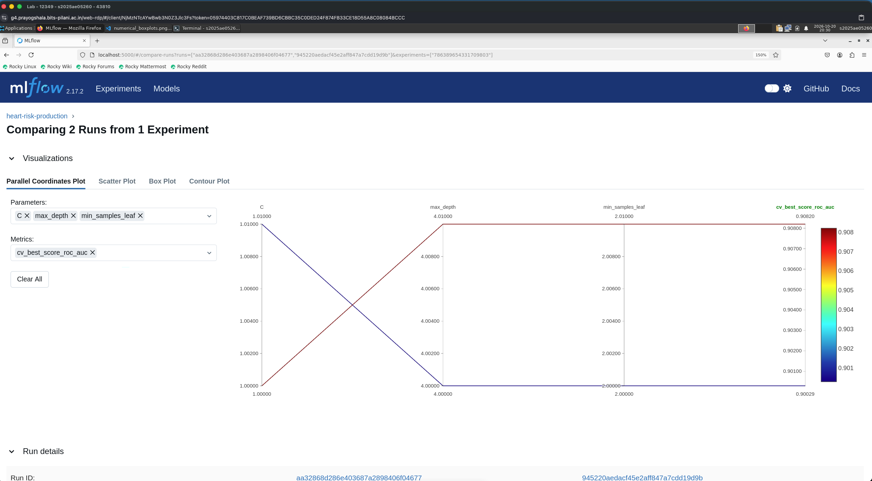
Figure 7. MLflow comparison visualization for the two tracked runs.
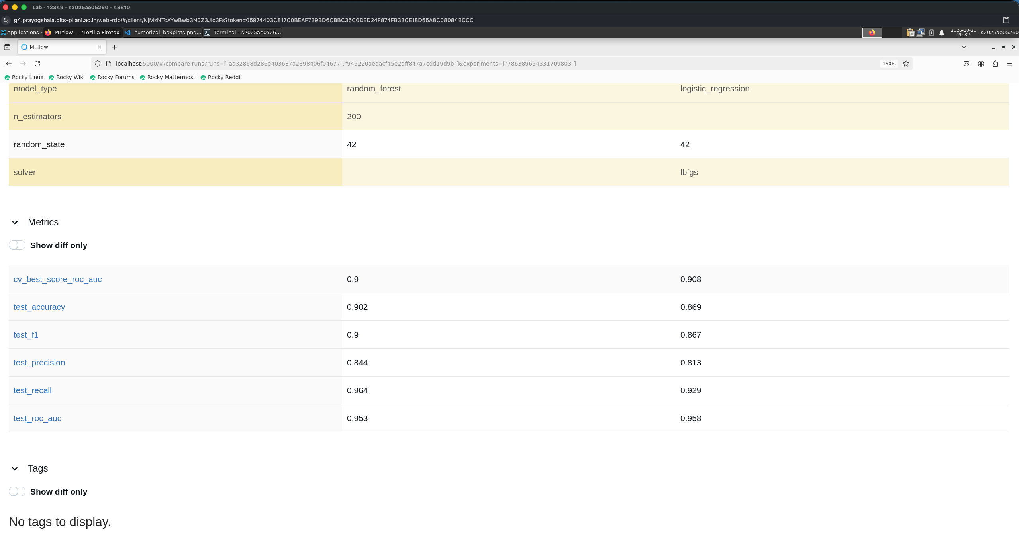
Figure 8. Side-by-side MLflow metrics: Random Forest has higher accuracy and recall; Logistic Regression has higher ROC-AUC.
MLflow tracking is configured with a local file-based store (mlruns/). The repository includes artifacts/metrics.json and plots for reproducible inspection; the tracking UI itself is not a remote model registry.

06 QUALITY CONTROLS

Automated tests and linting
The refreshed remote run provides direct terminal evidence for the project’s test suite and lint check.
The test suite covers data validation, API health and prediction behavior, input rejection, metrics exposition, pipeline fitting and serialization. The captured run collected 13 tests and shows each test passing. Ruff reports “All checks passed!”. The screenshots also show deprecation warnings from installed dependencies; they did not cause test failures.
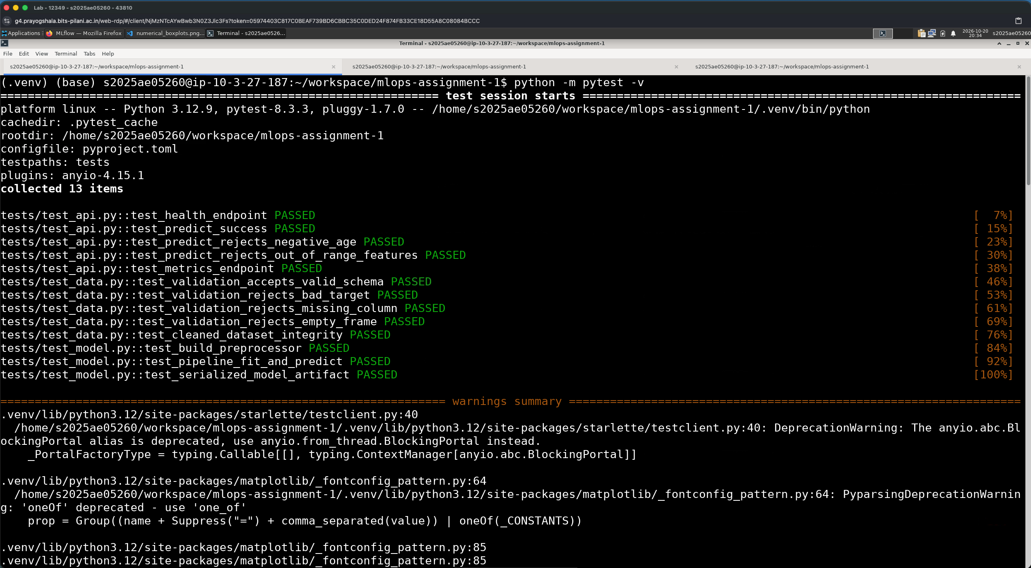
Figure 9. Test run: all 13 tests passed. The captured environment reports Python 3.12.9.
Ruff reported “All checks passed” in the refreshed remote run. Test coverage is grouped below by responsibility.
Test area | Verified behavior
API | Health, prediction success, invalid input and metrics endpoint
Data | Schema, target validation, missing columns and empty frame handling
Model | Preprocessor construction, fit/predict and serialized artifact load
The GitHub Actions workflow is configured for Python 3.10 and runs Ruff, data preparation, model training, Pytest, EDA generation and artifact upload. The recorded test screenshot is from Python 3.12.9, so it is separate evidence from the configured CI runtime.

07 SERVING

FastAPI inference and container execution
The serving interface validates the request schema and returns a class label with a disease probability.
FastAPI exposes GET /health, POST /predict and GET /metrics. The model is loaded through a one-entry cache, so requests reuse the serialized pipeline. Pydantic bounds validate the 13 fields before inference. The prediction endpoint reports prediction, risk_label, confidence, disease_probability and model_version.
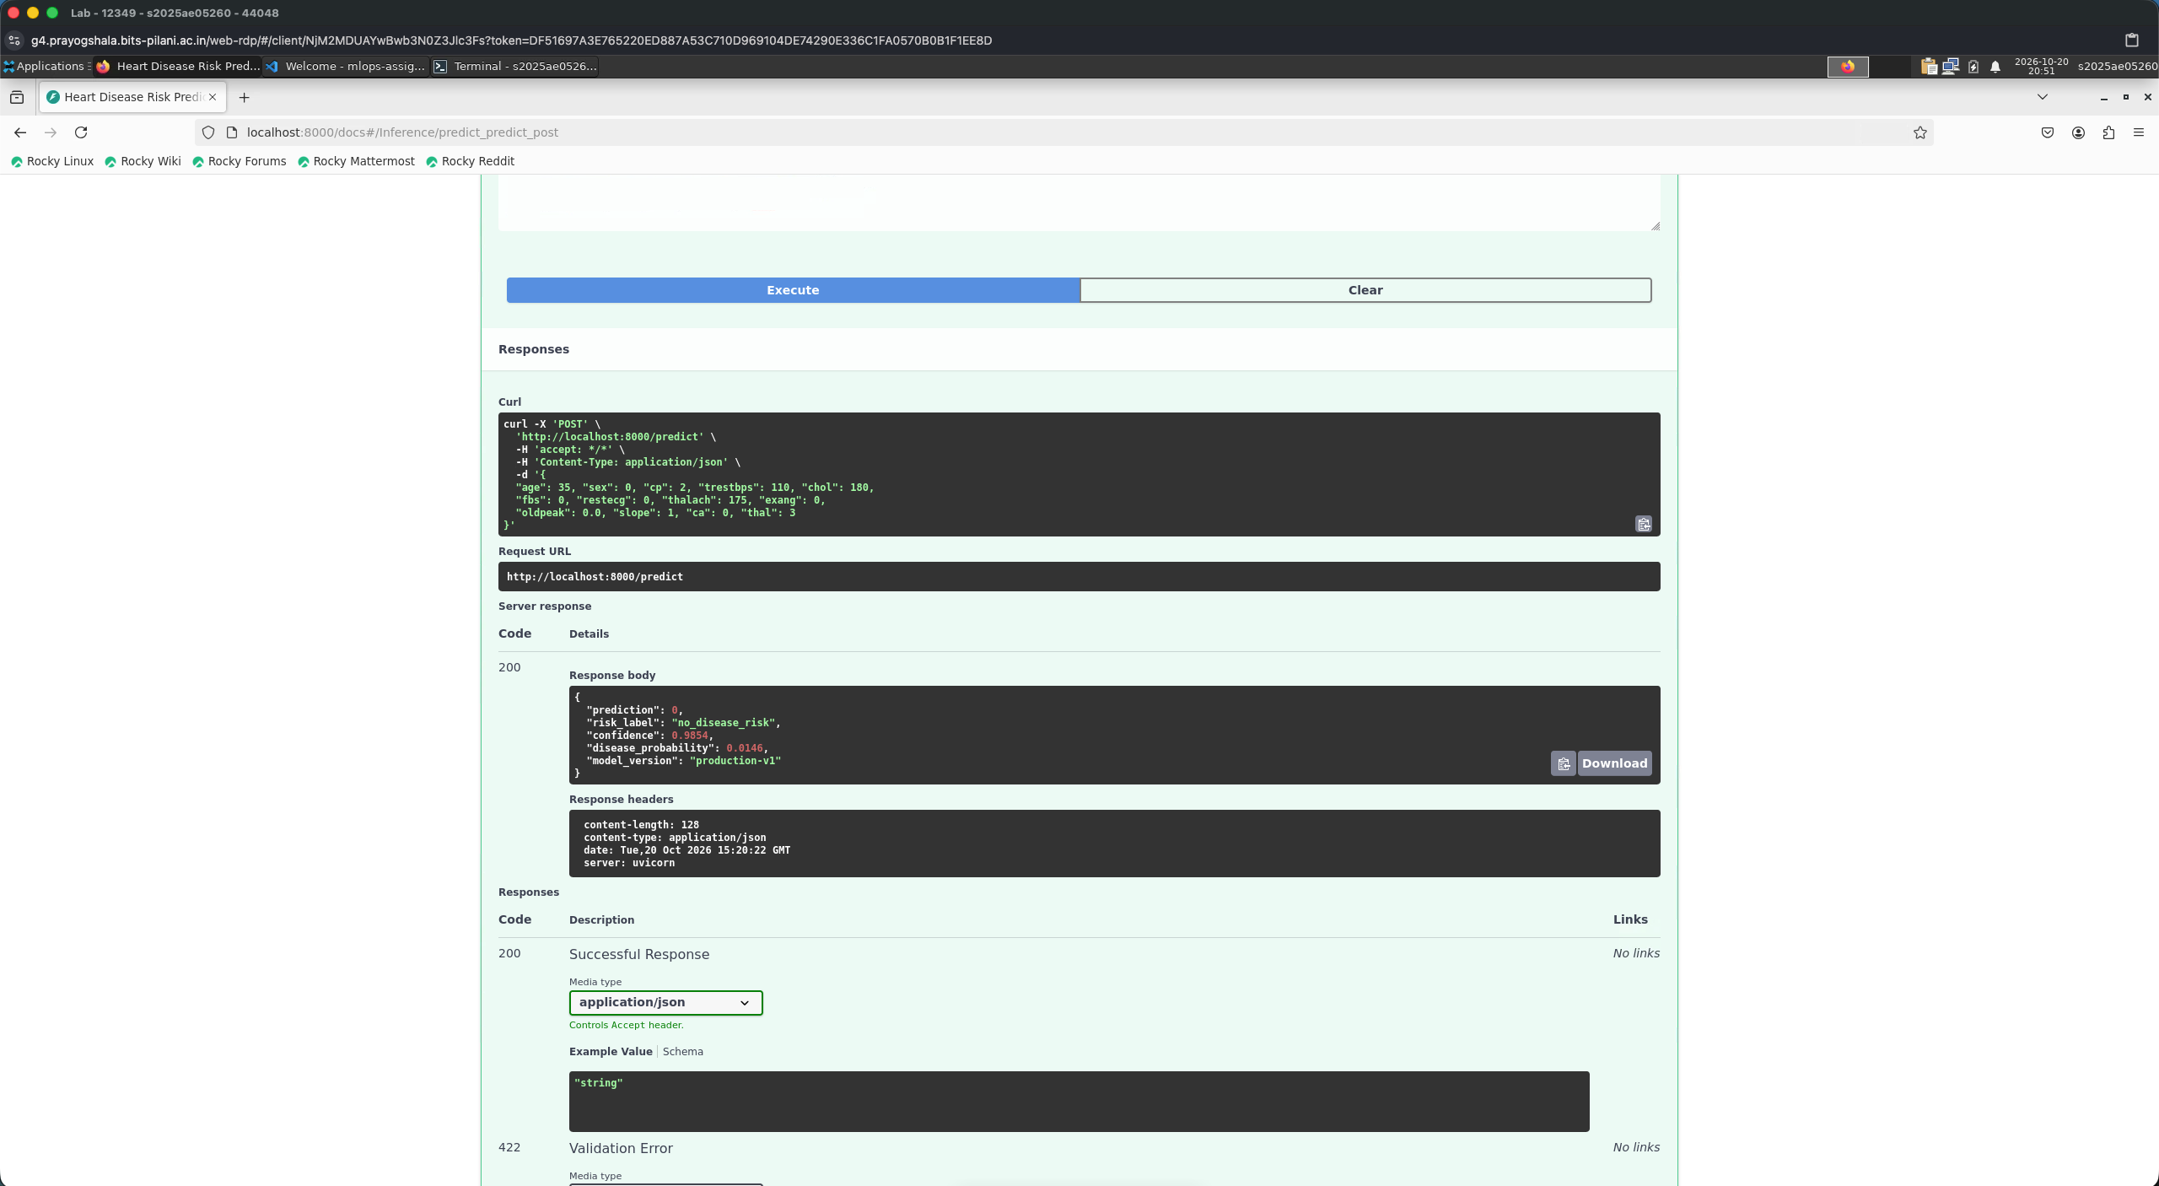
Figure 10. Swagger prediction request returned HTTP 200 with a no-disease-risk result for the submitted example.
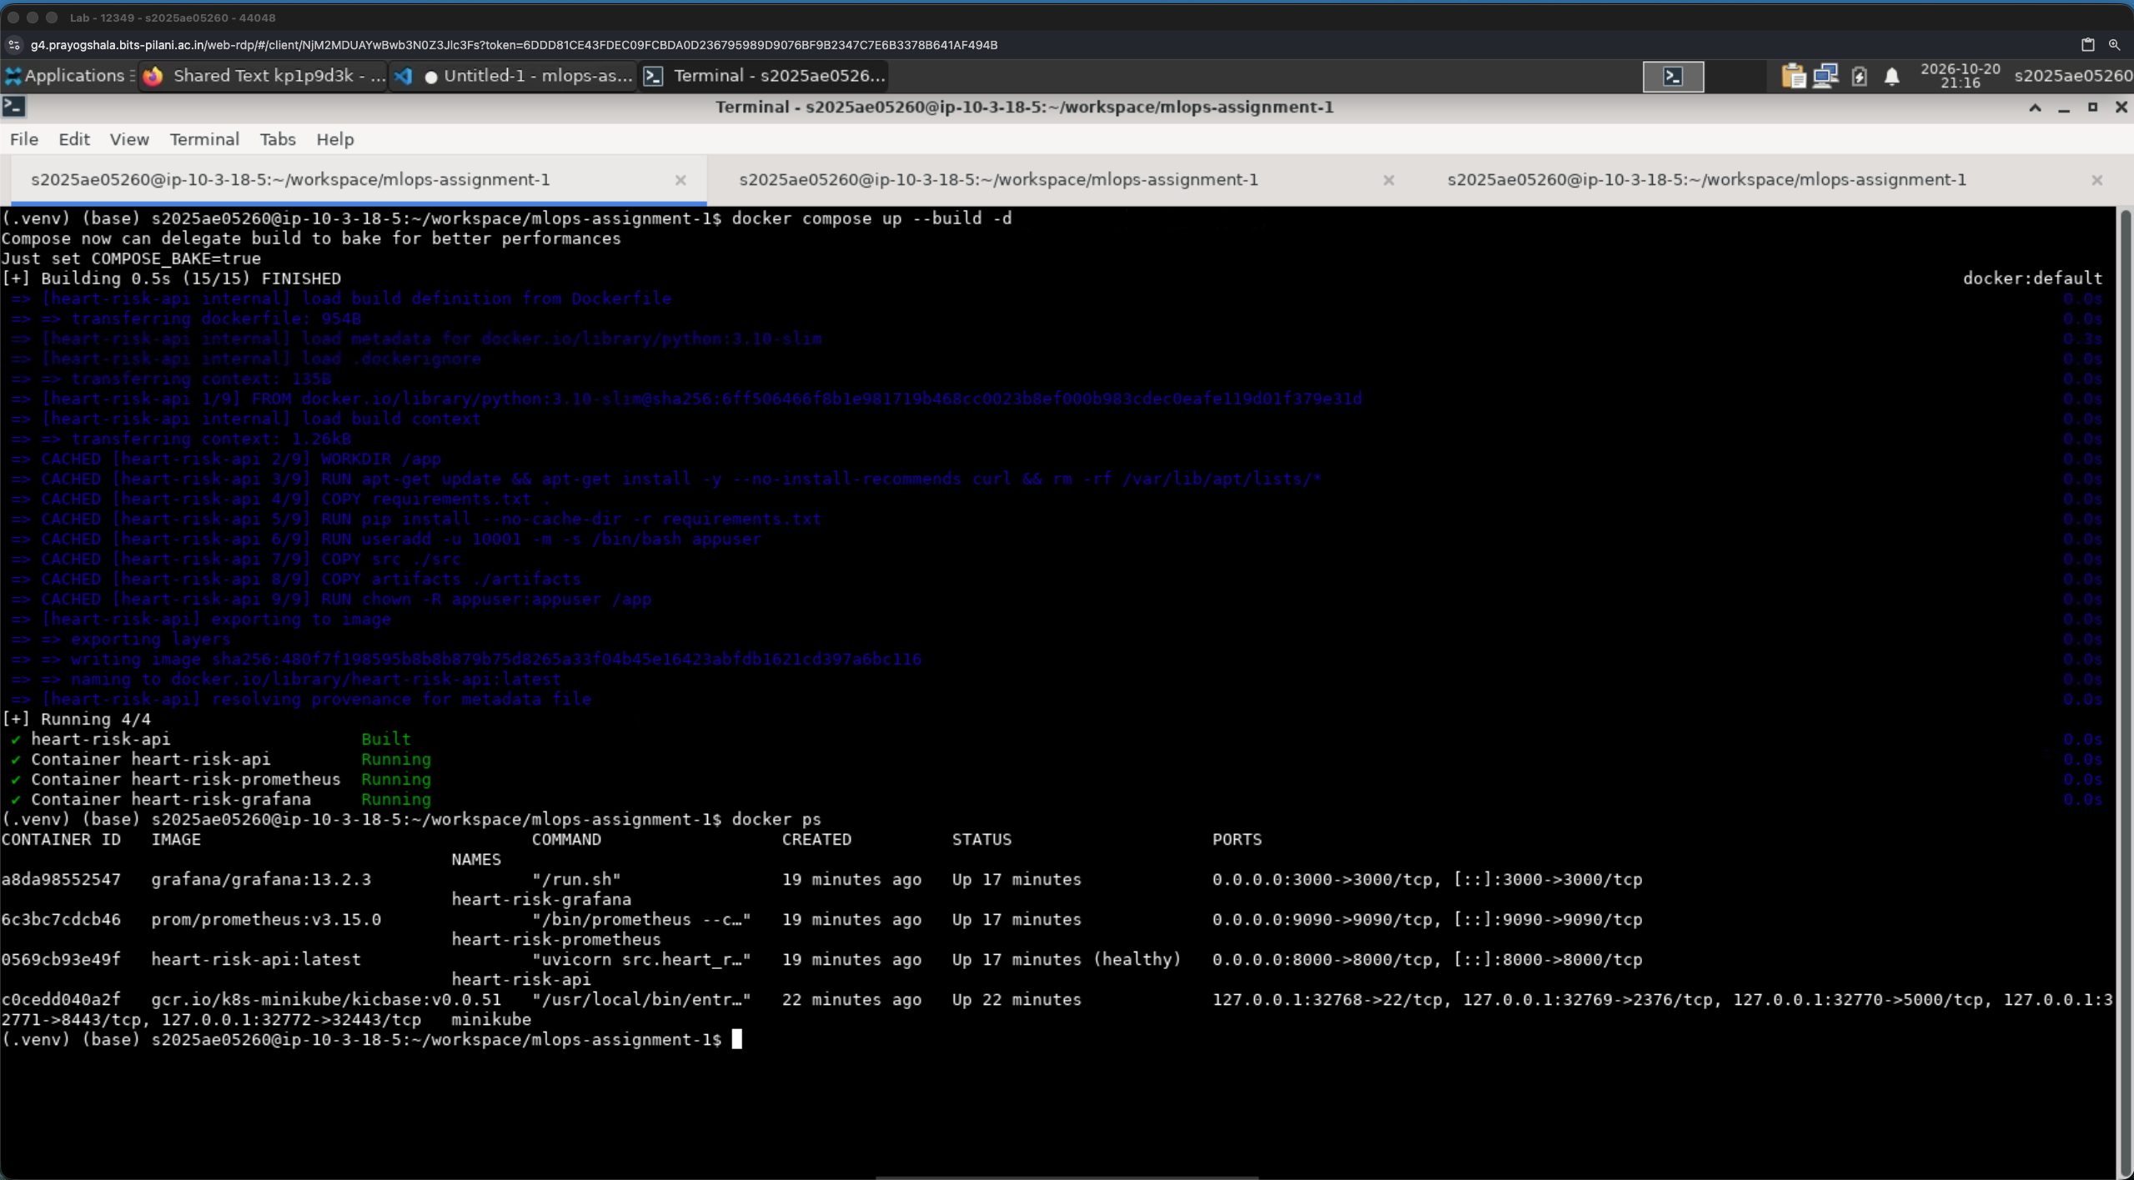
Figure 11. Docker Compose build and runtime status for the API, Prometheus and Grafana services.
The Docker Compose stack provides local service ports for the API, Prometheus and Grafana. The screenshots evidence a successful build and a healthy API container. The endpoint is a demonstration interface; the dataset and model are not clinically validated.

08 MONITORING

Prometheus metrics and Grafana dashboard
The API exposes prediction counts by outcome and an inference-latency histogram for scraping.
Prometheus is configured to scrape the API’s /metrics endpoint every five seconds. The Grafana dashboard reports total predictions, disease-risk and no-disease predictions, prediction share, request rate, latency quantiles, average latency and container resource panels. During the recorded view, the dashboard showed 17 predictions: 8 disease-risk and 9 no-disease outcomes (47.1% disease-risk share). These are demonstration requests, not population estimates.
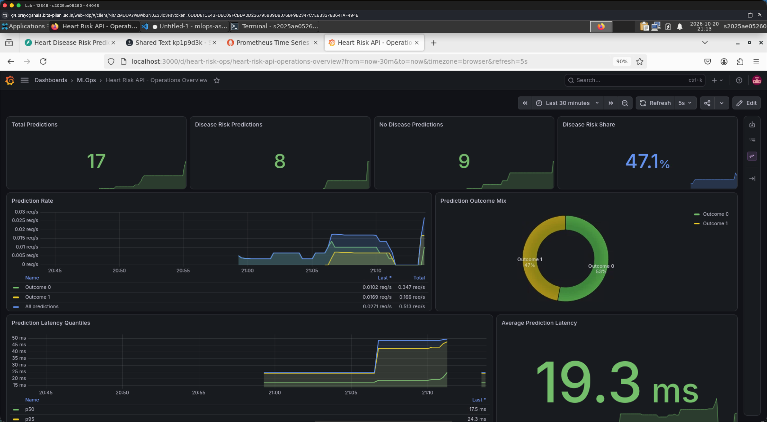
Figure 12. Operations overview during the recorded demonstration: 17 predictions, 8 positive and 9 negative.
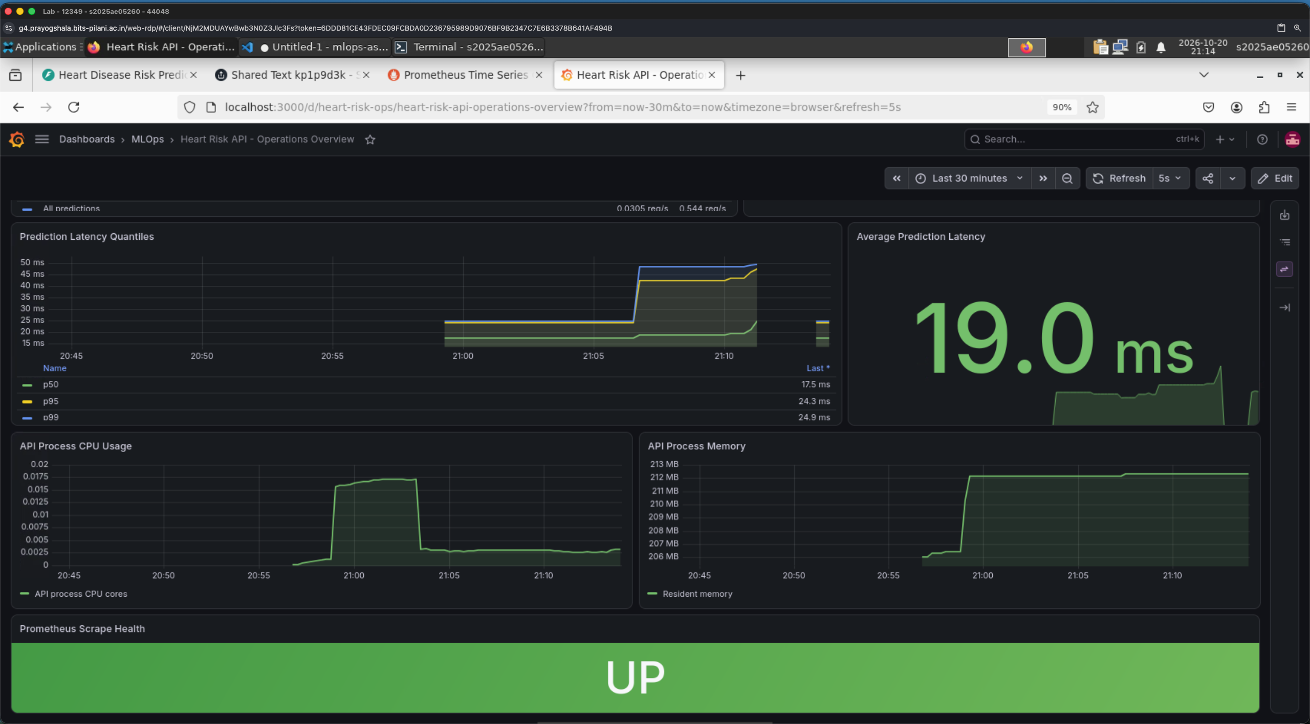
Figure 13. Latency and resource panels; the screenshot shows monitoring targets in the UP state.
Observed latency and resource values are specific to this short test session and host. They do not establish service-level objectives or sustained-load performance.

09 DEPLOYMENT AND REPRODUCIBILITY

Minikube evidence, limits and run instructions
The remote demonstration used the BITS Prayogshala environment and the heart-risk Kubernetes namespace.
The Kubernetes evidence shows two heart-risk-api pods in Running state and a deployment with two available replicas. A kubectl port-forward to service/heart-risk-api on local port 8002 returned a healthy /health response with model_loaded=true. Helm lint completed with one chart and no failures; it displayed an informational recommendation to add a chart icon.
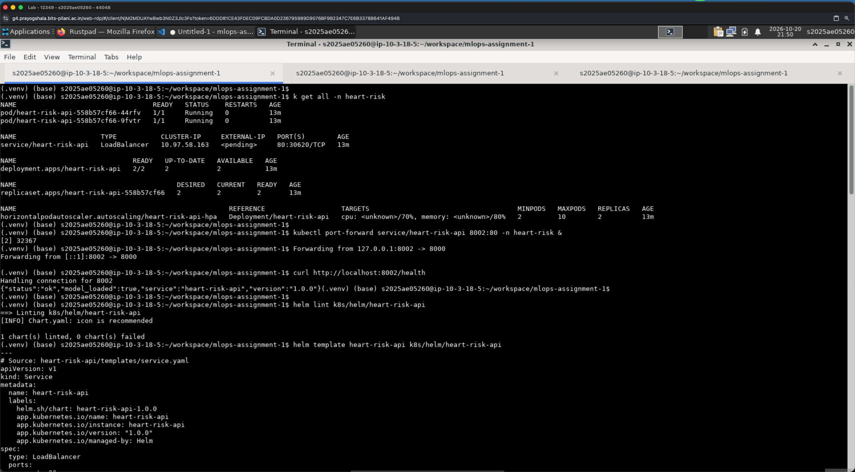
Figure 14. Minikube and Helm evidence from Prayogshala.
Deployment limits observed: the LoadBalancer Service had EXTERNAL-IP pending, so the service was accessed through port-forward rather than a public endpoint. HPA CPU and memory targets appeared as <unknown>; autoscaling configuration exists, but this run does not demonstrate active scaling. The shown HPA minimum and observed replicas were two.

Reproduction commands
python scripts/prepare_data.py
python scripts/run_eda.py
python -m src.heart_risk.train --experiment-name heart-risk-production
python -m pytest -v && python -m ruff check src tests scripts
docker compose up --build
kubectl apply -f k8s/00-namespace.yaml
kubectl apply -f k8s/
kubectl port-forward service/heart-risk-api 8002:80 -n heart-risk
Clinical and data limitations: the dataset is small, historical and limited to the Cleveland cohort. Missingness, sampling bias, label construction, calibration, subgroup fairness and temporal drift require further study. The model is an academic prototype, not a diagnostic device.
References
Janosi, A., Steinbrunn, W., Pfisterer, M., & Detrano, R. (1989). Heart Disease [Dataset]. UCI Machine Learning Repository. https://doi.org/10.24432/C52P4X
Source code and generated evidence: github.com/UjjwalSk/mlops-assignment-1

