Assignment 5

Question1:
Query that will give you all orders for more than Rs. 1000.
Answer 1:
select * from orders where amt>1000;

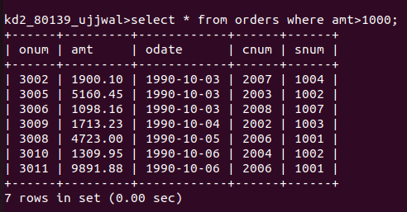
Question2:
Query that will give you the names and cities of all salespeople in london with a commission above 0.10.
Answer 2:
select sname,city from salespeople where
comm>0.10;

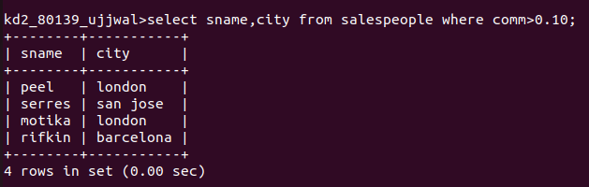
Question3:
Query on the customers table whose output will execute all customers with a rating<=100, unless they are located in rome.
Answer 3:
select * from customers where rating>100 or city='rome';

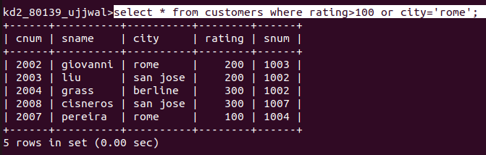

Question4:
Output for:-
Select * from orders where(amt<1000 OR NOT (odate=’1990-10-03’ AND cnum>2003));
Answer 4:
select * from orders where (amt<1000 or not (odate='1990-10-03' and cnum>2003));

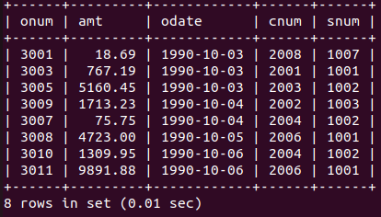

Question5:
select * from orders where (amt<1000 or not (odate='1990-10-03' and cnum>2003));
Answer 5:
select * from orders where (amt<1000 or not (odate='1990-10-03' and cnum>2003));
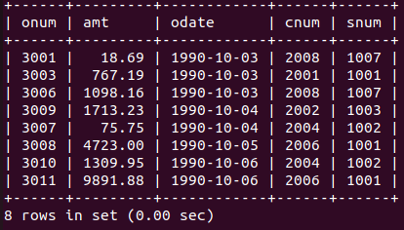

Question6:
select snum,sname,city,comm from salespeople where comm>.12 or comm<.14;
Answer 6:
select snum,sname, city ,comm from salespeople where comm=.13;
