Assignment 4

Question1:
Write a select command that produces the order number, amount, and date for all rows in the orders table.
Answer 1:
SELECT onum,amt,odate FROM orders;
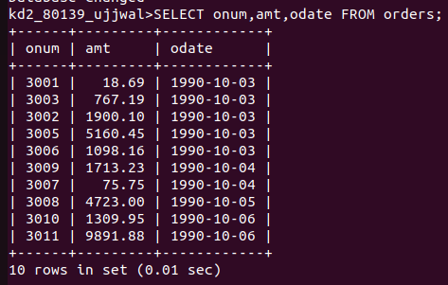

Question2:
Write a query that produces all the rows from the customers table for which the salesperson’s number is 1001.
Answer 2:
SELECT * FROM orders WHERE snum=1001;
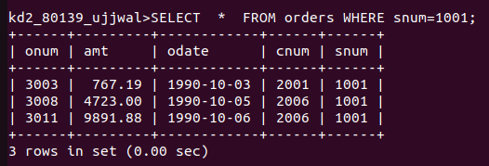

Question3:
Query to display the salespeople table with column in the following order : city,sname,snum,comm.
Answer 3:
SELECT city,sname,snum,comm FROM salespeople;
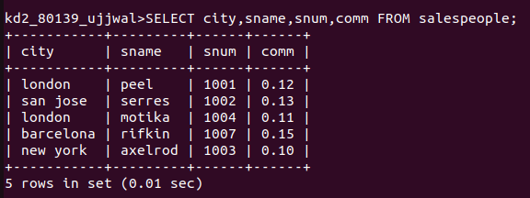
Question4:
Write a select command that produces the rating followed by the name of each customer in San Jose.
Answer 4:
SELECT rating,cname FROM customers WHERE city='san jose';

