Assignment 12

Question1:Question 1 = Write a query that selects all customers whose ratings are equal to or greater than any of Serres.
Answer1:

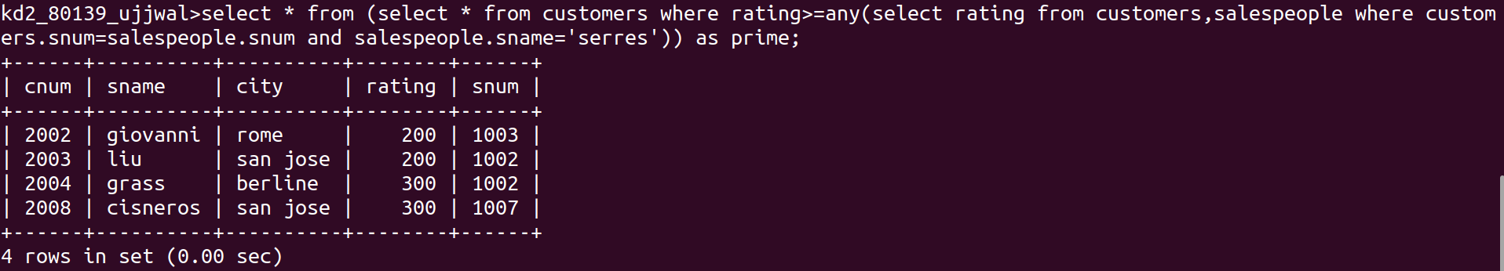
Question2:Write a query using ANY or ALL that will find all salespeople who have no customers located in their city.
Answer2:

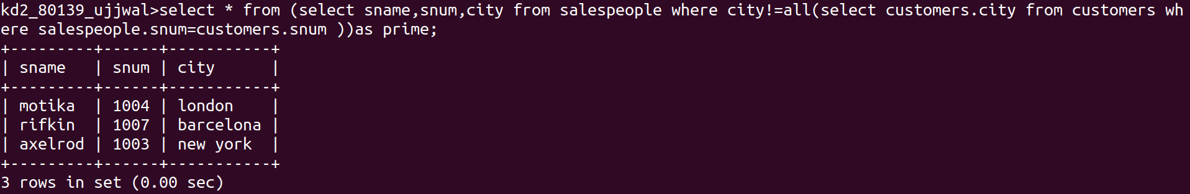
Question3:Write a query that selects all orders for amounts greater than any for the customers in london
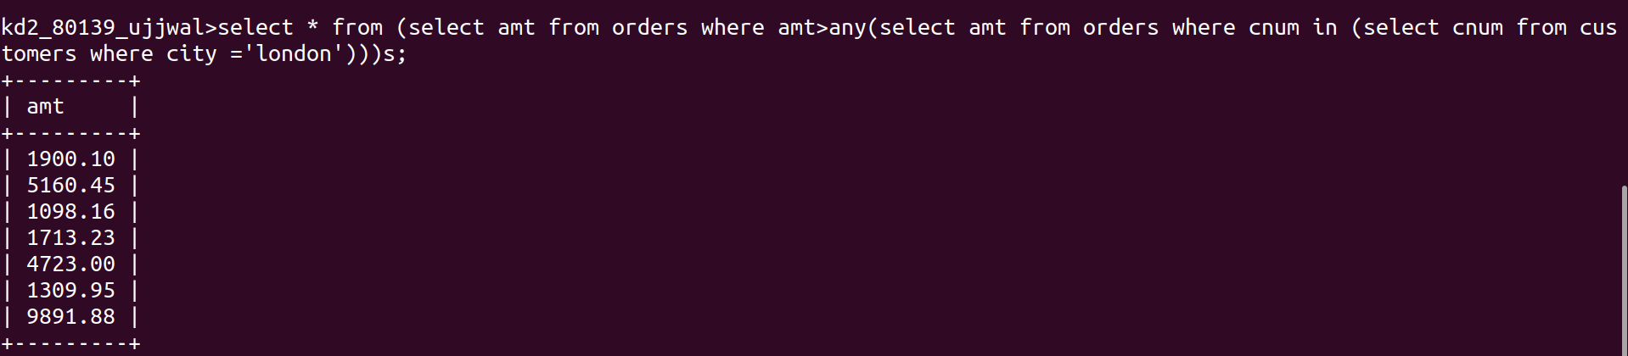
question 4:Write the above query using MIN or MAX.

