Assignment 9

Question1:Write a query that lists each other number followed by the name of the customer who made the order.
Answer1:
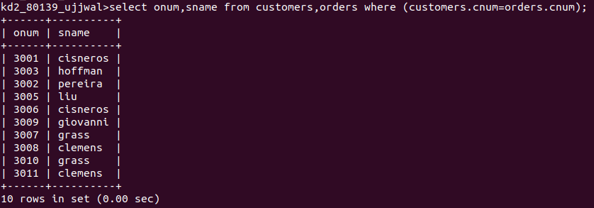
Question2:Write a query that gives the names of both the salesperson and the customer for each other along with the order number.
Answer2:
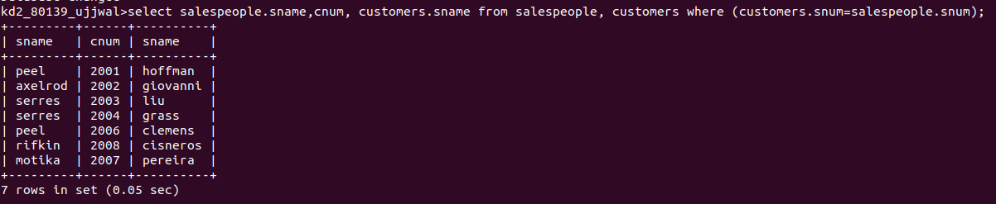
Question3:Write a query that produces all customers serviced by salespeople with a commision above 12%. Output the customer’s name, the salesperson’s name , and the salesperson’s rate of commission.
Answer3:
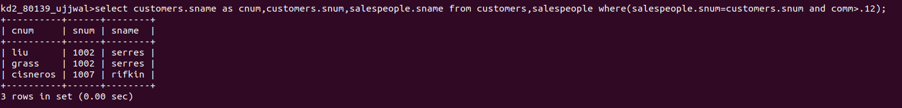
Question4:Write a query that calculates the amount of the salesperson’s commission on each order by customer with a rating above 100.
Answer4:
