Assignment 6

Answer1:
select * from orders where odate='1990-10-03';
select * from orders where odate='1990-10-04';
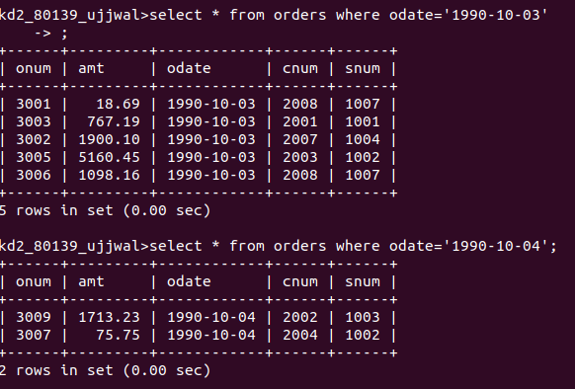

Answer2:
select * from salespeople join customers where salespeople.snum=customers.snum;
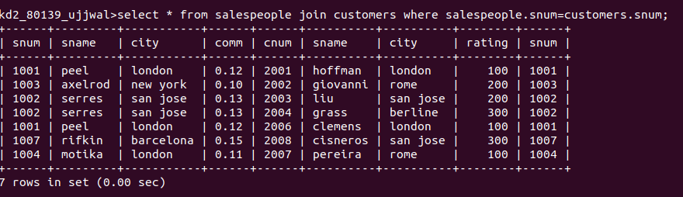
Answer3:
select * from customers where sname between 'a' and 'h';

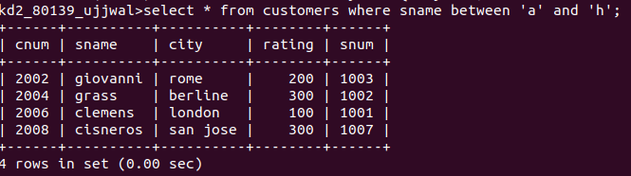
Answer4:
select * from customers where sname like 'c%';

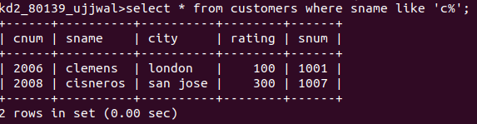
Answer5:
select * from orders where amt!=0 and amt is not null;
