**CS263-Web Technology Lab**

**HTML**

1. **a. Create a table to show your class timetable.**

**Code:**

**<!**DOCTYPE *html***>**

**<**html *lang*="en"**>**

**<**head**>**

**<**meta *charset*="UTF-8"**>**

**<**meta *http-equiv*="X-UA-Compatible" *content*="IE=edge"**>**

**<**meta *name*="viewport" *content*="width=device-width, initial-scale=1.0"**>**

**<**title**>**TimeTable**</**title**>**

**<**link *rel*="preconnect" *href*="https://fonts.googleapis.com"**>**

**<**link *rel*="stylesheet"

*href*="https://fonts.googleapis.com/css2?family=Material+Symbols+Rounded:opsz,wght,FILL,GRAD@48,500,0,0" **/>**

**<**style**>**

        body {

            background-color: **#202e38**;

            color: **#000000**;

            font-family: 'Zen Loop', cursive;

            font-size: **larger**;

            margin: 0;

        }

*.content* {

            margin: 10px;

            height: 100vh;

        }

*.wrap* {

            display: **flex**;

            justify-content: **center**;

            align-items: **center**;

            width: 90%;

            margin: **auto**;

            padding: 15px 10px 40px;

            border-radius: 10px;

            background-color: **#0a1c2a**;

        }

        table {

            color: rgba(240, 248, 255, 0.708);

            font-weight: 100;

            border: 2px **solid** **#FF4C29**;

            border-radius: 5px;

            width: 85%;

            font-family: 'Varela Round', **sans-serif**;

        }

        caption {

            font-size: **larger**;

            color: **#00ccff**;

        }

        td,

        th {

            text-align: **center**;

            width: 12.5%;

            padding: 5px 3px;

        }

        th {

            background-color: **#2C394B**;

        }

        td {

            font-size: **medium**;

            background-color: **#334756**;

        }

*.day* {

            font-size: **large**;

            font-weight: 600;

        }

        h1 {

            display: **block**;

            text-align: **center**;

            font-weight: **bold**;

            color: **aliceblue**;

            background-color: **#0a1c2a**;

            border-radius: 5px;

        }

*.subhead* {

            padding: 0px 1px 25px;

        }

        h2 {

            margin-left: 6%;

            display: **inline**;

            color: **#000000**;

            background-color: **#ffffff7c**;

            padding: 0px 10px;

            border-radius: 30px;

        }

**</**style**>**

**</**head**>**

**<**body**>**

**<**header**>**

**</**header**>**

**<**div *class*="content"**>**

**<**h1**>**TimeTable**</**h1**>**

**<**div *class*="subhead"**>**

**<**h2**>**B-Tech II Year II Semester**</**h2**>**

**</**div**>**

**<**div *class*="wrap"**>**

**<**table**>**

**<**caption**>**Time Table**</**caption**>**

**<**tr**>**

**<**th**>**Day-Time**</**th**>**

**<**th**>**8-9**</**th**>**

**<**th**>**9-10**</**th**>**

**<**th**>**10-11**</**th**>**

**<**th**>**11-12**</**th**>**

**<**th**>**12-1**</**th**>**

**<**th**>**1-2**</**th**>**

**<**th**>**2-3**</**th**>**

**</**tr**>**

**<**tr**>**

**<**td *class*="day"**>**Monday**</**td**>**

**<**td *colspan*="3"**>**&larr;WT Lab(C-III)&rarr;**</**td**>**

**<**td *rowspan*="6" *class*="Lunch"**>**Lunch**</**td**>**

**<**td**>**DBMS**</**td**>**

**<**td**>**OS**</**td**>**

**<**td**>**Sports**</**td**>**

**</**tr**>**

**<**tr**>**

**<**td *class*="day"**>**Tueday**</**td**>**

**<**td**>**SE**</**td**>**

**<**td**>**E&HV**</**td**>**

**<**td**>**CS**</**td**>**

**<**td *colspan*="3"**>**&larr;DBMS Lab(C-III)&rarr;**</**td**>**

**</**tr**>**

**<**tr**>**

**<**td *class*="day"**>**Wednesday**</**td**>**

**<**td**>**OS**</**td**>**

**<**td**>**DBMS**</**td**>**

**<**td**>**WT**</**td**>**

**<**td**>**SE**</**td**>**

**<**td**>**CS**</**td**>**

**<**td**>**Library**</**td**>**

**</**tr**>**

**<**tr**>**

**<**td *class*="day"**>**Thursday**</**td**>**

**<**td**>**SE**</**td**>**

**<**td**>**OS**</**td**>**

**<**td**>**DBMS**</**td**>**

**<**td**>**SOC**</**td**>**

**<**td**>**CS**</**td**>**

**<**td**>**WT**</**td**>**

**</**tr**>**

**<**tr**>**

**<**td *class*="day"**>**Friday**</**td**>**

**<**td *colspan*="3"**>**&larr;CS Lab(C-III)&rarr;**</**td**>**

**<**td**>**CS**</**td**>**

**<**td**>**DBMS**</**td**>**

**<**td**>**WT**</**td**>**

**</**tr**>**

**<**tr**>**

**<**td *class*="day"**>**Saturday**</**td**>**

**<**td *colspan*="2"**>**&larr;SOC Lab&rarr;**</**td**>**

**<**td**>**WT**</**td**>**

**<**td**>**E&HV**</**td**>**

**<**td *colspan*="2" *id*="CC"**>**&larr;Competitive Coding(E-LE)&rarr;**</**td**>**

**</**tr**>**

**</**table**>**

**</**div**>**

**</**div**>**

**</**body**>**

**</**html**>**

**Output:**

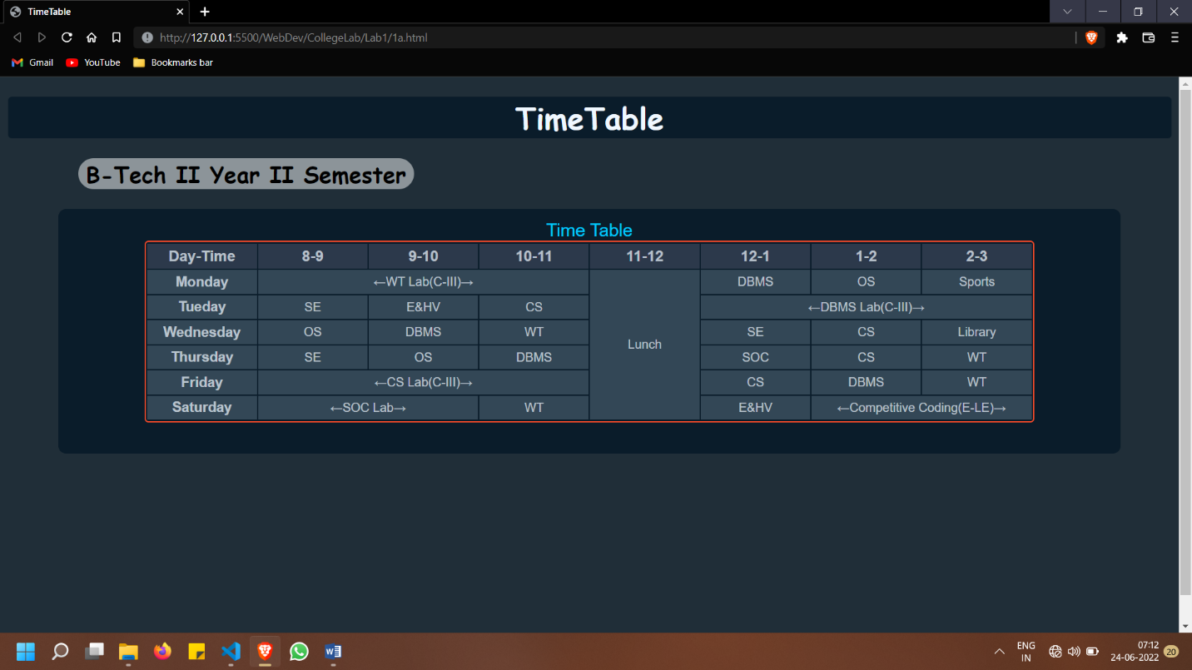

**b. Use tables to provide layout to your HTML page describing your college infrastructure.**

**Code:**

**<!**DOCTYPE *html***>**

**<**html *lang*="en"**>**

**<**head**>**

**<**meta *charset*="UTF-8"**>**

**<**meta *http-equiv*="X-UA-Compatible" *content*="IE=edge"**>**

**<**meta *name*="viewport" *content*="width=device-width, initial-scale=1.0"**>**

**<**title**>**InfraStructureTable**</**title**>**

**<**style**>**

        body {

            margin: 0;

        }

        table {

            width: 100vw;

        }

*.header1* {

            background-color: **beige**;

            justify-content: **center**;

        }

*.navigate* {

            background-color: rgb(208, 252, 252);

        }

*.navg* {

            list-style: **none**;

        }

*.navg*>li {

            padding: 10px 2px 0px;

        }

*.in* {

            background-color: **ghostwhite**;

        }

*.End* {

            background-color: **lavender**;

            text-align: **center**;

        }

        td {

            padding: 15px;

        }

        a {

            text-decoration: **none**;

            color: **black**;

        }

**</**style**>**

**</**head**>**

**<**body**>**

**<**div *class*="content"**>**

**<**table**>**

**<**tr *class*="header1"**>**

**<**td *colspan*="4"**>**

**<**h1**>**RVR&JC College of Engineering**</**h1**>**

**</**td**>**

**</**tr**>**

**<**tr *class*="in" *colpan*="1"**>**

**<**td *class*="navigate"**>**

**<**ul *class*="navg"**>**

**<**li**><**a *href*="#"**>**Main Block**</**a**></**li**>**

**<**li**><**a *href*="#"**>**Cyber Block**</**a**></**li**>**

**<**li**><**a *href*="#"**>**Digital Block**</**a**></**li**>**

**<**li**><**a *href*="#"**>**Centianal Block**</**a**></**li**>**

**<**li**><**a *href*="#"**>**Silver Jubliee Block**</**a**></**li**>**

**</**ul**>**

**</**td**>**

**<**td *class*="MainBody" *colspan*="3"**>**

**<**h2**>**RVR&JC InfraStructure**</**h2**>**

**<**h3**>**Information &rarr;**</**h3**>**

**<**ul**>**

**<**li**>**Administrative Block 1773 sq.m. (19077.48 sq.ft) (ground floor of

                            main building).**</**li**>**

**<**li**>**Principal Office 280 sq.mts. (3012.8 sq.ft.)**</**li**>**

**<**li**>**Staff Room 2472.35 sq.mt. (26602.486 sq.ft.)**</**li**>**

**<**li**>** Common Room 668.15 sq.mt. (7189.294 sq.ft.)**</**li**>**

**<**li**>**Canteen 1485.69 sq.mt. (15,986.02 sq.ft.)**</**li**>**

**<**li**>** Auditorium 743+743+1860 = 3346 sq.mts.**</**li**>**

**<**li**>**Internet facilities (35989.36 sq.ft.)**<**br**>**

                            1 GBPS**</**li**>**

**<**li**>** Medical facilities Dispensary provided in the college. Medicines

                            supplied free of cost to all students and staff. 2

                            Doctors, 1 Pharmacist and 1 Female Nurse are

                            appointed.**<**br**>**

                            Dispensary with free medicines provided in all

                            hostels with a Doctor and an Assistant.**</**li**>**

**<**li**>**Transport facilities 28 buses provided for students and staff.**</**li**>**

**</**ul**>**

**</**td**>**

**</**tr**>**

**<**tr *class*="End"**>**

**<**td *colspan*="4"**>**&larr;End of the Article&rarr;**</**td**>**

**</**tr**>**

**</**table**>**

**</**div**>**

**</**body**>**

**</**html**>**

**Output:**

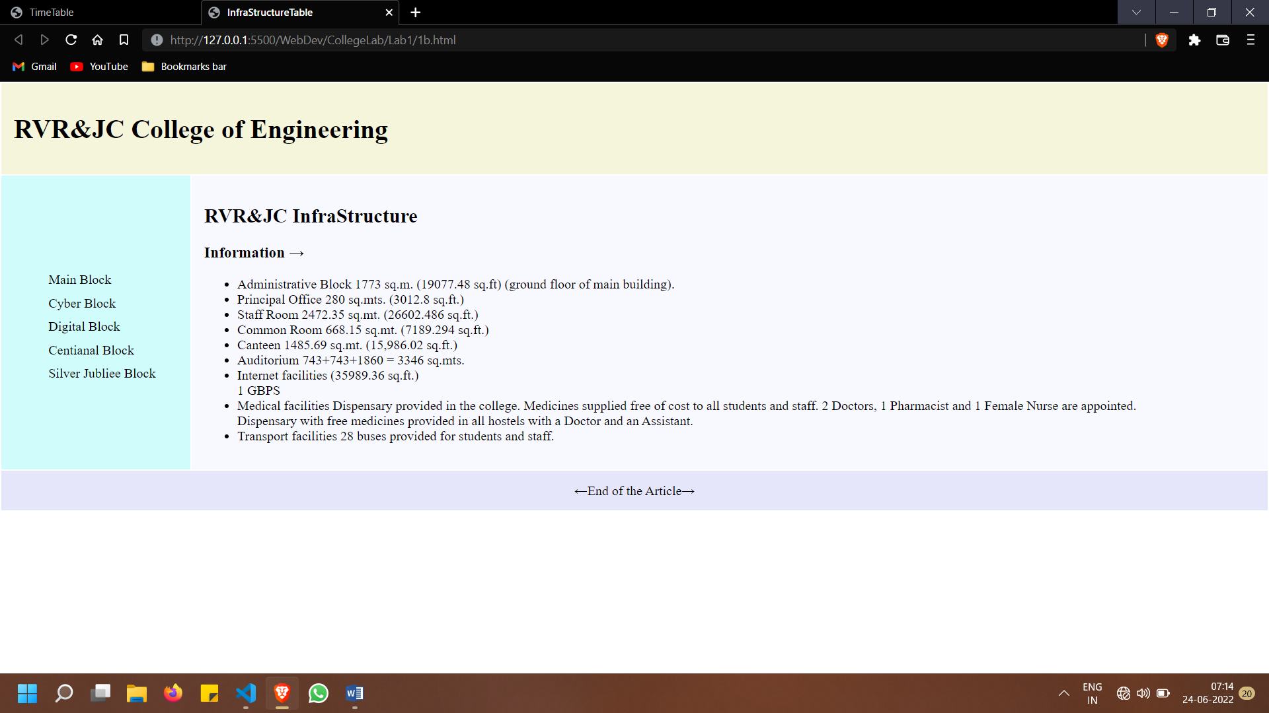

**c. Use <span> and <div> tags to provide a layout to the above page instead of a table layout.**

**Code:**

**<!**DOCTYPE *html***>**

**<**html *lang*="en"**>**

**<**head**>**

**<**meta *charset*="UTF-8"**>**

**<**meta *http-equiv*="X-UA-Compatible" *content*="IE=edge"**>**

**<**meta *name*="viewport" *content*="width=device-width, initial-scale=1.0"**>**

**<**title**>**InfraStructure Div and Span**</**title**>**

**<**style**>**

        body {

            margin: 0;

        }

*.header1* {

            background-color: **beige**;

            padding: 15px;

***/\**** height: 110px; ***\*/***

            width: 100vw;

        }

*.navigate* {

            width: 20%;

            background-color: rgb(208, 252, 252);

        }

*.in* {

            width: 80%;

            background-color: **ghostwhite**;

        }

*.navg* {

            list-style: **none**;

        }

*.navg*>li {

            padding: 10px 2px 0px;

        }

*.navigate*,

*.in* {

            float: **left**;

            height: 400px;

            padding: 15px;

            box-sizing: **border-box**;

        }

        a {

            text-decoration: **none**;

            color: **black**;

        }

*.End* {

            box-sizing: **border-box**;

            background-color: **lavender**;

            display: **flex**;

            justify-content: **center**;

            padding: 15px;

        }

**</**style**>**

**</**head**>**

**<**body**>**

**<**div *class*="content"**>**

**<**div *class*="header1"**>**

**<**h1**>**RVR&JC College of Engineering**</**h1**>**

**</**div**>**

**<**div *class*="mainbody"**>**

**<**div *class*="navigate"**>**

**<**ul *class*="navg"**>**

**<**li**><**a *href*="#"**>**Main Block**</**a**></**li**>**

**<**li**><**a *href*="#"**>**Cyber Block**</**a**></**li**>**

**<**li**><**a *href*="#"**>**Digital Block**</**a**></**li**>**

**<**li**><**a *href*="#"**>**Centianal Block**</**a**></**li**>**

**<**li**><**a *href*="#"**>**Silver Jubliee Block**</**a**></**li**>**

**</**ul**>**

**</**div**>**

**<**div *class*="in"**>**

**<**h2**>**RVR&JC InfraStructure**</**h2**>**

**<**h3**>**Information &rarr;**</**h3**>**

**<**ul**>**

**<**li**>**Administrative Block 1773 sq.m. (19077.48 sq.ft) (ground floor of

                        main building).**</**li**>**

**<**li**>**Principal Office 280 sq.mts. (3012.8 sq.ft.)**</**li**>**

**<**li**>**Staff Room 2472.35 sq.mt. (26602.486 sq.ft.)**</**li**>**

**<**li**>** Common Room 668.15 sq.mt. (7189.294 sq.ft.)**</**li**>**

**<**li**>**Canteen 1485.69 sq.mt. (15,986.02 sq.ft.)**</**li**>**

**<**li**>** Auditorium 743+743+1860 = 3346 sq.mts.**</**li**>**

**<**li**>**Internet facilities (35989.36 sq.ft.)**<**br**>**

                        1 GBPS**</**li**>**

**<**li**>** Medical facilities Dispensary provided in the college. Medicines

                        supplied free of cost to all students and staff. 2

                        Doctors, 1 Pharmacist and 1 Female Nurse are

                        appointed.**<**br**>**

                        Dispensary with free medicines provided in all

                        hostels with a Doctor and an Assistant.**</**li**>**

**<**li**>**Transport facilities 28 buses provided for students and staff.**</**li**>**

**</**ul**>**

**</**div**>**

**</**div**>**

**<**div *class*="End"**>**&larr;End of the Article&rarr;**</**div**>**

**</**div**>**

**</**body**>**

**</**html**>**

**Output:**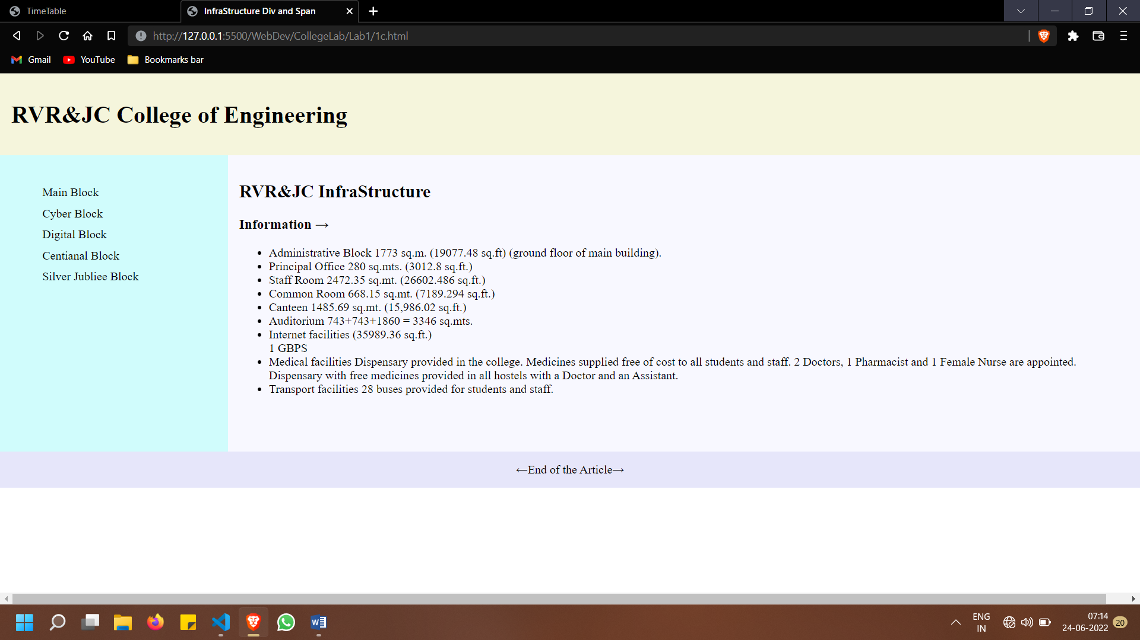

1. **a. Use frames such that page is divided into 3 frames 20% on left to show contents of pages, 60% in center to show body of page, remaining on right to show remarks.**

**Code:**

**Main::**

**<!**DOCTYPE *html***>**

**<**html *lang*="en"**>**

**<**head**>**

**<**meta *charset*="UTF-8"**>**

**<**meta *http-equiv*="X-UA-Compatible" *content*="IE=edge"**>**

**<**link *href*="https://fonts.googleapis.com/css2?family=Varela+Round&family=Zen+Loop&display=swap" *rel*="stylesheet"**>**

**<**meta *name*="viewport" *content*="width=device-width, initial-scale=1.0"**>**

**<**title**>**FrameSplit**</**title**>**

**<**style**>**

        body {

            margin: 0;

            background-color: rgb(170, 248, 254);

            color: rgb(5, 0, 7);

            font-family: 'Zen Loop', cursive;

            font-size: **larger**;

            letter-spacing: 2px;

        }

        iframe {

            border: **none**;

            border-radius: 5px;

        }

*.content* {

            padding: 15px;

        }

        h1 {

            background-color: rgba(0, 0, 0, 0.284);

            height: 70px;

            border-radius: 10px;

            padding: 5px;

            display: **flex**;

            justify-content: **center**;

            align-items: **center**;

        }

**</**style**>**

**</**head**>**

**<**body**>**

**<**div *class*="content"**>**

**<**h1**>**Inline Frames**</**h1**>**

**<**iframe *src*="2aCont.html" *width*="20%" *height*="330"**></**iframe**>**

**<**iframe *src*="2b.html" *height*="330" *width*="60%"**></**iframe**>**

**<**iframe *src*="2aremark.html" *width*="18%" *height*="330"**></**iframe**>**

**</**div**>**

**</**body**>**

**</**html**>**

**Sub1:**

**<!**DOCTYPE *html***>**

**<**html *lang*="en"**>**

**<**head**>**

**<**meta *charset*="UTF-8"**>**

**<**meta *http-equiv*="X-UA-Compatible" *content*="IE=edge"**>**

**<**meta *name*="viewport" *content*="width=device-width, initial-scale=1.0"**>**

**<**title**>**Document**</**title**>**

**<**style**>**

        body {

            margin: 0;

            background: **#3F3351**;

        }

*.content* {

            background-color: **#1F1D36**;

            color: **aliceblue**;

            padding: 10px 10px;

            width: 20;

        }

        h1 {

            color: **cyan**;

        }

        ul {

            list-style: **none**;

            padding: 10px;

        }

        li {

            padding: 10px;

        }

**</**style**>**

**</**head**>**

**<**body**>**

**<**div *class*="content"**>**

**<**h1**>**Contents**</**h1**>**

**<**ul**>**

**<**li**>**Home**</**li**>**

**<**li**>**Products**</**li**>**

**<**li**>**FAQ**</**li**>**

**<**li**>**About**</**li**>**

**<**li**>**Contact**</**li**>**

**</**ul**>**

**</**div**>**

**</**body**>**

**</**html**>**

**Sub2:**

**<!**DOCTYPE *html***>**

**<**html *lang*="en"**>**

**<**head**>**

**<**meta *charset*="UTF-8"**>**

**<**meta *http-equiv*="X-UA-Compatible" *content*="IE=edge"**>**

**<**meta *name*="viewport" *content*="width=device-width, initial-scale=1.0"**>**

**<**title**>**Remarks**</**title**>**

**</**head**>**

**<**body *style*="background:#100a1d;color:aliceblue"**>**

**<**div *class*="content"**>**

**<**h1**>**Remarks**</**h1**>**

**</**div**>**

**</**body**>**

**</**html**>**

**Output:**

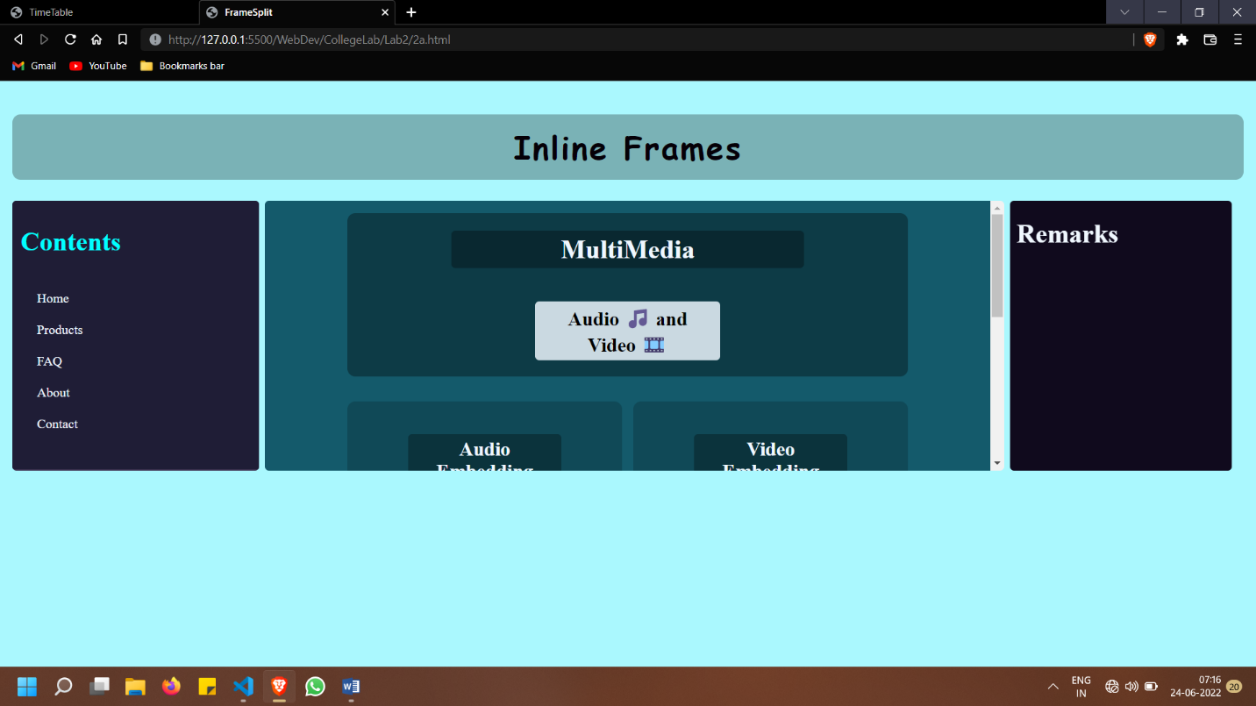

**b. Embed Audio and Video into your HTML web page.**

**Code:**

**<!**DOCTYPE *html***>**

**<**html *lang*="en"**>**

**<**head**>**

**<**meta *charset*="UTF-8"**>**

**<**meta *http-equiv*="X-UA-Compatible" *content*="IE=edge"**>**

**<**meta *name*="viewport" *content*="width=device-width, initial-scale=1.0"**>**

**<**link *href*="https://fonts.googleapis.com/css2?family=Varela+Round&family=Zen+Loop&display=swap" *rel*="stylesheet"**>**

**<**style**>**

        body {

            background-color: **#145a6b**;

            margin: 0;

            font-family: "zen loop";

        }

*.content* {

            padding: 15px;

        }

*.header1* {

            width: 80%;

            height: 20%;

            margin: **auto**;

            background-color: **#00000057**;

            border-radius: 10px;

            color: **aliceblue**;

            display: **flex**;

            flex-direction: **column**;

            justify-content: **center**;

            align-items: **center**;

        }

*#Head* {

***/\**** flex: 1; ***\*/***

            background-color: rgba(0, 0, 0, 0.315);

            width: 60%;

            text-align: **center**;

            padding: 4px 10px;

            border-radius: 5px;

        }

*#sub01* {

***/\**** flex: 2; ***\*/***

            background-color: rgba(240, 248, 255, 0.836);

            color: **black**;

            width: 30%;

            text-align: **center**;

            padding: 4px 10px;

            border-radius: 5px;

        }

*.main* {

            padding: 30px;

            width: 80%;

            height: 60%;

            margin: **auto**;

            display: **flex**;

            justify-content: **space-between**;

        }

*.Aud*,

*.Vid* {

            width: 49%;

            display: **flex**;

            flex-direction: **column**;

            align-items: **center**;

            float: **left**;

            box-sizing: **border-box**;

            padding: 20px;

            background-color: **#0000002f**;

            border-radius: 10px;

        }

*.Aud1* {

            padding: 100px 0px;

        }

*.text1* {

            background-color: **#0000004e**;

            color: **aliceblue**;

            width: 60%;

            text-align: **center**;

            border-radius: 5px;

            padding: 5px;

        }

*.text2* {

            background-color: rgba(240, 248, 255, 0.597);

            width: 50%;

            text-align: **center**;

            border-radius: 5px;

            padding: 5px;

        }

        video {

            width: 20vw;

            height: **auto**;

            border-radius: 10px;

        }

**</**style**>**

**<**title**>**Audio and Video**</**title**>**

**</**head**>**

**<**body**>**

**<**div *class*="content"**>**

**<**div *class*="header1"**>**

**<**h1 *id*="Head"**>**MultiMedia**</**h1**>**

**<**h2 *id*="sub01"**>**Audio 🎵 and Video 🎞️**</**h2**>**

**</**div**>**

**<**div *class*="main"**>**

**<**div *class*="Aud"**>**

**<**h2 *class*="text1"**>**Audio Embedding**</**h2**>**

**<**h3 *class*="text2"**>**Click Here to Play the Song &darr;**</**h3**>**

**<**div *class*="Aud1"**>**

**<**audio *controls***>**

**<**source *src*="song1.mp3" *type*="audio/mp3"**>**

                        Browser Doesn't support

**</**audio**>**

**</**div**>**

**</**div**>**

**<**div *class*="Vid"**>**

**<**h2 *class*="text1"**>**Video Embedding**</**h2**>**

**<**h3 *class*="text2"**>**Click Here to Play the Video &darr;**</**h3**>**

**<**video *controls***>**

**<**source *src*="https://www.learningcontainer.com/wp-content/uploads/2020/05/sample-mp4-file.mp4"

*type*="video/mp4"**>**

                    Browser Doesn't support

**</**video**>**

**</**div**>**

**</**div**>**

**</**div**>**

**</**body**>**

**</**html**>**

**Output:**

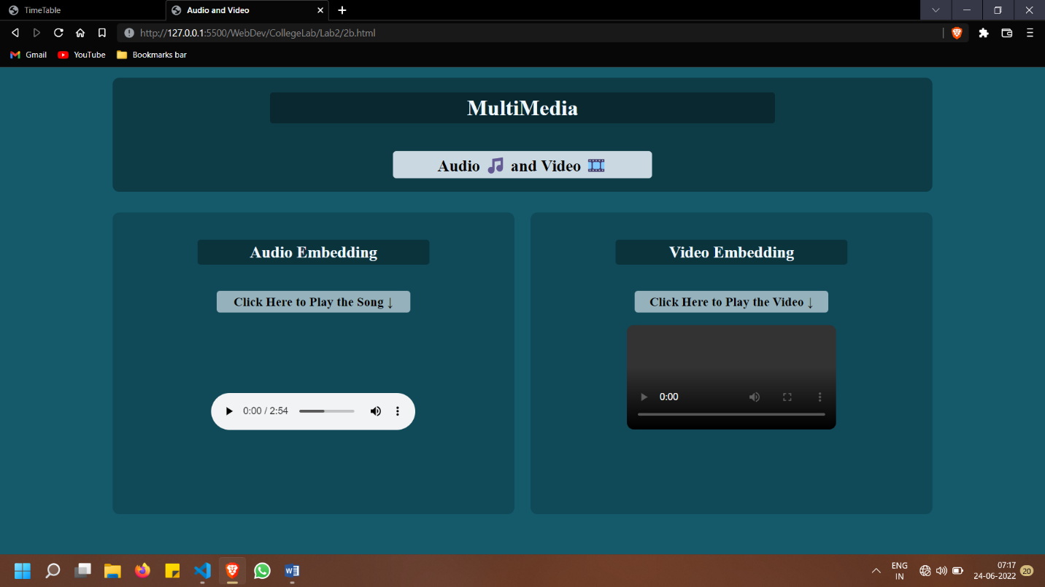

**3. a. Create a webpage with HTML describing your department use paragraph and list tags.**

**b. Apply various colors to suitably distinguish key words, also apply font styling like italics, underline and two other fonts to words you find appropriate, also use header tags.**

**c. Create links on the words e.g. ―Wi-Fi and ―LAN‖ to link them to Wikipedia pages.**

**d. Insert an image and create a link such that clicking on image takes user to other page.**

**e. Change the background color of the page; at the bottom create a link to take user to the top of the page.**

**Code:**

**<!**DOCTYPE *html***>**

**<**html *lang*="en"**>**

**<**head**>**

**<**meta *charset*="UTF-8"**>**

**<**meta *http-equiv*="X-UA-Compatible" *content*="IE=edge"**>**

**<**meta *name*="viewport" *content*="width=device-width, initial-scale=1.0"**>**

**<**title**>**ComputerScience Department**</**title**>**

**<**link *href*="https://fonts.googleapis.com/css2?family=Raleway:wght@400;700&display=swap" *rel*="stylesheet"**>**

**<**style**>**

        html {

            scroll-behavior: **smooth**;

        }

        body {

            margin: 0;

            background-color: rgb(255, 250, 230);

            box-sizing: **border-box**;

            font-family: 'Raleway', **sans-serif**;

        }

*.content* {

            margin: **auto**;

            padding: 15px;

        }

*.header* {

            text-align: **center**;

            background-color: rgba(0, 0, 0, 0.149);

            height: 20%;

            padding: 10px;

            border-radius: 10px;

        }

*#subhead* {

            color: **aliceblue**;

            font-weight: 100;

            background-color: rgba(100, 148, 237, 0.434);

            width: 30%;

            margin: **auto**;

            padding: 5px;

            border-radius: 10px;

        }

*.navbar* {

            background-color: rgba(1, 11, 28, 0.1);

            border-radius: 10px;

            border: 1px **solid** **black**;

            margin: **auto**;

            width: 50%;

            padding: 5px;

        }

*.navbar* {

            margin: **auto**;

            display: **flex**;

            list-style: **none**;

            justify-content: **space-evenly**;

            align-items: **center**;

            flex-wrap: **wrap**;

        }

*@media* (max-width: 800px) {

*.navbar*,

*.navg* {

                flex-direction: **column**;

                height: 30vh;

                width: 30vw;

                margin: **auto**;

                align-items: **center**;

                justify-content: **space-around**;

            }

*.mainwraper* {

                flex-direction: **column**;

                align-items: **center**;

            }

*.mainwraper*>div {

                width: 80vw;

            }

        }

        a {

            text-decoration: **none**;

            color: **black**;

        }

*.navbar*>li {

            background-color: rgba(0, 0, 0, 0.071);

            padding: 0.2rem;

            border-radius: 5px;

        }

*.mainwraper* {

            width: 100%;

            padding: 15px;

            display: **flex**;

            justify-content: **space-around**;

            flex-wrap: **wrap**;

        }

*.mainwraper*>div {

            margin: 10px;

        }

*.sidehead* {

            width: **min-content**;

            height: **fit-content**;

            background-color: rgba(0, 0, 0, 0.158);

            border-radius: 10px;

            padding: 10px;

            display: **flex**;

            text-align: **center**;

            align-items: **center**;

        }

*.text*,

*.images* {

            border-radius: 10px;

            width: 40%;

            padding: 10px;

            float: **left**;

            display: **flex**;

            justify-content: **center**;

            align-items: **center**;

            flex-direction: **column**;

        }

*.text* {

            flex: 2;

            background-color: rgba(0, 0, 0, 0.056);

        }

*.images* {

            background-color: rgba(86, 191, 193, 0.104);

        }

*.images*>img {

            margin: 20px;

            width: 75%;

            height: **auto**;

        }

        a {

            font-weight: **bold**;

            cursor: **pointer**;

        }

*.secondblock*>a>img {

            width: 50vw;

            height: **auto**;

            border-radius: 10px;

            background-color: rgba(0, 0, 0, 0.09);

        }

*.secondblock* {

            position: **relative**;

            margin: **auto**;

            display: **flex**;

            justify-content: **center**;

            flex-direction: **column**;

            align-items: **center**;

        }

*.toup* {

            border-radius: 30px;

            width: 15%;

            background-color: rgb(255, 0, 98);

***/\**** padding: 7px 10px; ***\*/***

            cursor: **pointer**;

            text-align: **center**;

        }

**</**style**>**

**</**head**>**

**<**body**>**

**<**div *class*="content"**>**

**<**div *class*="header"**>**

**<**h1 *id*="head"**>**RVR&JC College of Engineering.**</**h1**>**

**<**h2 *id*="subhead"**>**Computer Science Department**</**h2**>**

**</**div**>**

**<**hr**>**

**<**div *class*="navg"**>**

**<**ul *class*="navbar"**>**

**<**li *class*="home"**><**a *href*=""**>**Home**</**a**></**li**>**

**<**li *class*="acad"**><**a *href*=""**>**Academics**</**a**></**li**>**

**<**li *class*="peop"**><**a *href*=""**>**People**</**a**></**li**>**

**<**li *class*="resrc"**><**a *href*=""**>**Resources**</**a**></**li**>**

**<**li *class*="stdChap"**><**a *href*=""**>**StudentChapter**</**a**></**li**>**

**</**ul**>**

**</**div**>**

**<**div *class*="mainwraper"**>**

**<**div *class*="sidehead"**>**

**<**h2**>**Department Profile**</**h2**>**

**</**div**>**

**<**div *class*="text"**>**

**<**p**>**

**<**b**>**The R.V.R. & J.C. College of Engineering**</**b**>** introduced the undergraduate program in **<**i**>**Computer

                        Science &

                        Engineering (CSE)**</**i**>** in

                    1994. Since its inception, the department has grown exponentially in the areas of student intake,

                    quality of academic

                    work and student achievements.

**<**br**>**

                    The department has excellent infrastructure to support the teaching learning process. More than half

                    of the class rooms

                    of the department have the integrated computer-assisted teaching systems. The faculty of the

                    department utilizes these

                    systems to deliver lectures effectively. A new training facility named E-class room was developed in

                    the year 2009.

                    With **<**a *href*="https://en.wikipedia.org/wiki/Wi-Fi" *target*="_blank" *class*="s"**>**Wifi**</**a**>** and **<**a

*href*="https://en.wikipedia.org/wiki/Local_area_network" *target*="_blank" *class*="s"**>**Lan**</**a**>**

                    facility in every Lab

                    and Class

                    Room

**<**br**>**

                    The department is well supported in academics by qualified and experienced faculty including six

                    doctorates. The faculty

                    members of the department actively pursue research in their respective areas and publish research

                    papers in renowned

                    journals. The students are encouraged to participate in national and international conferences,

                    workshops, student

                    symposiums and to publish papers in national / international journals.

**<**br**>**

                    The department strives towards delivering quality education to the students. This fact is attested

                    to by the National

                    Board of Accreditation (NBA). The department of CSE received accreditation from NBA for 5 times

                    during 2002, 2007, 2012,

                    2017 and 2021. The department invites experts from premiere educational institutions and the

                    industry to conduct

                    seminars / workshops on the advanced topics in Computer Science.

**<**br**>**

**</**p**>**

**</**div**>**

**<**div *class*="images"**>**

**<**img *src*="acc_main.jpg" *alt*="Sarasvathi Devi Statue"**>**

**<**br**>**

**<**cite**>**Sarasvathi Statue in **<**b**>**Cyber block**</**b**></**cite**>**

**</**div**>**

**</**div**>**

**<**div *class*="secondblock"**>**

**<**h2**>**Here is The Main website of the RVRJCCE CSE Department**</**h2**>**

**<**a *href*="http://cse.rvrjcce.ac.in/"**><**img

*src*="https://images4.content-hci.com/commimg/myhotcourses/blog/post/myhc_89683.jpg"

*alt*="ComputerScience"**></**a**>**

**<**h3**>**Click Here To Naviagate to the website&uarr;**</**h3**>**

**<**div *class*="toup"**>**

**<**a *href*="#head"**>**

**<**p**>**To Top &uarr;**</**p**>**

**</**a**>**

**</**div**>**

**</**div**>**

**</**div**>**

**</**body**>**

**</**html**>**

**Output:**

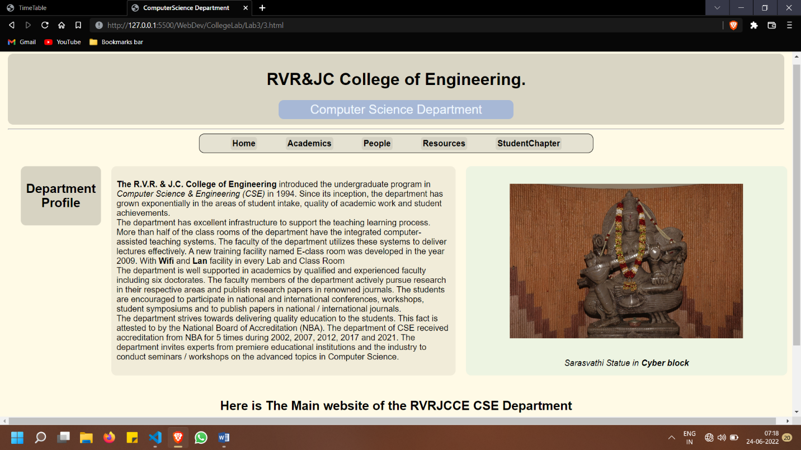

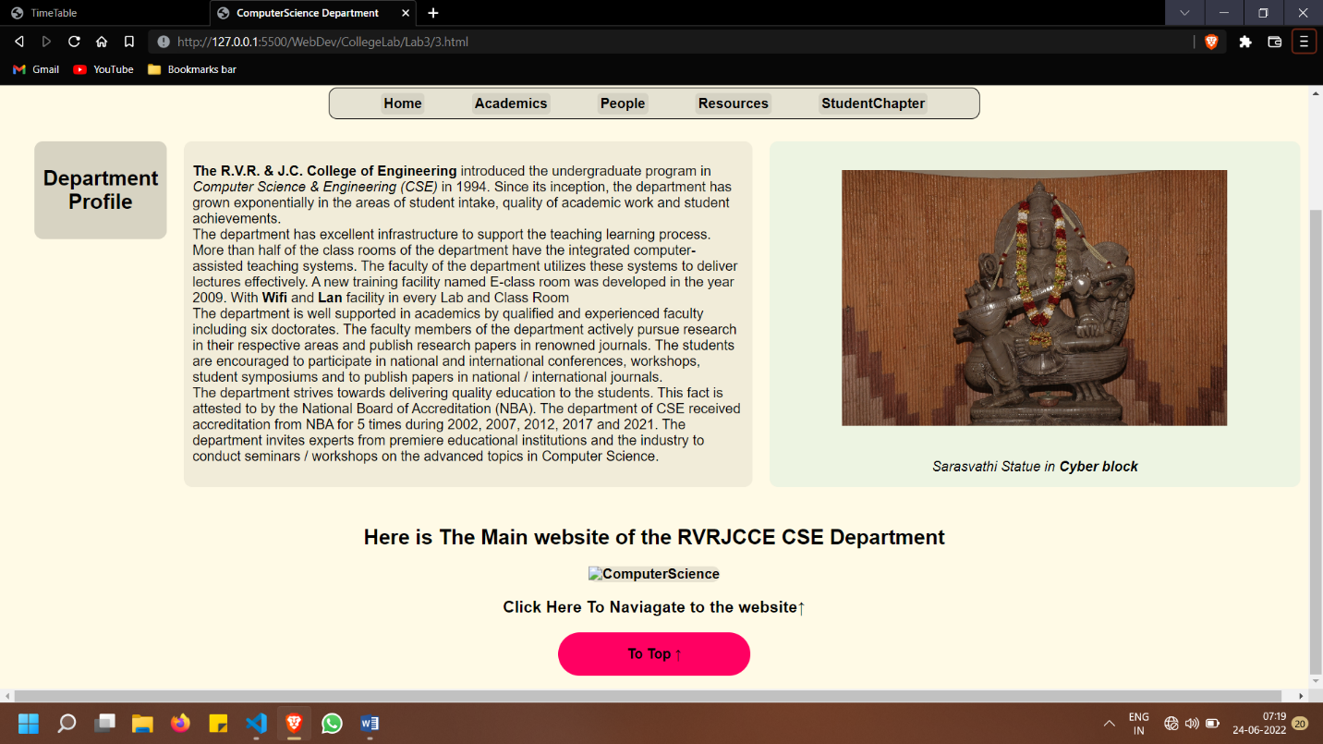

**4.Develop static pages (using only HTML) of an online book store, the pages should resemble: www.amazon.com, the website should consist the following pages, home page, registration and user login, user profile page, books catalog, shopping cart, payment by credit card, order confirmation.**

**Code:**

**<!**DOCTYPE *html***>**

**<**html *lang*="en"**>**

**<**head**>**

**<**meta *charset*="UTF-8"**>**

**<**meta *http-equiv*="X-UA-Compatible" *content*="IE=edge"**>**

**<**meta *name*="viewport" *content*="width=device-width, initial-scale=1.0"**>**

**<**title**>**Book-Nation**</**title**>**

**<**link

*href*="https://fonts.googleapis.com/css2?family=Abril+Fatface&family=Zilla+Slab&family=Plus+Jakarta+Sans:wght@200&display=swap"

*rel*="stylesheet"**>**

**<**link *rel*="stylesheet"

*href*="https://fonts.googleapis.com/css2?family=Material+Symbols+Rounded:opsz,wght,FILL,GRAD@48,400,0,0" **/>**

**<**style**>**

        body {

            margin: 0 **auto**;

            padding: 0;

            box-sizing: **border-box**;

            font-family: 'Zilla Slab', **serif**;

            white-space: **nowrap**;

            width: 100vw;

        }

*.logo*>img {

            height: 40px;

            background-color: **aliceblue**;

            padding: 5px;

            border-radius: 10px;

        }

*.header* {

            display: **flex**;

            flex-wrap: **wrap**;

            justify-content: **space-between**;

            align-items: **center**;

            margin: 0px;

            width: 100vw;

            background-color: **#D9AFD9**;

            background-image: linear-gradient(63deg, **#D9AFD9** 0%, **#97D9E1** 100%);

        }

*.header*>div {

            padding: 5px 10px;

        }

*.name*>h1 {

            padding: 10px;

            height: 40px;

            border-radius: 20px;

            background-color: rgba(255, 255, 255, 0.405);

        }

*.login*>a {

            display: **flex**;

# justify-content: **center**;

            align-items: **center**;

            justify-content: **center**;

        }

*.menu* {

            width: 100vw;

            display: **flex**;

            flex-wrap: **wrap**;

            align-items: **center**;

            background-color: **#99FEFF**;

        }

*.menu*>*.signin* {

            margin-left: **auto**;

        }

*.search* {

            background-color: **#97dae124**;

            display: **flex**;

            align-items: **center**;

            justify-content: **space-evenly**;

        }

*.search*>img {

            height: 20px;

        }

*.search*>form>input {

            width: 30vw;

            border: **hidden**;

            height: 25px;

            border-radius: 20px;

            background-color: **#ffffffc2**;

        }

*.menu*>div {

            background-color: **#00000027**;

            margin: 5px;

            padding: 5px;

***/\**** height: 20px; ***\*/***

            border-radius: 5px;

            font-weight: **bold**;

            text-decoration: **none**;

        }

*.lib* {

            display: **flex**;

            justify-content: **space-between**;

            padding: 10px;

            background-color: **#e1d0f0**;

            display: **flex**;

            border-radius: 20px;

        }

*.lib*>div {

            padding: 10px;

            cursor: **pointer**;

        }

*.product* {

            padding: 20px;

            width: 70vw;

            margin: **auto**;

            margin-top: 5vh;

            margin-bottom: 5vh;

            display: **flex**;

            flex-direction: **row**;

            align-items: **center**;

            justify-content: **space-evenly**;

            border-radius: 20px;

            background-color: **#00343f10**;

        }

*.panel* {

            display: **flex**;

            flex-direction: **column**;

            align-items: **center**;

            background-color: **#d9afd92c**;

            border-radius: 20px;

        }

*.panel*>div {

            padding: 10px;

            margin: 10px;

        }

*.image*>img {

            height: 40vh;

            margin: 10px;

        }

*.image* {

            padding: 10px;

            display: **flex**;

            flex-direction: **column**;

            align-items: **center**;

            border-radius: 10px;

        }

*.price* {

            font-family: 'Plus Jakarta Sans', **sans-serif**;

            margin: 10px;

            padding: 10px;

            background-color: **#94daff4a**;

            border-radius: 20px;

            display: **flex**;

            align-items: **center**;

        }

*.buy* {

            display: **flex**;

        }

*.buy*>div {

            padding: 10px;

            border-radius: 25px;

            margin: 5px;

            text-align: **center**;

        }

*.addtocart* {

            border: 2px **solid**;

            color: **#ff839e**;

        }

*.addtocart*>a {

            color: **#ff839e**;

        }

*.buynow* {

            background-color: **#ff839e**;

            border: 2px **solid** **#ff839e**;

        }

        a {

            text-decoration: **none**;

            color: **#000000**;

            font-weight: 600;

        }

*@media* (max-width:800px) {

*.menu*>*.search*>form {

                display: **none**;

            }

*.menu*>*.search*>form*:hover* {

                display: **block**;

            }

*.product* {

                flex-direction: **column**;

            }

*.mainbody* {

                flex-direction: **column**;

            }

        }

**</**style**>**

**</**head**>**

**<**body**>**

**<**div *class*="content"**>**

**<**div *class*="header"**>**

**<**div *class*="logo"**><**img *src*="Nlogo.png" *alt*="Logo"**></**div**>**

**<**div *class*="name"**>**

**<**h1**>**Book-Nation**</**h1**>**

**</**div**>**

**</**div**>**

**<**div *class*="menu"**>**

**<**div *class*="home"**><**a *href*="#"**>**Home**</**a**></**div**>**

**<**div *class*="search"**>**

**<**img *src*="search.png" *alt*="search"**>**

**<**form**>**

**<**input *type*="search" *placeholder*="      Search"**>**

**</**form**>**

**</**div**>**

**<**div *class*="signin"**><**a *href*="#"**>**Sign In**</**a**></**div**>**

**<**div *class*="login"**><**a *href*="#"**>**Log In**<**div *class*="material-symbols-rounded"**>**

                        login

**</**div**></**a**></**div**>**

**</**div**>**

**<**div *class*="product"**>**

**<**div *class*="image"**>**

**<**img *src*="https://upload.wikimedia.org/wikipedia/en/b/b9/Girl_in_room_105.png" *alt*="The Book"**>**

**<**h2**>**The Girl in room 105**</**h2**>**

**<**cite**>**By **<**b**>**Chetan Bhagat**</**b**></**cite**>**

**</**div**>**

**<**div *class*="panel"**>**

**<**div *class*="price"**>**

**<**h3**>**Price: &nbsp; **</**h3**>**

**<**h3**>**

**<**h2**>**199.99 **</**h2**>** &nbsp;&#x20B9;

**</**h3**>**

**</**div**>**

**<**div *class*="lib"**>**

**<**div *class*="like"**>**

**<**span *class*="material-symbols-rounded"**>**

                            favorite

**</**span**>**

**</**div**>**

**<**div *class*="share"**>**

**<**span *class*="material-symbols-rounded"**>**

                            share

**</**span**>**

**</**div**>**

**<**div *class*="rate"**>**

**<**span *class*="material-symbols-rounded"**>**

                            reviews

**</**span**>**

**</**div**>**

**</**div**>**

**<**div *class*="buy"**>**

**<**div *class*="addtocart"**><**a *href*="#"**>**Add to Cart**</**a**></**div**>**

**<**div *class*="buynow"**><**a *href*="#"**>**Buy Now**</**a**></**div**>**

**</**div**>**

**</**div**>**

**</**div**>**

**</**div**>**

**</**body**>**

**</**html**>**

**Output:**

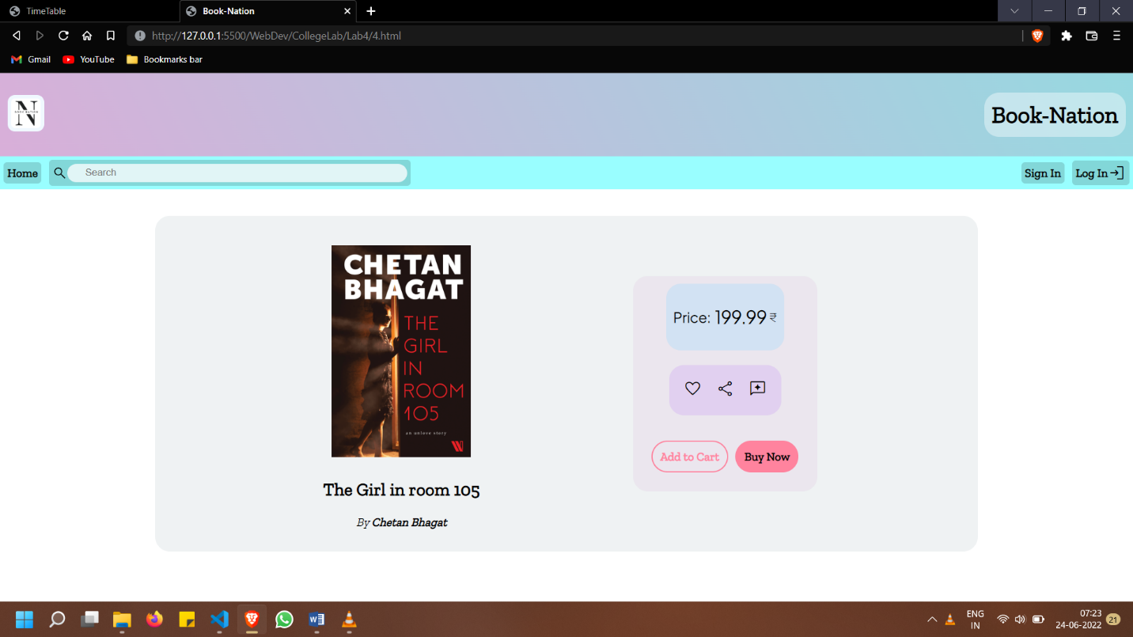

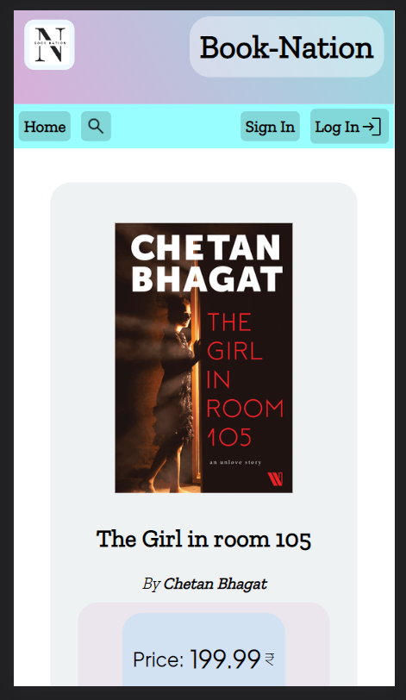

**CSS**

**5. Write an HTML page that contains a selection box with a list of 5 countries, when the user selects a country, its capital should be printed next to the list; Add CSS to customize the properties of the font of the capital (color, bold and font size).**