**Amazon Page Clone**

This project is a simple clone of an Amazon page using HTML and CSS. Below is an overview of the different parts of the UI, the HTML tags used, and the CSS properties applied.

**Table of Contents**

1. **Header Section**
2. **Navigation Bar**
3. **Banner**
4. **Home Section**
5. **Image Section**
6. **Footer Section**

**Header Section**



HTML

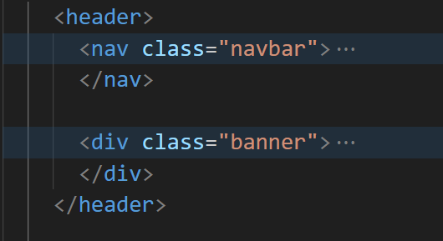

CSS

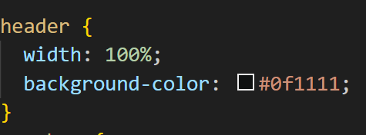

**Navigation Bar**



HTML

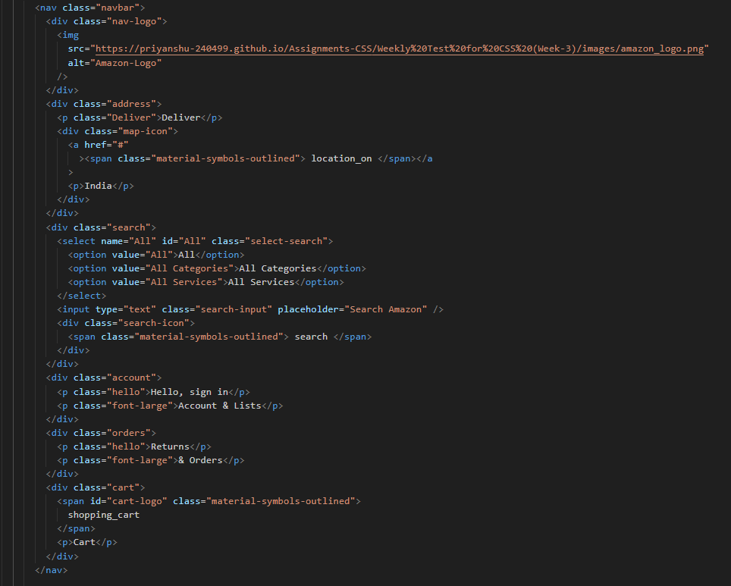

CSS

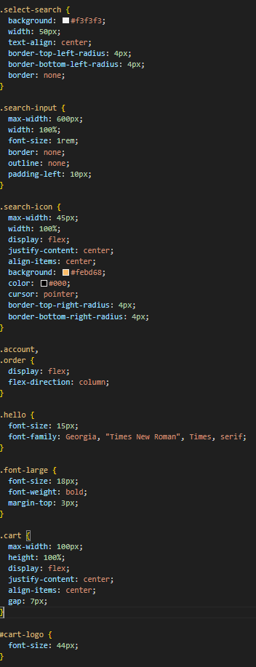

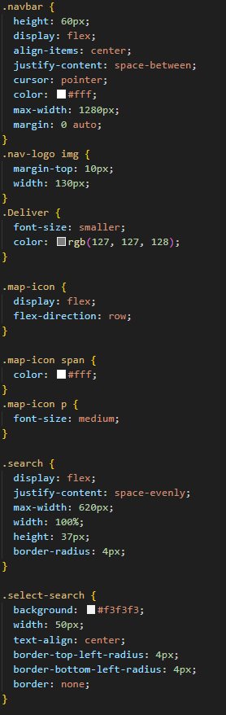

**Banner**



**HTML**

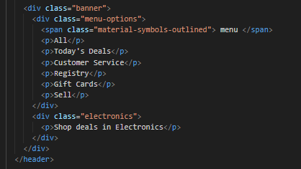

CSS

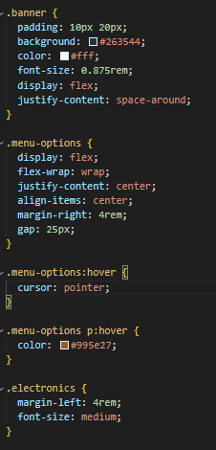

**Home Section**



HTML



CSS

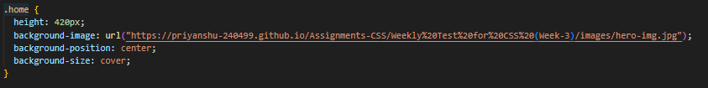

**Image Section**



HTML

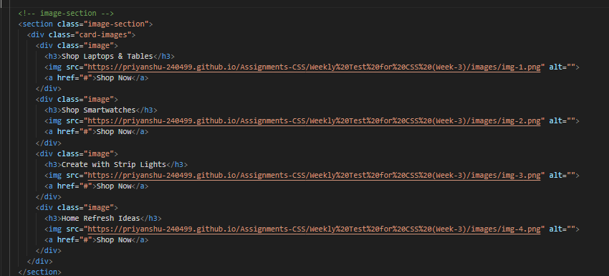

CSS

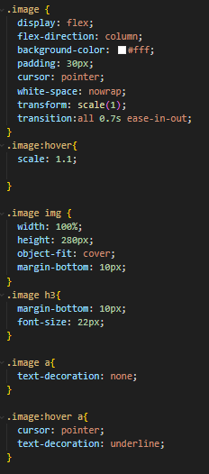

**Footer Section**



HTML

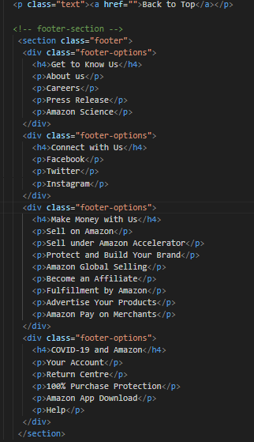 CSS

