**PURBANCHAL UNIVERSITY**



**DEPARTMENT OF COMPUTER ENGINEERING**

**KHWOPA ENGINEERING COLLEGE**  
**LIBALI-8, BHAKTAPUR**

**FINAL PROJECT REPORT**

**ON**

**CAR RENTAL SYSTEM**

 Project work proposal in partial fulfillment of requirements for the award of the degree of Bachelor of Engineering in Computer Engineering

**SUBMITTED BY**

1. Manseez Bahadur Pradhan (780320)

2. Riju Phaiju (780330)

3. Trilok Thapa (780344)

4. Ujjwol Tamang (780345)

**SUBMITTED TO**

Department of Computer Engineering

**Under The Supervision of**Er. Shiva Pd. Mahato

November 24, 2023

**KHWOPA ENGINEERING COLLEGE**

**DEPARTMENT OF COMPUTER ENGINEERING**

# APPROVAL LETTER

The undersigned certify that they have read and recommended to the Institute of Engineering for acceptance, a project report entitled “CAR RENTAL SYSTEM” submitted by Manseez Bdr Pradhan, Riju Phaiju, Trilok Thapa and Ujjwol Tamang in partial fulfillment for the degree of Bachelor of Engineering in Computer Engineering.

**Panel of Examiners:**

**Name Signature Date**

**External examiner**

**..………………… ……………………… …………………..**

**Project Supervisor**

**Er. Shiva pd. Mahato ……………………… …………………..**

**Head of Department**

**Er. Bikash Chawal ……………………… …………………..**

# ACKNOWLEDGEMENT

We would like to express our sincere gratitude our respected teachers and **Purbanchal University** for including the Project - I in our course of study and all those who have supported in the completion of this project.

We would like to express our sincere appreciation to Er. Shiva Pd. Mahato for his kind and proper guidance and supervision.We would also like to expand our gratitude to **Khwopa Engineering College** and **Department of Computer Engineering** for including this project in our curriculum.

Thank you.

# ABSTRACT

This project aims to develop a car rental system using the C programming language to address the specific needs of car rental businesses. It provides the interface for administration and customer separately where, administrator can be able to register, login, and rent the chosen car. Similarly, administrator can be able to add or delete the cars and could store the details of users or customers and also generate the bill.

Keywords: - Registration, rent, forget password, invoice

**Table of Contents**

APPROVAL LETTER i

ACKNOWLEDGEMENT ii

ABSTRACT 1

LIST OF FIGURES 3

CHAPTER 1 4

INTRODUCTION 4

1.1 Background 4

1.2 Motivation 4

1.3 Statement of Problems 5

1.4 Objectives 5

1.5 Scope and Applications 5

1.6 Limitations 5

CHAPTER 2 6

LITERATURE REVIEW 6

CHAPTER 3 7

PROJECT MANAGEMENT 7

3.1 Team Members 7

3.2 Work Breakdown Planning 7

CHAPTER 4 8

METHODOLOGY 8

4.1 Block Diagram of Car Rental System 8

4.2 Use Case Diagram 9

4.3 Algorithm 10

4.4 Flowchart 11

4.5 Tools and Platforms 12

CHAPTER 5 13

Result And Discussion 13

CONCLUSION 20

REFERENCES 21

# LIST OF FIGURES

Figure 5.1 Homepage…………………………………………………………………..10

Figure 5.2 Car Details…………………………………………………………………..11

Figure 5.3 Login Page…………………………………………………………………..11

Figure 5.4 User Functions……………………………………………………………….12

Figure 5.5 Renting process………………………………………………………………12

Figure 5.6 Customer Invoice……………………………………………………………13

Figure 5.7 Admin Functions…………………………………………………………….13

Figure 5.8 Adding Car Details…………………………………………………………..14

Figure 5.9 Deleting Car Details………………………………………………………....14

Figure 5.10 Registration page…………………………………………………………...15

Figure 5.11 User login…………………………………………………………………..15

Figure 5.12 Admin login………………………………………………………………..16

# CHAPTER 1

# INTRODUCTION

## Background

The earliest known example of cars being offered for rent dates to 1906. The German company Sixt was established in 1912 under the name Sixt Autofahrten und Selbstfahrer (Sixt Car Cruises and Self Drivers). [1]

Joe Saunders of Omaha, Nebraska first started with only one borrowed Model T Ford in 1916, but by 1917, his Ford Livery Company was renting out 18 Model Ts at 10 cents per mile. The company name became Saunders Drive-It-Yourself System and then Saunders System. By 1926, Saunders had expanded to 56 cities. Saunders' company was bought by Avis in 1955. [2]

An early competitor to Saunders was Walter L. Jacobs, whose Chicago-based Rent-a-Car opened in 1918 with twelve Ford Model T. The company was bought in 1923 by John Hertz. [3]

The sector expanded rapidly in the US; in 1926, the American Driveurself Association assembled over 1200 delegates in Chicago.

National Car Rental, Europcar, Enterprise Rent-A-Car, Thrifty Rent a Car, and Budget Rent a Car are some of the new companies to enter this field.

## 1.2 Motivation

The motivation behind developing a car rental system is to provide a user-friendly and automated solution for customers and rental agencies. This system will eliminate the traditional manual paperwork and improve the overall rental experience. It will allow customers to easily browse and select available cars, make reservations, manage bookings, and facilitate efficient car allocation for rental agencies.

## 1.3 Statement of Problems

The current state of car rental systems is characterized by several challenges. Reservation processes are hindered by complexity and time-consuming procedures, leading to difficulties in booking cars. Real-time updates on car availability are lacking, resulting in issues such as overbooking or underutilization. Fleet management faces challenges due to inadequate tracking of maintenance schedules, contributing to increased breakdowns and repair costs, and limited visibility into car location and status impacting operational efficiency. Security and authentication concerns, including vulnerabilities risking customer information exposure and potential unauthorized car access, add complexity. In summary, these challenges highlight the pressing need for comprehensive enhancements to transform the efficiency, security, and digital experience of car rental systems.

## 1.4 Objectives

The objective of the car rental system is to develop a centralized car rental system.

## 1.5 Scope and Applications

This project is specifically tailored to enable individuals to rent cars for designated periods rather than opting for conventional hiring services. In the context of our country, which boasts a thriving tourism industry, both local and foreign tourists express a desire to explore various destinations using their own cars. However, the prevalent practice of daily car hiring proves to be economically burdensome. Our system addresses this challenge by allowing customers to effortlessly rent a car for a specified duration, empowering them to enjoy the flexibility of self-driven exploration without the high costs associated with daily rentals.

## 1.6 Limitations

The limitations that we need to overcome in our car rental system are as followed:

* Limited car details
* License verification
* Multiple car renting

# CHAPTER 2

# LITERATURE REVIEW

Car rental especially car rental has long history from being a directly to customer, to now a digital system based rental services. User can directly choose the car online and get it delivered it to their place. One of the oldest and still operating, service is Hertz car rental service. It has both web app as well as mobile app. Using Hertz, user can choose their own car and the destination to deliver it. The destination to receive the car and return can be selected by the user. The time to deliver the car and return can be selected by the user. The amount of time to rent the car can also be selected by user [4].

Revv-self-drive car rental is one of the popular rental apps of India. It provides user with the extra feature of subscription where they can get rental cars for cheaper price. The user does have to provide security deposit for renting the cars. People who are travelling from state to state are really the customers of this service [5].

From these existing services, we can see the scope and need of rental services. So, we will be creating a user-friendly management system.

Mainly the focus of rental systems is to enhance customer satisfaction, improve efficiency and increase customer accessibility. The bloom in technology has forced the traditional car rental business to adapt new rental systems for competitive pricing, customer feasibility as well as their needs. Change in customer needs as well as easier access to internet has made rental systems valid and need of the time. The use of technology, such as online reservation systems, mobile application and GPS tracking has improved the efficiency and convenience of rental systems. Efficient management of inventory, customer detail and predictive maintenance has been linked to better car availability.

With the emergence of ride sharing apps and services, the need of proper rental business can easily be seen in Nepal. Pathao, Indriver and so on are some of the examples of ride sharing apps in Nepal.

# CHAPTER 3

# PROJECT MANAGEMENT

## 3.1 Team Members

This project will be the joint effort of:

1. Manseez B. Pradhan (780320)
2. Riju Phaiju (780330)
3. Trilok Thapa (780344)
4. Ujjwol Tamang (780345)

## 3.2 Work Breakdown Planning

|  |  |  |  |  |  |  |  |  |
| --- | --- | --- | --- | --- | --- | --- | --- | --- |
| S. N |  | Week Duration | 1st week | 2nd week | 3rd week | 4th week | 5th week | 6th week |
| 1. | Problem Identification | 3days |  |  |  |  |  |  |
| 2. | Analysis | 4days |  |  |  |  |  |  |
| 3. | Design | 7days |  |  |  |  |  |  |
| 4. | Coding | 20days |  |  |  |  |  |  |
| 5. | Implementation & testing | 6days |  |  |  |  |  |  |
| 6. | Documentation | 45days |  |  |  |  |  |  |

# CHAPTER 4

# METHODOLOGY

## 4.1 Block Diagram of Car Rental System

Fig 4.1: Block Diagram of Car Rental System

## 4.2 Use Case Diagram

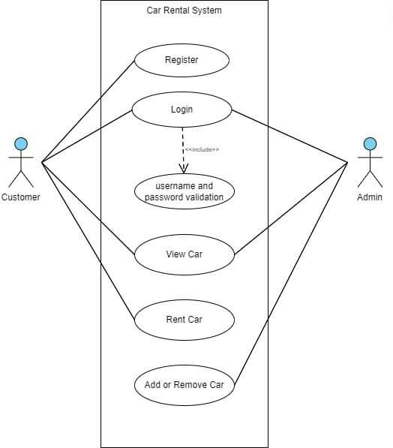

Fig 4.2: Use Case Diagram

## 4.3 Algorithm

**Step 1:** Start **Step 2:** Select an option from main menu, opt 1.

Show the car details available.

**Step 3:** If **opt 2**

3.1 select an option from menu, opt 2.

**(For Admin)**

**Step 4:** Enter the username and password, if valid then show admin’s menu

1.View Car

2.Add Car

3. Delete Car

4. Home

4.1 select an option from menu, opt 1.

Show the car details available.

4.2 if opt 2, then let the admin add the car details.

4.3 if opt 3, then let the admin delete the car details.

4.4 if opt 4, then go back to home page.

**Step 5:** If **opt 1,**

**(For Customer)**

**Step 6:** If the user is an **old customer**, user can directly login or if the user is a **new** customer, you can register.

**Step 7:** Enter the username and password that user had. If the validation success, then the next page appears with the options given below:

1. View car
2. Rent car.
3. Home

**Step 8:** Choose the option as per needed.

**Step 9:** Exit.

## 4.4 Flowchart

Fig 4.4: Flowchart

## 4.5 Tools and Platforms

Tools: CodeBlocks

Platform: Windows

# CHAPTER 5

# Result And Discussion

This system can be used in renting of cars systematically. Admin can also perform such as to insert and delete cars, add the cost to rent the car. Following are the available features of admin and user:

Admin:

1. View cars
2. Add cars
3. Remove cars

Customer:

1. View cars
2. Register a new customer
3. Login to existing account
4. Rent cars

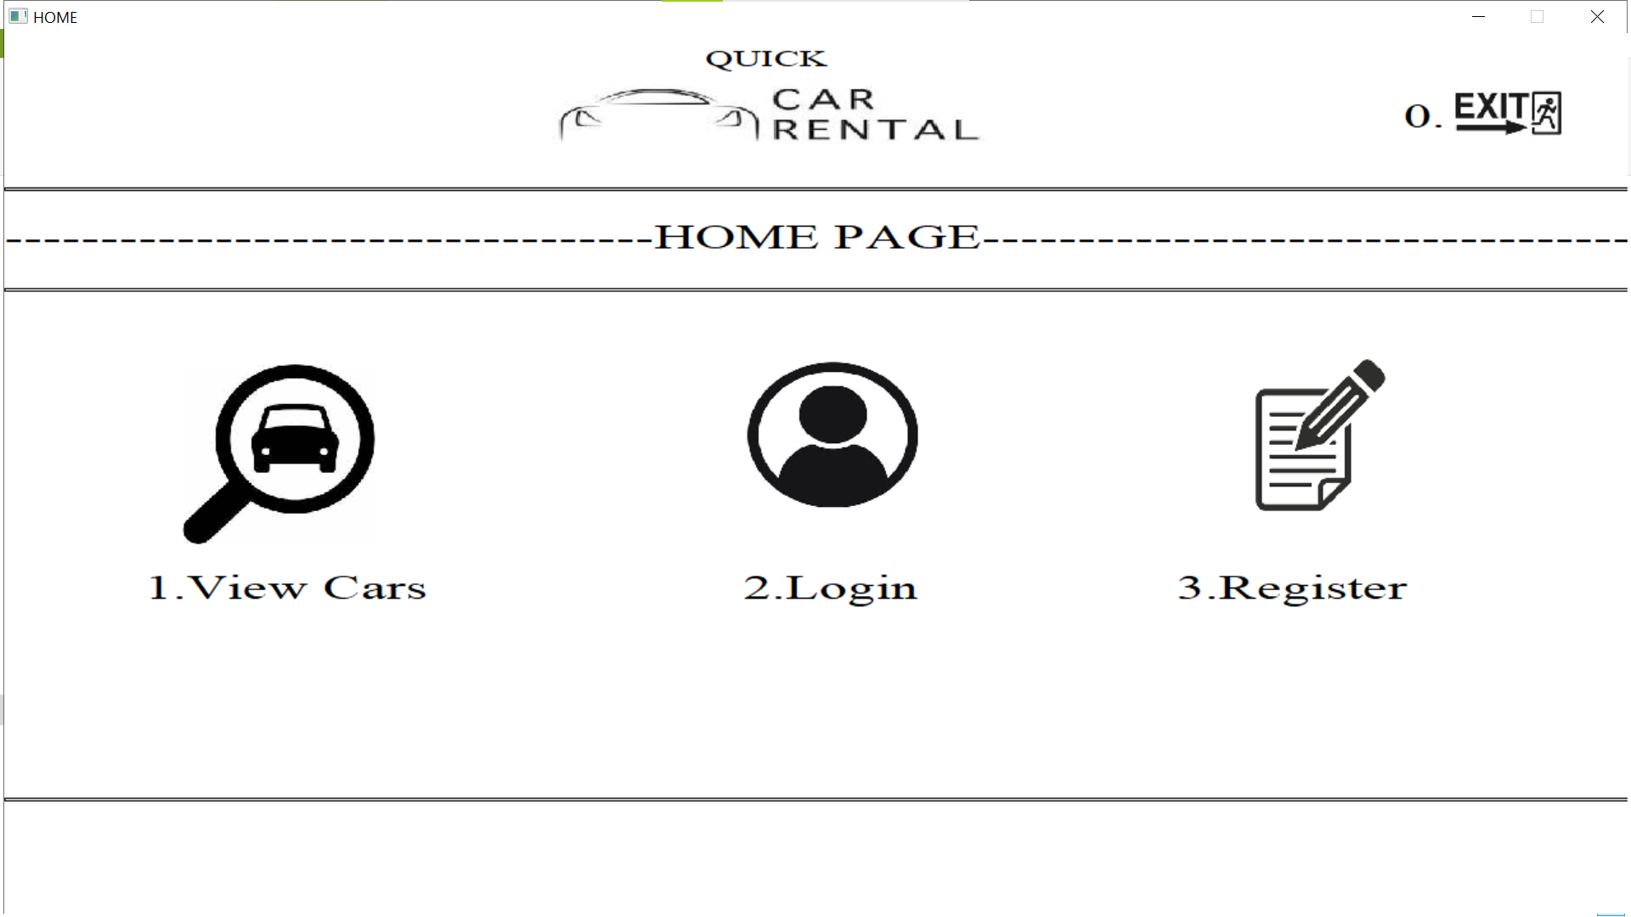

OUTPUTS:

Figure 5.1 Homepage

This page includes the general home page including view cars, login and register.

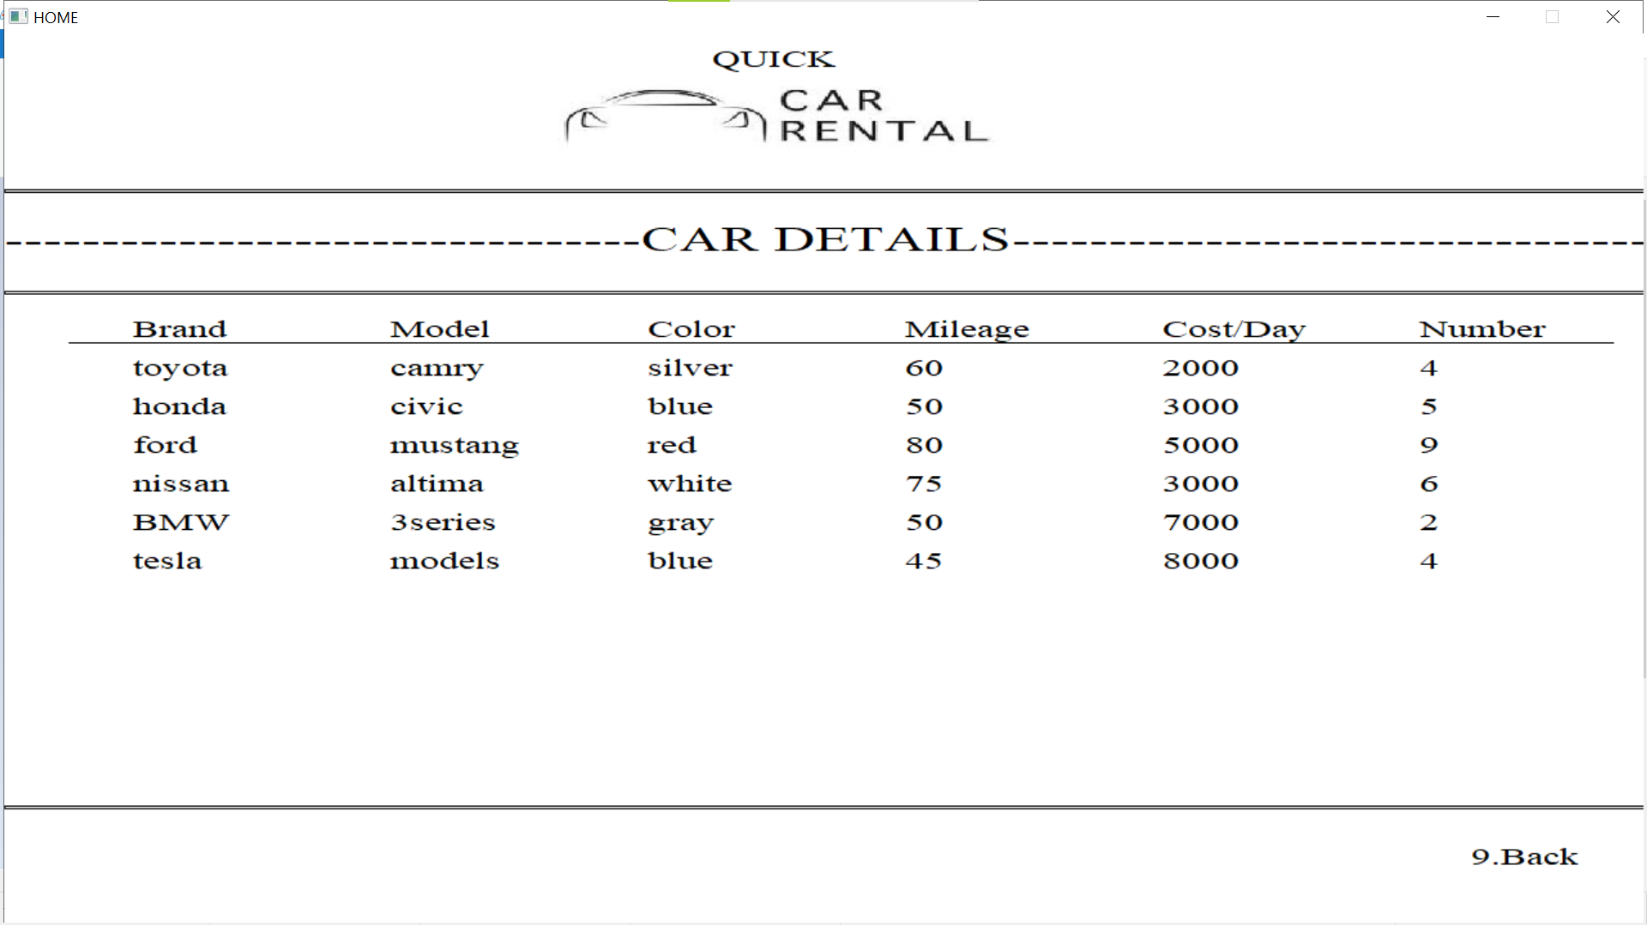  
  
  
  
  
  
  
  
  
  
  
  
  
  
  
  
Figure 5.2 Car details

The details of the car will be shown

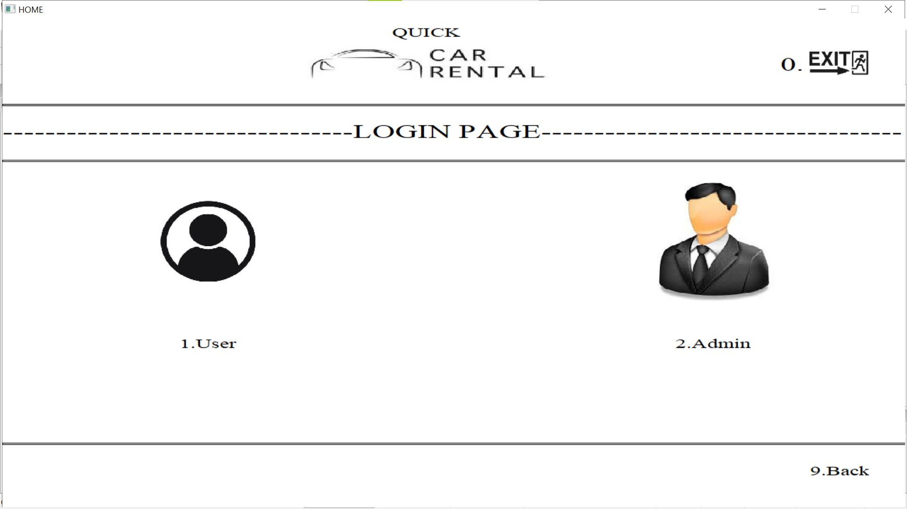Figure 5.3 Login Page

It will link to the login page where there is one user and admin

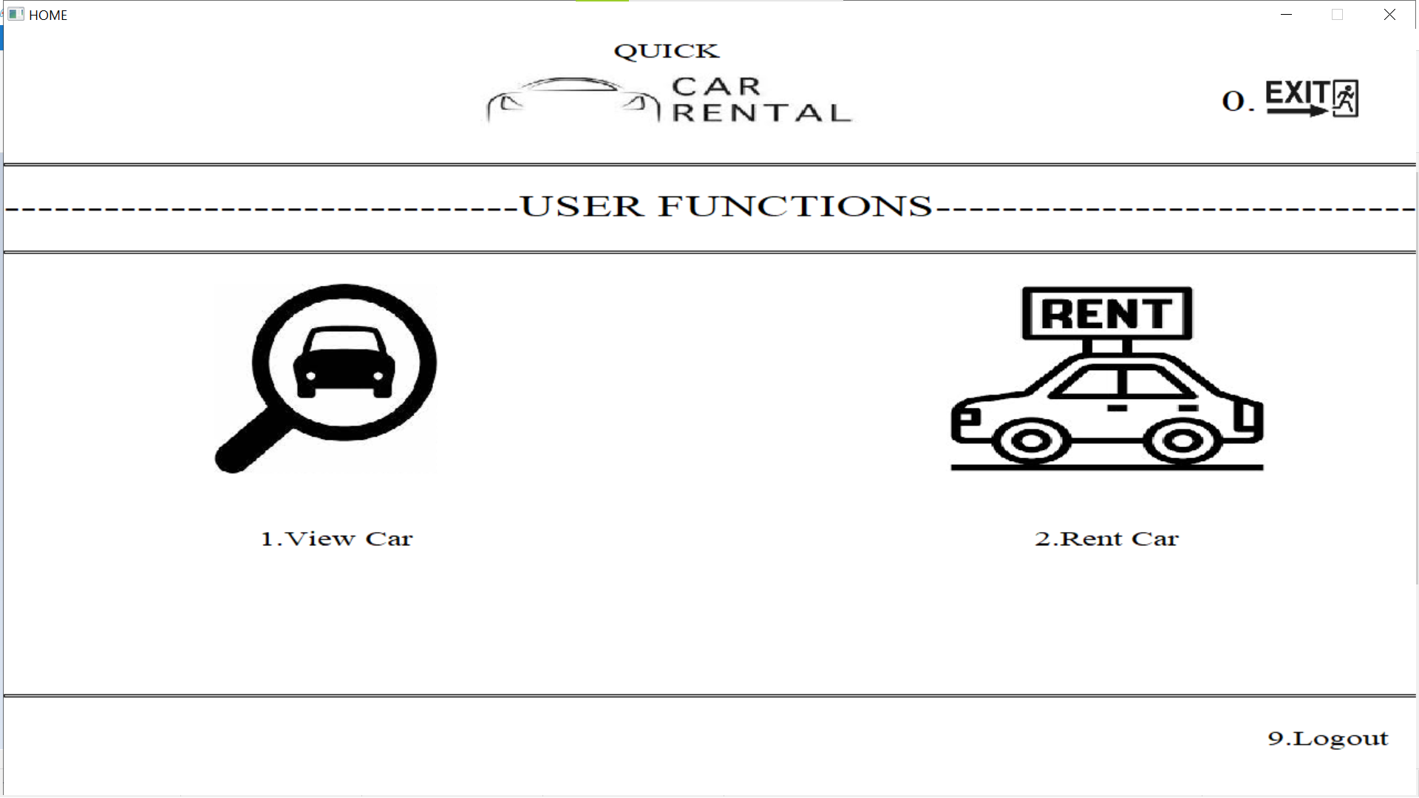Figure 5.4 User Functions

Inside the user funtion the user can view the available cars and rent the cars.

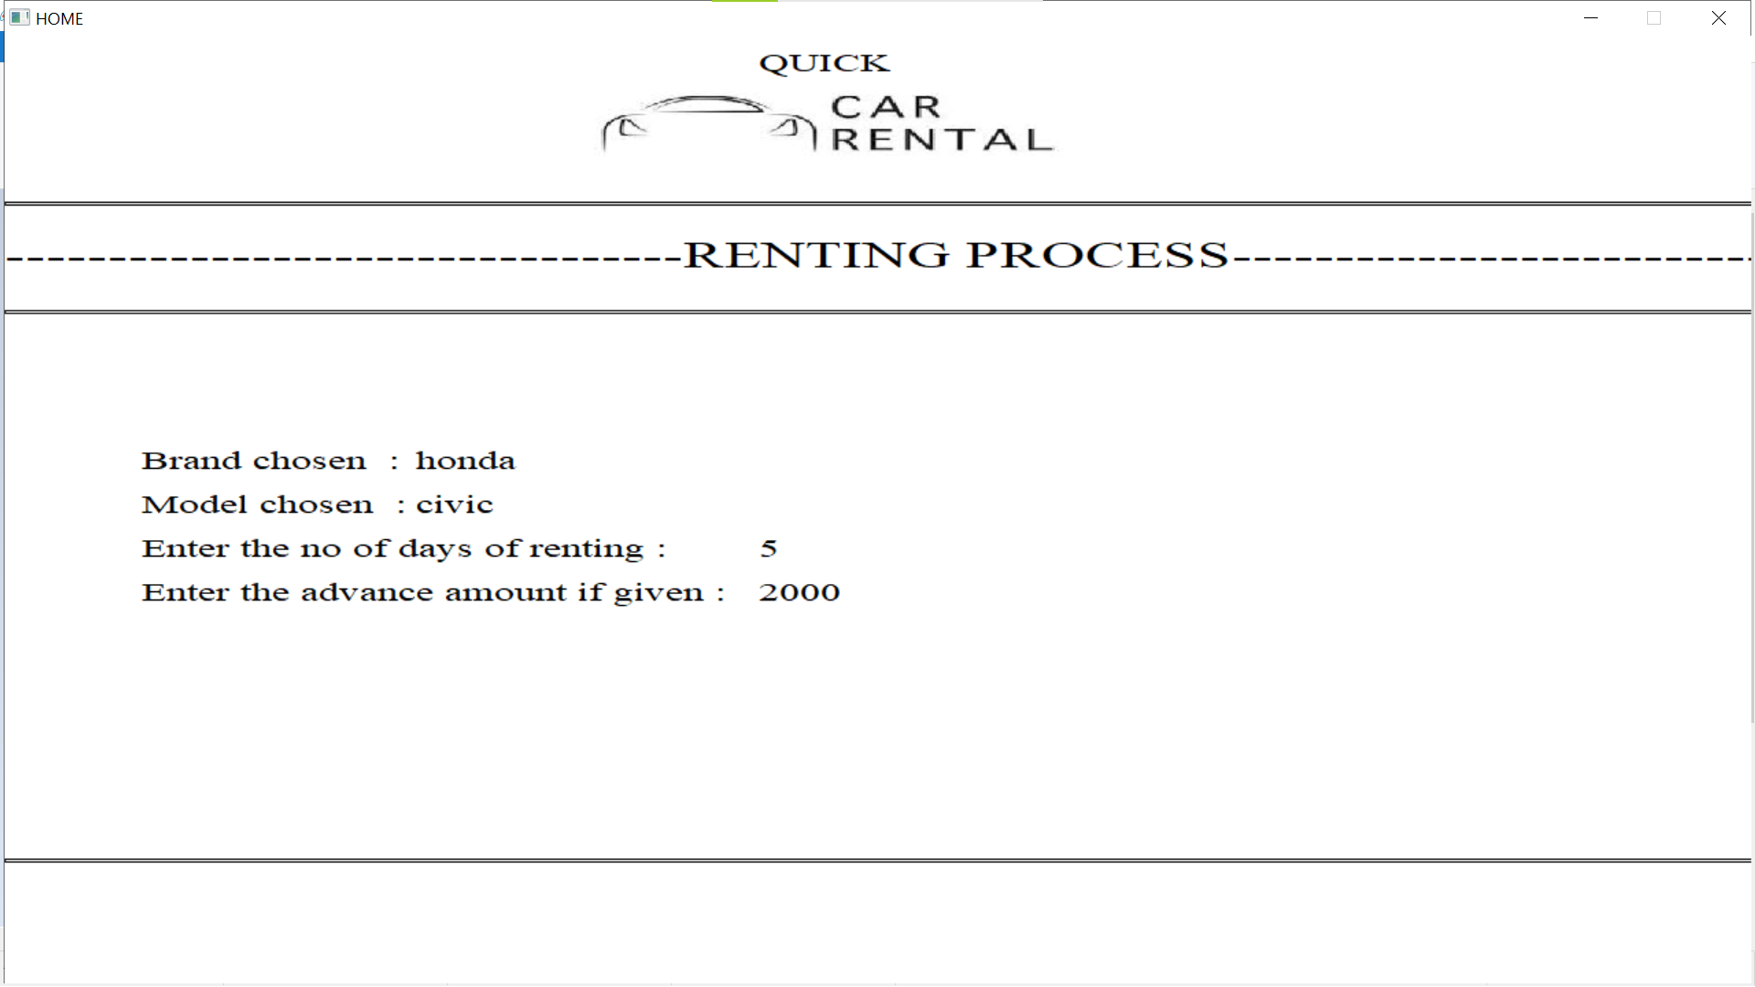Figure 5.5 Renting process

This is where the user is allowed to rent the available cars

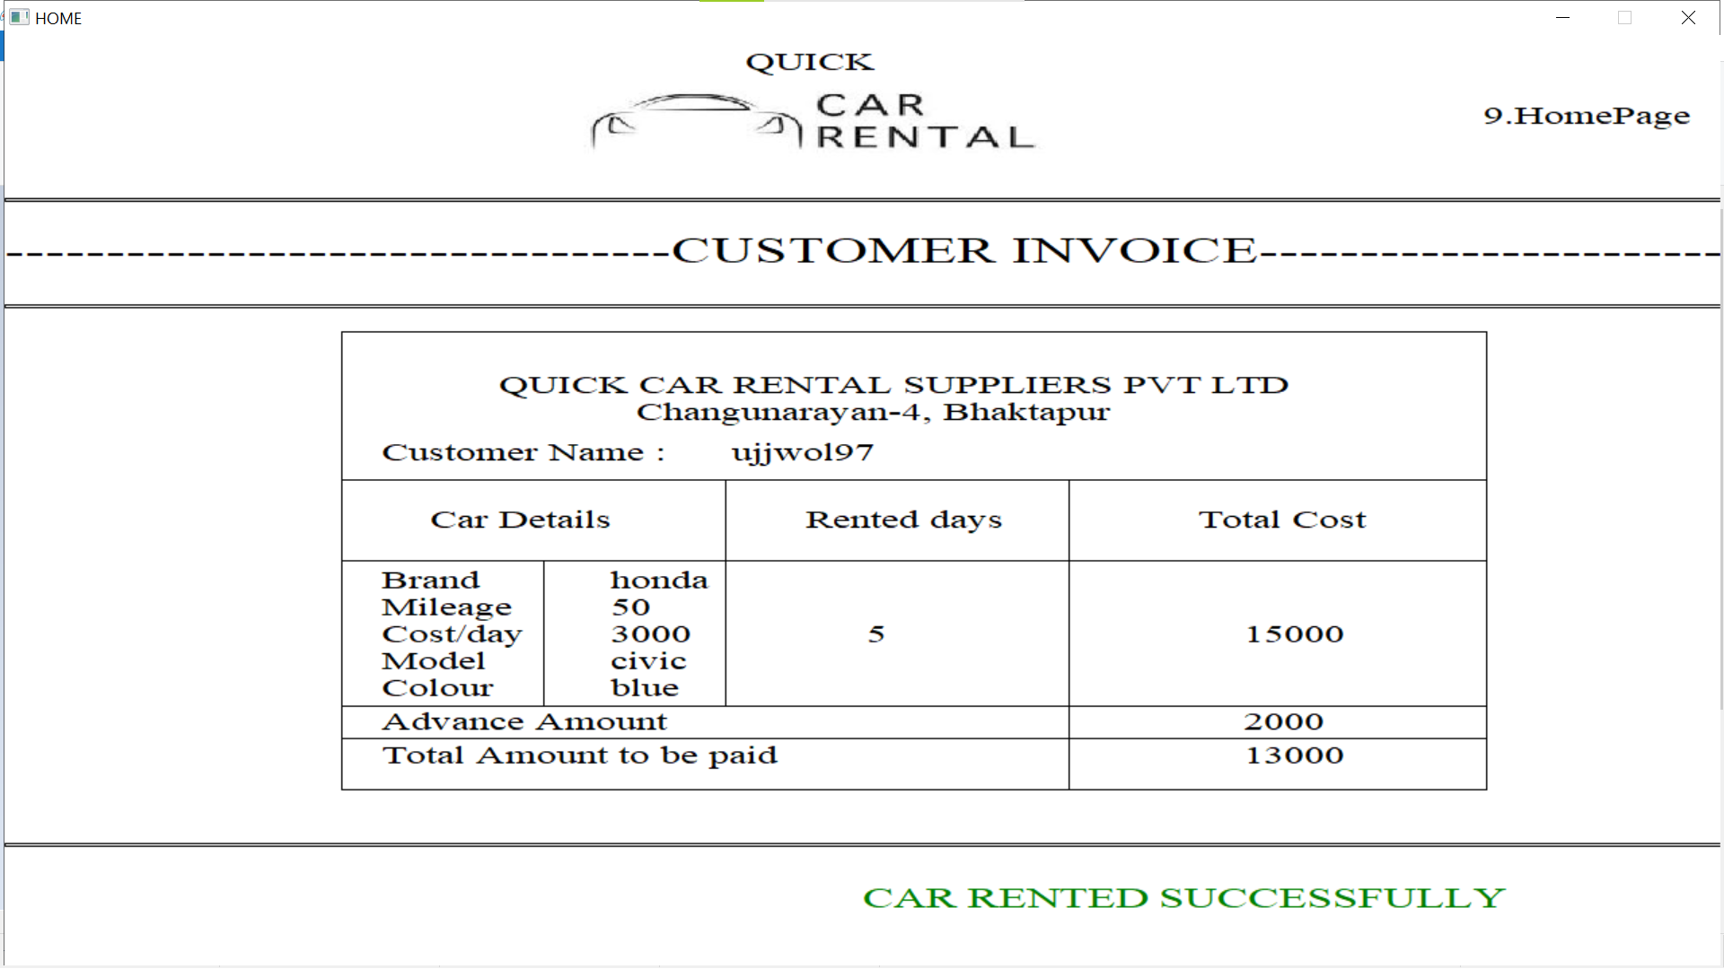Figure 5.6 Customer Invoice  
After customer rents the car an invoice will be generated

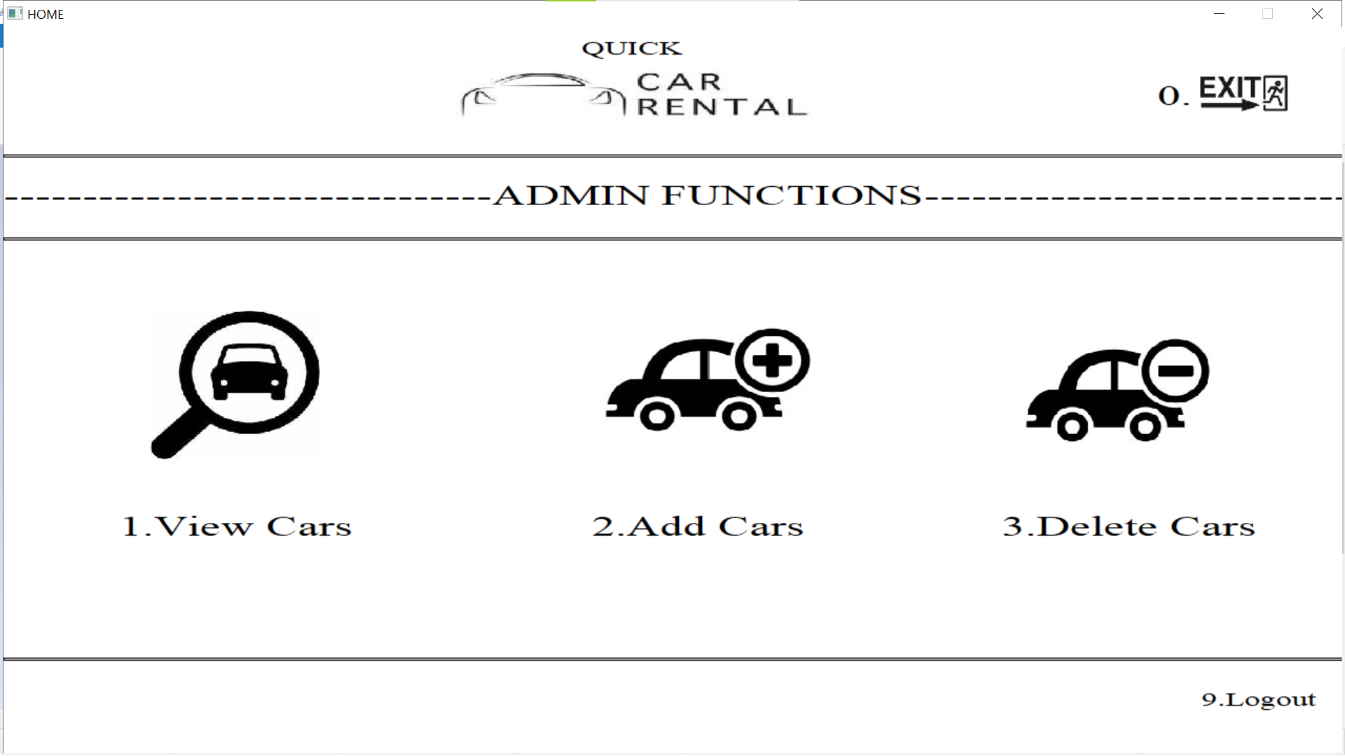Figure 5.7 Admin Functions

The admin functions iinclude the view cars, add cars, delete cars.

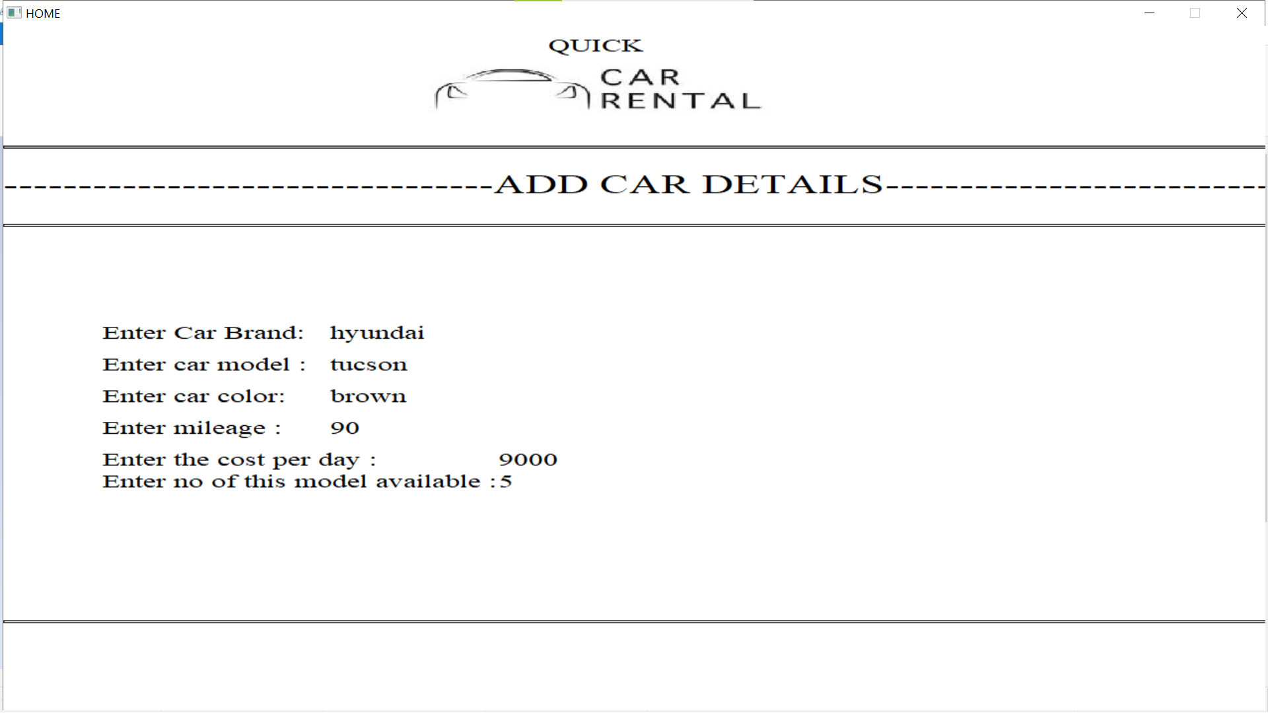  
  
  
  
  
  
  
  
  
  
  
  
  
  
  
Figure 5.8 Adding Car Details

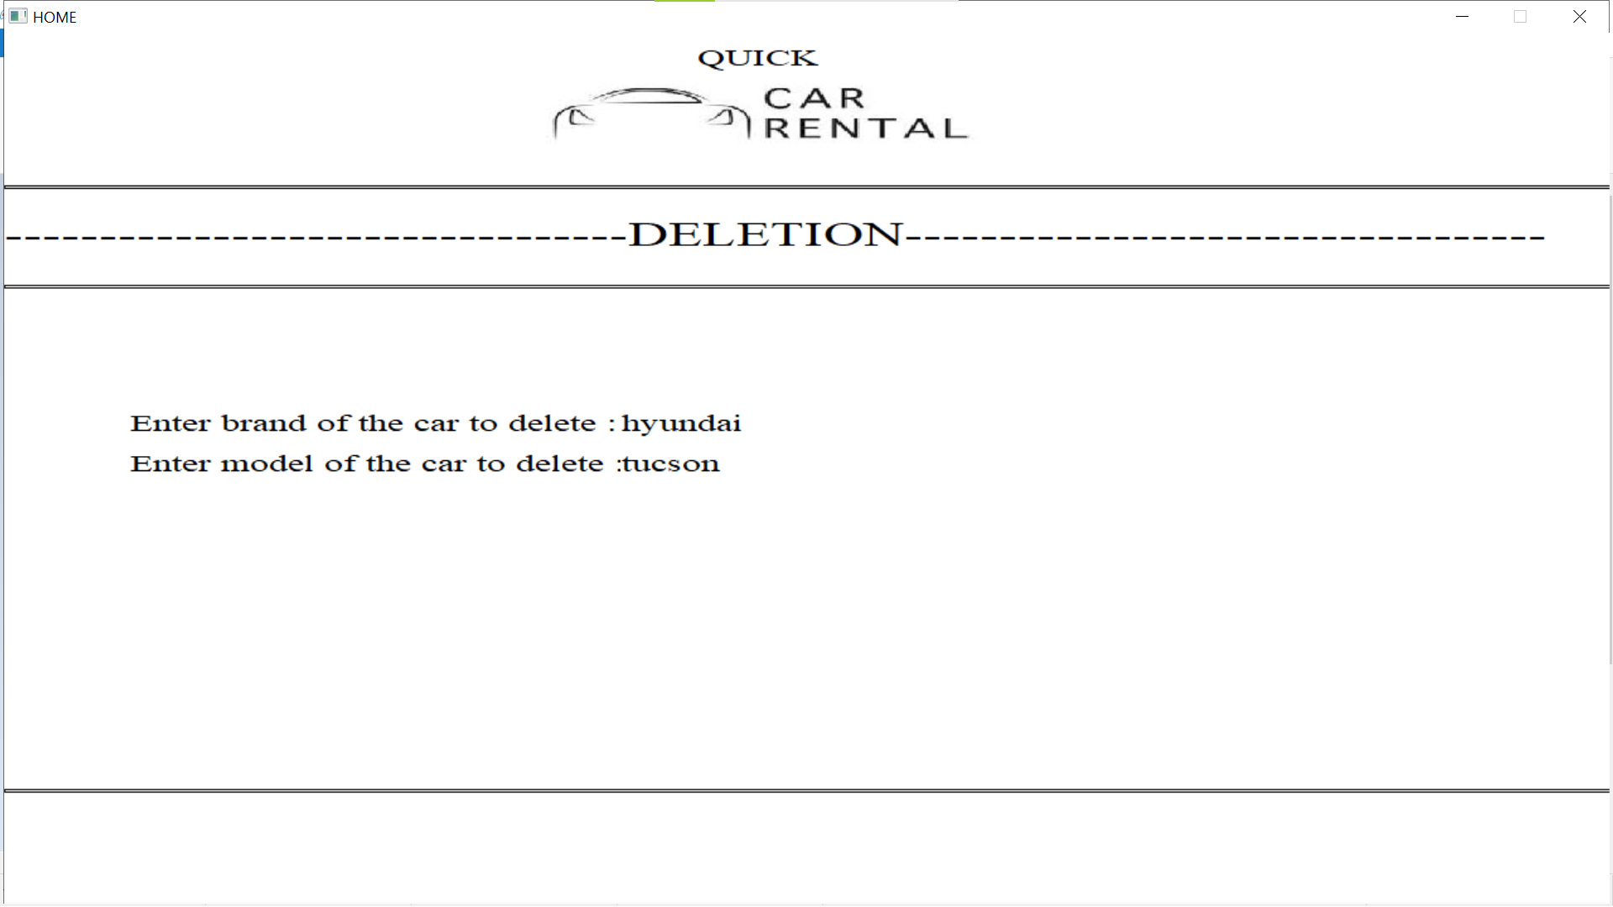The admin can add the car details according to given details  
  
  
  
  
  
  
  
  
  
  
  
  
  
  
  
  
  
Figure 5.9 Deleting Car Details  
The admin can also delete the car details accordingly

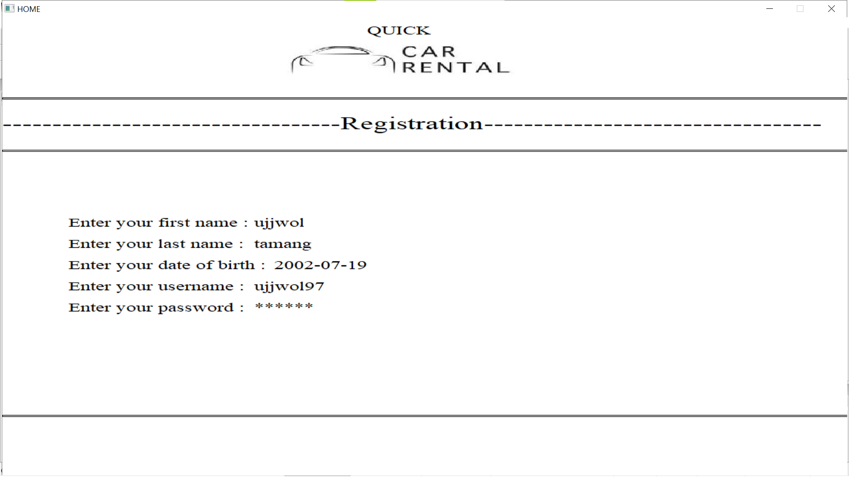Figure 5.10 Registration page  
This page allows new user to create a new account

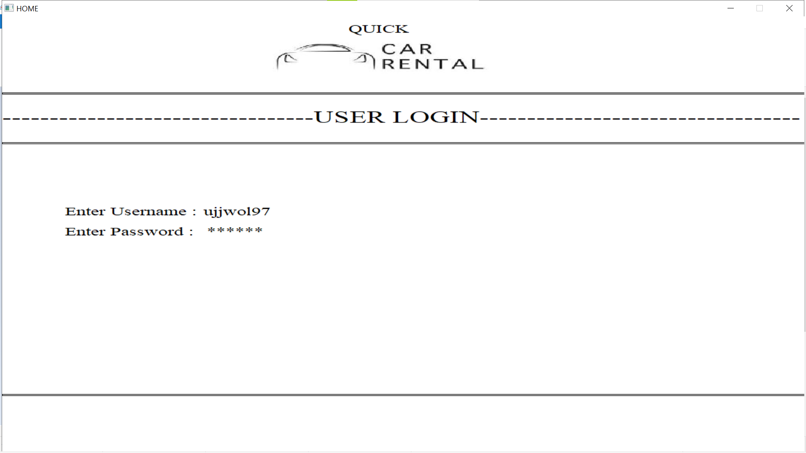  
  
  
  
  
  
  
  
  
  
  
  
  
  
  
  
  
  
Figure 5.11 User Login  
This allows the user to access the user functions

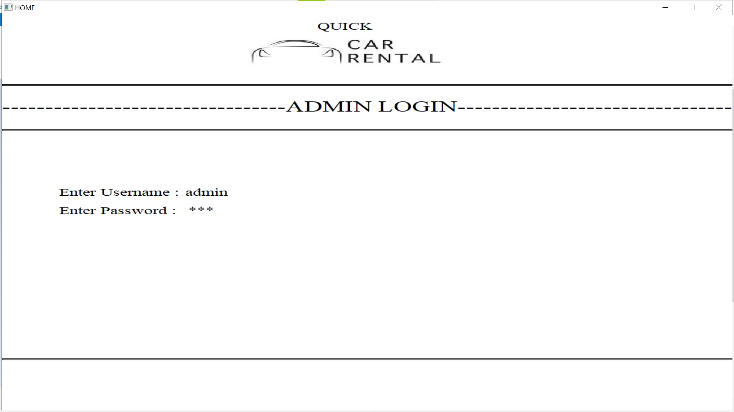Figure 5.12 Admin Login page  
This allows the admin to access admin functions

# CONCLUSION

In conclusion, the development of the car rental system in C has been a rewarding journey, offering an efficient solution for managing car rentals. This project has successfully addressed key challenges in the industry by providing a user-friendly interface for both customers and administrators, streamlining the process of booking and managing cars.

Ultimately, this car rental system in C stands as a testament to the power of software solutions in optimizing operations, improving customer experiences, and driving efficiency in the car rental industry.

# REFERENCES

* + - 1. https://www.automotive-fleet.com/147063/car-renting-its-development-and-future (August 29,2023)
      2. https://about.sixt.com/websites/sixt_cc/English/0/about-us.html (August 29,2023)
      3. <http://www.douglascohistory.org/Education_Innovators_Saunders.html> (August 29, 2023)
      4. https://www.hertz.com/rentacar/reservation/ (August 29, 2023)
      5. https://play.google.com/store/apps/details?id=com.selfdrive&hl=en/ (August 29, 2023)
      6. https://app.diagrams.net/ (September 1, 2023)