**PURBANCHAL UNIVERSITY**



**DEPARTMENT OF COMPUTER ENGINEERING**

**KHWOPA ENGINEERING COLLEGE**  
**LIBALI-2, BHAKTAPUR**

**A MID - TERM REPORT**

**ON**

**CAR RENTAL SYSTEM**

 Project work proposal in partial fulfillment of requirements for the award of the degree of Bachelor of Engineering in Computer Engineering

**SUBMITTED BY**

1. Manseez Bahadur Pradhan(780320)

2. Riju Phaiju (780330)

3. Trilok Thapa (780344)

4. Ujjwol Tamang (780345)

**UNDER THE GUIDANCE OF**

Er. Shiva Pd. Mahato

September 5, 2023

**ACKNOWLEDGEMENT**

We would like to express our sincere gratitude our respected teachers and **Purbanchal University** for including the Project - I in our course of study and all those who have supported in the completion of this project.

We would like to express our sincere appreciation to Er. Shiva Pd. Mahato for his kind and proper guidance and supervision.We would also like to expand our gratitude to **Khwopa Engineering College** and **Department of Computer Engineering** for including this project in our curriculum.

Thank you.

**ABSTRACT**

This project aims to develop a car rental system using the C programming language to address the specific needs of car rental businesses.

It provides the interface for administration and customer separately where, administrator can be able to register, login, and rent the chosen car. Similarly, administrator can be able to add or delete the cars and could store the details of users or customers and also generate the bill.

Keywords: - Registration, rent, forget password, invoice.

TABLE OF CONTENT

**CHAPTER 1**

**INTRODUCTION 1**

1.1 Background 1

1.2 Motivation 1

1.3 Statements of Problem 1

1.4 Objectives 2

1.5 Applications 2

1.6 Scope 2

**CHAPTER 2** 3

**LITERATURE REVIEW 3**

**CHAPTER 3** 4

**PROJECT MANAGEMENT** 4

3.1 Project Members 4

3.2 Work Breakdown Planning 4

**CHAPTER 4** 5

**METHODOLOGY** 5

4.1 Background 5

4.2 Block Diagram 5

4.3 Algorithm 6-7

4.4. Flowchart 8

**CHAPTER 5** 9

**EXPECTED OUTCOMES** 9

**REFERECES**  10

**List of Figures**

4.2 Block Diagram…………..……………………………………………………………..5

4.4 Flowchart…………………………………………………………...…………………..8

**List of Tables**

3.2 Work Break Down Planning…………………………………………………………..…..4

**CHAPTER 1**

**INTRODUCTION**

**1.1 Background**

The car rental industry is growing rapidly, and businesses in this sector need efficient and reliable software solutions to manage their operations effectively. A car rental system simplifies the process of booking, managing and ensuring a seamless experience for both customers and rental agencies. With the advancement of technology, a well-designed car rental system can streamline the process of booking and managing vehicles for both customers and rental agencies.

This project aims to develop a car rental system using the C programming language to address the specific needs of car rental businesses.

**1.2 Motivation**

The motivation behind developing a car rental system is to provide a user-friendly and automated solution for customers and rental agencies. This system will eliminate the traditional manual paperwork and improve the overall rental experience. It will allow customers to easily browse and select available vehicles, make reservations, manage bookings, and facilitate efficient vehicle allocation for rental agencies.

**1.3 Statement of Problems**

Traditional car rental systems heavily rely on manual paperwork, making the booking process time-consuming and prone to errors. Managing a fleet of vehicles manually can be challenging, leading to difficulties in tracking vehicle availability, maintenance schedules, and documentation. Customers often face difficulties in finding suitable vehicles, comparing prices, and making reservations according to their preferences.

**1.4 Objectives**

Develop a user-friendly interface for customers to search, compare, and book vehicles easily. Create an efficient vehicle management system to track availability, maintenance schedules, and documentation and to implement a secure login system for both customers and admin to access the system.

**1.5 Application**

The car rental system will encompass the following key features:   
a) User-friendly interface for customers to search, compare, and book vehicles  
b) Vehicle management system to track availability, maintenance schedules, and documentation.   
c) Secure login system for customers and rental agency staff.   
d) Billing and payment module for secure and accurate transactions.   
e) Reporting and analysis features for monitoring business performance.

**1.6 Scope**

The scope of the Car Rental System project in C programming involves developing a user-friendly interface for customers to search, compare, and book vehicles, implementing a vehicle management system to track availability and maintenance schedules, integrating a secure login system for users, incorporating a billing and payment module for transactions, providing reporting and analysis features for business monitoring, and creating an administrative panel for system management. The project aims to streamline operations, enhance customer satisfaction, and optimize business processes for car rental agencies, catering to their specific needs and ensuring efficiency and reliability throughout the rental process.

**CHAPTER 2**

**LITERATURE REVIEW**

We have site searched and reviewed a lot of works and changes that have been done so far in the process of development of car rental system.

The concept of renting if car or other vehicles started in the 19th century.

**Saunders Drive-it-yourself system**

Initially, Joe Saunders of Omaha, Nebraska started renting Model T Ford in 1915. Later on he named his company ‘Saunders Drive-It-Yourself System’. In this period, renting of car involved a lot of paper works and a long process which was kind of problem for every people.

**Modern car renting system**

As the automotive industry progressed and expanded, so did the car rental companies. People moved from old Model T cars and have diversified their fleets with hundreds of different car brands.

Nowadays, you often need nothing more than your driving license, which reduces a lot of monotonous paper works. More importantly, this system is made available online due to which we can easily rent the desired cars without even going out in the location [1].

**2.1 Study on Existing Systems**

There is an existing car rental system made by the students at Zeal institute, Pune. It is a built-a console with c++ programming.

In their system, there was only the interface for customers and not for the admin. Analyzing the very system, we had tried to add the interface for the administrator which can have access to few more functions. Such as view and modify car details, view, and store the details of customers [2].

**CHAPTER 3**

**PROJECT MANAGEMENT**

**3.1 Team Members**

This project will be the joint effort of:

1. Manseez B. Pradhan (780320)
2. Riju Phaiju (780330)
3. Trilok Thapa (780344)
4. Ujjwol Tamang (780345)

**3.2 Work Breakdown Planning**

|  |  |  |  |  |  |  |  |  |
| --- | --- | --- | --- | --- | --- | --- | --- | --- |
| S. N |  | Week Duration | 1st week | 2nd week | 3rd week | 4th week | 5th week | 6th week |
| 1. | Problem Identification | 3days |  |  |  |  |  |  |
| 2. | Analysis | 4days |  |  |  |  |  |  |
| 3. | Design | 7days |  |  |  |  |  |  |
| 4. | Coding | 20days |  |  |  |  |  |  |
| 5. | Implementation & testing | 6days |  |  |  |  |  |  |
| 6. | Documentation | 45days |  |  |  |  |  |  |

**CHAPTER 4**

**METHODOLOGY**

**4.1 Background**

A system design is a conceptual model that define structure, behavior, and more view of the system. It is a formal description and representation of a system organized in a way that support rezoning about the structure and system architecture can comprise the system component, the extremely visible of those components, and the relationship between them. It provides a platform that will work together to implement the whole system.

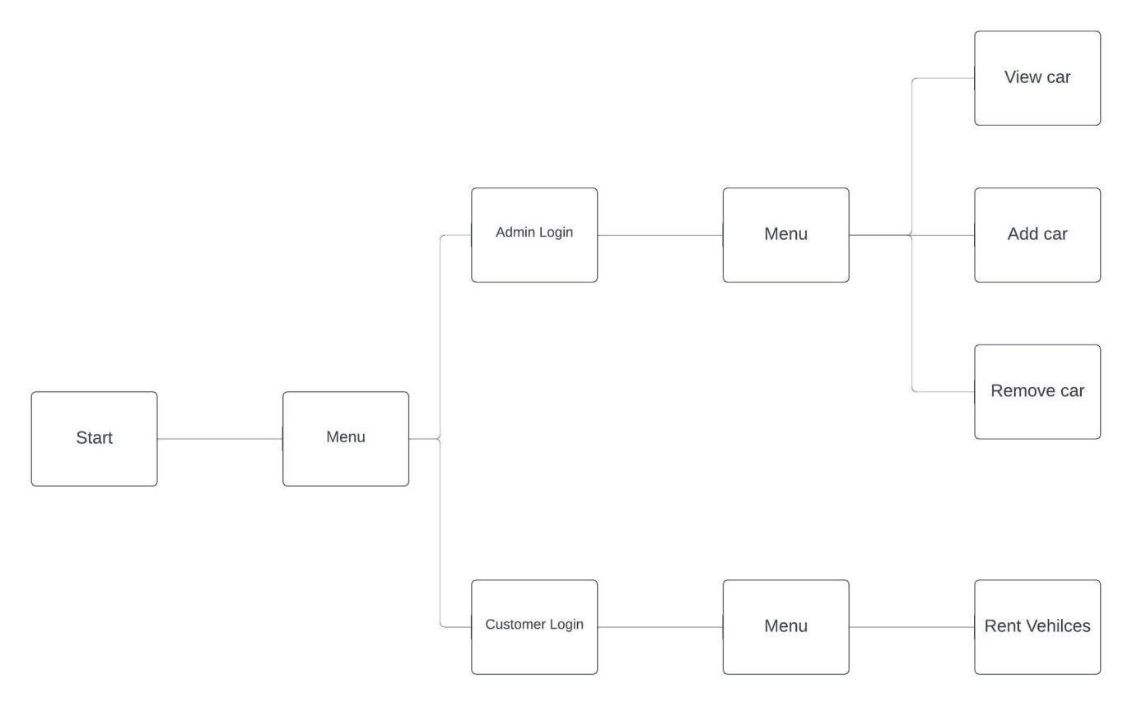**4.2 Block Diagram of Car Rental System**

Fig 4.2: Block Diagram of Car Rental System

In the above diagram, the whole process that our developed system is shown. In this system first of all administrators will have to login to it to use features like adding cars, delete cars, viewing cars etc. In another side customer will have features to use the system when they login. They can go to renting, returning and viewing option after login. System can be shut- down when the use for the day is fulfilled by pressing exit option in it.

**4.3 Algorithm**

**Step 1:** Start **Step 2:** Choose who you are. ADMIN OR CUSTOMER

**(For Admin)**

**Step 3:** Enter provided username and password, if validation successfully then next page appears with the given below:

1. View Car Details
2. Add Cars
3. Remove cars.
4. Exit

**Step 4:** If verification failed, Goto **Step 2**

**Step 5:** Choose the option as per needed shown in the console/screen.

**(For Customer)**

**Step 6:** If user is an **old customer**, user can directly login or if the user is a **new** **customer**

**Step 7:** Enter the username and password that user had. If the validation success, then the next page appears with the options given below:

1. View car
2. Rent car
3. Exit

**Step 8:** If verification failed, Goto **Step 6.**

**Step 9:** Choose the option as per needed.

**Step 10:** Finally, user can **exit.**

**Step 11:** Exit.

**4.4 Flowchart**

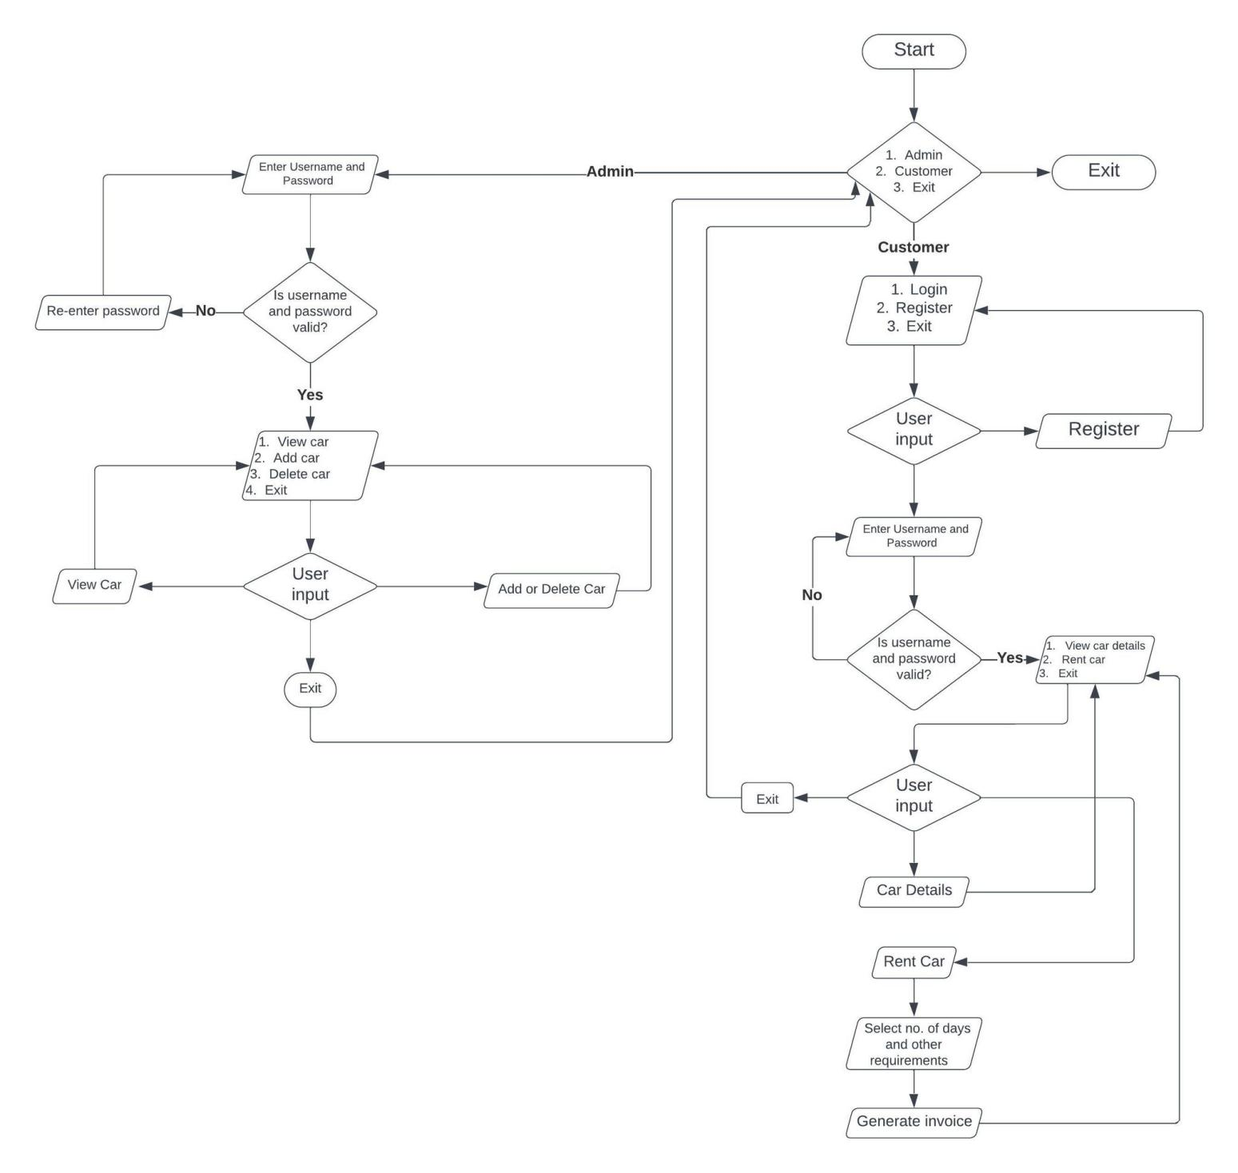

**CHAPTER 5**

**PROJECT WORK STATUS**

**5.1 Work done**

This system can be used in renting of car systematically. CRS provides login system for admin and customer to have access to multiple features. Here are the some outputs of this project:

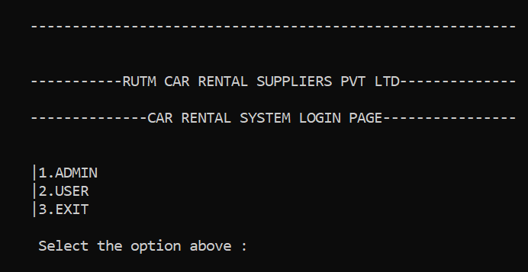The program’s home page :

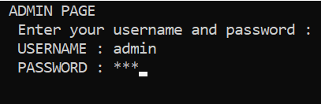ADMIN’S login and other features:

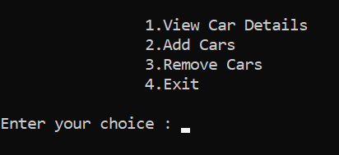

Viewing Details :

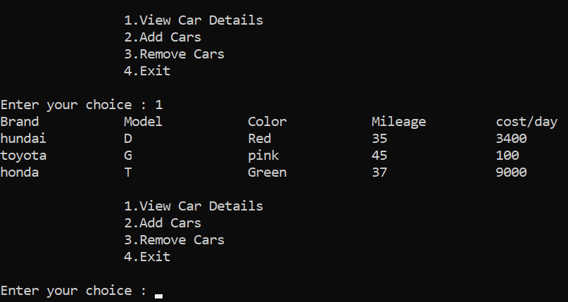

Adding/Removing Car details:

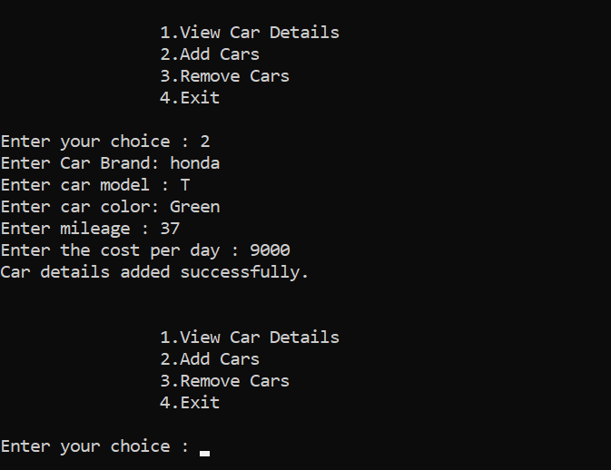

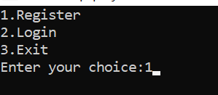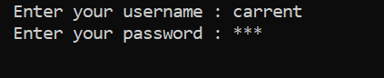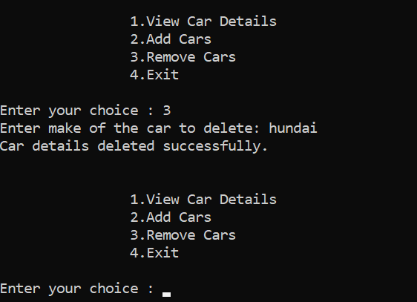CUSTOMER PAGE:

CUSTOMER’S functions :

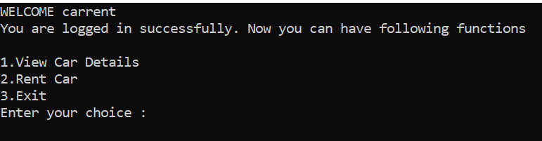

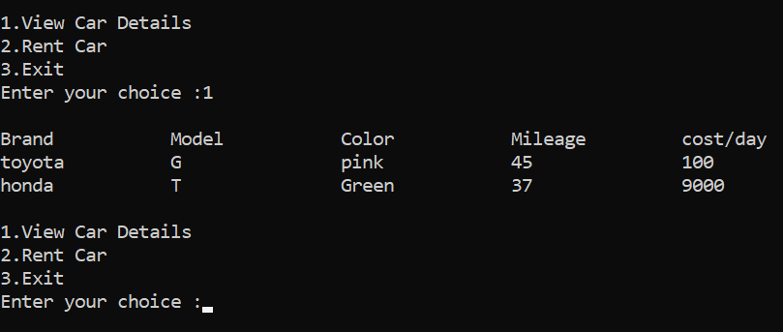VIEWING DETAILS :

RENT CAR AND GENERATION OF INVOICE :

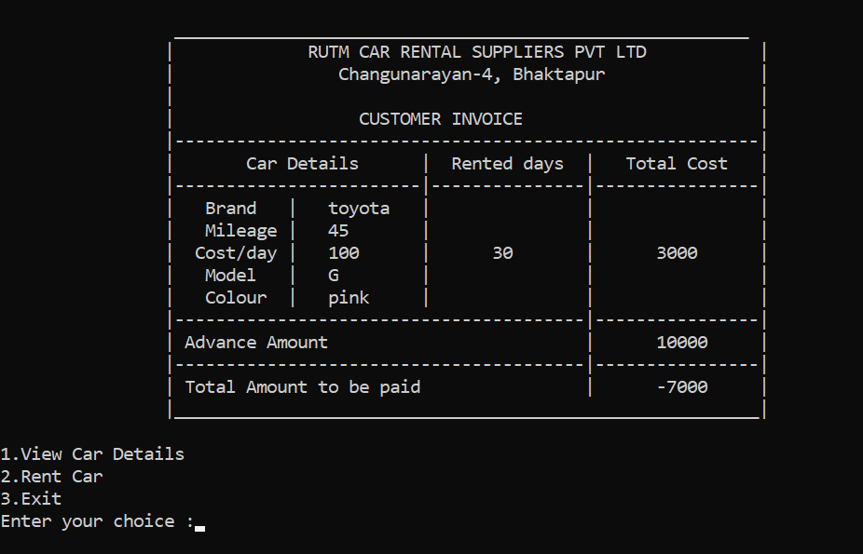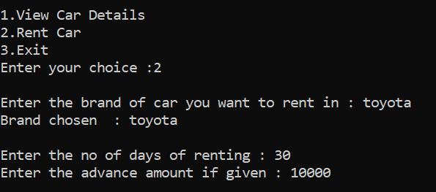

**REFERENCES**

**Websites**

1. <https://www.arnoldclarkrental.com/latest-news/275-history-of-car-rental-what-has-changed#:~:text=The%20earliest%20records%20of%20car,for%20rent%20and%20quickly%20expanded.>
2. <https://www.smartdraw.com/flowchart/flowchart-maker.htm>

**Books**

Venugopal K.R., Rajkumar and Ravishankar T. (1979). Mastering C++.

Kanetkar Yashavant (2019). Let Us C++.