Ujval Bangalore Umesh
Mail:banga038@umn.edu,ujvalumesh113@gmail.com Contact:9164302679

The objective of the report is to study and analyze the NYC green taxi data as recorded by the New York City Taxi and Limousine commission.

I will initially highlight a few anomalies observed.

- The pickup and drop off locations coordinates are 0 longitude and 0 latitude. The subsequent questions answered in usage of this data, ignores these values in computations.
- Trip_type has 4 missing values in it.
- Ehail_fee column has missing values throughout. Hence this column can be removed.
- The count of passengers for the trip mentioned in passenger count column has values of 0 in many observations. These values are omitted. Having a thorough lookup of the data, It might be ignored too as it does not influence the results obtained.
- Certain Trip Distances can be treated as outliers after visualization.
- The trip_distances and travel time of trip (Drop off time-pickup time) of several observations are zero. These are anomalies. Hence, in calculations of the speed, the speed is 0 for any column with trip distance equal to 0 or travel time of trip =0.

The packages required to run the program are all mentioned in the code along with the libraries.

Question1.

a) There are two ways of loading the data set. One way is to download the dataset from the url "https://s3.amazonaws.com/nyc-tlc/trip+data/green_tripdata_2015-09.csv" or by downloading the dataset to a local memory and then using read.csv function followed by the location in the local memory.

b) The number of columns can be obtained by using the ncol function. ncol(dataset)
The number of rows can be obtained by using the nrow function. nrow(dataset). There are 22 columns and 1494926 rows.

Alternatively, str(dataset) function returns the rows and columns along with the internal structure of each of the variables passed in the dataset.

Question2.

a)

Histogram considering all the outliers is depicted. The graph is highly right skewed in nature. Hence, another Histogram is plotted considering data points restricted by the x-axis limit.

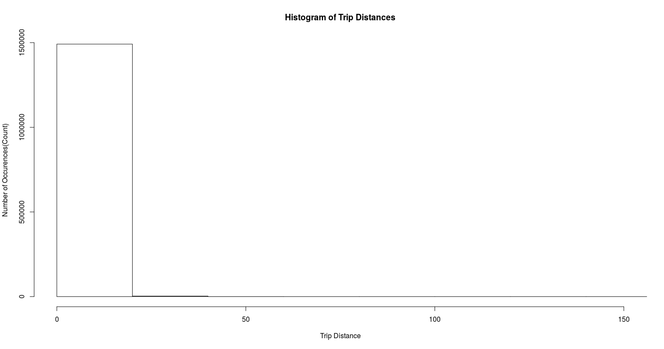
b)

The data is right skewed and has the skewness quotient of 8.442.Typically the mean is greater than the median.
The Kurtosis quotient is a measure of the outliers and hence this suggests that most of the data points are concentrated at one end.
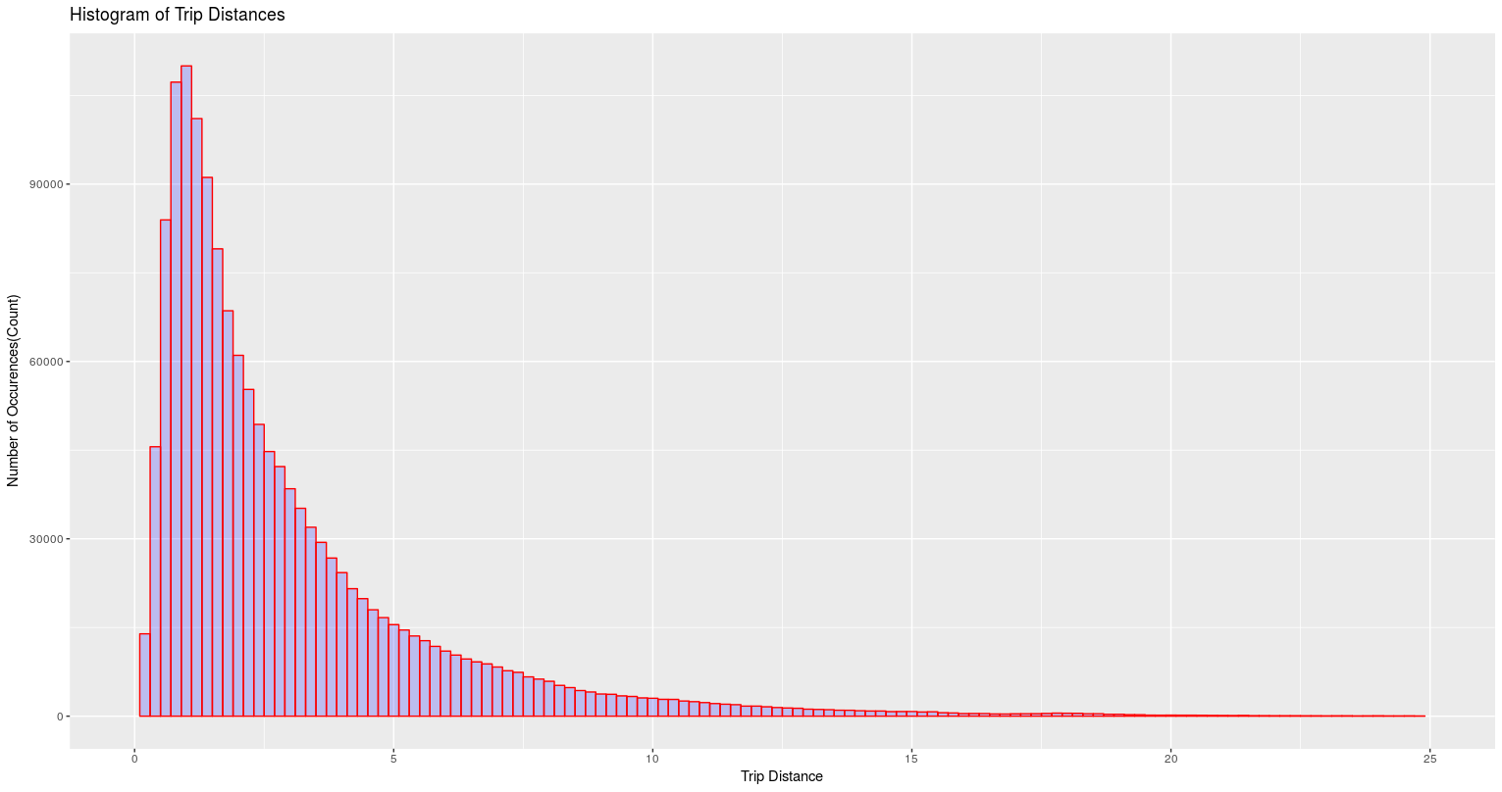

Question 3

3(a) The Hourly Mean and Median Trip Distances are tabulated below.

Hours meantripdistance mediantripdistance
1 00 3.115276 2.20
2 01 3.017347 2.12
3 02 3.046176 2.14
4 03 3.212945 2.20
5 04 3.526555 2.36
6 05 4.133474 2.90
7 06 4.055149 2.84
8 07 3.284394 2.17
9 08 3.048450 1.98
10 09 2.999105 1.96
11 10 2.944482 1.92
12 11 2.912015 1.88
13 12 2.903065 1.89
14 13 2.878294 1.84
15 14 2.864304 1.83
16 15 2.857040 1.81
17 16 2.779852 1.80
18 17 2.679114 1.78
19 18 2.653222 1.80
20 19 2.715597 1.85
21 20 2.777052 1.90
22 21 2.999189 2.03
23 22 3.185394 2.20
24 23 3.191538 2.22

Plot of Hourly mean distances

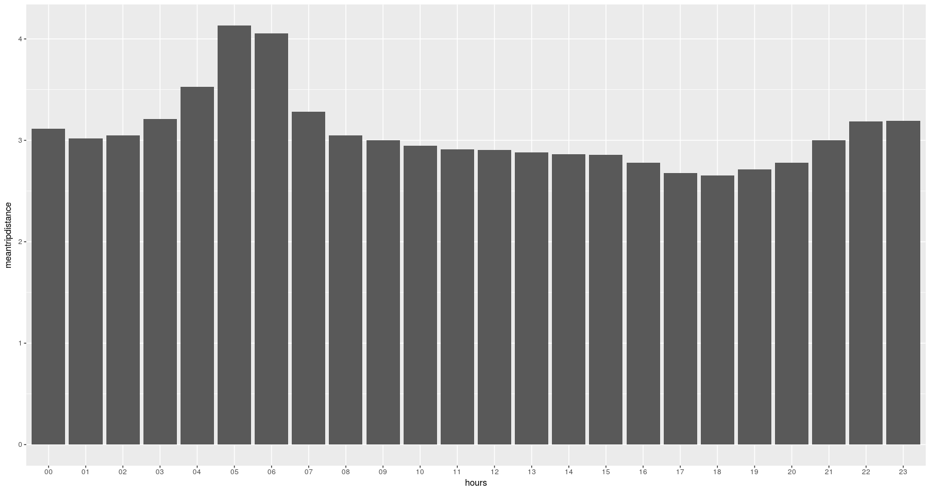

Plot of Hourly Median Distances
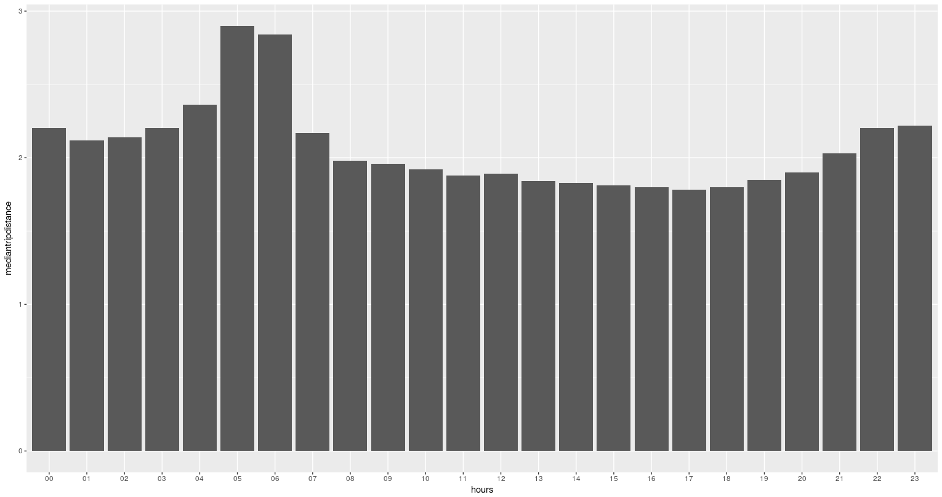

3(b)

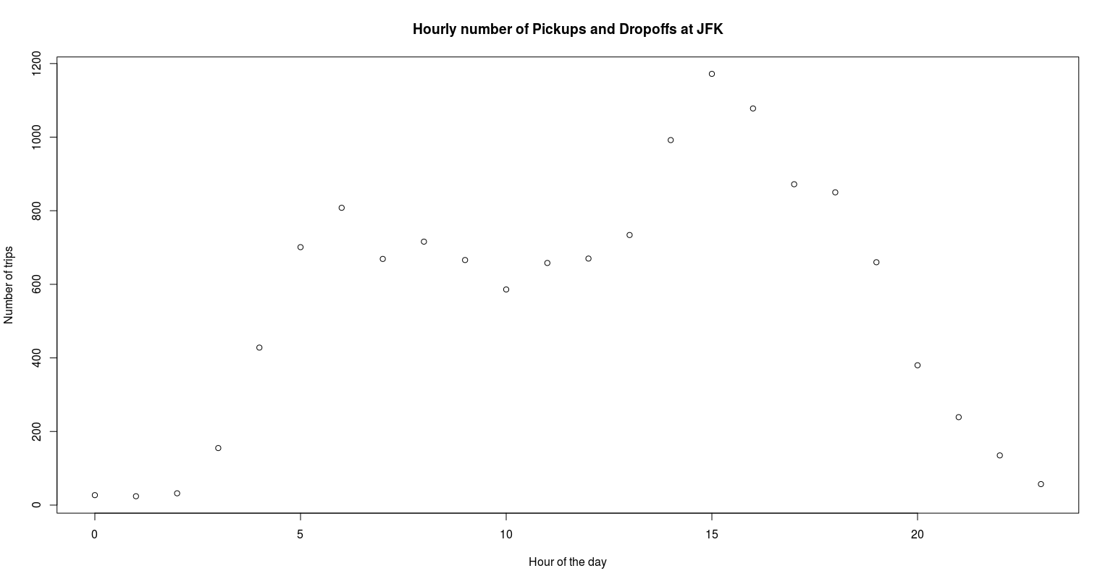
The number of Pickups and Dropoffs at any hour of the day is a bimodal graph with its maximum peak at around 3 pm. Hence, more number of Green Taxis can be deployed from 2PM-4PM and early hours in the morning from 5-6 AM.

The average Fare amount statistics is given by

 | jfk_dropoff | avg_Fare
1 | 0 | 12.28637
2 | 1 | 41.37869

Question 4

4(a)

A derived variable for tip as a percentage of the total fare is done .
The data set consists of observations with Tip_amount=0 or Total_amount=0. In both the cases, the derived variable is kept 0.
4(b) A predictive model for tip as a percentage of the total fare is obtained by considering several parameters in the dataset as predictors for the response variable to be Tippercent(Tip as a percentage of the Total Fare). Linear Regression model is used for this. With the base assumption of normality in the data, and the correlation is inspected to be uncorrelated predictors.
The filtering of data is done based on removal of missing values, anomalies and outliers detection is some cases.
Regression is done on 75% of data known as a training data and prediction is done on the remaining 25% of the test data.
The summary of the regression fit is shown below. This suggests that all the regressors play an important role as their p-values are less than 0.05 (with 95% Confidence).

lm(formula = tippercent ~ VendorID + Passenger_count + Extra +
Tolls_amount + Total_amount + Payment_type + Trip_type, data = training_set)

Residuals:
Min 1Q Median 3Q Max
-30.405 -1.026 -0.375 2.604 112.974

Coefficients:
Estimate Std. Error t value Pr(>|t|)
(Intercept) 2.966e+01 4.857e-02 610.655 < 2e-16 ***
VendorID -7.325e-01 1.289e-02 -56.823 < 2e-16 ***
Passenger_count 3.171e-02 5.123e-03 6.190 6.03e-10 ***
Extra -1.241e-01 1.463e-02 -8.482 < 2e-16 ***
Tolls_amount -1.609e-01 6.345e-03 -25.366 < 2e-16 ***
Total_amount 3.809e-02 5.083e-04 74.941 < 2e-16 ***
Payment_type -1.289e+01 1.050e-02 -1228.042 < 2e-16 ***
Trip_type -2.355e+00 3.630e-02 -64.875 < 2e-16 ***
---
Signif. codes: 0 ‘***’ 0.001 ‘**’ 0.01 ‘*’ 0.05 ‘.’ 0.1 ‘ ’ 1

Residual standard error: 5.612 on 1121185 degrees of freedom
(1 observation deleted due to missingness)
Multiple R-squared: 0.6002, Adjusted R-squared: 0.6002
F-statistic: 2.404e+05 on 7 and 1121185 DF, p-value: < 2.2e-16

The R-squared obtained from the model is 60% which means the goodness of fit of the model on the training set is 70%.
The root mean square error in the prediction model is 5.577. The root mean square is low for the prediction model.

Question 5

5(a) A derived variable representing average speed over the course of a trip is implemented. The Average speed is given by the formula= (Trip Distance)/(Drop off time-Pickup time). The dataset contains observation with several zero for Trip distance and Trip Traveled. Hence, the Average speed is zero for these observations.

5(b)
The results obtained when speed is averaged over a particular week in a month is tabulated. It differs from each other and not equal. The Hypothesis used to test the difference is the One way ANOVA. In One way ANOVA, the Null Hypothesis NH is that all the means are equal and the Alternate Hypothesis is that the means differ from each other. The F-statistic value is 0.5954 with a p-value of 0.4404. The High p-value suggest that we have strong evidence to contradict and reject the Null hypothesis in favor of the Alternate Hypothesis.

A t-test also shows the same values of F statistic and p-value. This is obtained by using the summary function of the fit. The results from the tests below are depicted.

summary(fit)

Call:
lm(formula = speed ~ data$week_num, data = df2)

Residuals:
Min 1Q Median 3Q Max
-16 -6 -4 -1 202664

Coefficients:
Estimate Std. Error t value Pr(>|t|)
(Intercept) 15.4680 0.4418 35.014 <2e-16 ***
data$week_num 0.1207 0.1564 0.772 0.44
---
Signif. codes: 0 ‘***’ 0.001 ‘**’ 0.01 ‘*’ 0.05 ‘.’ 0.1 ‘ ’ 1

Residual standard error: 215.8 on 1494924 degrees of freedom
Multiple R-squared: 3.983e-07, Adjusted R-squared: -2.707e-07
F-statistic: 0.5954 on 1 and 1494924 DF, p-value: 0.4404
anova(fit)
Analysis of Variance Table

Response: speed
Df Sum Sq Mean Sq F value Pr(>F)
data$week_num 1 2.7730e+04 27730 0.5954 0.4404
Residuals 1494924 6.9629e+10 46577

5(c)
A hypothesis of Average trip speed as a function of the day was implemented using a linear regression model. The data fit was for a linear model and then for a polynomial model. It is observed that the line is almost parallel to the x-axis and although the p-value is low in favor of the Alternate hypothesis, the R-squared is very low and doesn’t explain the variability in the data.
The summary of linear and polynomial models are shown below along with the plot.
lm(formula = training_set$speed ~ training_set$hour)

Residuals:
Min 1Q Median 3Q Max
-0.3 -0.1 -0.1 0.0 3377.7

Coefficients:
Estimate Std. Error t value Pr(>|t|)
(Intercept) 0.3001720 0.0086389 34.75 < 2e-16 ***
training_set$hour -0.0024880 0.0005541 -4.49 7.11e-06 ***
---
Signif. codes: 0 ‘***’ 0.001 ‘**’ 0.01 ‘*’ 0.05 ‘.’ 0.1 ‘ ’ 1

Residual standard error: 3.994 on 1121192 degrees of freedom
Multiple R-squared: 1.798e-05, Adjusted R-squared: 1.709e-05
F-statistic: 20.16 on 1 and 1121192 DF, p-value: 7.107e-06

lm(formula = training_set$speed ~ training_set$hour + I(training_set$hour^2))

Residuals:
Min 1Q Median 3Q Max
-0.3 -0.1 -0.1 0.0 3377.8

Coefficients:
Estimate Std. Error t value Pr(>|t|)
(Intercept) 3.367e-01 1.226e-02 27.466 < 2e-16 ***
training_set$hour -1.132e-02 2.173e-03 -5.209 1.90e-07 ***
I(training_set$hour^2) 3.591e-04 8.544e-05 4.203 2.63e-05 ***
---
Signif. codes: 0 ‘***’ 0.001 ‘**’ 0.01 ‘*’ 0.05 ‘.’ 0.1 ‘ ’ 1

Residual standard error: 3.994 on 1121191 degrees of freedom
Multiple R-squared: 3.374e-05, Adjusted R-squared: 3.196e-05
F-statistic: 18.91 on 2 and 1121191 DF, p-value: 6.104e-09

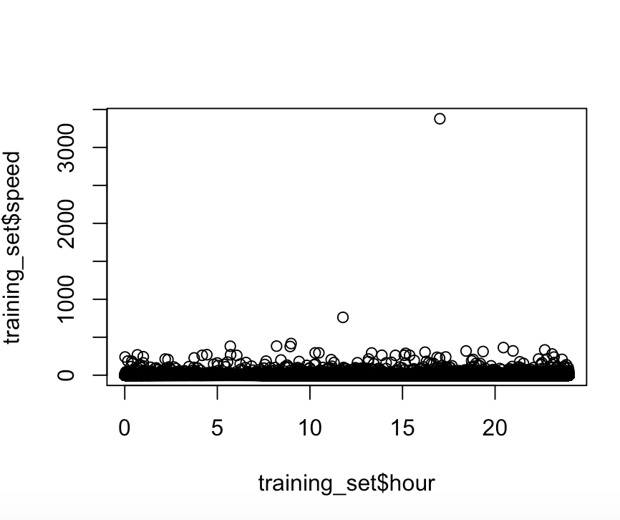

IDEAS to be implemented
1. Better cleaning of data and visualization
2. Random forest algorithm for the predictive model of tip as a percentage of total fare.
3. Better approaches to handle outliers using Cook’s Distance.
4. Mode Imputations in categorical regressors.
5. Stepwise Forward and backward Regression Algorithm for predictive models.
6. Tukey HSD test for hypothesis testing of equal means.

