EE 577A SPRING 2026 LAB 1: FULL ADDER DELAY ANALYSIS
PART I: (55 Points) STANDARD CELL BASED FULL ADDER DESIGN
1. (5 Points) Restore the given FA_p1 schematic by designing a full adder (FA) using standard cells from GSCLIB045.
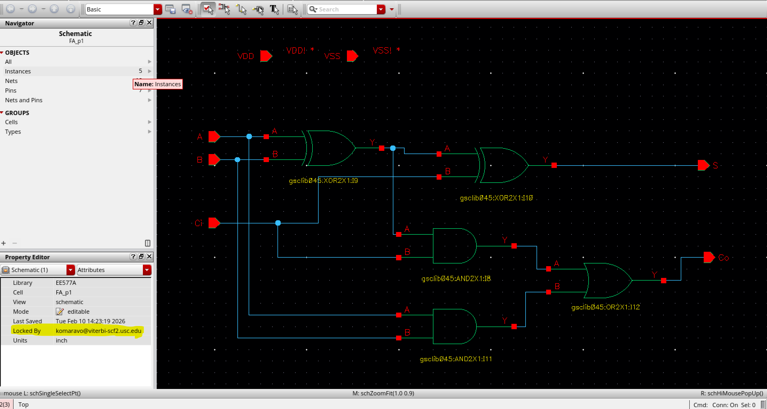
2. (5 Points) Create a maestro cell view for the testbench provided. (In this part only cover the (A1, B1, Ci1) signal set. Verify the logical correctness of your FA through functional simulation
Testbench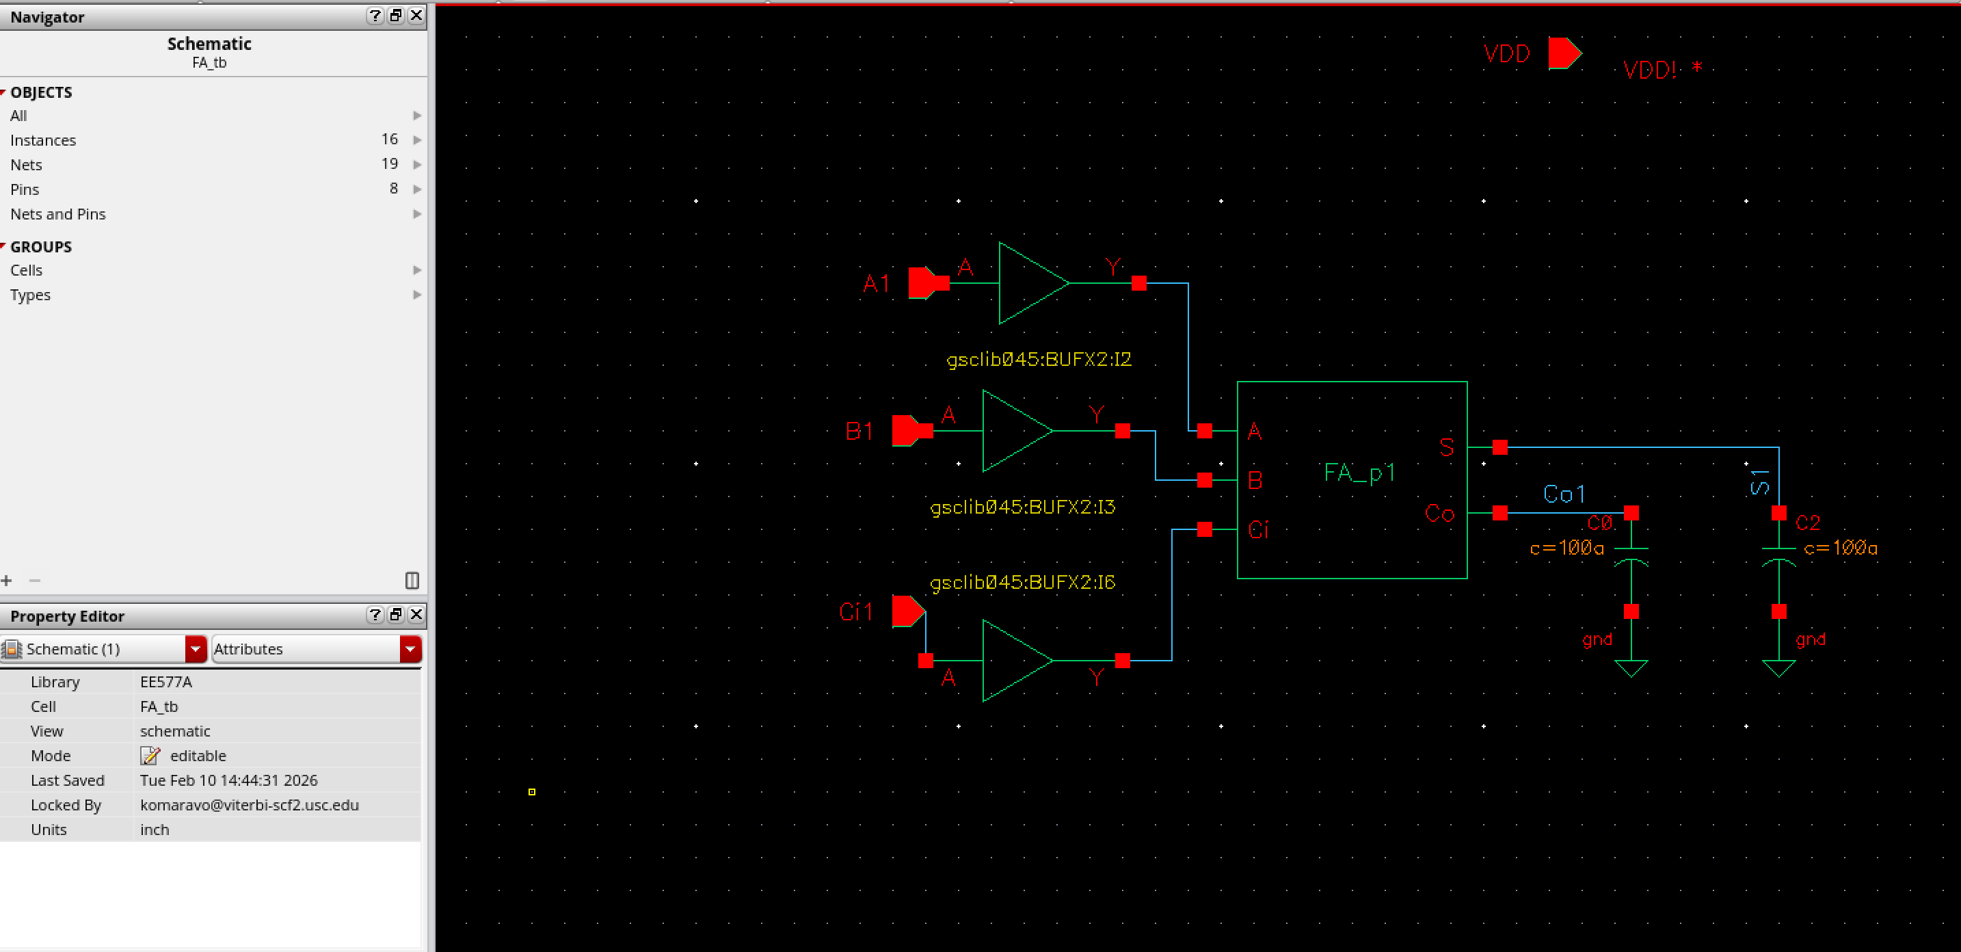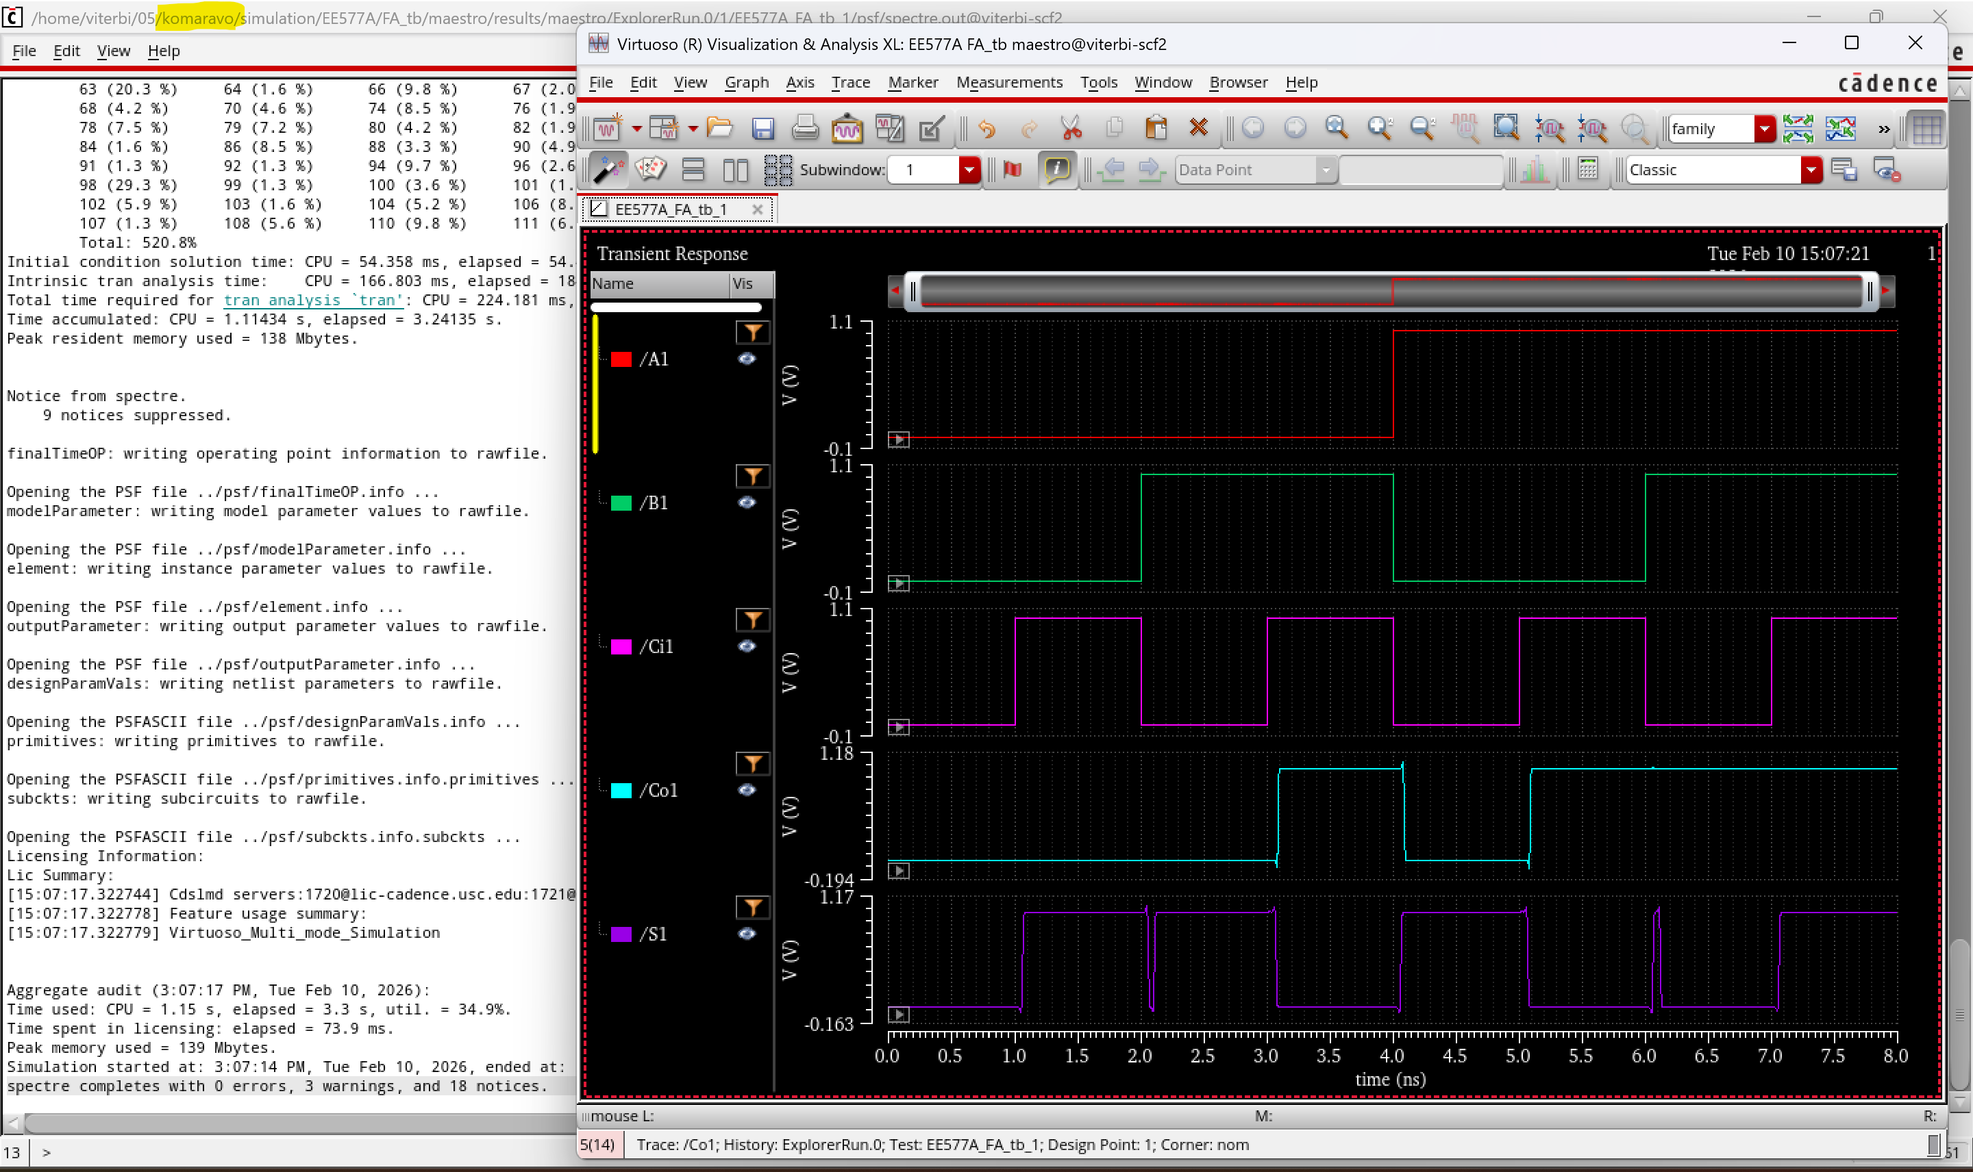
the waveform shows the correct functionality
it has been verified with the truth table of Full adder
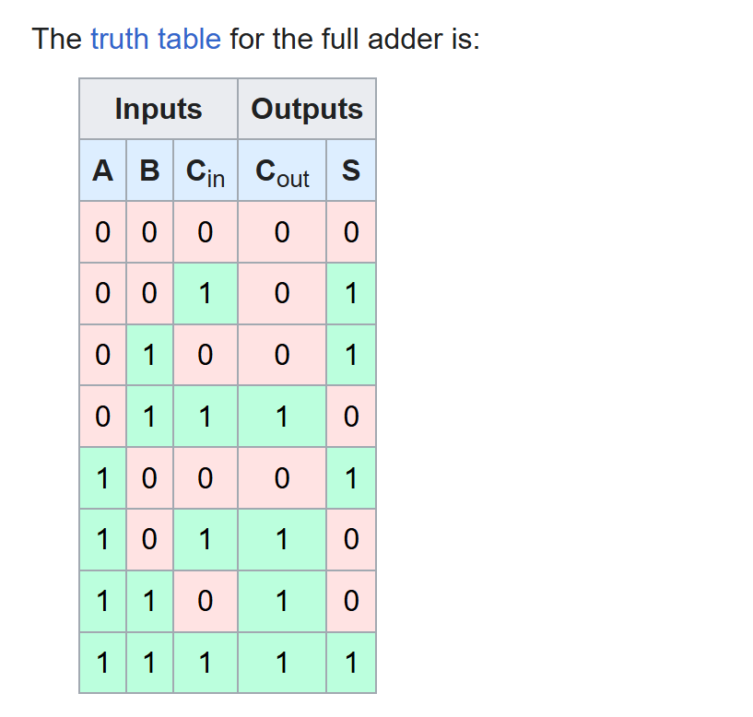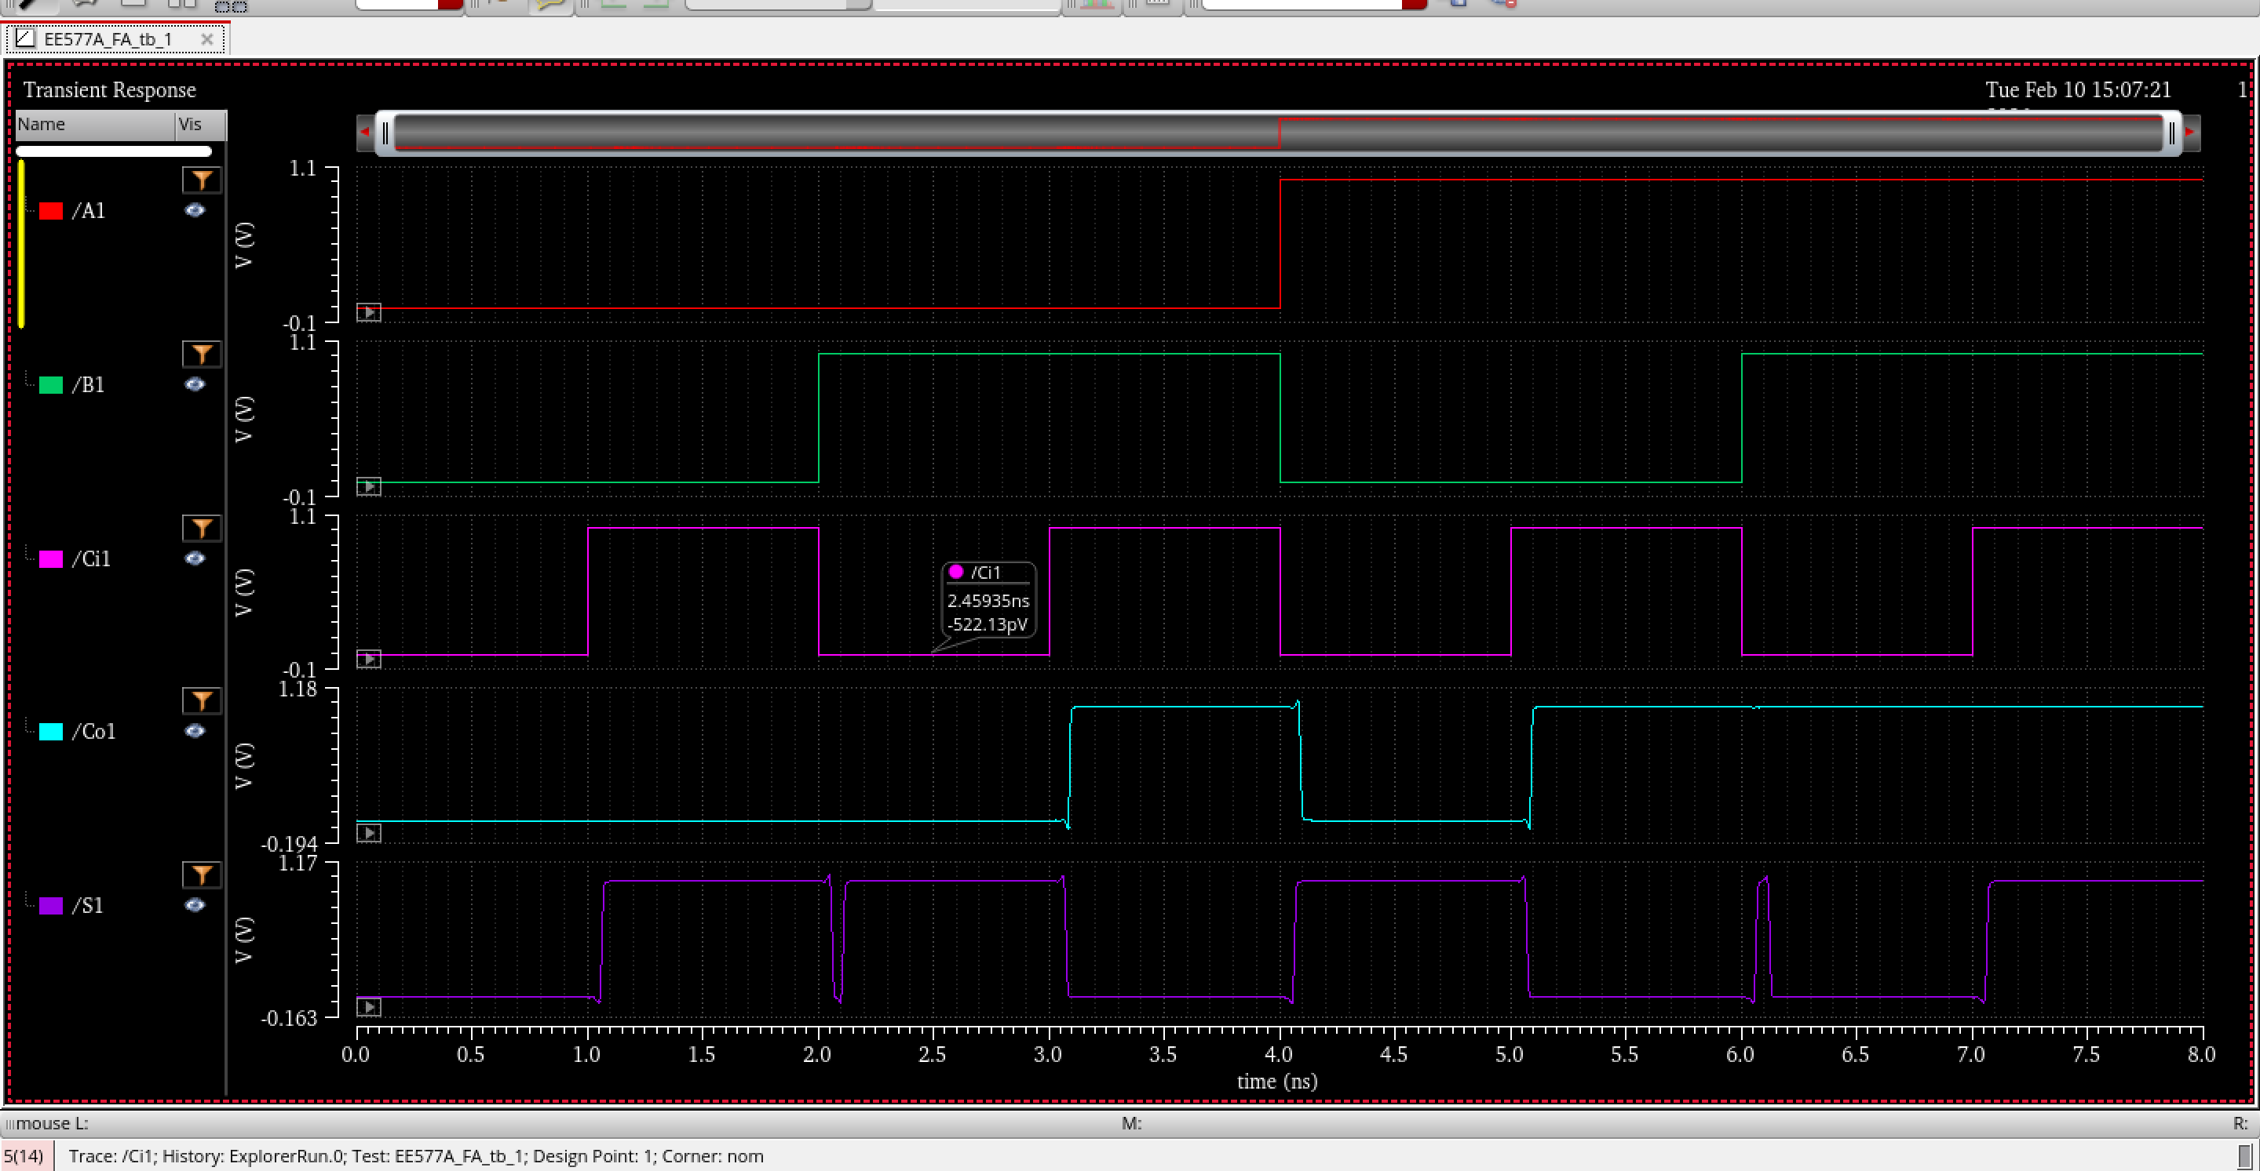
it gives the output exactly as the truth table
4. Question: What is the minimum steps that you need to cover all 32 vectors? Do your simulation with minimum steps. (Bonus: +5 points)
step1: we need to set trans analysis to 33ns
step2: VDD and VSS values need to be fed from stimuli
step3:select the output pins from design
step4:upload the desired vector file
step 5:run the simulation and view the result in waveform
Area calculation and pin placement estimation
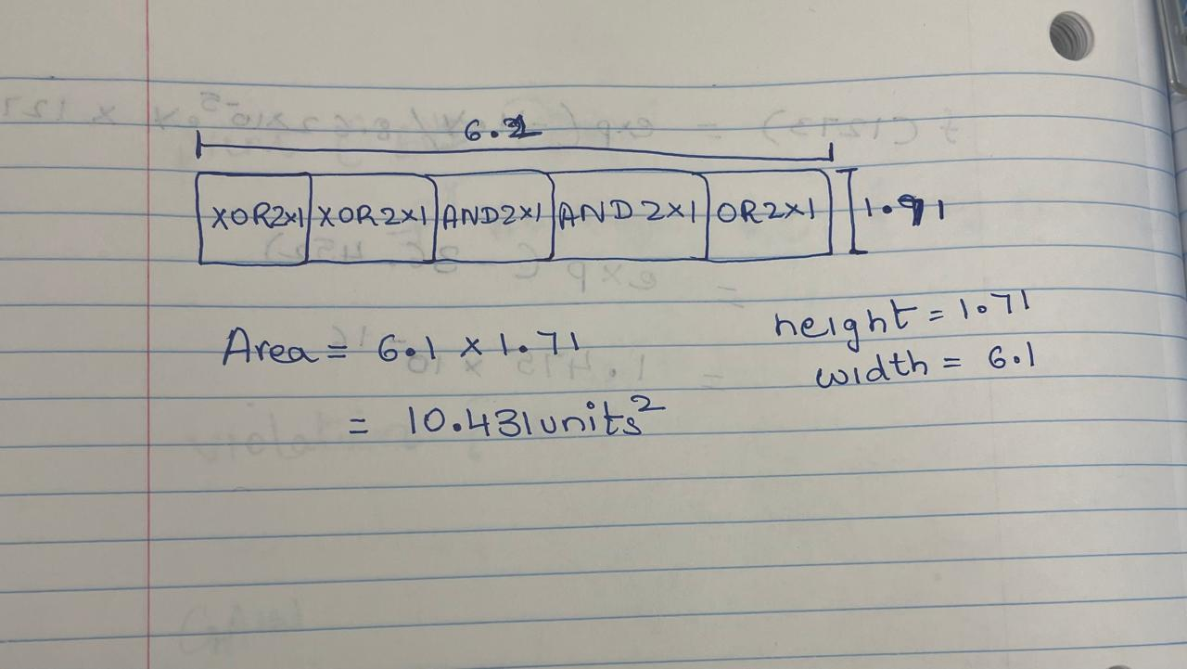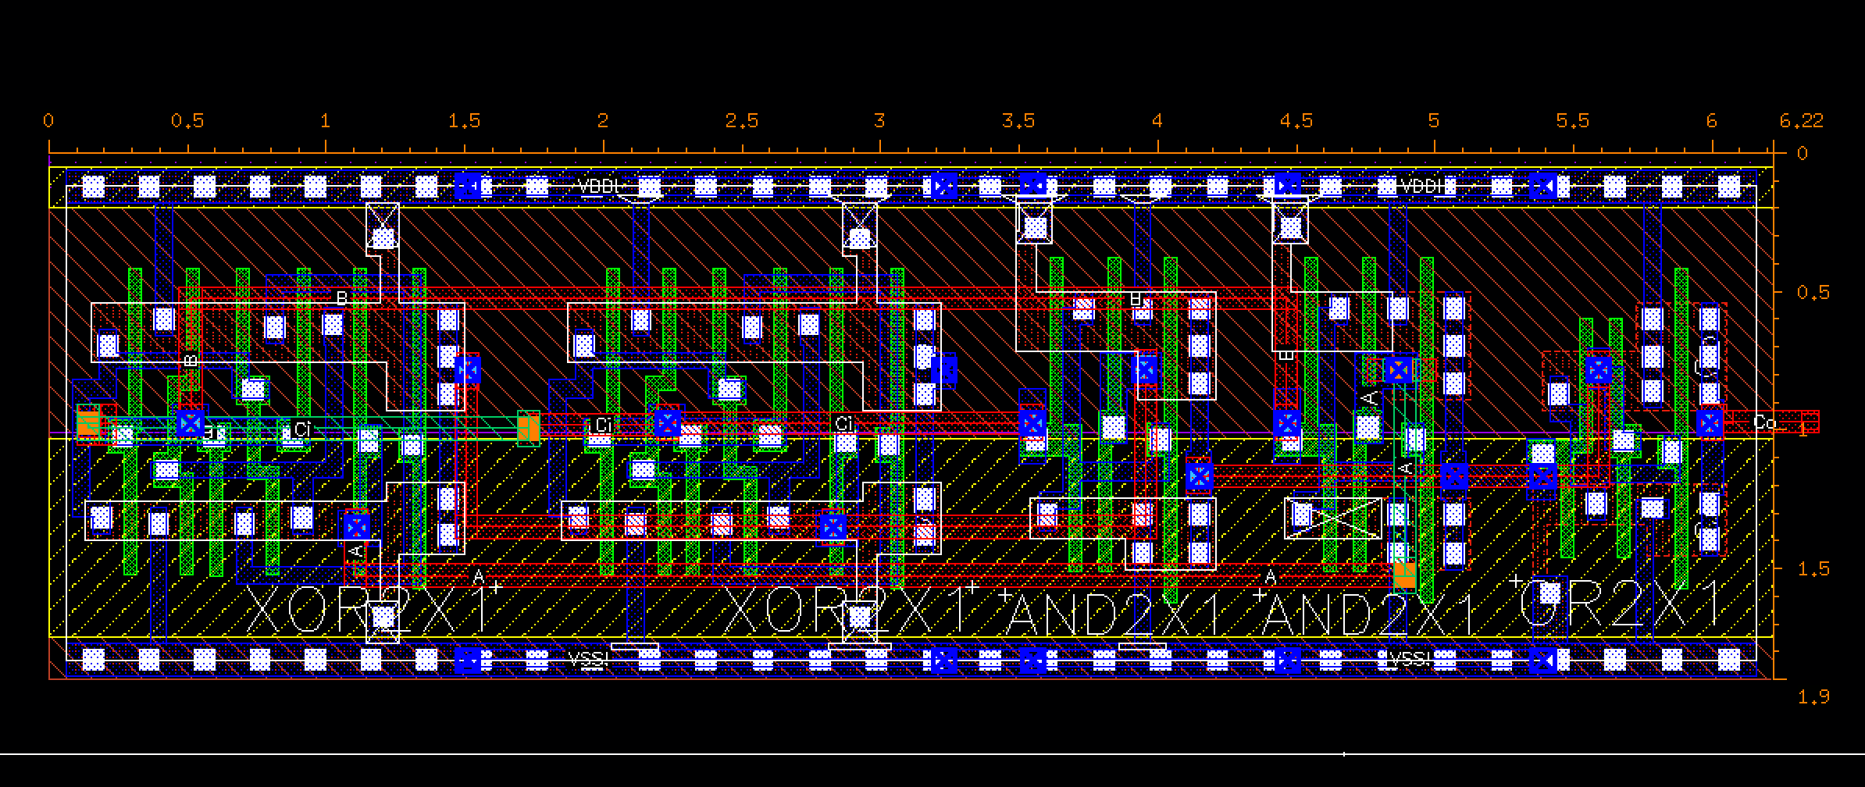
layout 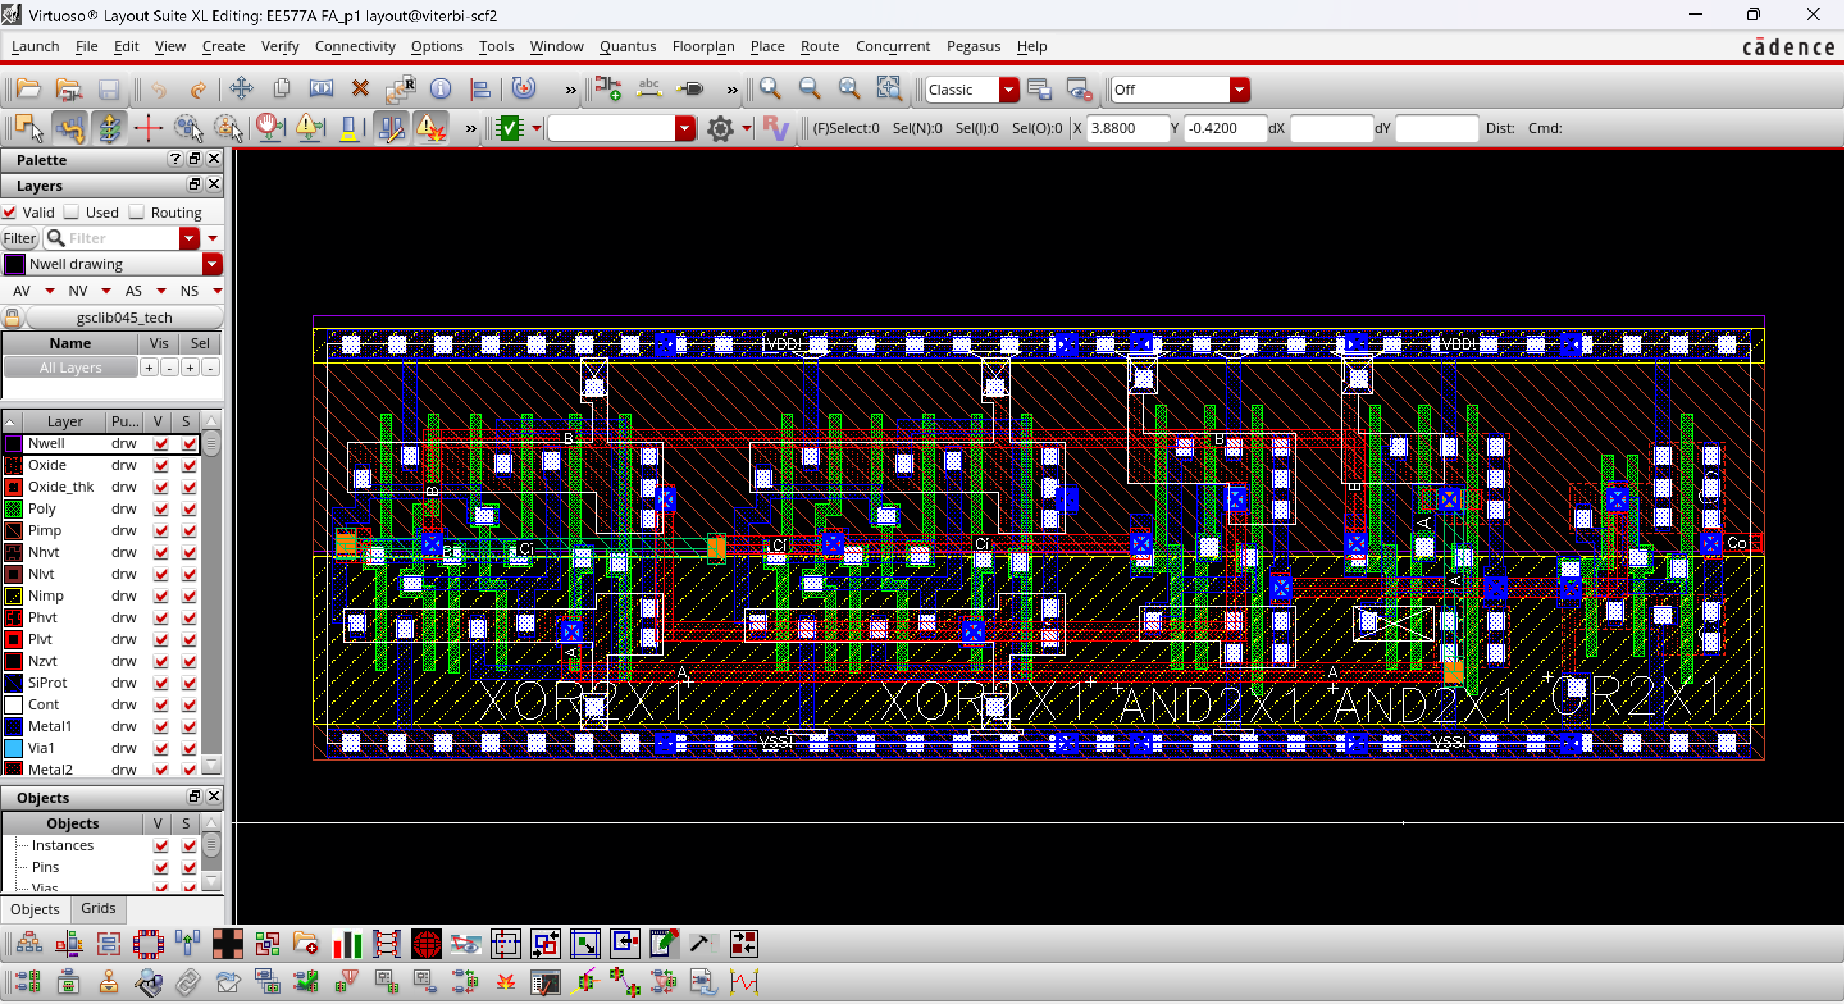
No DRC errors reported
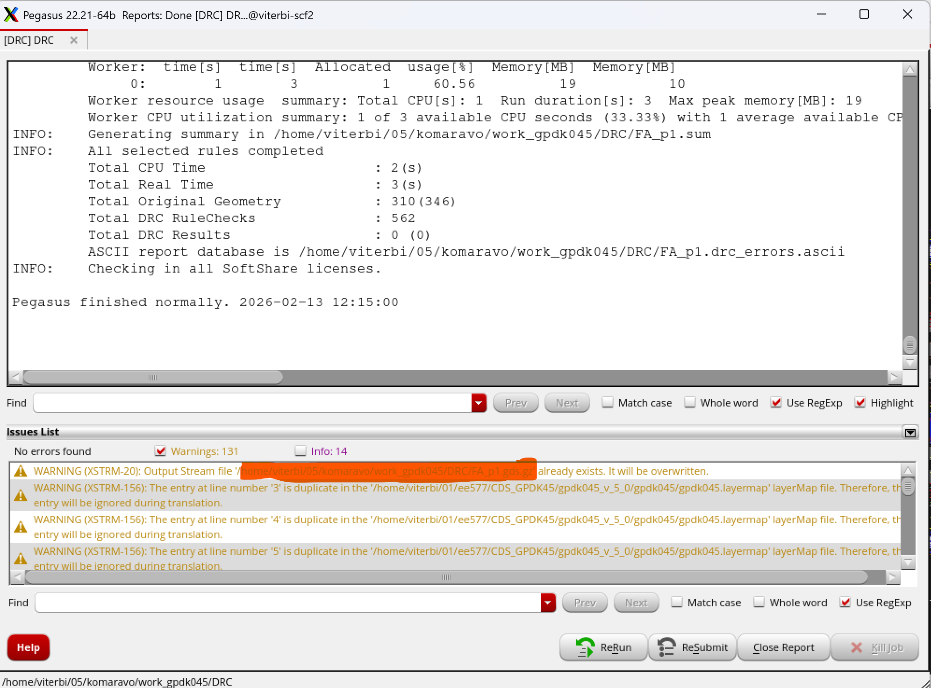
LVS is also clean
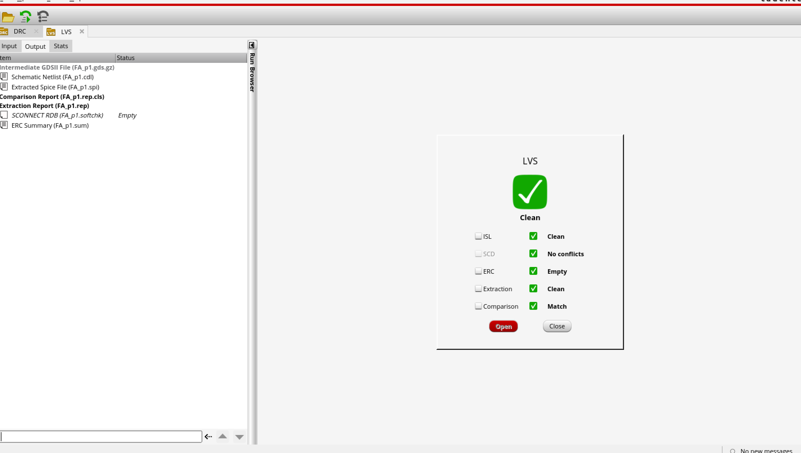
PART II: (55 Points) TRANSISTOR-LEVEL MIRRORED STRUCTURE
1. (5 Points) Restore the given FA_p2 cell by designing a full adder (FA) using mirrored design from Figure 1. Please follow the sizing values in the figure by referencing the standard library inverter (with [1, 1.5] sizing).
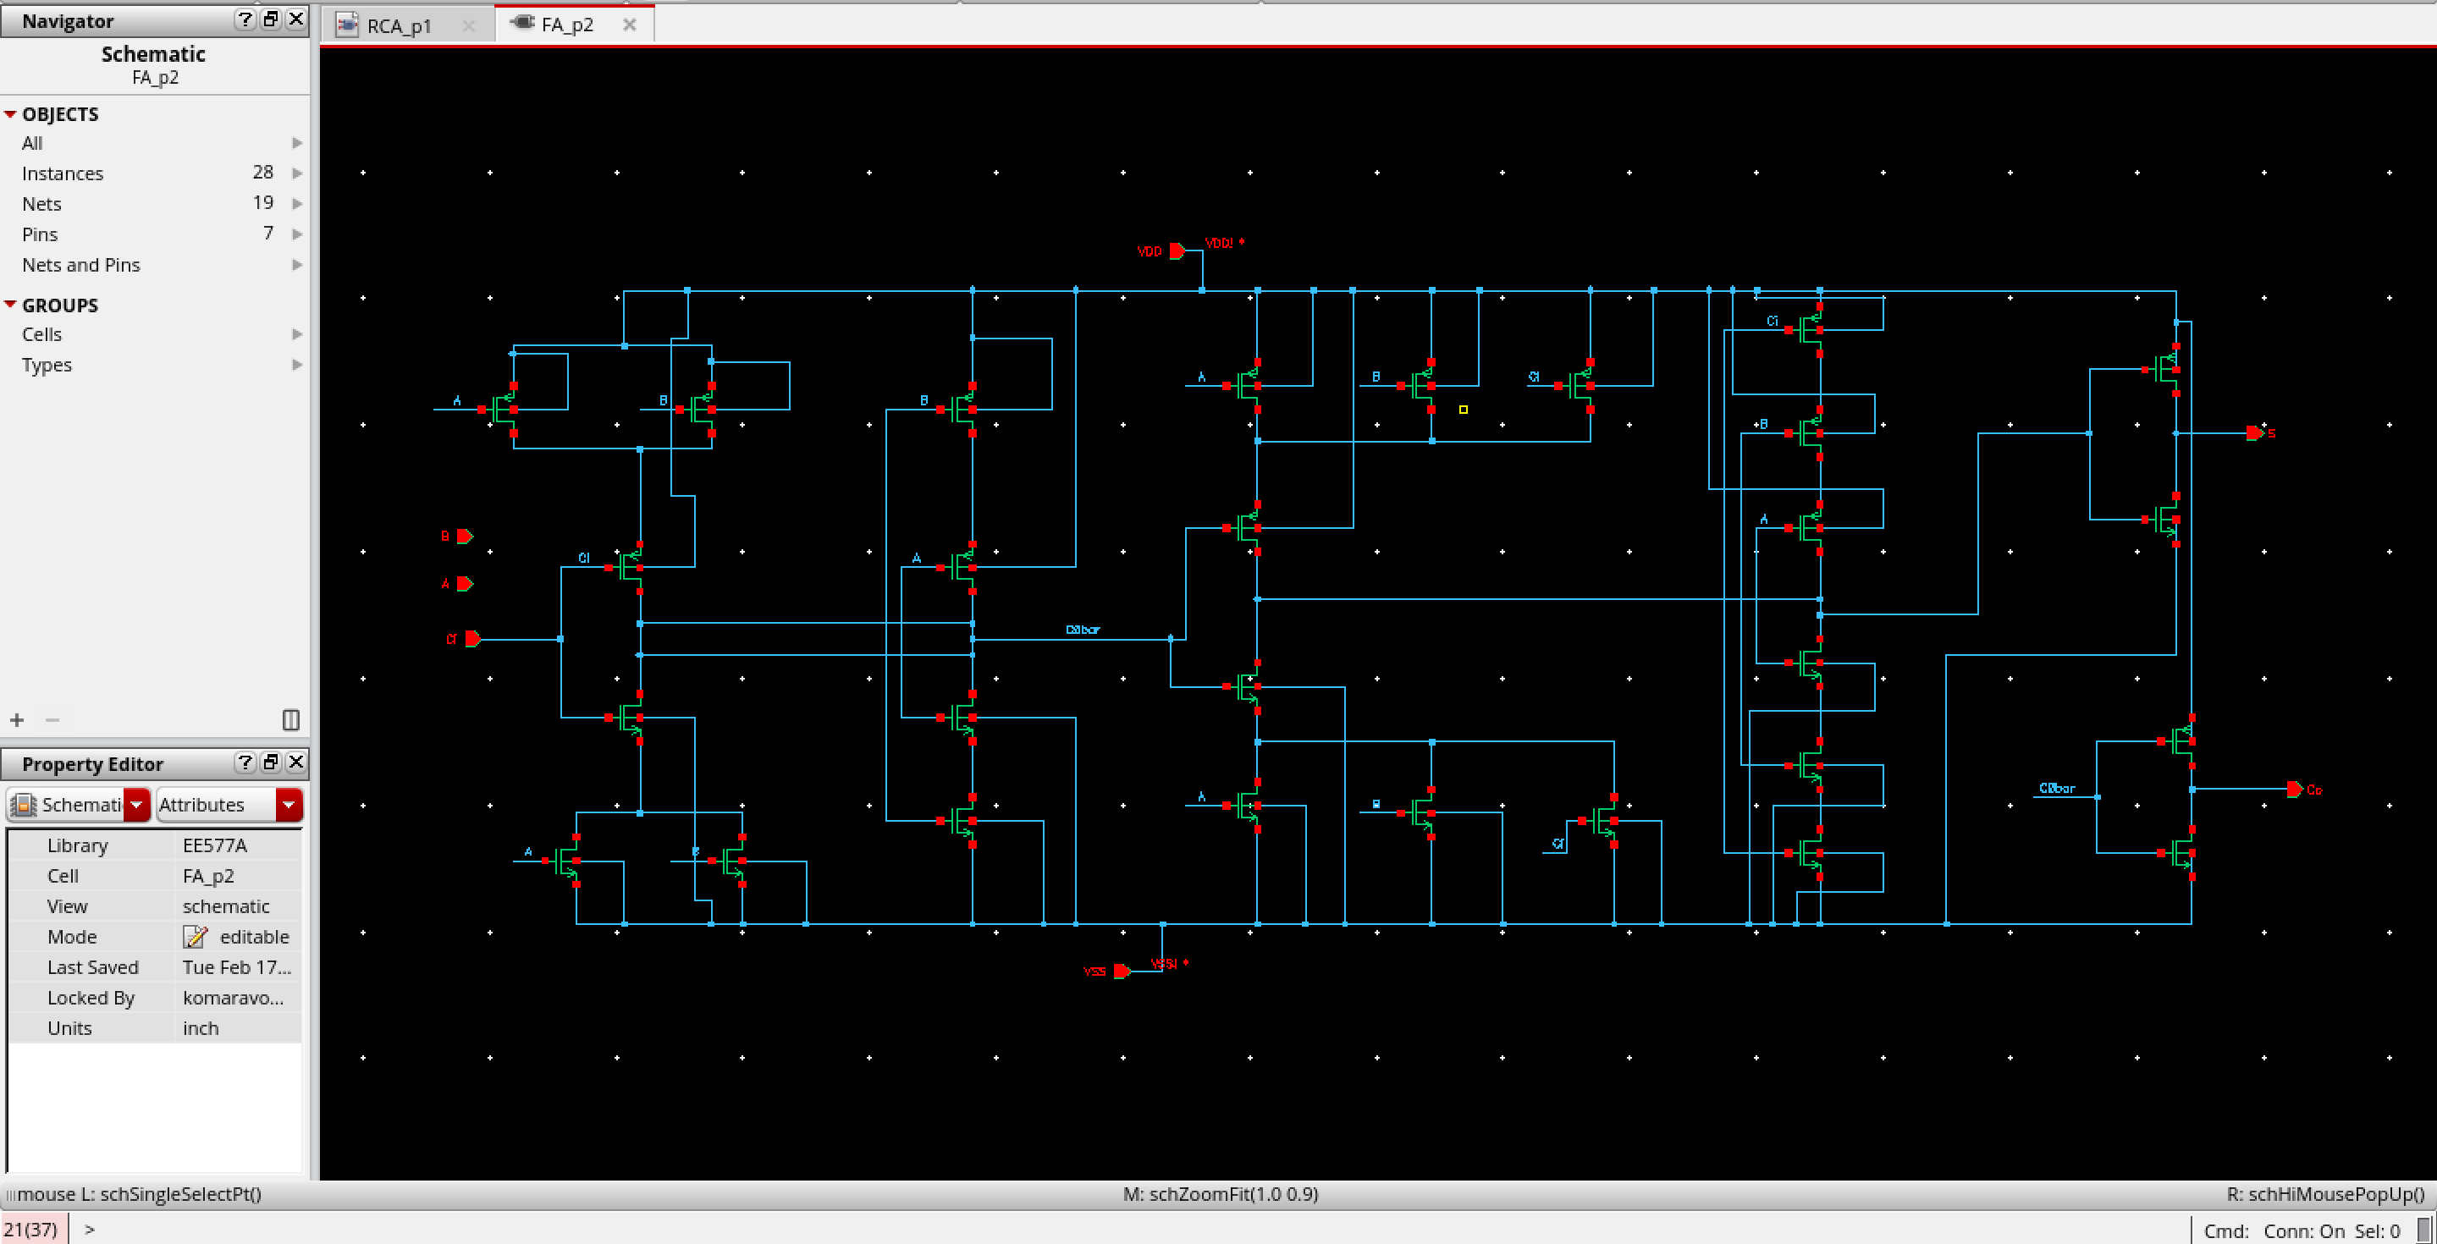
Note: - PMOS is 390nm,NMOS is 260nm, but the one at the extreme left are
PMOS= 390nm x 6, NMOS = 260nm x 4
functionality and the symbol has been created successfully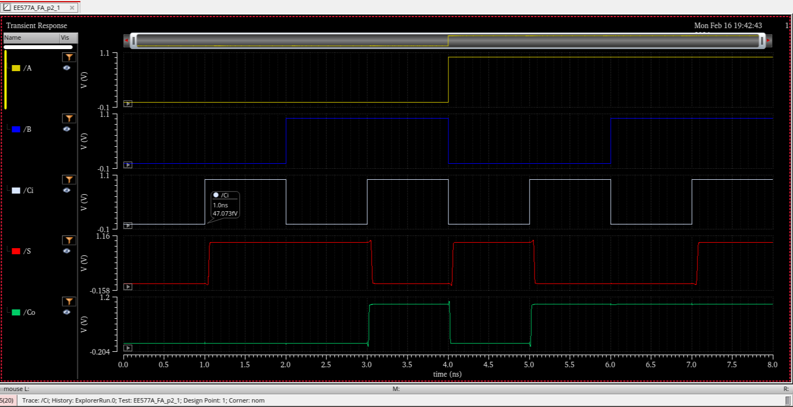
also the testbench has been created for both the parts
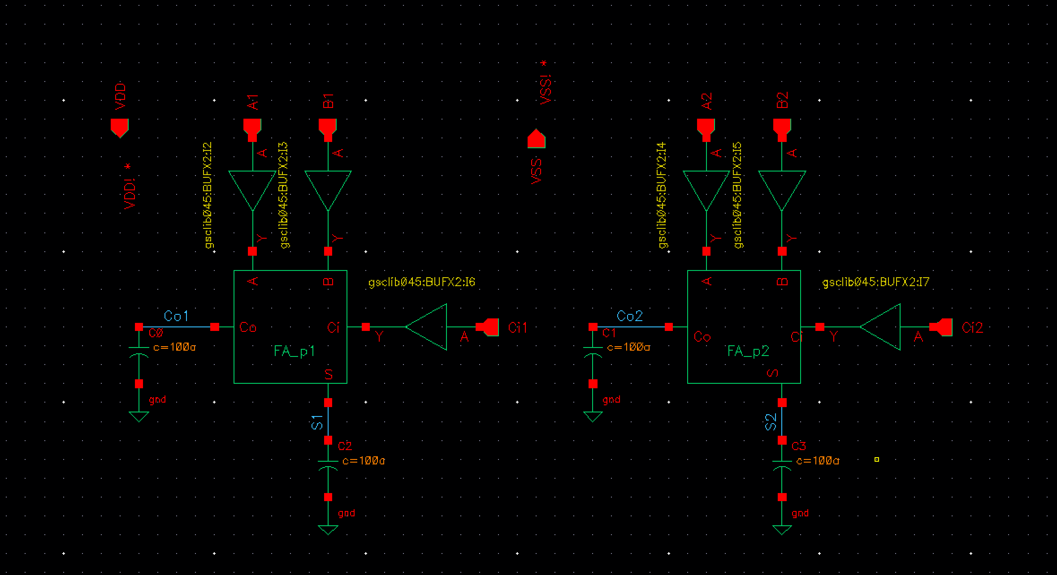
Layout for part 2 has been created
due to the huge size screenshot cannot be taken
PART III: (30 Points) MULTI-BIT ADDER CONSTRUCTION
Two RCA have been made
One is made by the Fa_p1
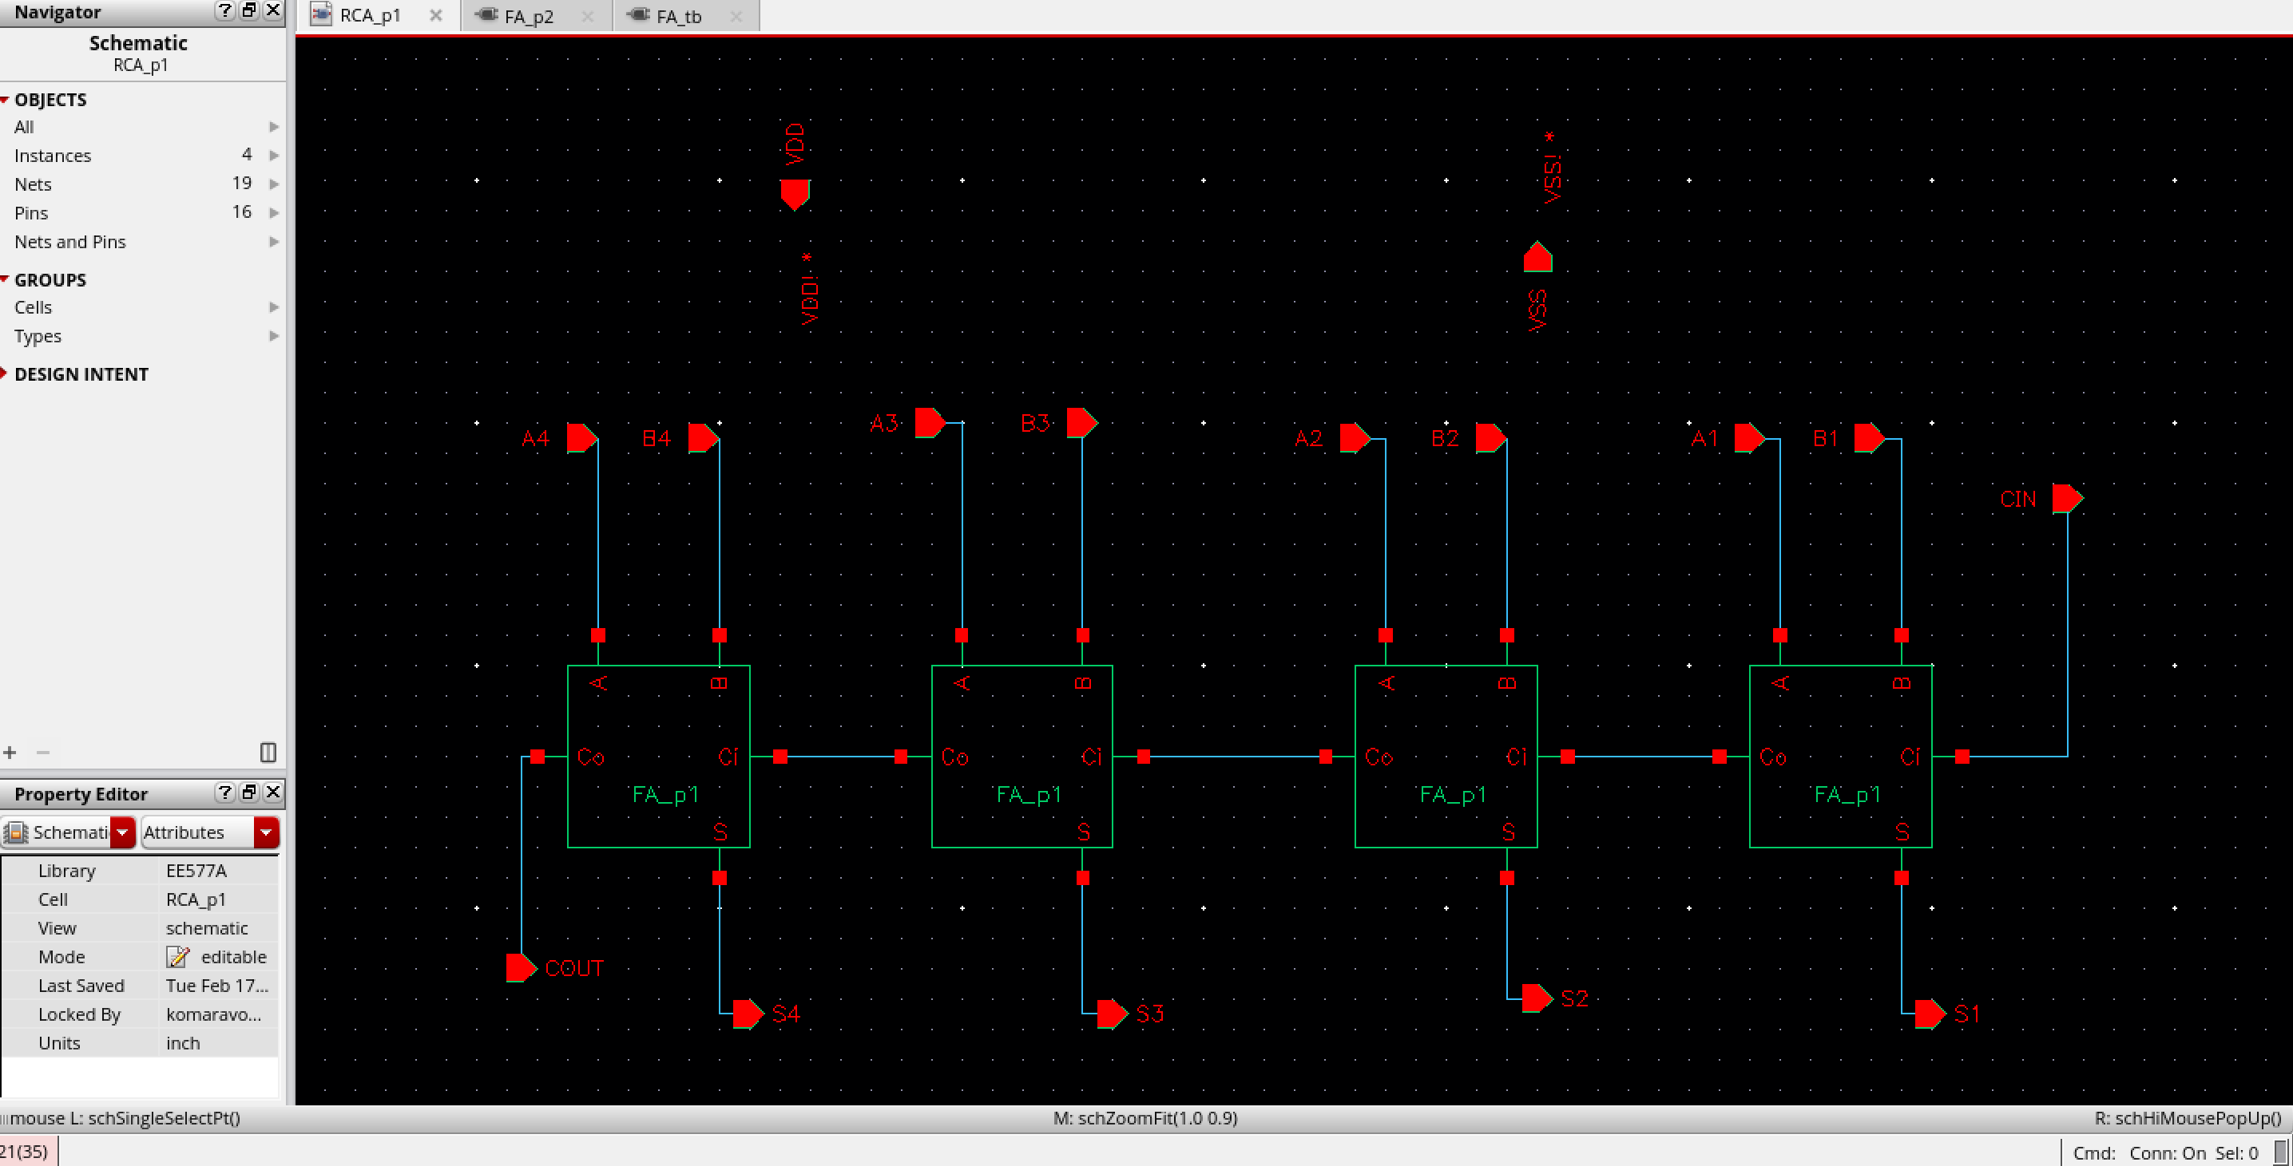
another by the Fa_p2
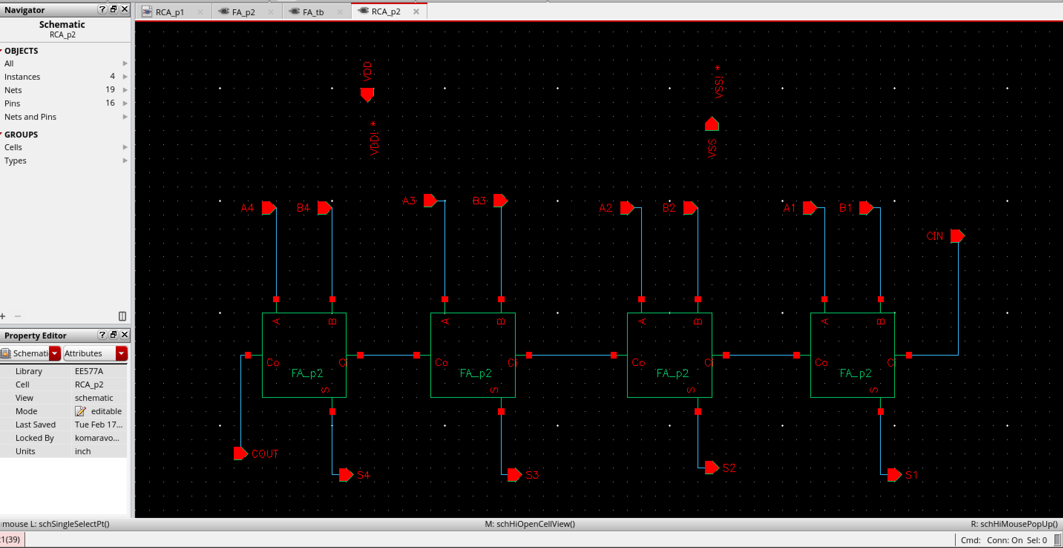
both the layouts have been created without any DRC or LVS errors
RCA_p1 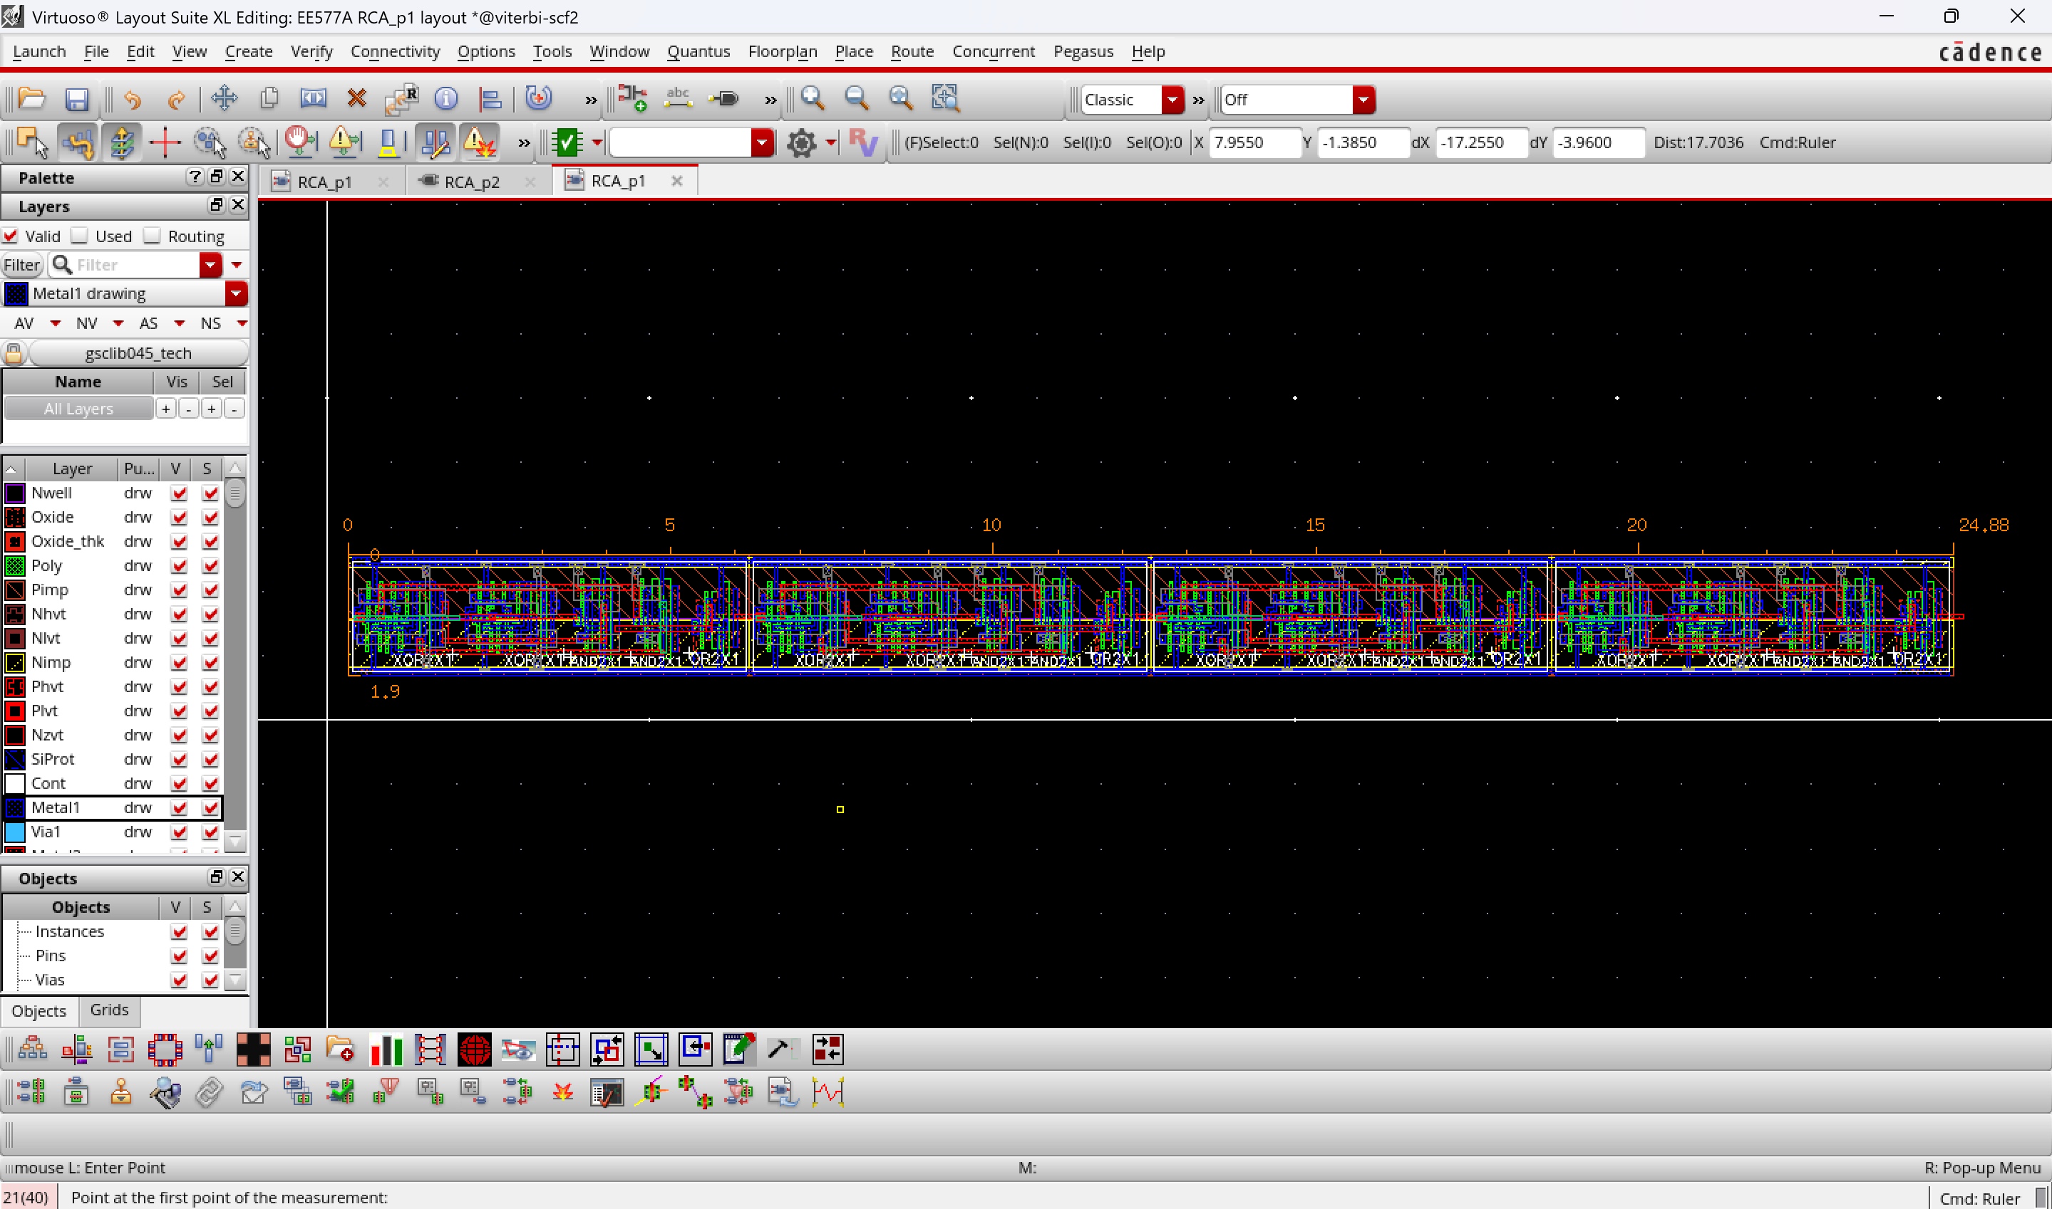
RCA_p2
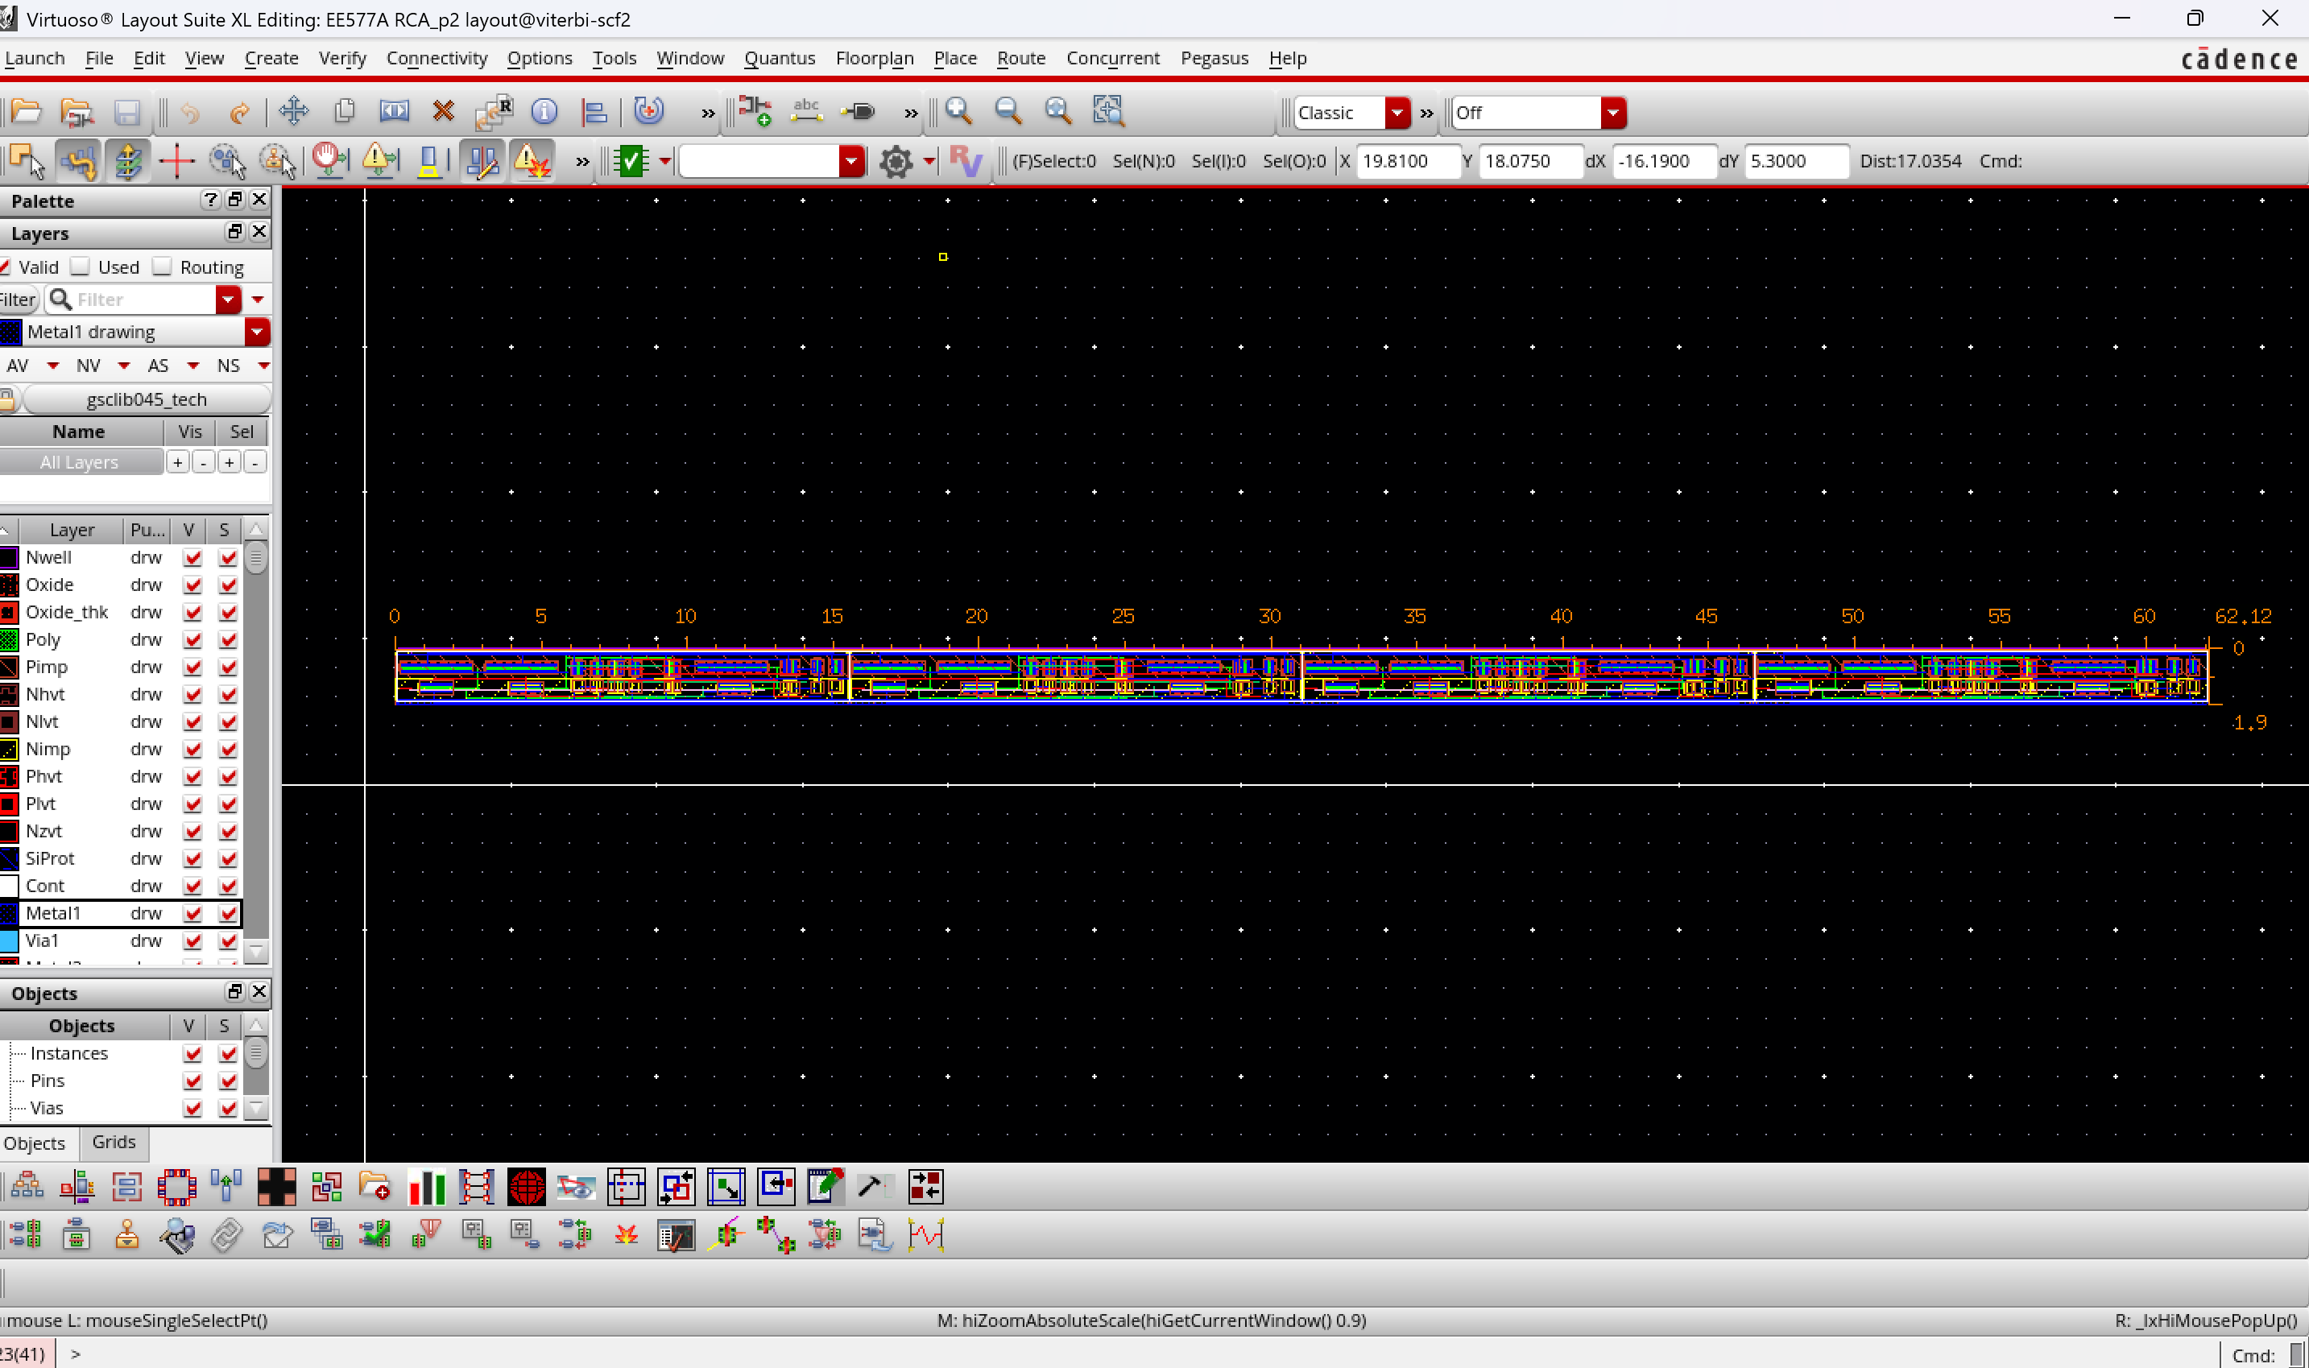
clearly RCA_p1 has less area and was more abutable compared to RCA_p2

