**Experiment 4:-**

Design an automatic night lamp.

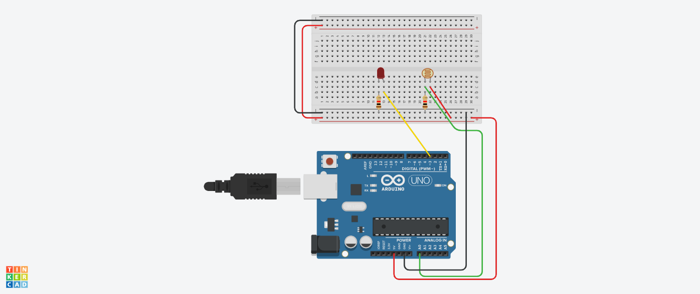**Circuit Diagram:-**

**Theory:-**

Concepts used in this project:-

LDR(LIGHT DEPENDENT RESISTOR):-

* The resistance of a LDR decreases with increasing incident light intensity.

ADC(ANALOG TO DIGITAL CONVERTER):-

* An analog to digital converter is a system that converts an analog signal, such as light entering a digital camera, into a digital signal.

**Learning:-**

* I have learned through this project the use of LDR practically.

**Observations:-**

* When we pass electrical signals through our code the LED glows.
* When the light intensity is more than a particular value in our code then LED glows else off.

**Problems faced:-**

The problems I faced:-

* The circuit was not working because the connections were not proper.
* The LED was in a bad condition.

**Precautions:-**

The precautions that should be taken while doing this experiment are:-

* The connections should not be loose.
* Every stuff should be joined at their appropriate place and it should be properly closed.
* The code should be written properly.

**Learning Outcomes:-**

* I have learned how to add components and use them with Arduino board.
* I have learned how all the hardwares should be connected to make them work in a proper condition.