SVD (**Singular Value Decomposition)**

* The Singular Value Decomposition (SVD) of a matrix is a factorization of that matrix into three matrices.
* It has some interesting algebraic properties and conveys important geometrical and theoretical insights about linear transformations.
* It also has some important applications in data science.
* 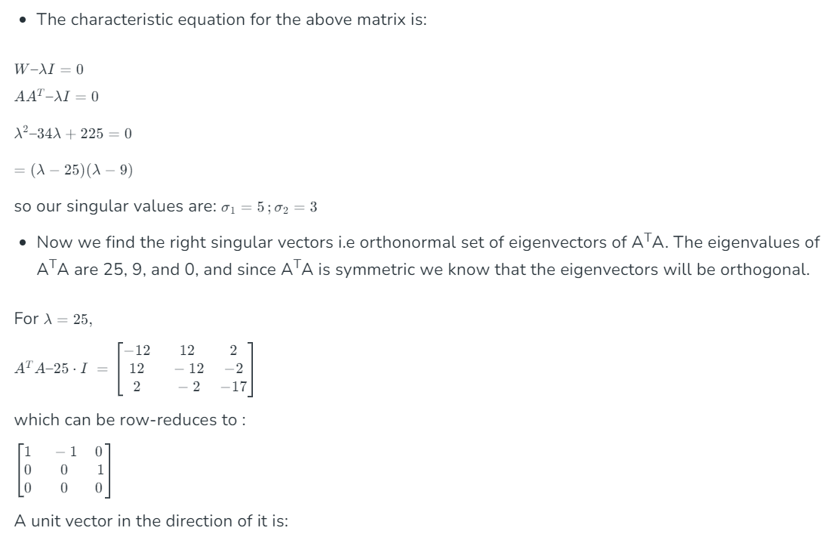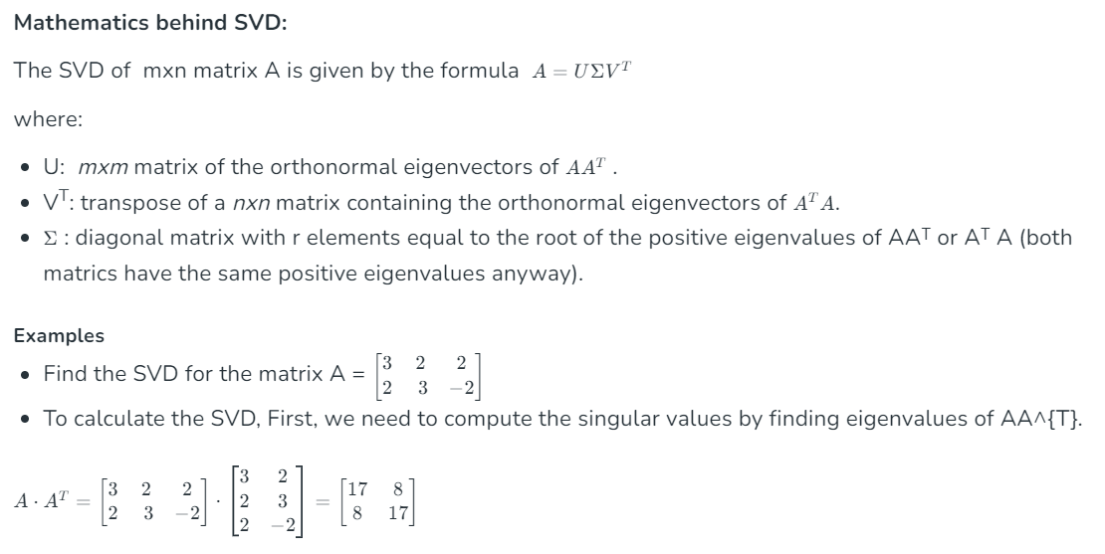 In this article, I will try to explain the mathematical intuition behind SVD and its geometrical meaning.

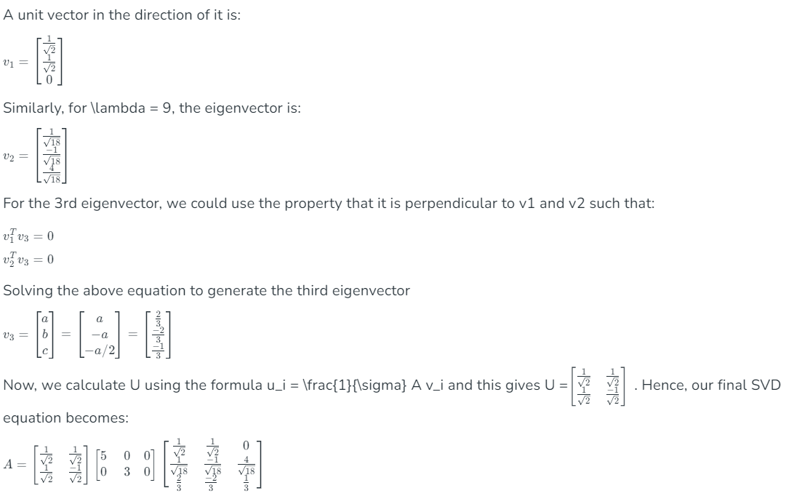

**Principal Component Analysis(PCA)**

* 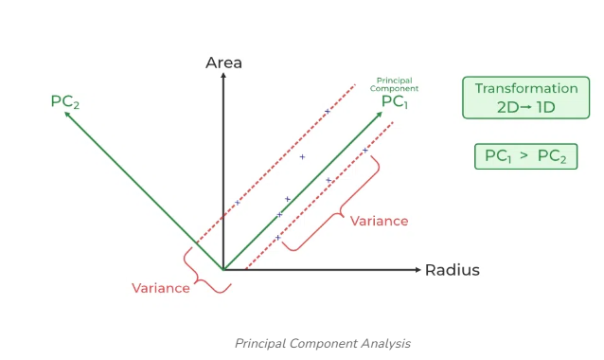Principal Component Analysis (PCA) is used to reduce the dimensionality of a data set by finding a new set of variables, smaller than the original set of variables, retaining most of the sample’s information, and useful for the [regression and classification](https://www.geeksforgeeks.org/regression-classification-supervised-machine-learning/) of data.

**orthogonal vectors**