SIMATS ENGINEERING
Department of Information Technology
DSA01 – Object-Oriented Programming with C++

ASSIGNMENT 4 – CO4
Designing Reusable Class Hierarchies
CO4: Analyse and implement C++ applications using inheritance, types of inheritance, virtual base classes, abstract classes, pointers and polymorphism to design reusable and extensible programs.
Student Name | Ukasha Salih | Register Number | 1924260267
MARK SHEET (Rubric-based Evaluation)
Task | Task Title | Max | Marks Awarded | Remarks
1 | Class Design Review | 6
2 | From Requirement to Hierarchy | 8
3 | Constructors in Derived Classes and Member Classes | 9
4 | Pointers to Derived Classes: Forensics | 7
5 | Pointers to Objects and the this Pointer | 7
6 | Design Challenge: Vehicle Rental Fleet | 13
 | TOTAL | 50 |  | Percentage:
OVERALL REMARKS

Student Signature | Faculty Signature | Program Director

OBJECT-ORIENTED PROGRAMMING WITH C++
ASSIGNMENT 4 – CO4: DESIGNING REUSABLE CLASS HIERARCHIES
CO4: Analyse and implement C++ applications using inheritance, types of inheritance, virtual base classes, abstract classes, pointers and polymorphism (constructors in derived classes, member classes, pointers to objects, the this pointer and pointers to derived classes).
Nature of Assignment: Individual Duration: 1 Week Total Marks: 50
Bloom’s Level Assessed: K5 – Evaluate (every task is at K5 level)

Mandatory Execution and GitHub Submission
- Execute every task individually, including all “Complete the Code” programs, and compare the output with the expected output.
- GitHub repository DSA01-<RegisterNumber>-Assignment4, shared with the course faculty; one folder per task (Q1 … Q6) with source files and output screenshots.
- README.md with name, register number, compiler and version, the g++ command used, steps to run each program and a short result note.
- Commit progressively – at least one commit for each task.
GitHub Repository Link: ____________________________________________
Note on this report: The programs were written by design and desk-checking and have not been compiled. Outputs shown are expected (predicted) outputs; add your own screenshots, sanitizer logs and timings after execution. Pseudocode follows the ALGORITHM / INPUT / OUTPUT / BEGIN / END layout.

TASK 1 – CLASS DESIGN REVIEW | 6 Marks
Problem context: Diagnose and repair duplicated classes – a college payroll program has three unrelated classes (Professor, LabAssistant, GuestFaculty) that repeat data and pay rules.
Ans:
Class Design Review
Task 1.1 – Diagnosis of the original design (2 Marks)
Table 1: Task 1.1 – Diagnosis of the original design (2 Marks)
No. | Deficiency | Why it is a problem
1 | Repeated fields: name, id, basic, da in Professor and LabAssistant; the same fields under other names in GuestFaculty | The same data and the same rule are written several times, so a fix must be repeated in every class
2 | Repeated pay rule: basic + basic × 0.42 appears in two classes | If the allowance rule changes, one copy is easily forgotten
3 | All data members are public | Any code can set basic or rate to a negative value; no class can protect its own data
4 | Inconsistent names: name/nm and id/code mean the same thing | The same information cannot be handled by common code; confusing to read
5 | da field is declared but never used | The allowance is really 0.42 × basic, so the stored da value is ignored and misleading; wasted memory
6 | Magic number 0.42 | Meaning is hidden and it is typed in many places; it should be one named constant
7 | No common base class | Three kinds of staff cannot be placed in one array or one loop; payroll needs three loops
8 | Adding a new category (e.g. VisitingResearcher) means copying a class and editing every loop | High effort and high risk of forgetting a place
9 | No constructors and pay() is not const | Objects can be created half-filled; pay() cannot be called on a const object

Task 1.2 – Repaired design (3 Marks)
The common data (name, id) and the common rule (basic plus 42% allowance) are moved up into base classes. Each derived class overrides only pay(). Staff is abstract, so no meaningless "plain staff" object can exist.
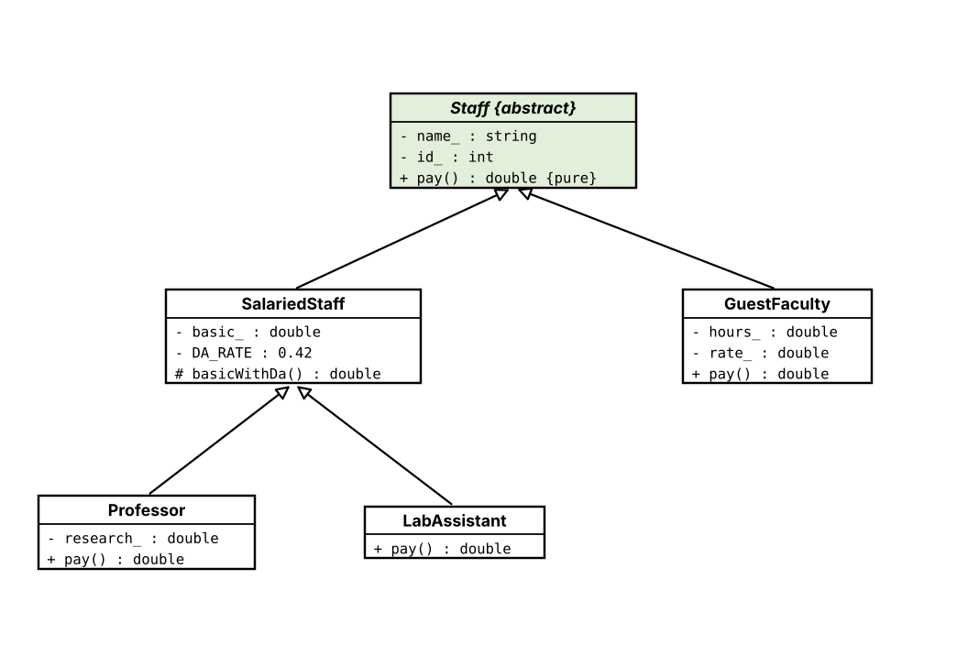
Figure 1: UML class diagram of the repaired payroll hierarchy (hollow arrow = is-a)
#include <iomanip>
#include <iostream>
#include <memory>
#include <string>
#include <vector>

class Staff { // abstract base class
std::string name_;
int id_;
public:
Staff(const std::string& name, int id) : name_(name), id_(id) {}
virtual ~Staff() = default;
const std::string& name() const { return name_; }
int id() const { return id_; }
virtual double pay() const = 0; // each category pays differently
};

class SalariedStaff : public Staff { // shared rule: basic + DA
double basic_;
static constexpr double DA_RATE = 0.42; // the magic number, now named once
protected:
double basicWithDa() const { return basic_ + basic_ * DA_RATE; }
public:
SalariedStaff(const std::string& name, int id, double basic)
: Staff(name, id), basic_(basic) {}
};

class Professor final : public SalariedStaff {
double research_;
public:
Professor(const std::string& n, int id, double basic, double research)
: SalariedStaff(n, id, basic), research_(research) {}
double pay() const override { return basicWithDa() + research_; }
};

class LabAssistant final : public SalariedStaff {
public:
LabAssistant(const std::string& n, int id, double basic) : SalariedStaff(n, id, basic) {}
double pay() const override { return basicWithDa(); }
};

class GuestFaculty final : public Staff {
double hours_, rate_;
public:
GuestFaculty(const std::string& n, int id, double hours, double rate)
: Staff(n, id), hours_(hours), rate_(rate) {}
double pay() const override { return hours_ * rate_; }
};

int main() {
std::vector<std::unique_ptr<Staff>> staff;
staff.push_back(std::make_unique<Professor>("Dr. Ravi", 101, 50000, 8000));
staff.push_back(std::make_unique<LabAssistant>("Meena", 102, 20000));
staff.push_back(std::make_unique<GuestFaculty>("Arun", 201, 10, 1500));

std::cout << std::fixed << std::setprecision(2);
double total = 0;
for (const auto& s : staff) { // one loop for all staff
std::cout << s->name() << " (" << s->id() << ") : " << s->pay() << '\n';
total += s->pay();
}
std::cout << "Total payroll : " << total << '\n';
}

Expected output:
Dr. Ravi (101) : 79000.00
Meena (102) : 28400.00
Arun (201) : 15000.00
Total payroll : 122400.00

Hand check: Professor 50000 + 0.42 × 50000 + 8000 = 79000; Lab assistant 20000 + 8400 = 28400; Guest faculty 10 × 1500 = 15000.
Task 1.3 – Design defence (1 Mark, under 100 words)
Each staff type now owns only what is different: its own pay() rule. Name, id and the allowance rule are written once in the base classes. To add a new category, I write one new class that derives from Staff and overrides pay(), and add its objects to the vector. The payroll loop, the Staff class and all existing classes remain unchanged, so working code is not disturbed, and the compiler forces the new class to supply pay() because it is pure virtual.
Alternative concept – one Staff class with a type field and switch
enum class Kind { Professor, LabAssistant, Guest };
class Staff {
public:
Kind kind;
std::string name; int id;
double basic = 0, research = 0, hours = 0, rate = 0; // fields for ALL kinds
double pay() const {
switch (kind) {
case Kind::Professor: return basic * 1.42 + research;
case Kind::LabAssistant: return basic * 1.42;
case Kind::Guest: return hours * rate;
}
return 0;
}
};

Table 2: Alternative concept – one Staff class with a type field and switch
Aspect | Base class + derived classes | Single class + switch
Time per pay() | O(1) – one virtual call | O(1) – one switch (jump)
Space per object | Only the fields of its own kind (+ one vptr, 8 bytes) | Every object carries all fields; a Guest wastes basic and research (24 bytes), a Professor wastes hours and rate
Places to change for a new type | 1 new class; 0 existing classes edited | enum, switch in pay(), every other switch (print, validation), constructor – at least 3 places in the same class
Risk | Compiler rejects a missing pay() | A forgotten case silently returns 0

TASK 2 – FROM REQUIREMENT TO HIERARCHY | 8 Marks
Problem context: University people management – persons, students, staff, teaching assistants (both student and staff) and research scholars (student with a fellowship).
Ans:
From Requirement to Hierarchy
Task 2.1 – Is-a and has-a relationships (2 Marks)
Table 3: Task 2.1 – Is-a and has-a relationships (2 Marks)
Relationship | Kind | Inheritance type / reason
Student is a Person | is-a | Single inheritance
Staff is a Person | is-a | Student and Staff both derive from Person = hierarchical inheritance
TeachingAssistant is a Student and is a Staff | is-a (two bases) | Multiple inheritance
Person → Student/Staff → TeachingAssistant as a whole | – | Hybrid inheritance (hierarchical + multiple) = the diamond
ResearchScholar is a Student | is-a | Single; Person → Student → ResearchScholar is multilevel inheritance
ResearchScholar has a Fellowship | has-a | Member class: a fellowship is something a scholar holds, not a kind of scholar
Person has an Address; Student has a Course | has-a | Member classes (Task 3)

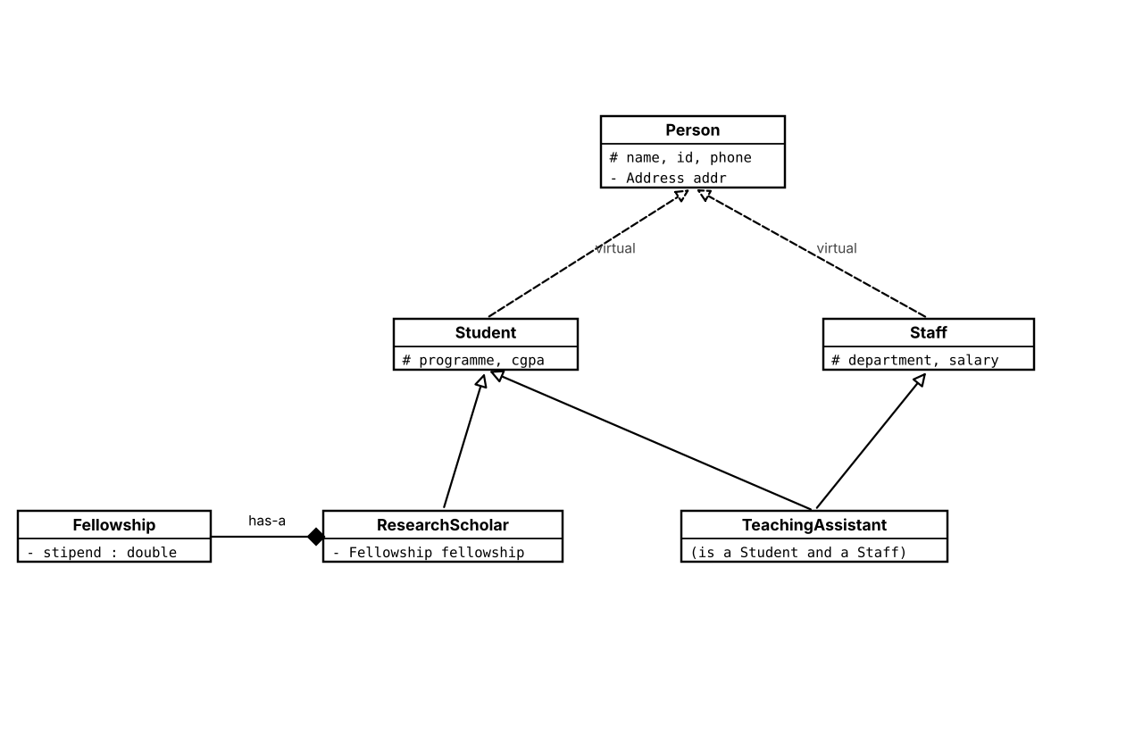
Figure 2: UML diagram of the university hierarchy (dashed = virtual inheritance, diamond = has-a)
Task 2.2 – Resolving the diamond (2 Marks)
- Problem: TeachingAssistant gets Person through Student and again through Staff, so each TeachingAssistant object contains two Person sub-objects. ta.name is ambiguous ("request for member name is ambiguous"), the data is stored twice and may become inconsistent, and Person is constructed twice.
- Solution: declare Student : virtual public Person and Staff : virtual public Person. All paths now share a single Person sub-object, which is constructed once, by the most-derived class (TeachingAssistant).
Task 2.3 – Class declarations (3 Marks)
class Person {
protected: // visible to derived classes, hidden from outside
std::string name;
int id;
std::string phone;
public:
Person(const std::string& n, int i, const std::string& ph);
virtual ~Person() = default;
};

class Student : virtual public Person { // is-a Person
protected:
std::string programme;
double cgpa;
public:
Student(/* ... */);
};

class Staff : virtual public Person { // is-a Person
protected:
std::string department;
double salary;
public:
Staff(/* ... */);
};

class TeachingAssistant : public Student, public Staff { /* ... */ };

class Fellowship { double stipend; /* ... */ };
class ResearchScholar : public Student {
Fellowship fellowship; // has-a (member class)
/* ... */
};

Access mode: every base is inherited publicly, because each relationship is a true is-a (a Student can be used wherever a Person is expected). Protected inheritance would hide the base interface from outside code and is used only for "implemented in terms of" relations; private inheritance is closer to composition. None is needed here. The full constructors are written in Task 3.
Task 2.4 – Access table (1 Mark)
Table 4: Task 2.4 – Access table (1 Mark)
Member of Person | public inheritance | protected inheritance | private inheritance
public | public in Student | protected in Student | private in Student
protected | protected in Student | protected in Student | private in Student
private | not accessible | not accessible | not accessible

A private member of Person is never directly accessible in Student in any mode; it can be reached only through public or protected functions of Person.
Predict the Output
#include <iostream>

struct Person { Person() { std::cout << "Person "; } };
struct Student : virtual Person { Student() { std::cout << "Student "; } };
struct Staff : virtual Person { Staff() { std::cout << "Staff "; } };
struct TeachingAssistant : Student, Staff {
TeachingAssistant() { std::cout << "TA "; }
};

int main() {
TeachingAssistant ta;
std::cout << '\n';
}

My predicted output (written before running):
Person Student Staff TA

Explanation: the virtual base Person is constructed first, once, by the most-derived class; then Student, then Staff (declaration order of the bases), then TA. Person is printed only once because there is only one shared Person sub-object.
Without virtual (prediction):
Person Student Person Staff TA

Each base builds its own Person first, so Person appears twice. This compiles without any error or warning; an error appears only if code uses a Person member through TA (for example ta.id: "request for member id is ambiguous"). Verify by running.
Alternative concept – composition (has-a) and sizeof
struct Person { int id; };
struct S1 : virtual Person { int a; }; struct T1 : virtual Person { int b; };
struct TA1 : S1, T1 {}; // diamond, shared Person
struct S2 : Person { int a; }; struct T2 : Person { int b; };
struct TA2 : S2, T2 {}; // diamond, two Persons
struct TA3 { S2 s; T2 t; }; // composition: two Persons

std::cout << sizeof(TA1) << ' ' << sizeof(TA2) << ' ' << sizeof(TA3) << '\n';

Table 5: Alternative concept – composition (has-a) and sizeof
Aspect | Virtual inheritance | Composition (has-a)
Person sub-objects | 1 shared | 2 (one inside Student, one inside Staff)
sizeof | Larger than TA2 because of hidden virtual-base pointers (record your value) | Same as non-virtual TA2: data only, no hidden pointers
Reaching name | ta.name – unambiguous, O(1) with one extra indirection through the virtual base | ta.s.name or ta.t.name – O(1), but two different names must be kept consistent
Substitution | TA can be used as Student* and as Staff* | TA is neither; no polymorphic use

TASK 3 – CONSTRUCTORS IN DERIVED CLASSES AND MEMBER CLASSES | 9 Marks
Problem context: Order of construction and destruction – constructors in derived classes, virtual base classes and member classes.
Ans:
Constructors in Derived Classes and Member Classes
Tasks 3.1 and 3.2 – Constructors and member classes
#include <iostream>
#include <string>

struct Address { // member class of Person
std::string city;
explicit Address(const std::string& c) : city(c) { std::cout << "Address "; }
~Address() { std::cout << "~Address "; }
};

struct Course { // member class of Student
std::string title;
explicit Course(const std::string& t) : title(t) { std::cout << "Course "; }
~Course() { std::cout << "~Course "; }
};

class Person {
protected:
std::string name;
Address addr;
public:
Person(const std::string& n, const std::string& city) : name(n), addr(city) {
std::cout << "Person ";
}
virtual ~Person() { std::cout << "~Person "; }
};

class Student : virtual public Person {
Course course;
public:
Student(const std::string& n, const std::string& city, const std::string& c)
: Person(n, city), course(c) { std::cout << "Student "; }
~Student() override { std::cout << "~Student "; }
};

class Staff : virtual public Person {
double salary;
public:
Staff(const std::string& n, const std::string& city, double s)
: Person(n, city), salary(s) { std::cout << "Staff "; }
~Staff() override { std::cout << "~Staff "; }
};

class TeachingAssistant : public Student, public Staff {
public:
TeachingAssistant(const std::string& n, const std::string& city,
const std::string& c, double s)
: Person(n, city), // most-derived class builds the virtual base
Student(n, city, c), Staff(n, city, s) { std::cout << "TA "; }
~TeachingAssistant() override { std::cout << "~TA "; }
};

int main() {
std::cout << "Student : ";
{ Student s("Asha", "Salem", "C++"); std::cout << "| "; }
std::cout << "\nStaff : ";
{ Staff f("Ravi", "Chennai", 50000); std::cout << "| "; }
std::cout << "\nTA : ";
{ TeachingAssistant t("Kavya", "Madurai", "DSA", 20000); std::cout << "| "; }
std::cout << '\n';
}

Why the most-derived class calls the virtual base constructor: the shared Person must be built exactly once, but Student and Staff could pass different arguments. The language therefore lets only the most-derived class (TeachingAssistant) choose them; the Person(...) calls written in Student and Staff are ignored when a TeachingAssistant is built. Because Person has no default constructor, TeachingAssistant must call Person(n, city) itself or the program will not compile.
Task 3.3 – Order of construction and destruction (expected trace)
Student : Address Person Course Student | ~Student ~Course ~Person ~Address
Staff : Address Person Staff | ~Staff ~Person ~Address
TA : Address Person Course Student Staff TA | ~TA ~Staff ~Student ~Course ~Person ~Address

Rule observed: virtual base classes are built first, then the other base classes in the order they are declared, then the members of the class in declaration order, and finally the body of the derived constructor. Within Person, the Address member is built before the body prints "Person". Destruction is exactly the reverse order.
Task 3.4 – Experiment: removing virtual
- Output for TA becomes: Address Person Course Student Address Person Staff TA – Person (and its Address) is built twice.
- The Person(n, city) call in TeachingAssistant now gives a compile error ("type Person is not a direct or virtual base of TeachingAssistant"); it must be removed.
- sizeof(TeachingAssistant) changes: the two Person sub-objects are stored (name and Address twice), but the hidden virtual-base pointers disappear. Record both values from your run.
Predict the Output
#include <iostream>
struct Engine { Engine() { std::cout << "Engine "; } ~Engine() { std::cout << "~Engine "; } };
struct Vehicle { Vehicle() { std::cout << "Vehicle "; } ~Vehicle() { std::cout << "~Vehicle "; } };
struct Car : Vehicle {
Engine e;
Car() { std::cout << "Car "; }
~Car() { std::cout << "~Car "; }
};
int main() {
{ Car c; std::cout << "| "; }
std::cout << '\n';
}

My predicted output (written before running):
Vehicle Engine Car | ~Car ~Engine ~Vehicle

Rule: base class first (Vehicle), then member objects in declaration order (Engine), then the body of Car. Destruction is the reverse: body of Car, then members (Engine), then the base (Vehicle). Note that the closing brace of the inner block ends the life of c.
Complete the Code
#include <iostream>
#include <string>

class Person {
protected:
std::string name;
int age;
public:
Person(const std::string& n, int a) : name(n), age(a) {}
};

class Address { // used as a member class
std::string city;
int pin;
public:
Address(const std::string& c, int p) : city(c), pin(p) {}
std::string str() const { return city + "-" + std::to_string(pin); }
};

class Student : public Person {
long long regNo;
Address home;
public:
// TODO 1
Student(const std::string& n, int a, long long r, const std::string& city, int pin)
: Person(n, a), regNo(r), home(city, pin) {}

void print() const {
std::cout << regNo << ' ' << name << " (" << age << ") " << home.str() << '\n';
}
};

int main() {
Student s("Kavya", 19, 192311001, "Salem", 636001);
s.print();
}

Expected output:
192311001 Kavya (19) Salem-636001

Swapping the list to : Person(n, a), home(city, pin), regNo(r) compiles but -Wall gives: warning: Student::home will be initialized after long long Student::regNo [-Wreorder]. Members are initialised in declaration order (regNo, then home), not in the order written in the list.
Alternative concept – pointer to a dynamically created Address
class Student : public Person {
long long regNo;
Address* home; // pointer instead of member object
public:
Student(const std::string& n, int a, long long r, const std::string& c, int p)
: Person(n, a), regNo(r), home(new Address(c, p)) {}
Student(const Student& o) : Person(o), regNo(o.regNo), home(new Address(*o.home)) {}
Student& operator=(const Student& o) {
if (this != &o) { Person::operator=(o); regNo = o.regNo; *home = *o.home; }
return *this;
}
~Student() { delete home; } // must release the Address
};

Extra time: one heap allocation (and one release) per Student, roughly tens of nanoseconds, O(1). Extra space: an 8-byte pointer plus allocator overhead (typically 16–32 bytes) on top of the Address itself. The constructor must allocate with new, the copy constructor must make a deep copy, the copy assignment must copy the contents safely and the destructor must delete the Address (Rule of Three). The member-object design needs none of this and is preferred unless the Address is optional or shared.

TASK 4 – POINTERS TO DERIVED CLASSES: FORENSICS | 7 Marks
Problem context: A bank stores accounts through base-class pointers; senior accounts earn the wrong interest and memory is never released.
Ans:
Pointers to Derived Classes: Forensics
Task 4.1 – Locating the defects (2 Marks)
Table 6: Task 4.1 – Locating the defects (2 Marks)
Defect | Cause | Effect
1. Senior rate never used | rate() is not virtual; the call a->rate() through an Account* is bound at compile time to Account::rate | Every account prints 3.5 instead of 4.0
2. Memory leak (and undefined behaviour) | ~Account() is not virtual; delete a on an Account* that points to a SeniorAccount runs only ~Account() | ~SeniorAccount() never runs, so history (100 doubles = 800 bytes) is never freed
3. Object slicing | Account copy = SeniorAccount(); copies only the Account part into an Account object | The SeniorAccount part and its behaviour are lost; copy.rate() is always 3.5. The same happens to every element of a vector<Account>

Task 4.2 – Evidence
#include <iostream>

class Account {
public:
double rate() const { return 3.5; }
~Account() { std::cout << "~Account\n"; }
};
class SeniorAccount : public Account {
double* history = new double[100];
public:
double rate() const { return 4.0; }
~SeniorAccount() { delete[] history; std::cout << "~SeniorAccount\n"; }
};

int main() {
Account* accounts[2] = { new Account, new SeniorAccount };
for (Account* a : accounts) std::cout << a->rate() << "\n";
for (Account* a : accounts) delete a;
Account copy = SeniorAccount(); // slicing
}

Compile with: g++ -std=c++17 -Wall -Wextra -fsanitize=address -g q4_defects.cpp -o q4_defects
Expected output:
3.5
3.5
~Account
~Account
~SeniorAccount
~Account
~Account

Table 7: Task 4.2 – Evidence
Evidence | What it proves
Both rate() lines print 3.5 | Defect 1: static binding
After the loop of delete there are two "~Account" lines and no "~SeniorAccount" | Defect 2: derived destructor skipped
AddressSanitizer / LeakSanitizer: "Direct leak of 800 byte(s)" from new double[100]; it may also report new-delete-type-mismatch for the delete through Account* | Defect 2: leak and undefined behaviour
The temporary SeniorAccount is destroyed (~SeniorAccount ~Account) but "copy" later prints only ~Account | Defect 3: copy is a plain Account (sliced)

Task 4.3 – Repaired program
#include <iomanip>
#include <iostream>

class Account {
public:
virtual ~Account() { std::cout << "~Account\n"; } // virtual destructor
virtual double rate() const { return 3.5; } // virtual function
};

class SeniorAccount : public Account {
double* history = new double[100];
public:
~SeniorAccount() override { delete[] history; std::cout << "~SeniorAccount\n"; }
double rate() const override { return 4.0; }
};

int main() {
std::cout << std::fixed << std::setprecision(1);
Account* accounts[2] = { new Account, new SeniorAccount };
for (Account* a : accounts) std::cout << a->rate() << '\n';
const Account& alias = *accounts[1]; // reference, no copy, no slicing
std::cout << alias.rate() << '\n';
for (Account* a : accounts) delete a;
}

Expected output:
3.5
4.0
4.0
~Account
~SeniorAccount
~Account

The sanitizer now reports no leak.
Task 4.4 – Rules to prevent recurrence (1 Mark)
- A base class that has virtual functions or is deleted through a base pointer must have a virtual destructor (the compiler flag -Wnon-virtual-dtor helps).
- Write override on every function meant to override a base function; the compiler then rejects it if the base function is not virtual or the signature differs.
- Store polymorphic objects only as pointers, references or smart pointers, never by value (no slicing).
Predict the Output
#include <iostream>

struct Account {
double rate() const { return 3.5; }
virtual double vrate() const { return 3.5; }
virtual ~Account() = default;
};
struct SeniorAccount : Account {
double rate() const { return 4.0; }
double vrate() const override { return 4.0; }
};

int main() {
SeniorAccount s;
Account* p = &s;
Account copy = s;
std::cout << p->rate() << ' ' << p->vrate() << ' ' << copy.vrate() << '\n';
}

My predicted output (written before running):
3.5 4 3.5

- p->rate(): rate() is not virtual, so the call is bound at compile time using the pointer type Account*, giving 3.5.
- p->vrate(): vrate() is virtual, so the call is bound at run time to the real object (SeniorAccount), giving 4 (cout prints 4.0 as 4).
- copy.vrate(): copy is a separate Account object created by slicing; its dynamic type is Account, so even the virtual call gives 3.5.
Alternative concept – std::unique_ptr in a std::vector
std::vector<std::unique_ptr<Account>> accounts;
accounts.push_back(std::make_unique<Account>());
accounts.push_back(std::make_unique<SeniorAccount>());
for (const auto& a : accounts) std::cout << a->rate() << '\n'; // no delete needed

Time to process n accounts is O(n) and space is n pointers (8 bytes each) plus the objects – the same as raw pointers (a unique_ptr with the default deleter is the size of a pointer). Defects that can still occur: (1) a non-virtual rate() still gives the wrong rate; (2) deleting through unique_ptr<Account> without a virtual destructor is still undefined behaviour and still skips ~SeniorAccount; (3) slicing still occurs if someone writes Account c = *accounts[1]. What smart pointers remove is the forgotten delete and double delete.

TASK 5 – POINTERS TO OBJECTS AND THE THIS POINTER | 7 Marks
Problem context: A grocery delivery app keeps a shopping Cart object for each customer; reach it directly, through pointers and references, and use the this pointer.
Ans:
Pointers to Objects and the this Pointer
Complete the Code (TODO 1 and TODO 2)
#include <iomanip>
#include <iostream>
#include <string>

class Cart {
std::string items[10];
double prices[10];
int n = 0;
double discount = 0; // percent
public:
// TODO 1
Cart& add(const std::string& item, double price) {
if (n < 10) { items[n] = item; prices[n] = price; ++n; }
return *this; // allows chaining
}
// TODO 2
Cart& setDiscount(double discount) {
this->discount = discount; // member = parameter
return *this;
}
double total() const {
double t = 0;
for (int i = 0; i < n; ++i) t += prices[i];
return t * (100 - discount) / 100;
}
};

int main() {
Cart c;
c.add("Rice", 60).add("Dal", 120).setDiscount(10);
Cart* p = &c; // pointer to an object
p->add("Oil", 180);
std::cout << std::fixed << std::setprecision(2) << p->total() << '\n';
}

Expected output:
324.00

Check: (60 + 120 + 180) = 360; after 10% discount = 324.00.
If add() returned Cart instead of Cart&: it would return a copy of the cart. In c.add("Rice", 60).add("Dal", 120).setDiscount(10) the second and third calls would act on temporary copies, so c would contain only Rice and no discount; the final output would be 240.00 (Rice 60 + Oil 180). Copying the two arrays on every call would also be wasteful.
Task 5.1 and 5.2 – Four ways to reach a Cart and the search
(The Cart class is exactly as in the program above; paste it above main.)
int main() {
std::cout << std::fixed << std::setprecision(2);

Cart a; // (a) directly by name
a.add("Rice", 60);
Cart* pa = &a; // (b) through a pointer
pa->add("Dal", 120);
Cart& ra = a; // (c) through a reference
ra.add("Oil", 180);
std::cout << "Cart a : " << a.total() << '\n';

Cart* h = new Cart; // (d) created with new
h->add("Milk", 50).add("Eggs", 70);
std::cout << "Heap cart: " << h->total() << '\n';
delete h; // released by us

// Task 5.2: array of pointers, find the highest total
Cart* carts[3] = { new Cart, new Cart, new Cart };
carts[0]->add("A", 100);
carts[1]->add("B", 250).add("C", 50);
carts[2]->add("D", 120);

Cart** best = carts;
for (Cart** it = carts + 1; it < carts + 3; ++it) // pointer arithmetic
if ((*it)->total() > (*best)->total()) best = it;
std::cout << "Highest cart index " << (best - carts)
<< " total " << (*best)->total() << '\n';
for (Cart* c : carts) delete c;
}

Expected output:
Cart a : 360.00
Heap cart: 120.00
Highest cart index 1 total 300.00

Task 5.3 – Comparison of the four ways
Table 8: Task 5.3 – Comparison of the four ways
Way | Lifetime | Safety | When to use
Direct object | Automatic: ends at the closing brace | Safest; no leak, no dangling pointer | Default choice when the object lives in one scope
Pointer with -> | Does not own the object (when pointing to a local) | Can be null or dangling; needs checks | Optional object, or a variable that must point to different objects
Reference | Alias of an existing object | Cannot be null and cannot be re-seated; safe if the object outlives it | Function parameters and return values (e.g. Cart& for chaining)
new / delete | Until delete is called | Risk of leak, double delete, dangling pointer | Lifetime longer than the scope, size known at run time, polymorphic objects (prefer smart pointers)

this is a pointer because every non-static member function receives a hidden first argument holding the address of the object it was called on, so it has the type Cart* (const Cart* in a const function). *this is the object itself; returning *this by reference returns that same object, which is what makes c.add(...).add(...) work.
Alternative concept – std::vector<Cart>
std::vector<Cart> carts;
carts.push_back(Cart()); // object is copied/moved into the vector
carts[0].add("A", 100);
const Cart* best = &carts[0];
for (const Cart& c : carts) if (c.total() > best->total()) best = &c;

Time to find the highest total is O(n) in both designs. Space: each vector element stores the whole Cart (about 450 bytes: 10 strings, 10 doubles and two numbers, which is roughly 32 × 10 + 80 + 12) instead of an 8-byte pointer plus a separately allocated object. The objects are contiguous, which is faster to scan. When the vector grows it may reallocate and move all elements, so every pointer, reference or iterator into the vector becomes invalid (dangling); pointers to separately allocated carts stay valid.

TASK 6 – DESIGN CHALLENGE: VEHICLE RENTAL FLEET | 13 Marks
Problem context: Vehicle Rental Fleet – bicycles, two-wheelers, cars and electric cars, each with its own charge rule; new vehicle types must be added without changing existing classes.
Ans:
Design Challenge: Vehicle Rental Fleet
Stage 1 – Interpret the problem (2 Marks)
Table 9: Stage 1 – Interpret the problem (2 Marks)
Entity | Data | Behaviour that differs
Vehicle (all) | registration number, daily rate, rented flag | Charge rule
Bicycle | nothing extra | Charge = days × rate (+ late charge)
TwoWheeler | fuel level, service due date | Adds fuel charge per litre used
Car | fuel level, service due date, seating capacity | Adds fuel charge per litre used
ElectricCar | charge level, service due date, seats, battery capacity (kWh) | Adds energy charge per kWh used instead of per litre

Assumptions (not given in the question): late charge = 1.5 × daily rate for each late day; fuel Rs 100 per litre; energy Rs 12 per kWh; the electric bus added later also has a flat driver fee of Rs 500. All money values are examples and are kept in named constants.
Testable requirements:
- R1: Renting a free vehicle marks it rented; renting a rented vehicle is refused with a message.
- R2: charge = agreed days × rate + late days × 1.5 × rate + usage charge (litres × 100, or kWh × 12 for electric vehicles).
- R3: Returning a vehicle that is not rented is refused; a returned vehicle becomes free.
- R4: One loop over the fleet lists every vehicle, whatever its type.
- R5: A new vehicle type can be added by writing a new class only; no existing class is edited.
Stage 2 – Class hierarchy (2 Marks)
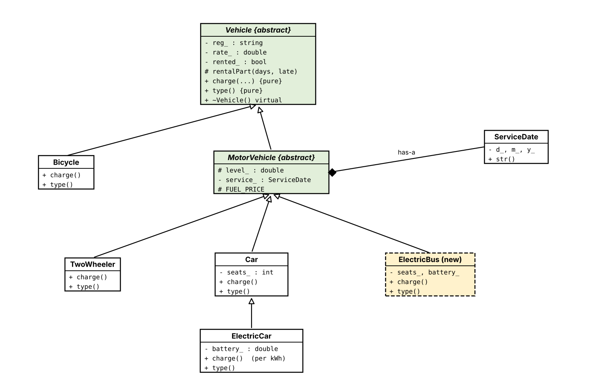
Figure 3: UML class diagram of the fleet (green = abstract, yellow dashed = class added later)
Types of inheritance: hierarchical (Bicycle and MotorVehicle from Vehicle; TwoWheeler, Car and ElectricBus from MotorVehicle) and multilevel (Vehicle → MotorVehicle → Car → ElectricCar). ServiceDate is a member class (has-a) of MotorVehicle. No multiple inheritance is needed, so no diamond arises.
Stage 3 – Critical design decisions (2 Marks)
Table 10: Stage 3 – Critical design decisions (2 Marks)
Decision | Choice and reason
What goes in Vehicle | Registration, rate, rented flag and the rental/late-charge calculation – needed by every vehicle, so written once
What goes in MotorVehicle | Fuel/charge level and the ServiceDate member – only motor vehicles have them (bicycle is excluded)
Pure virtual functions | charge() and type(): every concrete vehicle must define them; Vehicle and MotorVehicle stay abstract
Virtual destructor | Needed because objects are deleted through Vehicle* pointers
Access | Data private in the class that owns it; protected only for the helper rentalPart() and constants used by derived classes
Fleet storage | Vehicle* fleet[8]: an array of base-class pointers, so one loop handles all types and new types can be added to the same array
Why electric car derives from Car | It is a car (seats, service date); it only overrides charge() to use kWh

Stage 4 – Class design and pseudocode (4 Marks)
ALGORITHM RentVehicle
INPUT : fleet[0..n-1] (array of Vehicle pointers), registration number reg
OUTPUT : TRUE if the vehicle was rented, FALSE otherwise
BEGIN
v <- NULL
FOR i <- 0 TO n - 1 DO
IF fleet[i].reg() = reg THEN
v <- fleet[i]
END IF
END FOR
IF v = NULL THEN
RETURN FALSE // unknown vehicle
END IF
IF v.rented = TRUE THEN
RETURN FALSE // already rented
END IF
v.rented <- TRUE
RETURN TRUE
END

ALGORITHM ReturnVehicle
INPUT : fleet, n, reg, days, lateDays, used (litres or kWh consumed)
OUTPUT : rental charge, or -1 if the vehicle cannot be returned
BEGIN
v <- vehicle in fleet with registration reg
IF v = NULL OR v.rented = FALSE THEN
RETURN -1
END IF
v.rented <- FALSE
amount <- v.charge(days, lateDays, used) // run-time binding: the rule of the real type
RETURN amount
END

The class declarations appear in the program of Stage 5.
Stage 5 – Implementation and demonstration (3 Marks)
#include <iomanip>
#include <iostream>
#include <string>

class ServiceDate { // member class
int d_, m_, y_;
public:
ServiceDate(int d, int m, int y) : d_(d), m_(m), y_(y) {}
std::string str() const {
return std::to_string(d_) + "/" + std::to_string(m_) + "/" + std::to_string(y_);
}
};

class Vehicle { // abstract base class
std::string reg_;
double rate_;
bool rented_ = false;
public:
static constexpr double LATE_FACTOR = 1.5;
Vehicle(const std::string& reg, double rate) : reg_(reg), rate_(rate) {}
virtual ~Vehicle() = default;

const std::string& reg() const { return reg_; }
bool rented() const { return rented_; }
bool rent() { if (rented_) return false; rented_ = true; return true; }
double giveBack(int days, int lateDays, double used) {
rented_ = false;
return charge(days, lateDays, used);
}
virtual double charge(int days, int lateDays, double used) const = 0;
virtual std::string type() const = 0;
virtual std::string info() const { return ""; }
void print() const {
std::cout << std::left << std::setw(15) << type() << std::setw(12) << reg_
<< std::setw(8) << (rented_ ? "rented" : "free") << info() << '\n';
}
protected:
double rentalPart(int days, int lateDays) const {
return days * rate_ + lateDays * rate_ * LATE_FACTOR;
}
};

class Bicycle : public Vehicle {
public:
Bicycle(const std::string& reg, double rate) : Vehicle(reg, rate) {}
double charge(int days, int late, double) const override { return rentalPart(days, late); }
std::string type() const override { return "Bicycle"; }
};

class MotorVehicle : public Vehicle { // still abstract
double level_; // fuel (litres) or charge (kWh)
ServiceDate service_;
protected:
static constexpr double FUEL_PRICE = 100.0; // Rs per litre
public:
MotorVehicle(const std::string& reg, double rate, double level, const ServiceDate& sd)
: Vehicle(reg, rate), level_(level), service_(sd) {}
double level() const { return level_; }
std::string info() const override { return "service due " + service_.str(); }
};

class TwoWheeler : public MotorVehicle {
public:
TwoWheeler(const std::string& reg, double rate, double level, const ServiceDate& sd)
: MotorVehicle(reg, rate, level, sd) {}
double charge(int days, int late, double used) const override {
return rentalPart(days, late) + used * FUEL_PRICE;
}
std::string type() const override { return "Two-wheeler"; }
};

class Car : public MotorVehicle {
int seats_;
public:
Car(const std::string& reg, double rate, double level, const ServiceDate& sd, int seats)
: MotorVehicle(reg, rate, level, sd), seats_(seats) {}
int seats() const { return seats_; }
double charge(int days, int late, double used) const override {
return rentalPart(days, late) + used * FUEL_PRICE;
}
std::string type() const override { return "Car"; }
};

class ElectricCar : public Car {
double battery_; // kWh
static constexpr double ENERGY_PRICE = 12.0; // Rs per kWh
public:
ElectricCar(const std::string& reg, double rate, double level, const ServiceDate& sd,
int seats, double battery)
: Car(reg, rate, level, sd, seats), battery_(battery) {}
double charge(int days, int late, double used) const override {
return rentalPart(days, late) + used * ENERGY_PRICE;
}
std::string type() const override { return "Electric car"; }
};

// ---------- ADDED LATER: new file ElectricBus.h – no existing class is edited ----------
class ElectricBus : public MotorVehicle {
int seats_;
double battery_;
static constexpr double ENERGY_PRICE = 12.0;
static constexpr double DRIVER_FEE = 500.0;
public:
ElectricBus(const std::string& reg, double rate, double level, const ServiceDate& sd,
int seats, double battery)
: MotorVehicle(reg, rate, level, sd), seats_(seats), battery_(battery) {}
double charge(int days, int late, double used) const override {
return rentalPart(days, late) + used * ENERGY_PRICE + DRIVER_FEE;
}
std::string type() const override { return "Electric bus"; }
};
// ---------------------------------------------------------------------------------------

Vehicle* findVehicle(Vehicle* fleet[], int n, const std::string& reg) {
for (int i = 0; i < n; ++i)
if (fleet[i]->reg() == reg) return fleet[i];
return nullptr;
}

void rentVehicle(Vehicle* fleet[], int n, const std::string& reg) {
Vehicle* v = findVehicle(fleet, n, reg);
if (!v) { std::cout << reg << " not found\n"; return; }
if (!v->rent()) { std::cout << reg << " is already rented\n"; return; }
std::cout << reg << " rented\n";
}

void returnVehicle(Vehicle* fleet[], int n, const std::string& reg,
int days, int late, double used) {
Vehicle* v = findVehicle(fleet, n, reg);
if (!v || !v->rented()) { std::cout << reg << " cannot be returned\n"; return; }
std::cout << "Returned " << reg << " (" << v->type() << "): Rs "
<< v->giveBack(days, late, used) << '\n';
}

int main() {
std::cout << std::fixed << std::setprecision(2);
Vehicle* fleet[8];
int n = 0;
fleet[n++] = new Bicycle("BC-01", 150);
fleet[n++] = new TwoWheeler("TN-37-1234", 400, 6, ServiceDate(1, 3, 2027));
fleet[n++] = new Car("TN-38-5678", 1500, 40, ServiceDate(15, 2, 2027), 5);
fleet[n++] = new ElectricCar("TN-39-0001", 2000, 60, ServiceDate(10, 4, 2027), 5, 60);

std::cout << "--- Fleet ---\n";
for (int i = 0; i < n; ++i) fleet[i]->print();

std::cout << "--- Rent ---\n";
for (int i = 0; i < n; ++i) rentVehicle(fleet, n, fleet[i]->reg());
rentVehicle(fleet, n, "BC-01"); // already rented

std::cout << "--- Return ---\n";
returnVehicle(fleet, n, "BC-01", 2, 0, 0);
returnVehicle(fleet, n, "TN-37-1234", 3, 1, 4); // one late day, 4 litres
returnVehicle(fleet, n, "TN-38-5678", 2, 0, 10);
returnVehicle(fleet, n, "TN-39-0001", 1, 0, 20); // 20 kWh

std::cout << "--- New type: electric bus (no existing class changed) ---\n";
fleet[n++] = new ElectricBus("TN-40-9999", 5000, 200, ServiceDate(5, 5, 2027), 40, 300);
rentVehicle(fleet, n, "TN-40-9999");
returnVehicle(fleet, n, "TN-40-9999", 1, 0, 50);

for (int i = 0; i < n; ++i) delete fleet[i]; // virtual destructor
}

Expected output:
--- Fleet ---
Bicycle BC-01 free
Two-wheeler TN-37-1234 free service due 1/3/2027
Car TN-38-5678 free service due 15/2/2027
Electric car TN-39-0001 free service due 10/4/2027
--- Rent ---
BC-01 rented
TN-37-1234 rented
TN-38-5678 rented
TN-39-0001 rented
BC-01 is already rented
--- Return ---
Returned BC-01 (Bicycle): Rs 300.00
Returned TN-37-1234 (Two-wheeler): Rs 2200.00
Returned TN-38-5678 (Car): Rs 4000.00
Returned TN-39-0001 (Electric car): Rs 2240.00
--- New type: electric bus (no existing class changed) ---
TN-40-9999 rented
Returned TN-40-9999 (Electric bus): Rs 6100.00

Hand check: Two-wheeler 3 × 400 + 1 × 400 × 1.5 + 4 × 100 = 1200 + 600 + 400 = 2200; Car 2 × 1500 + 10 × 100 = 4000; Electric car 2000 + 20 × 12 = 2240; Electric bus 5000 + 50 × 12 + 500 = 6100.
Note: the "already rented" test runs while BC-01 is still rented, and the first loop of rentVehicle rents each vehicle once.
Alternative concept – one Vehicle class with a type code and switch
enum class Type { Bicycle, TwoWheeler, Car, ElectricCar };
class Vehicle {
public:
Type type; std::string reg; double rate;
double level = 0; ServiceDate* service = nullptr; // unused by Bicycle
int seats = 0; double battery = 0; // unused by most
double charge(int days, int late, double used) const {
double base = days * rate + late * rate * 1.5;
switch (type) {
case Type::Bicycle: return base;
case Type::TwoWheeler:
case Type::Car: return base + used * 100;
case Type::ElectricCar: return base + used * 12;
}
return base;
}
};

Table 11: Alternative concept – one Vehicle class with a type code and switch
Aspect | Abstract base + virtual functions | Single class + switch
Time per charge() | O(1): one indirect call through the vtable | O(1): one switch (jump table or comparisons); slightly faster, no indirection
Space per object | Only own fields + one vtable pointer (8 bytes) | All fields in every object: a Bicycle carries level, service, seats and battery that it never uses
Classes changed for a new type | 0 existing classes edited; 1 new class added | The Vehicle class itself: enum, switch in charge(), constructor, print and every other switch
Safety | Missing charge() is a compile error (pure virtual) | A forgotten case compiles and silently returns the base charge

Conclusion: the switch is simpler for a fixed set of vehicles, but the requirement that new types be added without changing existing classes is met only by the abstract-base-class design.
Submission Checklist
- GitHub repository DSA01-<RegisterNumber>-Assignment4 with folders Q1–Q6 (source, outputs, screenshots) and README.md.
- At least one commit for each task.
- Add your own output screenshots, sanitizer reports (Task 4 defects and repaired program) and sizeof / timing values in the places marked.

