**DataSpark : Illuminating Insights for Global Electronics**

**Global Electronics** is a customer focused Trader and Authorized distributor of Electronic Components & System with headquarters in Pune established in the year 2007.

The main goal of this project is to deliver a comprehensive Exploratory Data Analysis (EDA) report for Global Electronics,in-depth insights into customer demographics, purchasing behaviors, product performance, store operations, and currency impact on sales. The report will include visually compelling visualizations and actionable recommendations. This analysis will empower Global Electronics to increase customer satisfaction, maximize revenue, and drive overall business growth.

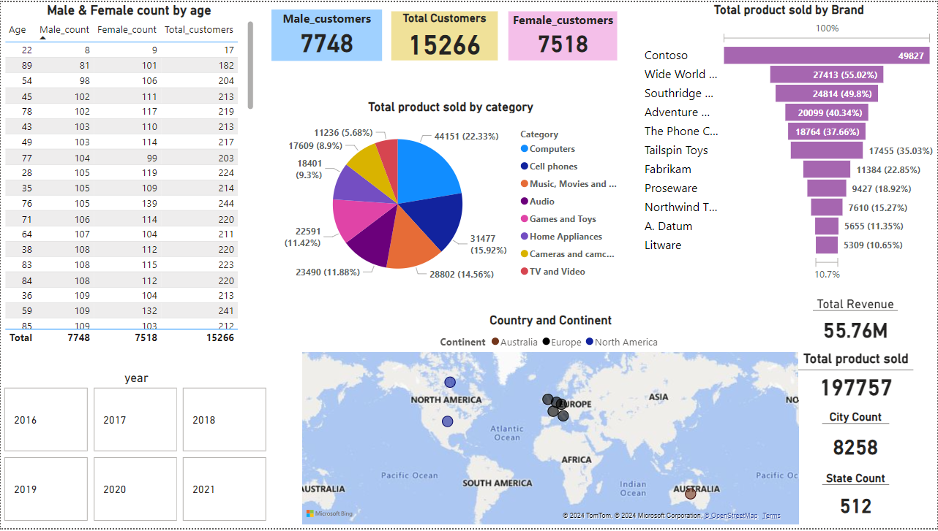

**Analysis:**

1. The above figure shows the demographic distribution of customers by age , country and continent
2. The total revenue generated by company over years is displayed in the above picture , which will be helpful to compare the current year sales revenue with previous year sales revenue
3. Total product sold by category and brands, shows the most preferred product by the customers based on category and brand

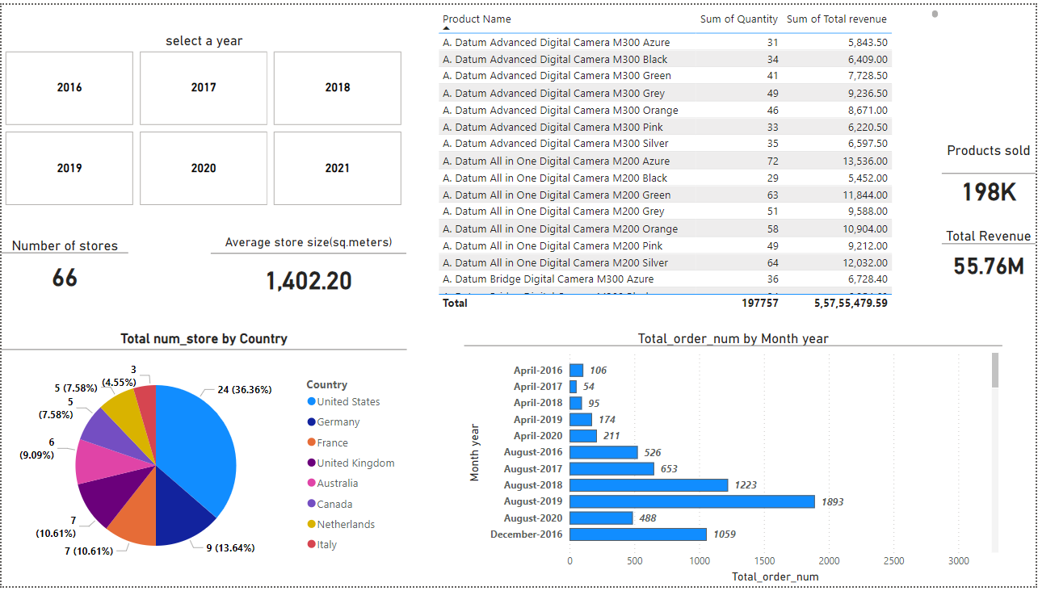

**Analysis:**

1. In the above image, the total quantity sold and total revenue generated by an individual product over years is shown.
2. Total number of stores present in different countries and its average store size is reported in the above image.
3. Total number of products sold by the company over years is recorded as 198K.
4. Month and year wise product sales report will help us to understand in which month and year the high number of products were sold

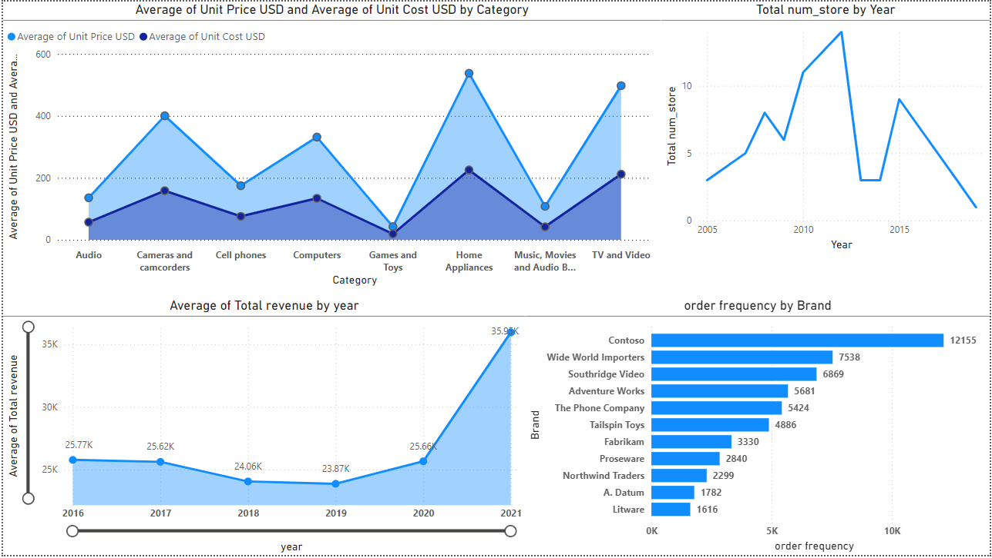

**Analysis:**

1. Average of total revenue by year can tell us whether the sales value increases over years.
2. The order frequency by brand reports the frequency of purchase by customers on the basis of various brand names.
3. Number of stores opened in different years will tell us the age of the store.
4. The average cost price and selling price of a product shows whether the product is sold for profit or loss.

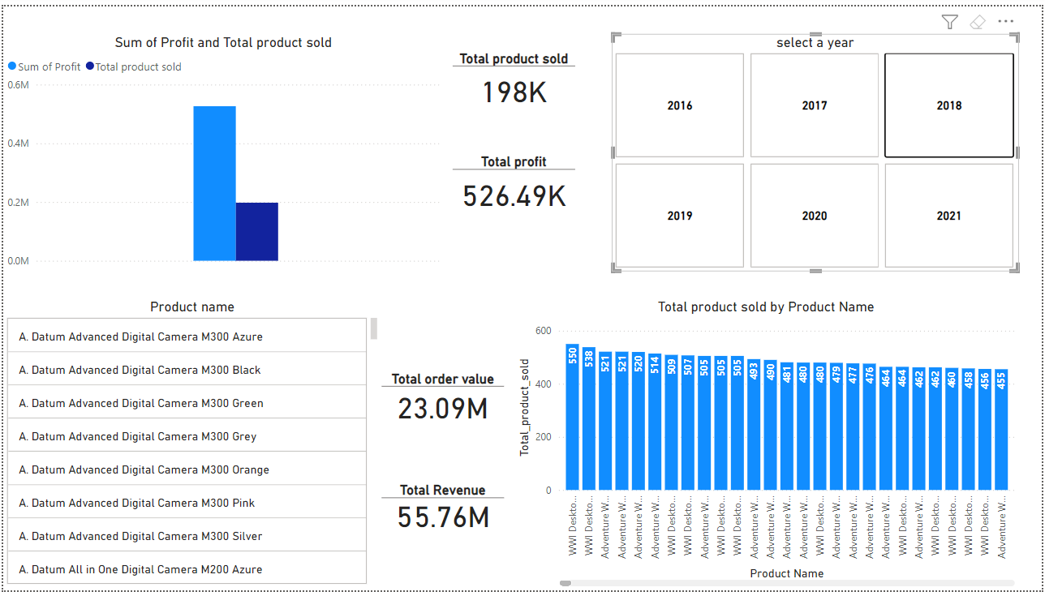

**Analysis:**

1. The overall profit , order value over years is reported on the above picture.
2. Number of individual product sold and their profit is also recorded.
3. Name of the different products sold over years are shown in the above picture

**Actionable recommendations:**

**Customers buying pattern :**

1. The frequency of the orders is 26326, which is a good sign of active customers involving a steady purchase pattern.
2. This can be leveraged by conducting loyalty programme , phone/email marketing , bringing new products for sales and maintaining a healthy relationship with customers by actively engaging with them eg: sending them wishes on their birthday through sms/phone.
3. Most of the customers tend to buy products based on their brand name eg: In the above pictures a brand named contoso sells most of the products.
4. Marketing focus on the most preferred products like computers, cell phones and music-movies-books will improve sales.
5. Products like Tv and video , home appliances and cameras require special promotions and product discount to make it popular.

**Sales performance:**

1. There are some fluctuation in the revenue but the average revenue over the years are increasing, even though there is no detailed trend.
2. On March and April of every year the sales are comparatively low in numbers, the sales can be boosted by offering special discounts during those months.
3. Providing occasional offers will help the company to sell more product and generate more revenue
4. Analysing and knowing which product generates higher revenue will help us to increase the overall sales performance

**Product analysis:**

1. Products like computers and cell phones are performing well in the market and generates a steady revenue over the years.
2. Meanwhile products like home appliances needs marketing efforts to gain popularity, which can be done by providing some fashionable offers.
3. Analysing which product sold the most and which was sold very less in numbers will help us to build the marketing strategies.
4. The order frequency of different brand products will help us to know which brand products are mostly preferred by the people.

**Store analysis:**

1. The average store size is recorded as 1,402.20 sq.meters, which is quit spacious.
2. Analysing the customer flow and getting feed back about the stores layout will help us to boost the sales.
3. Location of the stores also plays a major role in sales.

**Visualizations and reports :**

1. Creating visually appealing dashboards to analyse the KPIs (key performance indicators) like sales analysis ,product performance and customer engagement.
2. The above insights and recommendations will help us to make informed decisions.
3. These insights will help global electronics to generate maximum revenue and grow their business.