EX.NO:08 REG.NO:210701295

DATE:

**CLOUD SIMULATION**

**IMPLEMENT ROUND ROBIN TASK SCHEDULING IN BOTH**

**TIMESHARED AND SPACE SHARED CPU ASSIGNMENT**

**AIM:**

Implement RoundRobin task scheduling in both TimeShared and SpaceShared CPU

assignments.

**PROCEDURE:**

1. Create a new project by selecting java console line application template and JDK 18.

2. Open project settings from the file menu of the options window.

3. Navigate to project dependencies and select on add external jars and then click on ‘Browse’ to open the path where you have unzipped the Cloudsim Jars and click on apply.

4. Create a java file with the cloudsim code to implement the Round robin scheduling algorithm.

5. Run the application as a java file to see the output in the console below.

**OUTPUT:**

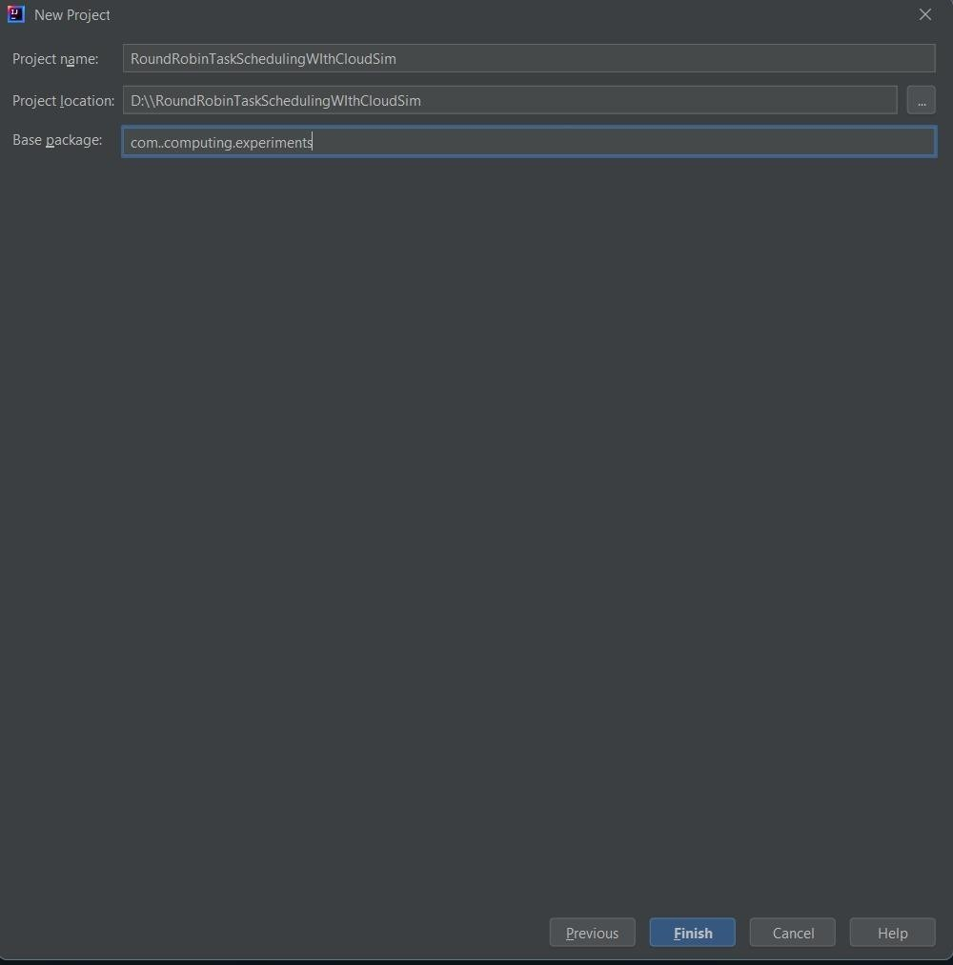

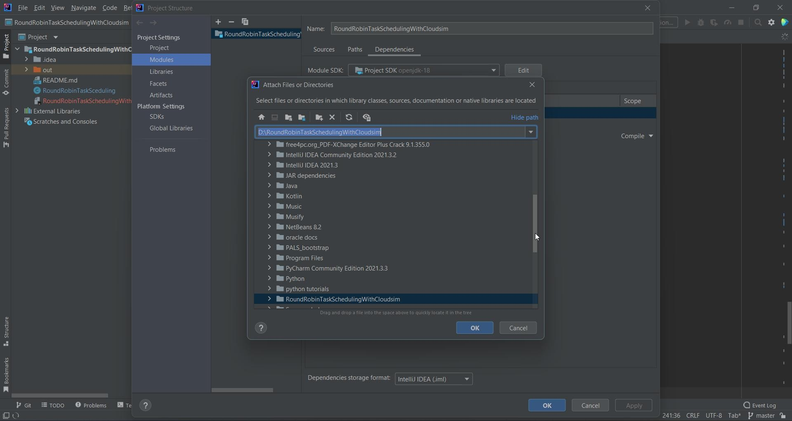

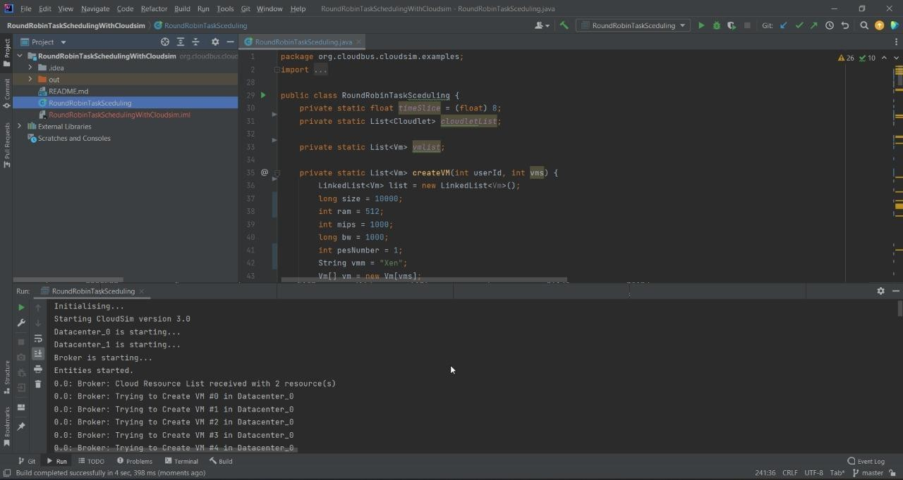

**RESULT:**

Thus, Round Robin task scheduling in both TimeShared and SpaceShared CPU assignment is implemented successfully**.**