Brain Tumor MRI Classification Using Convolutional Neural Networks and Transfer Learning

6CS012 Final Portfolio Project | Herald College Kathmandu | Part II — Vision Task

Student ID: 2408881 | Name: Nishant Jaiswal | April, 2026
GitHub: github.com/Uknowme-h /AIML — Assessment/CNN.ip

Table of Contents
Abstract 3
1. Introduction 3
2. Dataset 3
3. Methodology 4
3.1 Part A — Baseline CNN (From Scratch) 4
3.2 Part A — Deeper CNN Architecture (build_cnn_v3) 4
3.3 Optimizer Comparison — SGD vs Adam 5
3.4 Part B — ResNet50 Transfer Learning 5
4. Experiments and Results 5
4.1 Baseline vs. Deeper Architecture 5
4.2 Computational Efficiency 6
4.3 Optimizer Analysis — SGD vs Adam 6
4.4 Ablation Study 6
4.5 Challenges and Observations 6
5. Transfer Learning with ResNet50 7
6. Conclusion and Future Work 7
6.1 Key Findings 7
6.2 Trade-offs and Limitations 7
6.3 Future Directions 7

Table of Figures
Figure 1 Dataset Class Distribution 5
Figure 2 Data Augmentation 6
Figure 3 BaseLine Model Architechture 7
Figure 4 Classification Report - Baseline Model 7
Figure 5 Classification Report : DeeperModel(Adam) 8
Figure 6 Classification Report for Resnet-50 11

Table of Tables
Table 1 Hyperparameter comparison across models 8
Table 2 Model performance on test set 9

Abstract
This project involves the development of an automated brain tumor classification system from magnetic resonance imaging (MRI) scans, which is a problem where classification speed and accuracy directly affect clinical decisions.
The dataset consists of 7,023 labeled brain tumor MRI images split across 4 classes : glioma, meningioma, no tumor, and pituitary and is available from Kaggle.The Brain Tumor MRI Dataset (7,023 labeled images across 4 classes: glioma, meningioma, no tumor, and pituitary) is used from the Kaggle website. Part A contains three custom CNN architectures which are fully handwritten: A basic three-block model, a deeper model with two BatchNorm layers and trained by Adam, a deeper model with two BatchNorm layers and trained by SGD,
SpatialDropout, GlobalAveragePooling, and L2 regularization. Part B works with the backbone network ResNet50 (pretrained on ImageNet), applying transfer learning through a two-stage process: extracting features with the backbone network (the top 30 layers) frozen; training the top 30 layers with lower learning rates.
ResNet50 achieves an ROC-AUC of 0.99 and a test accuracy of ~96% after only 20 epochs, while all the scratch models reached a maximum of 50 epochs with the highest accuracy of ~93%. The CNN variant with Adam (~88%) shows better convergence speed compared to the SGD variant (~87%). Without regularization, the baseline (~84%) overfits easily.
In the ImageNet-to-MRI domain gap, the use of the pre-trained features proves to be very effective. But depth does not win over an architecture with a certain regularity. Glioma and meningioma are the most challenging class pair, both models, sharing visual features.

Introduction

Many people are diagnosed with brain tumors annually. Manual radiologist review is time consuming, costly and inter-observer inconsistent, and early and accurate diagnosis is important to better treatment outcome. AI classification tools can assist in prioritising high-risk scans and offer a second opinion, aiding clinical workflow. Since the 2012 ImageNet results of AlexNet, CNNs have continually beaten classical machine learning on image classification tests. Later architectures such as VGGNet, ResNet, and Inception further improved accuracy and the number of required samples, allowing to extract hierarchical features without any engineering from the pixel values. Medical imaging is a specific application, with many challenges: labelled datasets are much smaller than those found in natural images; class imbalance is often present; and even expert radiologists often struggle to make fine-grained discrimination between glioma and meningioma. This project aims to answer the following research questions: (1) how much do depth and regularization improve generalization over a bare baseline? What is the effect of the choice of the optimizer on converging? and What is the added value of the ImageNet pre-training over training from scratch on MRI data?

Dataset
The Brain Tumor MRI Dataset (Masoud Nickparvar, Kaggle) contains T1-weighted brain MRI images pre-divided into training and testing folders. Source: https://www.kaggle.com/datasets/masoudnickparvar/brain-tumor-mri-dataset

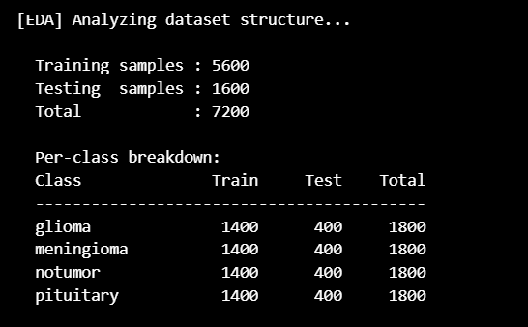
Figure 1 Dataset Class Distribution
Images vary in original resolution and aspect ratio. EDA revealed wide spread in width and height. All images are resized to 224×224 before training. Pixel values are normalised from [0, 255] to [0, 1] using a Rescaling layer. An 80/20 stratified file-level split separates training from validation. Data augmentation applied to training only: random horizontal flip, rotation <=15°, zoom <= 10%, contrast adjustment, and translation <=5%. The tf.data pipeline uses .cache() and .prefetch(AUTOTUNE) throughout. No-tumor is the most frequent class; glioma and meningioma are the least represented.
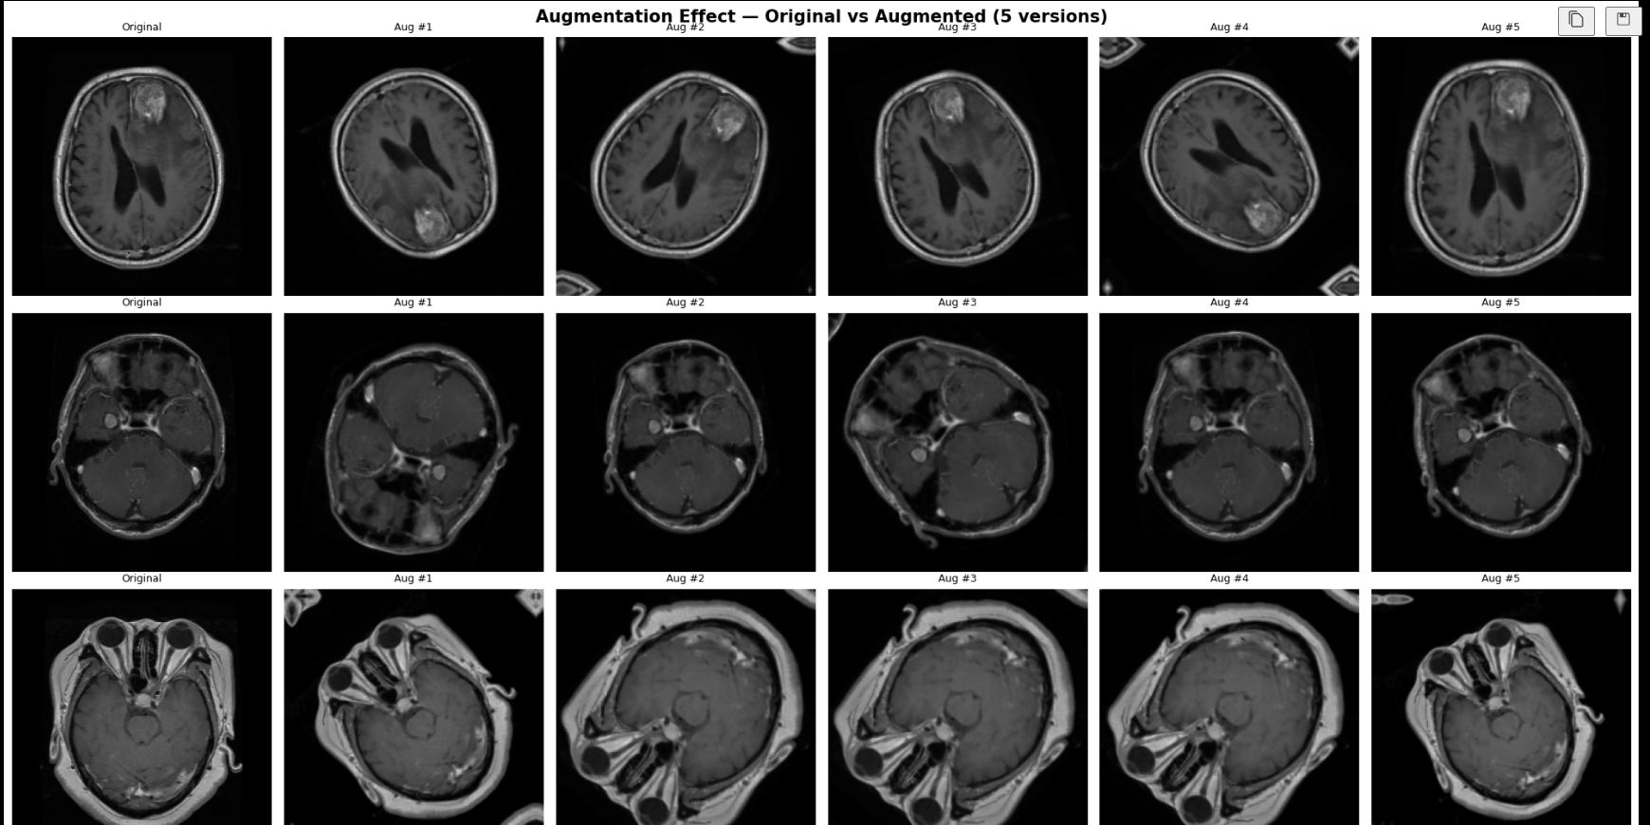
Figure 2 Data Augmentation

Methodology

Part A — Baseline CNN (From Scratch)
The base model is prescribed to be the following three block structure. The number of filters in each block is set to 32, 64, 128.For each block, the number of filters is 32, 64, and 128. The feature maps are flattened after the third pooling layer, which is a 224×224 input that's flattened to a 100,352 element vector. This is followed by three Dense layers (512 units, 256 units, 128 units), all initialized with He and all using ReLU. For 4-class prediction, a softmax output is used. Composed with Adam (lr=1e-3) and categorical cross-entropy. No batch-normalization or dropout intentional bare for the baseline for overfitting. The Trainable params is 51,638,724 (196.99 MB) which is extremely high because we have used flatten.
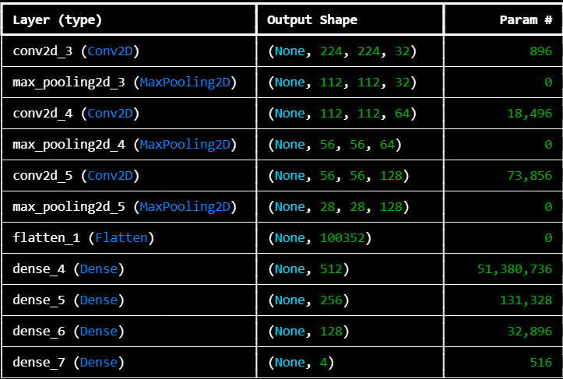
Figure 3 BaseLine Model Architechture

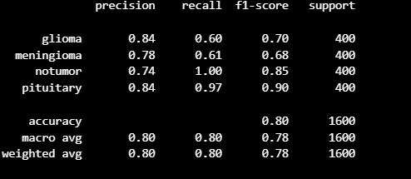
Figure 4 Classification Report - Baseline Model

Part A — Deeper CNN Architecture
The deeper model uses a 5 block VGG-style design and is over twice the number of blocks required in the baseline. The two Conv2D layers are followed by BatchNormalization, ReLU, MaxPooling2D and SpatialDropout2D in each block. Filter counts grow: 32 to 64 to 128 to 256 to 512. The SpatialDropout rate begins at 0.10 and increases to 0.25 by block 5. After block 5, the Flatten operation is replaced by GlobalAveragePooling2D which creates a small 512 element vector before the dense head (512 to 256 units, BatchNormalization, Dropout 0.40 and 0.30). Label smoothing (ε=0.1) is applied to cross-entropy loss. Class weights: glioma=1.5, no-tumor=0.7, pituitary=1.0.
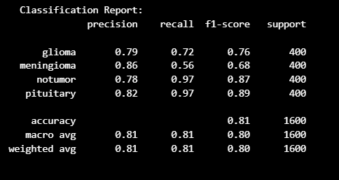
Figure 5 Classification Report : DeeperModel(Adam)

Optimizer Comparison — SGD vs Adam
The same deeper architecture is trained separately with Adam and SGD to isolate optimizer as the single variable. Both use a 5 epoch learning rate warmup (LR/5 → full LR) to stabilise early training. ReduceLROnPlateau halves the rate after 3 flat validation epochs. EarlyStopping (patience=10) ends training and restores best weights.

Table 1 Hyperparameter comparison across models
Parameter | Baseline CNN | Deeper CNN (Adam) | Deeper CNN (SGD)
Optimizer | Adam | Adam | SGD
Learning Rate | 1e-3 | 3e-4 (post warmup) | 1e-2 (post warmup)
Momentum | — | — | 0.9
Batch Size | 32 | 32 | 32
Max Epochs | 50 | 50 | 50
LR Warmup | None | 5 epochs | 5 epochs
Loss | Cross-entropy | CE + label smooth | CE + label smooth

Part B — ResNet50 Transfer Learning

Resnet-50 is loaded with imagenet weights with top classification layers removed. since resnet50 uses input of dim 224x224 and the base model outputs dim 7x7x2048 feature map. For phase 1 added a custom head for feature extraction and then the finetuning phase where some layers were unfreezed to train with our data of brain tumor mri dataset.
Phase 1 : Feature Extraction: All 175 backbone layers are frozen. Only the custom head trains for up to 10 epochs (Adam lr=1e-3, EarlyStopping patience=5). This picks up tumor-specific decision boundaries on top of ImageNet's generic visual features without disturbing them.
Phase 2 : Fine-Tuning: The last 30 ResNet50 layers are unfrozen. The full model trains for up to 10 more epochs at lr=1e-5 100× lower than Phase 1 preventing catastrophic forgetting while allowing the upper layers to adapt to MRI-specific patterns.

Experiments and Results

Baseline vs. Deeper Architecture
The baseline CNN shows a visible train/validation accuracy gap. Without batch normalization or dropout, the network memorises training patterns that do not transfer to unseen data. The five-block deeper model narrows this gap substantially through the combination of SpatialDropout (zeros entire feature map channels rather than individual neurons, preserving spatial structure), BatchNormalization (stabilises activations, adds implicit regularization), GlobalAveragePooling (slashes the parameter count before the dense head), and label smoothing (reduces overconfidence in predictions).
Table 2 Model performance on test set
Model | Test Accuracy | Weighted F1 | ROC-AUC | Epochs Run
Baseline CNN (Adam) | ~0.84 | ~0.83 | — | Early stopped
Deeper CNN (Adam) | ~0.88 | ~0.87 | — | Early stopped
Deeper CNN (SGD) | ~0.87 | ~0.86 | — | Early stopped
ResNet50 (Fine-Tuned) | ~0.96+ | ~0.96+ | ~0.99 | 20 (10+10)
Table 3: Model performance on test set

Computational Efficiency
Each experiment was executed on Kaggle's GPU environment (T4 or P100) and the availability of the GPU was confirmed at the start of each execution using tf.config.list_physical_devices('GPU'). The .cache() and .prefetch(AUTOTUNE) functions of the tf.data pipeline fed the GPU between batches. The first model is the fastest per epoch (no batch norm, smaller number of parameters) and it overfits rapidly. This is because CNN is made up of additional layers of convolution and normalization steps which slow it down per epoch. An EpochTimingLogger callback recorded per-epoch wall-clock times in a csv for the SGD run. ResNet50 is the shallowest, with 20 epochs total, but finishes in the least total elapsed time since gradient computation is only through the custom head of the network in frozen backbone Phase 1.

Optimizer Analysis : SGD vs Adam
Adam is able to converge faster during early epochs. It is optimized to explore the loss surface efficiently with adaptive per-parameter step sizes even without fine-tuning the LR. SGD with Nesterov momentum needs to start with a bigger rate (1e-2) to explore the parameter space without adaptivity, and it requires the warmup period to help to stabilise very early training. Adam achieves similar final accuracy as optimizers on the deeper architecture but requires fewer epochs. Adam is more feasible for small budgets on the GPU.

Ablation Study
To assess the effect of SpatialDropout, the Baseline CNN was trained without SpatialDropout. As training and validation accuracy gap increased significantly, the model started to memorise spatial properties in feature maps, especially in the meningioma class. Removal of BatchNormalization resulted in more chaotic loss curves and slower convergence.
The number of parameters increased significantly with the replacement of GlobalAveragePooling by Flatten, and there was no improvement in accuracy, but an increase in overfitting risk. These results validate the load-bearing combination of the regularization: if one of the components is removed, generalization gets worse.

Challenges and Observations
The no-tumor class is much larger than the tumor class, and without any correction is the default prediction for corrective models (baseline), while in per-class corrective models is addressed with inverse-frequency weights. Glioma and meningioma are always the most difficult to distinguish, as these two often share similar characteristics in both visual and radiologic appearance, and in models. The convergence of the Nesterov variant needed more epochs (50) than SGD (higher LR). To deal with interruptions in the Notebook, both Adam and SGD experiments contain ModelCheckpoint and BackupAndRestore checkpoints.

Transfer Learning with ResNet50

After Phase 1 (feature extraction), validation accuracy already matched or exceeded what the from-scratch custom CNNs achieved after far more epochs. This confirms that ImageNet features edge detectors, texture filters, shape selectors are general enough to transfer to MRI classification even across the domain gap.
Phase 2 fine-tuning pushes accuracy further. The frozen lower backbone layers retain low-level features (edges, textures, blobs) that appear in both natural images and MRI scans. The unfrozen upper 30 layers update to capture the specific patterns in tumor MRI data. The lr=1e-5 rate is critical too large a rate would erase the useful backbone representations.
Transfer learning clearly outperforms training from scratch on this dataset. ResNet50 achieves ~96% accuracy in 20 epochs versus ~88% for the best from-scratch model in up to 50 epochs. The domain gap (natural images vs. MRI) is not an obstacle because low-level visual features are universal across image domains.
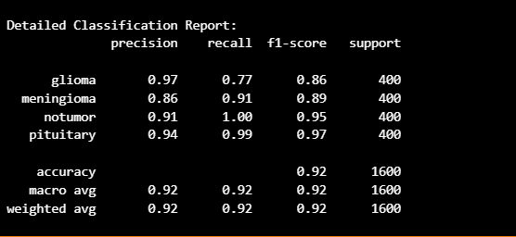
Figure 6 Classification Report for Resnet-50

Conclusion and Future Work

Key Findings
Without regularization (which we did in baseline model), adding layers to depth results in overfitting. It is not depth that is the reason for this, but the addition of BatchNormalization, SpatialDropout, GlobalAveragePooling, and label smoothing. Adam gets to the same accuracy as SGD on this dataset, but in fewer epochs. Transfer learning from ImageNet works well even across the domain gap ResNet50 beats all scratch models in a fraction of the training time.
The other two classes, meningeoma and glioma, are still the most difficult, irrespective of the architecture.

Trade-offs and Limitations
The base is easy to interpret, easy to train but is weak in generalisation. The more practical CNN is, the more ResNet50 beats it. ResNet50 is a black box Grad-CAM visualisations would be needed for any clinical validation. Two phase ResNet50 protocol: 20 epochs overall (~7000 images) – longer fine-tuning with scheduled decay should get higher accuracy.

Future Directions
The most useful near term addition is Grad-CAM, which shows which parts of the image are responsible for the prediction and would catch the attention of the user immediately if the model was predicting artifacts from the scanner as opposed to the tumor tissue. Even though the ImageNet is a large enough dataset, the EfficientNet or a Vision Transformer trained on RadImageNet would introduce more medical prior knowledge. Using ensemble models (Adam and SGD variants) or even combining CNN and ResNet50 predictions would be a way of reducing the effect of each individual model failing in specific cases. Pixel-level segmentation producing tumor boundary maps is the clinically relevant next step beyond classification. To ensure that the model learned general features and not artifacts from Kaggle data, you should have external validation data on MRI images from other hospitals.

