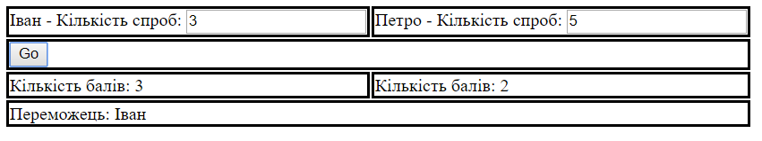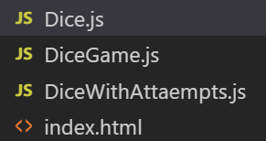

class Dice{

constructor(facesCount=6){

Object.defineProperty(this,'FacesCount',{

value:facesCount,

writable:false

})

}

getRandomScore(){

return 1+Math.floor(Math.random()\*this.FacesCount)

}

toString(){

return `Dice (ficeCount=${this.facesCount})`

}

valueOf(){

return this.getRandomScore()

}

}

================================================

class DiceWithAttaempts extends Dice{

constructor(facesCount=6,attemptsCount=1){

super(facesCount)

Object.defineProperty(this,'AttemptsCount',{

get:function(){

return attemptsCount

},

set:function(value){

if(value<1)

throw new Error('The value is incorrect')

attemptsCount=value

}

})

this.AttemptsCount=attemptsCount

}

getRandomScore(){

let sum=0

for (let i = 0; i < this.AttemptsCount; i++) {

sum+=super.getRandomScore()

}

console.log(sum);

return Math.floor(sum/this.AttemptsCount)

}

}

=========================================================

class DiceGame{

constructor(player1Name,player2Name){

this.player1Name=player1Name

this.player2Name=player2Name

}

GO(){

const player1Att=parseInt(this.player1AttInp.value)

const player2Att=parseInt(this.player2AttInp.value)

const dice1=new DiceWithAttaempts(6,player1Att)

const dice2=new DiceWithAttaempts(6,player2Att)

const score1=dice1.getRandomScore()

const score2=dice2.getRandomScore()

this.player1ResSpan.innerText=score1

this.player2ResSpan.innerText=score2

if(score1>score2)

this.winnerSpan.innerText=this.player1Name

else if(score1<score2)

this.winnerSpan.innerText=this.player2Name

else

this.winnerSpan.innerText='Нічия'

}

render(){

const crEl=(el)=>document.createElement(el) //Створюмєо константу для короткого виклику функції

const table= crEl('table')

let tr=crEl('tr')

let td=crEl('td')

td.innerText=this.player1Name

let label=crEl('label')

label.innerText=' - Кількість спроб: '

this.player1AttInp=crEl('input')

this.player1AttInp.type='number'

label.appendChild(this.player1AttInp)

td.appendChild(label)

tr.appendChild(td)

td=crEl('td')

td.innerText=this.player2Name

label=crEl('label')

label.innerText=' - Кількість спроб: '

this.player2AttInp=crEl('input')

this.player2AttInp.type='number'

label.appendChild(this.player2AttInp)

td.appendChild(label)

tr.appendChild(td)

table.appendChild(tr)

tr=crEl('tr')

td=crEl('td')

td.setAttribute('colspan','2')

let btn=crEl('button')

btn.innerText='Go'

btn.onclick=this.GO.bind(this)

td.appendChild(btn)

tr.appendChild(td)

table.appendChild(tr)

tr=crEl('tr')

td=crEl('td')

td.innerText='Кількість балів: '

this.player1ResSpan=crEl('span')

td.appendChild(this.player1ResSpan)

tr.appendChild(td)

td=crEl('td')

td.innerText='Кількість балів: '

this.player2ResSpan=crEl('span')

td.appendChild(this.player2ResSpan)

tr.appendChild(td)

table.appendChild(tr)

tr=crEl('tr')

td=crEl('td')

td.setAttribute('colspan','2')

td.innerText='Переможець: '

this.winnerSpan=crEl('span')

td.appendChild(this.winnerSpan)

tr.appendChild(td)

table.appendChild(tr)

return table

}

}

============================

<!DOCTYPE html>

<html lang="en">

<head>

<meta charset="UTF-8">

<meta name="viewport" content="width=device-width, initial-scale=1.0">

<meta http-equiv="X-UA-Compatible" content="ie=edge">

<title>Document</title>

<script src="Dice.js"></script>

<script src="DiceWithAttaempts.js"></script>

<script src="DiceGame.js"></script>

<script>

window.onload=function(){

const game=new DiceGame('Іван','Петро')

document.getElementById('container').appendChild(game.render())

}

</script>

<style>

td{

border: solid 2px black

}

</style>

</head>

<body>

<div id="container">

</div>

</body>

</html>