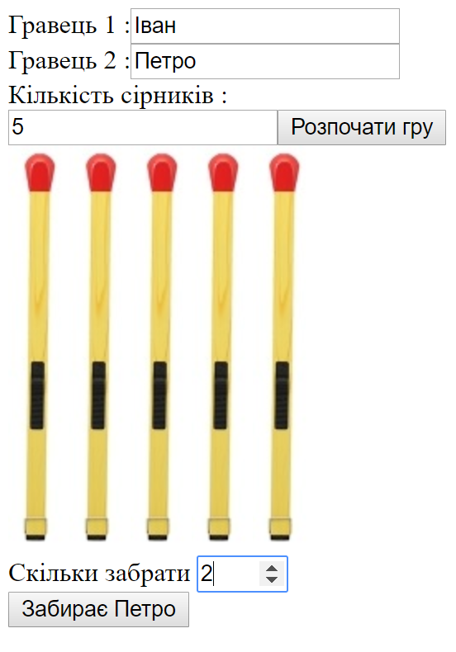

<!DOCTYPE html>

<html lang="en" xmlns="http://www.w3.org/1999/xhtml">

<head>

<meta charset="utf-8" />

<title></title>

<script>

class MatchesGame {

constructor(imgFile,containerID)

{

this.matchIMGFile = imgFile;

this.container = document.getElementById(containerID);

this.currentUser = Math.round(Math.random())+1;

}

addInput(container, title, type,inputID) {

var label = document.createElement("label");

label.innerText = title;

var inp = document.createElement("input");

inp.type = type;

inp.id = inputID;

label.appendChild(inp);

container.appendChild(label);

return inp;

}

renderStart()

{

this.startOptionDiv = document.createElement("div");

this.gameDiv = document.createElement("div");

this.container.appendChild(this.startOptionDiv);

this.container.appendChild(this.gameDiv);

//-----------------

this.player1Input = this.addInput(this.startOptionDiv, "Гравець 1 :", "text", "player1");

this.player2Input = this.addInput(this.startOptionDiv, "Гравець 2 :", "text", "player2");

this.matchesCountInput = this.addInput(this.startOptionDiv, "Кількість сірників :", "number", "matchesCount");

var btnStart = this.addInput(this.startOptionDiv, "", "button");

btnStart.value = "Розпочати гру";

btnStart.onclick = this.renderGame.bind(this);

}

renderGame()

{

this.player1Name = this.player1Input.value;

this.player2Name = this.player2Input.value;

this.matchesCount = this.matchesCountInput.value;

this.matchesDiv = document.createElement("div");

for (var i = 0; i < this.matchesCount; i++) {

var img = document.createElement("img");

img.src = this.matchIMGFile;

this.matchesDiv.appendChild(img);

}

this.gameDiv.appendChild(this.matchesDiv);

this.userCountForDelete = this.addInput(this.gameDiv, "Скільки забрати ", "number");

this.userCountForDelete.setAttribute("min", "1");

this.userCountForDelete.setAttribute("max", "3");

this.goBtn = this.addInput(this.gameDiv, "", "button");

this.goBtn.value = "Забирає " + this.getCurrentUserName();

this.goBtn.onclick = this.takeMatchesClick.bind(this);

}

getCurrentUserName()

{

if (this.currentUser == 1)

return this.player1Name;

else

return this.player2Name;

}

takeMatchesClick()

{

var countForDelete = +this.userCountForDelete.value;

if (countForDelete > this.matchesCount) {

alert("Немає такої кількості сірників");

return false;

}

for (var i = 0; i < countForDelete; i++) {

this.matchesDiv.lastElementChild.remove();

}

this.matchesCount -= countForDelete;

if (this.matchesCount == 0)

{

alert("Програв " + this.getCurrentUserName());

this.gameDiv.remove();

}

this.nextUser();

if (this.matchesCount < 2)

{

alert("Програв " + this.getCurrentUserName());

this.gameDiv.remove();

}

}

nextUser()

{

this.currentUser++;

if (this.currentUser > 2)

this.currentUser = 1;

this.goBtn.value = "Забирає "+ this.getCurrentUserName();

}

}

window.onload = function () {

var game = new MatchesGame("./img/match.jpg", "forGame");

game.renderStart();

}

</script>

</head>

<body>

<div id="forGame">

</div>

</body>

</html>