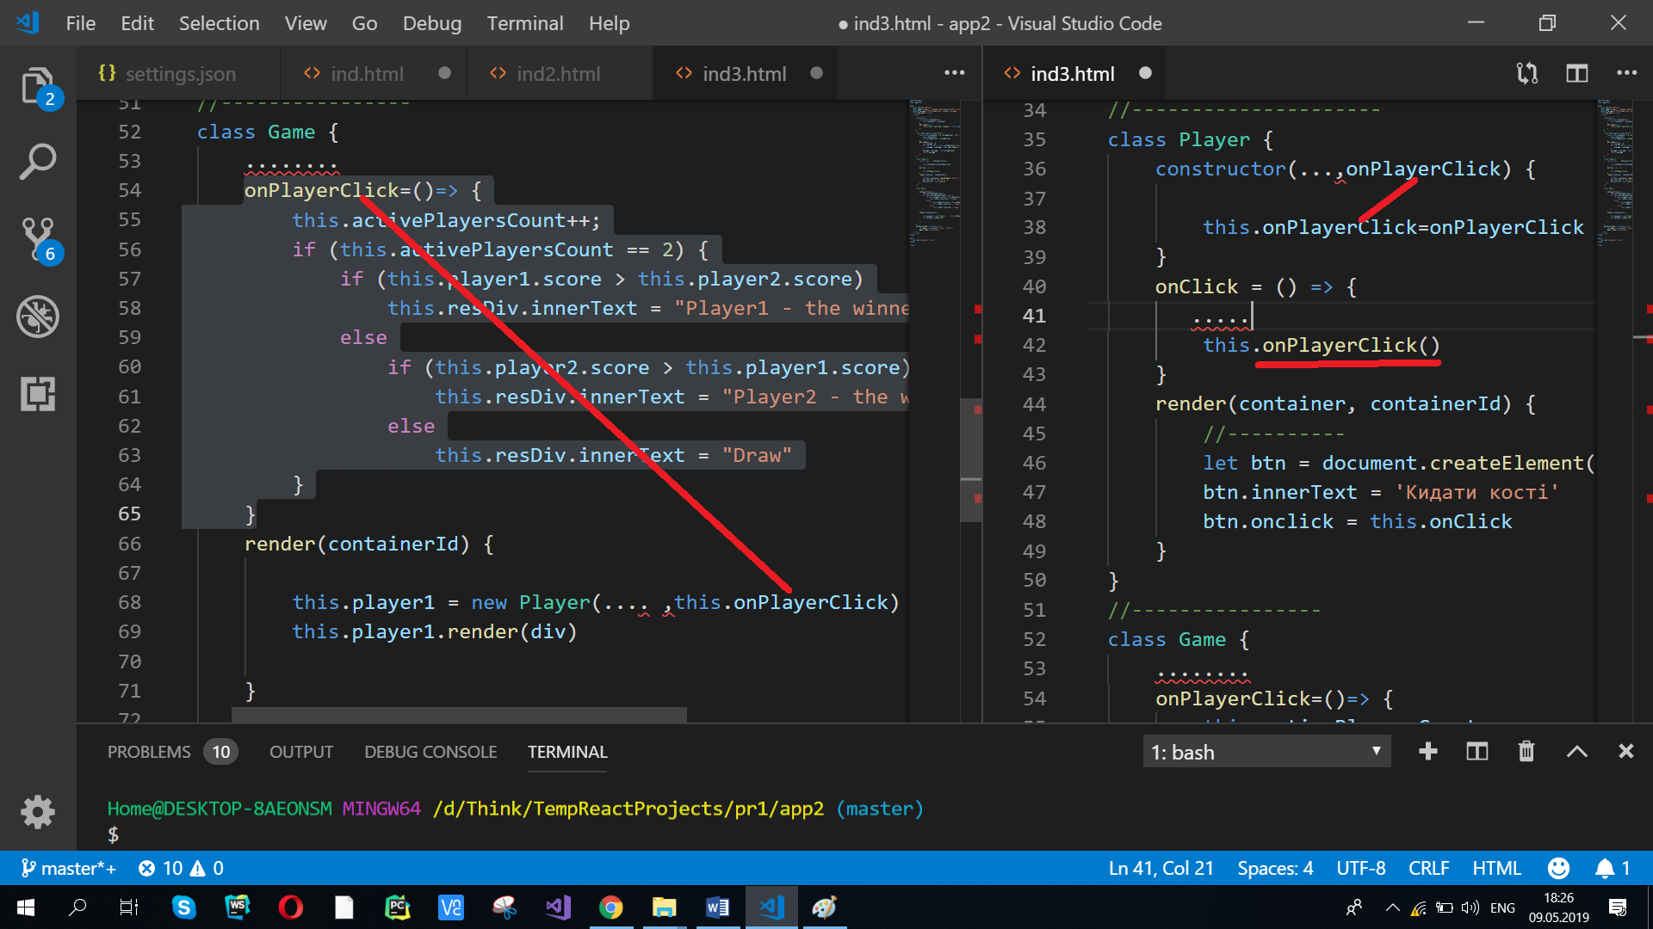

<!DOCTYPE html>

<html lang="en">

<head>

<meta charset="UTF-8">

<meta name="viewport" content="width=device-width, initial-scale=1.0">

<meta http-equiv="X-UA-Compatible" content="ie=edge">

<title>Document</title>

<script>

//---------------------------

class Dice {

constructor(faceCount) {

this.faceCount = faceCount

}

get_number() {

return Math.floor(Math.random() * (this.faceCount + 1))

}

}

//----------------------------------------

class Dice_super extends Dice {

constructor(faceCount = 6, attemptCount = 6) {

super(faceCount)

this.attemptCount = attemptCount

}

get_number() {

var evarage = 0

for (let i = 0; i < this.attemptCount; i++) {

evarage = evarage + super.get_number()

}

evarage = evarage / this.attemptCount

return evarage

}

}

//---------------------

class Player {

constructor(faceCount = 6, playerName,onPlayerClick) {

this.faceCount = faceCount

this.playerName = playerName

this.onPlayerClick=onPlayerClick

}

onClick = () => {

let attemptCount = parseInt(this.attemptCountInput.value)

let superDice = new Dice_super(this.faceCount, attemptCount)

this.score = superDice.get_number()

this.span.innerText = this.score.toFixed(2)

this.onPlayerClick()

}

render(container, containerId) {

// if(container==undefined)

// container=document.getElementById(containerId)

container = container ? container : document.getElementById(containerId)

let div = document.createElement('div')

div.innerText = `Ім"я гравця : ${this.playerName}`

container.appendChild(div)

//-------

div = document.createElement('div')

let lbl = document.createElement('label')

lbl.innerText = 'Кількість спроб: '

this.attemptCountInput = document.createElement('input')

this.attemptCountInput.type = 'number'

lbl.appendChild(this.attemptCountInput)

div.appendChild(lbl)

container.appendChild(div)

//----------

let btn = document.createElement('button')

btn.innerText = 'Кидати кості'

btn.onclick = this.onClick

container.appendChild(btn)

//------------

div = document.createElement('div')

div.innerText = 'Кількість балів: '

this.span = document.createElement('span')

this.span.innerText = '0'

div.appendChild(this.span)

container.appendChild(div)

}

}

//----------------

class Game {

constructor(faceCount = 6, player1_name, player2_name) {

this.faceCount = faceCount

this.player1_name = player1_name

this.player2_name = player2_name

this.activePlayersCount = 0

}

onPlayerClick=()=> {

this.activePlayersCount++;

if (this.activePlayersCount == 2) {

if (this.player1.score > this.player2.score)

this.resDiv.innerText = "Player1 - the winner"

else

if (this.player2.score > this.player1.score)

this.resDiv.innerText = "Player2 - the winner"

else

this.resDiv.innerText = "Draw"

}

}

render(containerId) {

let container = document.getElementById(containerId)

let div = document.createElement('div')

this.player1 = new Player(this.faceCount, this.player1_name,this.onPlayerClick)

this.player1.render(div)

container.appendChild(div)

//--------

div = document.createElement('div')

this.player2 = new Player(this.faceCount, this.player2_name,this.onPlayerClick)

this.player2.render(div)

container.appendChild(div)

//----

this.resDiv = document.createElement('div')

container.appendChild(this.resDiv)

}

}

window.onload = function () {

let game = new Game(6, 'Ivan', 'Petro')

game.render('container')

}

</script>

</head>

<body>

<div id="container"></div>

</body>

</html>