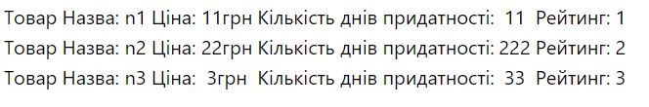

import React from 'react';

import logo from './logo.svg';

import './App.css';

import Game from './components/game'

import ProductList from './components/ProductList'

function App() {

let products=[

{name:'n1',

prise:11,

counterday:11,

rating:1

},

{name:'n2',

prise:22,

counterday:222,

rating:2

},

{name:'n3',

prise:3,

counterday:33,

rating:3

},

]

return (

<div className="App">

<ProductList products={products} />

</div>

);

}

export default App;

import React, { Component } from 'react';

import Product from '../Product'

const ProductList = ({products}) => {

return (

<table>

{products.map((product,i)=><Product {...product}/>)}

</table>

);

}

export default ProductList;

import React, { Component } from 'react';

const Product = ({name, prise, counterday, rating}) => {

return (

<tr>

<td> Товар </td>

<td> Назва: {name} </td>

<td> Ціна: </td>

<td>{prise}грн</td>

<td> Кількість днів придатності:</td>

<td> {counterday} </td>

<td> Рейтинг: </td>

<td> {rating} </td>

</tr>

);

}

export default Product;