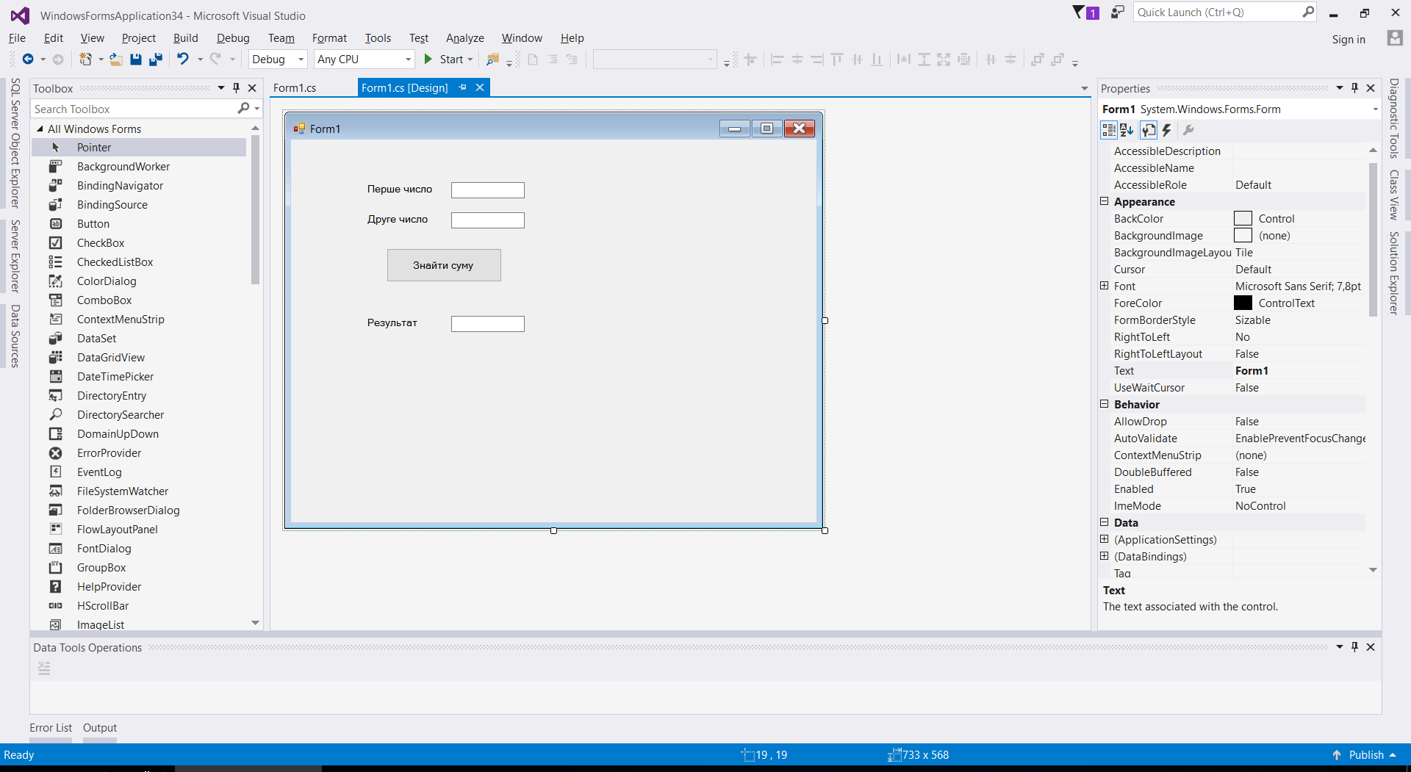

using System;

using System.Collections.Generic;

using System.ComponentModel;

using System.Data;

using System.Drawing;

using System.Linq;

using System.Text;

using System.Threading.Tasks;

using System.Windows.Forms;

namespace WindowsFormsApplication34

{

public partial class Form1 : Form

{

public Form1()

{

InitializeComponent();

}

private void button1_Click(object sender, EventArgs e)

{

int c1 =int.Parse(FirstNumber.Text);

int c2 = int.Parse(SecondNumber.Text);

int sum = c1 + c2;

Result.Text = sum.ToString();

}

private void label3_Click(object sender, EventArgs e)

{

}

}

}