Задача. Вибір типу квитка.

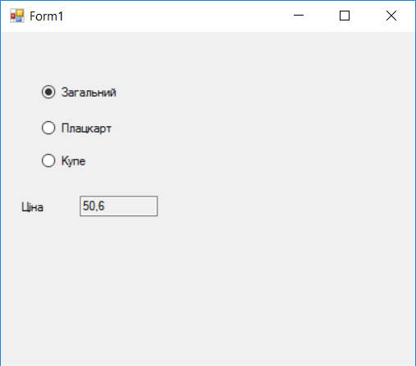

using System;

using System.Collections.Generic;

using System.ComponentModel;

using System.Data;

using System.Drawing;

using System.Linq;

using System.Text;

using System.Threading.Tasks;

using System.Windows.Forms;

namespace WindowsFormsApplication39

{

public partial class Form1 : Form

{

public Form1()

{

InitializeComponent();

}

double sum = 50.6;

private void radioButton1_CheckedChanged(object sender, EventArgs e)

{

sum = Convert.ToDouble((sender as RadioButton).Tag);

textBox1.Text = sum.ToString();

}

}

}

================================