using System;

using System.Collections.Generic;

using System.Linq;

using System.Text;

using System.Threading.Tasks;

namespace ConsoleApplication63

{

class Program

{

static void Main(string[] args)

{

int score = 0;

Random random = new Random(DateTime.Now.Millisecond);

for (int i = 1; i <= 10; i++)

{

Console.Write("{0}.number=",i);

int UserNumber = int.Parse(Console.ReadLine());

int ComputerNumber = random.Next(1, 11);

if (ComputerNumber == UserNumber)

{

score++;

}

}

Console.WriteLine("won="+score);

Console.ReadLine();

}

}

}

=======================

2.1. Відобразити трикутник за допомогою символів «о»

о

оо

ооо

оооо

ооооо

оооооо

ооооооо

using System;

using System.Collections.Generic;

using System.Linq;

using System.Text;

using System.Threading.Tasks;

namespace ConsoleApplication63

{

class Program

{

static void Main(string[] args)

{

int spaceCount=6, lettersCount = 1;

for (int i = 1; i < 7; i++)

{

//Виводимо пробіли

for (int j = 1; j <= spaceCount; j++)

{

Console.Write(" ");

}

//Виводимо літери о

for (int j = 1; j <= lettersCount; j++)

{

Console.Write("o");

}

//Переходимо на новий рядок

Console.WriteLine();

spaceCount--;

lettersCount++;

}

Console.ReadLine();

}

}

}

========================================================

1 2 3 ….9

3 4 5 …. 12

5 6 7 … 15

7 8 9 … 18

……

Рядків 12  
using System;

using System.Collections.Generic;

using System.Linq;

using System.Text;

using System.Threading.Tasks;

namespace ConsoleApplication63

{

class Program

{

static void Main(string[] args)

{

int start = 1, end = 9;

for (int i = 1; i <=12; i++)

{

for (int j = start; j <= end; j++)

{

Console.Write(" "+j);

}

Console.WriteLine();

start = start + 2;

end = end + 3;

}

Console.ReadLine();

}

}

}

//-------------------------------------

Обчислити

2+2+2+….+2 – 35 разів

using System;

using System.Collections.Generic;

using System.Linq;

using System.Text;

using System.Threading.Tasks;

namespace ConsoleApplication63

{

class Program

{

static void Main(string[] args)

{

int s = 0;

for (int i = 1; i <=35; i++)

{

s += 2; //s=s+2;

}

Console.WriteLine("sum={0}",s);

Console.ReadLine();

}

}

}

===================================  
3\*3\*3…\*3 -19разів //Math.Pow(3,19)

===================================  
2+4+6+8+…. 15 разів

=======================

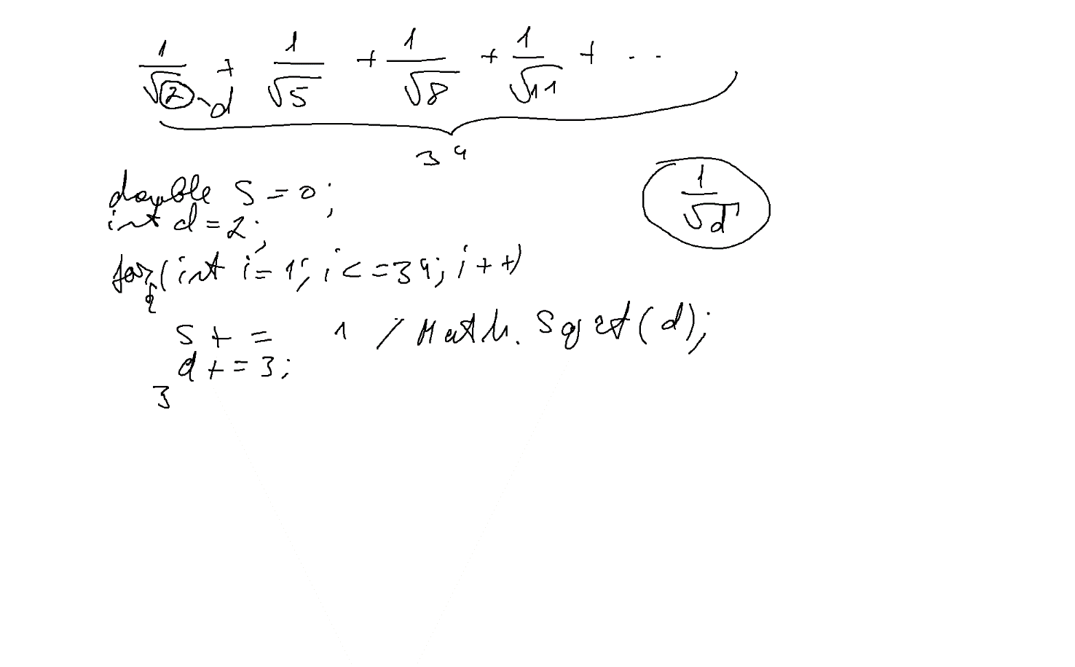

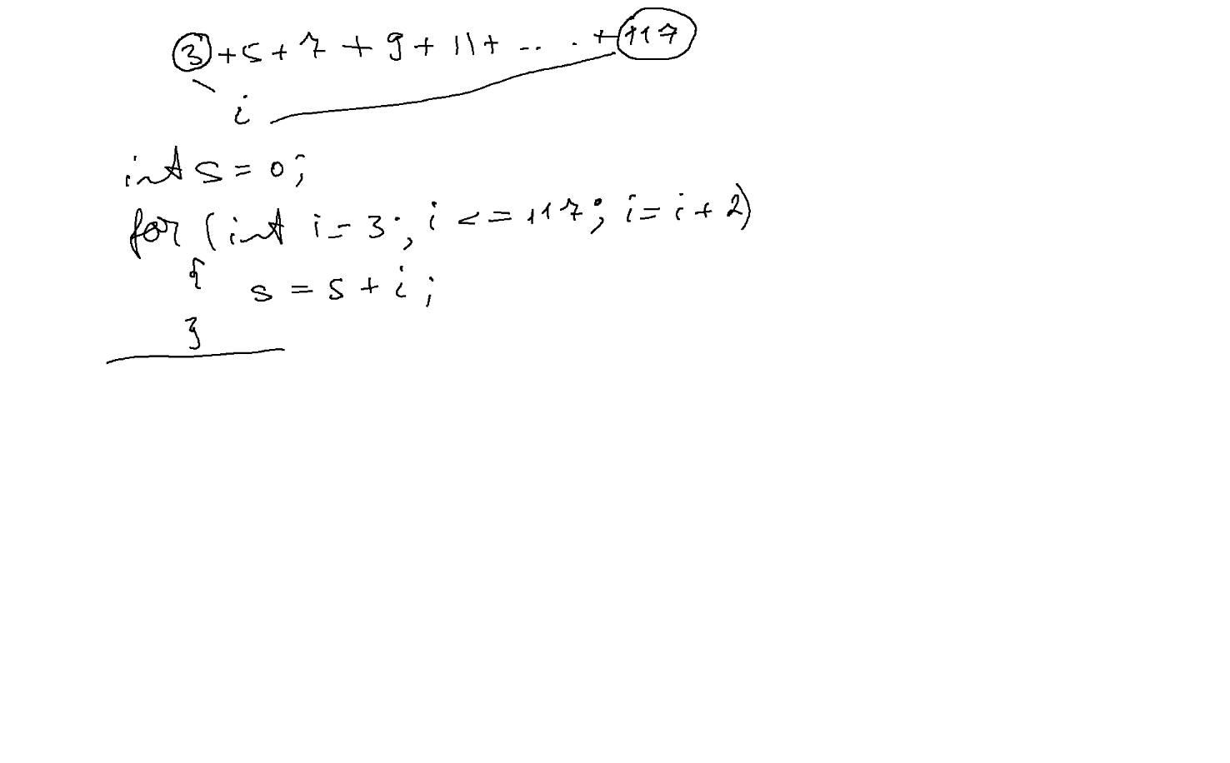

using System;

using System.Collections.Generic;

using System.Linq;

using System.Text;

using System.Threading.Tasks;

namespace ConsoleApplication63

{

class Program

{

static void Main(string[] args)

{

double money;

Console.Write("Money=");

money = double.Parse(Console.ReadLine());

while (money<3000)

{

Console.Write("Дайте ще :");

double extraMoney = double.Parse(Console.ReadLine());

money += extraMoney;

Console.WriteLine("Ми маємо {0}, не вистачає {1}", money,3000-money);

}

Console.ReadLine();

}

}

}

using System;

using System.Collections.Generic;

using System.Linq;

using System.Text;

using System.Threading.Tasks;

namespace ConsoleApplication63

{

class Program

{

static void Main(string[] args)

{

int rightPassword = 7;

int userPassword;

do

{

Console.Write("Password: ");

userPassword = int.Parse(Console.ReadLine());

} while (rightPassword!=userPassword);

Console.WriteLine("Welcome");

Console.ReadLine();

}

}

}

using System;

using System.Collections.Generic;

using System.Linq;

using System.Text;

using System.Threading.Tasks;

namespace ConsoleApplication63

{

class Program

{

static void Main(string[] args)

{

int S = 0;

int number;

do

{

Console.Write("number=");

number = int.Parse(Console.ReadLine());

S = S + number;

} while (number!=0);

Console.WriteLine("Sum="+S);

Console.ReadLine();

}

}

}