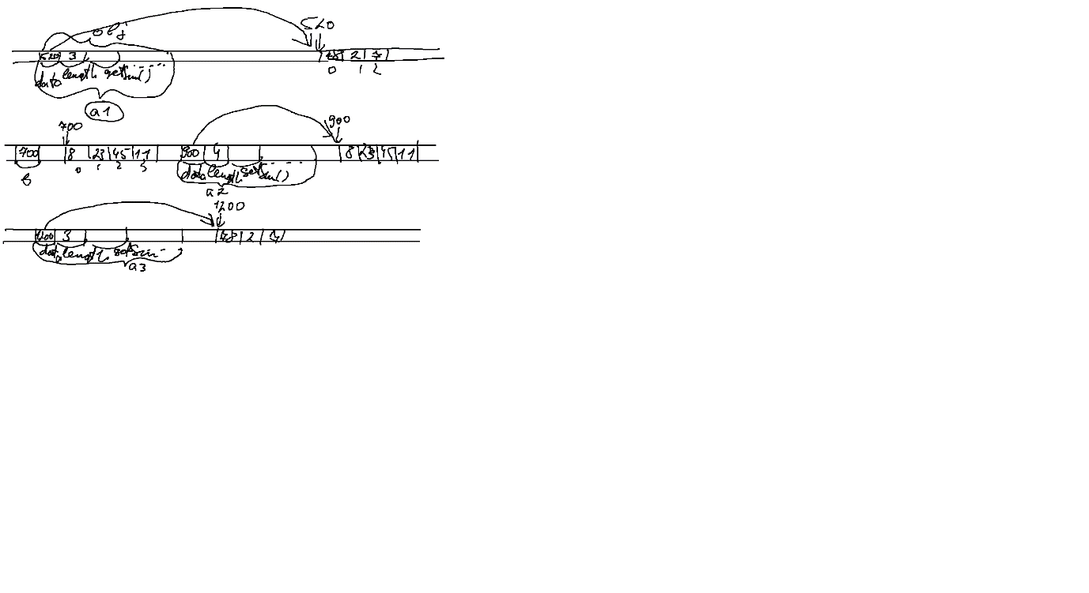

----------------------------Array.h---------------------------

#pragma once

class Array

{

public:

double\* data=0;

int length=0;

Array();

Array(int length);

Array(double\* data, int length);

Array(const Array& obj);

double getSum();

double getMax();

double getMin();

void input();

void output();

~Array();

};

-----------------------------------------------------------------

-------------------------- Array.cpp --------------------------

#include "stdafx.h"

#include "Array.h"

#include <iostream>

using namespace std;

Array::Array()

{

data = 0;

length = 0;

}

Array::Array(int length)

{

data = new double[length];

this->length = length;

}

Array::Array(double \* data, int length):Array(length)

{

for (int i = 0; i < length; i++)

{

this->data[i] = data[i];

}

}

Array::Array(const Array & obj):Array(obj.data,obj.length)

{

}

double Array::getSum()

{

double s = 0;

for (int i = 0; i < length; i++)

{

s += data[i];

}

return s;

}

double Array::getMax()

{

double max = data[0];

for (int i = 1; i < length; i++)

{

if (data[i]>max)

{

max = data[i];

}

}

return max;

}

double Array::getMin()

{

double min = data[0];

for (int i = 1; i < length; i++)

{

if (data[i]<min)

{

min = data[i];

}

}

return min;

}

void Array::input()

{

cout << "length=";

cin >> length;

if (data != 0)

delete[] data;

data = new double[length];

for (int i = 0; i < length; i++)

{

printf("data[%d]=",i);

cin >> data[i];

}

}

void Array::output()

{

for (int i = 0; i < length; i++)

{

printf("data[%d]=%5.2f ", i,data[i]);

}

cout << endl;

}

Array::~Array()

{

if (data!=0)

{

delete[] data;

cout << "--- detructor ----------" << endl;

}

}

---------------------------------------------------------------------

--------------------------- Main -------------------------------

// ConsoleApplication8.cpp : Defines the entry point for the console application.

//

#include "stdafx.h"

#include "Array.h"

#include <iostream>

using namespace std;

void fun1()

{

Array dd(5);

}

int main()

{

Array a1(3);

a1.data[0] = 78;

a1.data[1] = 2;

a1.data[2] = 7;

cout <<"Sum="<< a1.getSum() << endl;

//-----------------------

double\* b = new double[4];

b[0] = 8; b[1] = 23; b[0] = 45; b[0] = 11;

Array a2(b, 4);

//---------------------------

Array a3(a1);

//---------------------

Array\* a4 = new Array(a1);

delete a4; a4 = 0;

fun1();

system("pause");

return 0;

}

//===========================================================

//===========================================================

//===========================================================

// ------------ З статичним методом ---------------

//----------------- Array.h ------------------

#pragma once

class Array

{

public:

double\* data=0;

int length=0;

static int a;

Array();

Array(int length);

Array(double\* data, int length);

Array(const Array& obj);

double getSum();

double getMax();

double getMin();

double& getItem(int index);

static Array\* getRandomArray(int length);

void input();

void output();

~Array();

};

//----------------- Array.cpp ------------------

#include "stdafx.h"

#include "Array.h"

#include <iostream>

using namespace std;

Array::Array()

{

data = 0;

length = 0;

}

Array::Array(int length)

{

data = new double[length];

this->length = length;

}

Array::Array(double \* data, int length):Array(length)

{

for (int i = 0; i < length; i++)

{

this->data[i] = data[i];

}

}

Array::Array(const Array & obj):Array(obj.data,obj.length)

{

}

double Array::getSum()

{

double s = 0;

for (int i = 0; i < length; i++)

{

s += data[i];

}

return s;

}

double Array::getMax()

{

double max = data[0];

for (int i = 1; i < length; i++)

{

if (data[i]>max)

{

max = data[i];

}

}

return max;

}

double Array::getMin()

{

double min = data[0];

for (int i = 1; i < length; i++)

{

if (data[i]<min)

{

min = data[i];

}

}

return min;

}

double& Array::getItem(int index)

{

if(index>=0 && index<length)

return data[index];

else

throw "error";

}

Array\* Array::getRandomArray(int length)

{

Array\* obj=new Array(length);

for (int i = 0; i < length; i++)

{

obj->data[i] = rand() % 100;

}

return obj;

}

void Array::input()

{

cout << "length=";

cin >> length;

if (data != 0)

delete[] data;

data = new double[length];

for (int i = 0; i < length; i++)

{

printf("data[%d]=",i);

cin >> data[i];

}

}

void Array::output()

{

for (int i = 0; i < length; i++)

{

printf("data[%d]=%5.2f ", i,data[i]);

}

cout << endl;

}

Array::~Array()

{

if (data!=0)

{

delete[] data;

cout << "--- detructor ----------" << endl;

}

}

//----------------- Main --------------------------

// ConsoleApplication8.cpp : Defines the entry point for the console application.

//

#include "stdafx.h"

#include "Array.h"

#include <iostream>

using namespace std;

void fun1()

{

Array dd(5);

}

int main()

{

Array a5 = \*(Array::getRandomArray(9));

Array a1(3);

a1.data[0] = 78;

a1.data[1] = 2;

a1.data[2] = 7;

cout <<"data[1]="<< a1.data[1] << endl;

a1.getItem(1) = 47;

cout << "data[1]=" << a1.data[1] << endl;

cout <<"Sum="<< a1.getSum() << endl;

//-----------------------

double\* b = new double[4];

b[0] = 8; b[1] = 23; b[0] = 45; b[0] = 11;

Array a2(b, 4);

//---------------------------

Array a3(a1);

//---------------------

Array\* a4 = new Array(a1);

delete a4; a4 = 0;

fun1();

system("pause");

return 0;

}