Приклад 1. Ковертер валют
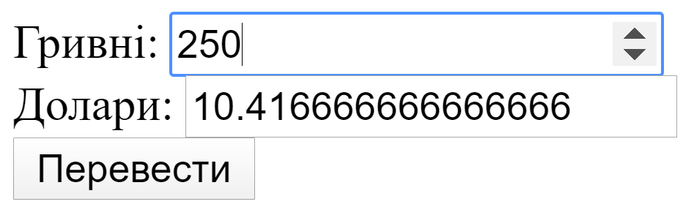
<!DOCTYPE html>
<html lang="en">
<head>
<meta charset="UTF-8" />
<meta name="viewport" content="width=device-width, initial-scale=1.0" />
<meta http-equiv="X-UA-Compatible" content="ie=edge" />
<title>Document</title>
<script src="https://cdn.jsdelivr.net/npm/vue/dist/vue.js"></script>
</head>
<body>
<div id="app">
Гривні: <input type="number" v-model="grn" /><br />
Долари: <input type="number" :value="dollars" /><br />
{{grn}}
<button @click="convert" :title="sum">Перевести</button> <br />
</div>
<script>
var app = new Vue({
el: "#app",
data: {
grn: 0,
dollars: 0
},
methods: {
convert() {
this.dollars = this.grn / 24;
}
}
});
</script>
</body>
</html>

Приклад 2. Додавання двох чисел

<!DOCTYPE html>
<html lang="en">
<head>
<meta charset="UTF-8" />
<meta name="viewport" content="width=device-width, initial-scale=1.0" />
<meta http-equiv="X-UA-Compatible" content="ie=edge" />
<title>Document</title>
<script src="https://cdn.jsdelivr.net/npm/vue/dist/vue.js"></script>
</head>
<body>
<div id="app">
Num1 <input type="number" v-model="num1" /><br />
Num2 <input type="number" v-model="num2" /><br />
<button @click="getSum" :title="sum">Get sum</button> <br />
Res : {{num1}} +{{num2}} = {{sum}}
</div>
<script>
var app = new Vue({
el: "#app",
data: {
num1: 0,
num2: 0,
sum: ""
},
methods: {
getSum() {
this.sum = +this.num1 + +this.num2;
}
}
});
</script>
</body>
</html>

