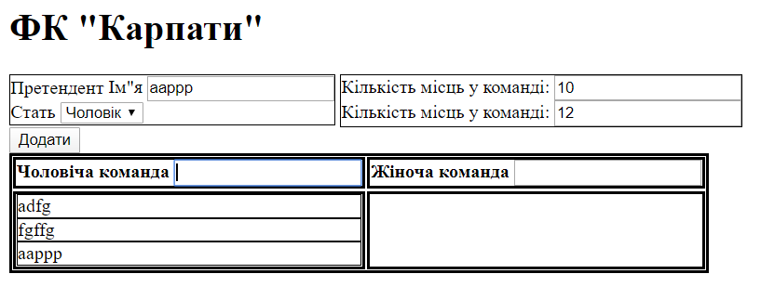
<!DOCTYPE html>
<html>
<head>
<meta charset="utf-8" />
<script src="https://cdn.jsdelivr.net/npm/vue/dist/vue.js"></script>
<style>
td,
th,
table {
border: 2px solid black;
}
#mainOpt div {
display: inline-block;
border: 1px solid black;
}
td div {
border: 1px solid black;
}
</style>
</head>
<body>
<div id="app" style="border-style: groove;">
<div>
<h1>ФК "Карпати"</h1>
</div>
<div id="mainOpt">
<div>
Претендент
<label>
Ім"я
<input type="text" v-model="name" /> </label
><br />
<label>
Стать
<select v-model="selectedGender">
<option
v-for="gender in genders"
:key="gender.id"
:value="gender.id"
>
{{gender.text}}
</option>
</select> </label
><br />
</div>
<div>
<label>
Кількість місць у команді:
<input type="number" v-model="manTeamNumber" /> </label
><br />
<label>
Кількість місць у команді:
<input type="number" v-model="womanTeamNumber" />
</label>
</div>
<br />
<button @click="addNewMember">Додати</button>
</div>
<table v-if="hasPlayers">
<tr>
<th>
Чоловіча команда
<input type="text" v-model="searchMan" />
</th>
<th>
Жіноча команда
<input type="text" v-model="searchWoman" />
</th>
</tr>
<tr>
<td>
<div v-for="(player,index) in getFilteredManList" :key="index">
{{player}}
</div>
</td>
<td>
<div v-for="(player,index) in getFilteredWomanList" :key="index">
{{player}}
</div>
</td>
</tr>
</table>
</div>

<script>
const genders = [
{
id: 1,
text: "Чоловік"
},
{
id: 2,
text: "Жінка"
}
];
var app = new Vue({
el: "#app",
data: {
name: null,
genders,
selectedGender: null,
manTeamNumber: 10,
womanTeamNumber: 12,
manTeam: [],
womanTeam: [],
searchMan: null,
searchWoman: null
},
computed: {
getFilteredManList() {
if (this.searchMan)
return this.manTeam.filter(player =>
player.startsWith(this.searchMan)
);
else return this.manTeam;
},
getFilteredWomanList() {
if (this.searchWoman)
return this.womanTeam.filter(player =>
player.startsWith(this.searchWoman)
);
else return this.womanTeam;
},
hasPlayers() {
return this.manTeam.length || this.womanTeam.length;
}
},
watch: {
searchMan(newVal) {}
},
methods: {
addNewMember() {
if (this.selectedGender === 1) {
if (this.manTeam.length < this.manTeamNumber) {
this.manTeam.push(this.name);
} else alert("Чоловіча команда заповнена");
} else {
if (this.womanTeam.length < this.womanTeamNumber) {
this.womanTeam.push(this.name);
} else alert("Жіноча команда заповнена");
}
}
}
});
</script>
</body>
</html>

